Supplementary Material for
A global atlas of genetic associations of 220 deep phenotypes.

Sakaue and Kanai et al.

Table of Contents:

Page 3 Extended Data Figure 1
Page 4 Extended Data Figure 2
Page 5 Extended Data Figure 3
Page 6 Extended Data Figure 4
Page 7 Extended Data Figure 5
Page 8 Extended Data Figure 6
Page 9 Extended Data Figure 7
Page 10 Extended Data Figure 8
Page 11 Extended Data Figure 9
Page 12 Extended Data Figure 10
Page 13 Extended Data Figure 11
Page 14 Extended Data Figure 12
Page 15 Extended Data Figure 13
Page 16 Extended Data Figure 14
Page 17 Extended Data Figure 15
Page 18 Supplementary Notes

Supplementary Tables are provided by a separate excel file.

Extended Data Figure 1.
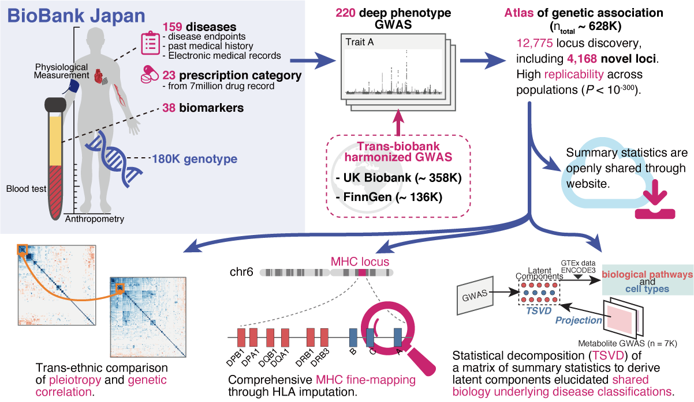
Extended Data Figure 1 | Overview of this study.
We performed 220 deep-phenotype GWASs in BioBank Japan, including 108 novel GWASs ever conducted in East Asian population. We performed trans-biobank meta-analyses with UK Biobank and FinnGen (n_{total} = 628,000), resulting in discovery of 4,168 novel loci. All summary statistics will be openly shared through web database. As downstream analyses, we performed (i) trans-ethnic comparison of pleiotropy and genetic correlation, (ii) comprehensive HLA fine-mapping, and (iii) statistical decomposition of a matrix of summary statistics to gain insights into biology underlying current disease classifications, by incorporating functional genomics, metabolomics, and biomarker data.

Extended Data Figure 2.
Extended Data Figure 2 | Locus plot for Pulmonary Tuberculosis (PTB) in BBJ.
Regional association plots are shown. The lead variant (rs140780894) is colored in pink, and colors of other dots indicate linkage disequilibrium measure r² with the lead variant.

Extended Data Figure 3.
Extended Data Figure 3 | Locus plot for dysentery in BBJ.
Regional association plots are shown. The lead variant (rs190894416) is colored in pink, and colors of other dots indicate linkage disequilibrium measure r² with the lead variant.

Extended Data Figure 4.
Extended Data Figure 4 | Locus plot for cholelithiasis in BBJ.
Regional association plots are shown. The lead variant (rs715) is colored in pink, and colors of other dots indicate linkage disequilibrium measure r² with the lead variant.

Extended Data Figure 5.
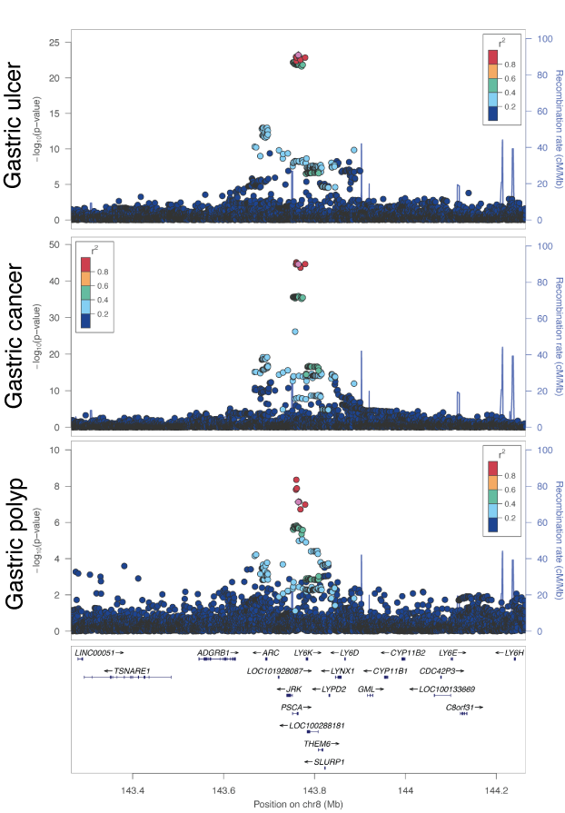
Extended Data Figure 5 | Locus plot for gastric diseases in BBJ.
Regional association plots at the PSCA locus in gastric ulcer, gastric cancer, and gastric polyp are shown. Rs2976397, which was a lead variant in gastric ulcer, is colored in pink, and colors of other dots indicate linkage disequilibrium measure r² with the lead variant.
Extended Data Figure 6.
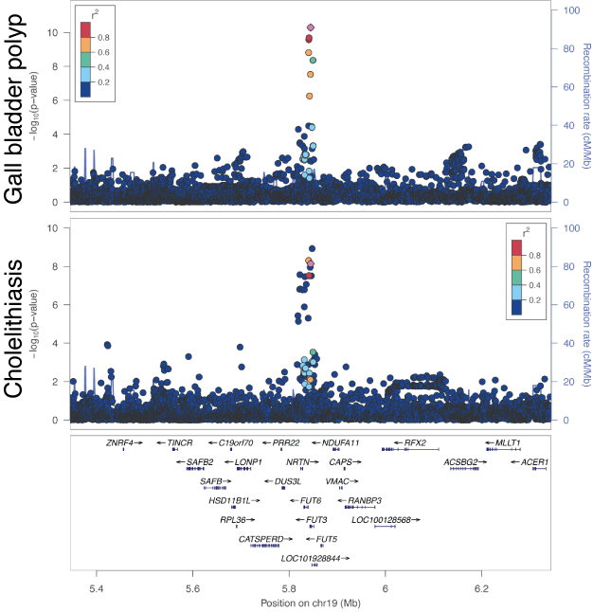
Extended Data Figure 6 | Locus plot for gall bladder diseases in BBJ.
Regional association plots at the FUT3 locus in gall bladder polyp and cholelithiasis are shown. Rs28362459, which was a lead variant in gall bladder polyp, is colored in pink, and colors of other dots indicate linkage disequilibrium measure r² with the lead variant.

Extended Data Figure 7.
Extended Data Figure 7 | Locus plot for urticaria in BBJ.
Regional association plots are shown. The lead variant (rs56043070) is colored in pink, and colors of other dots indicate linkage disequilibrium measure r² with the lead variant.

Extended Data Figure 8.
Extended Data Figure 8 | Locus plot for salicylic acids prescription in BBJ.
Regional association plots are shown. The lead variant (rs151193009) is colored in pink, and colors of other dots indicate linkage disequilibrium measure r² with the lead variant.

Extended Data Figure 9.
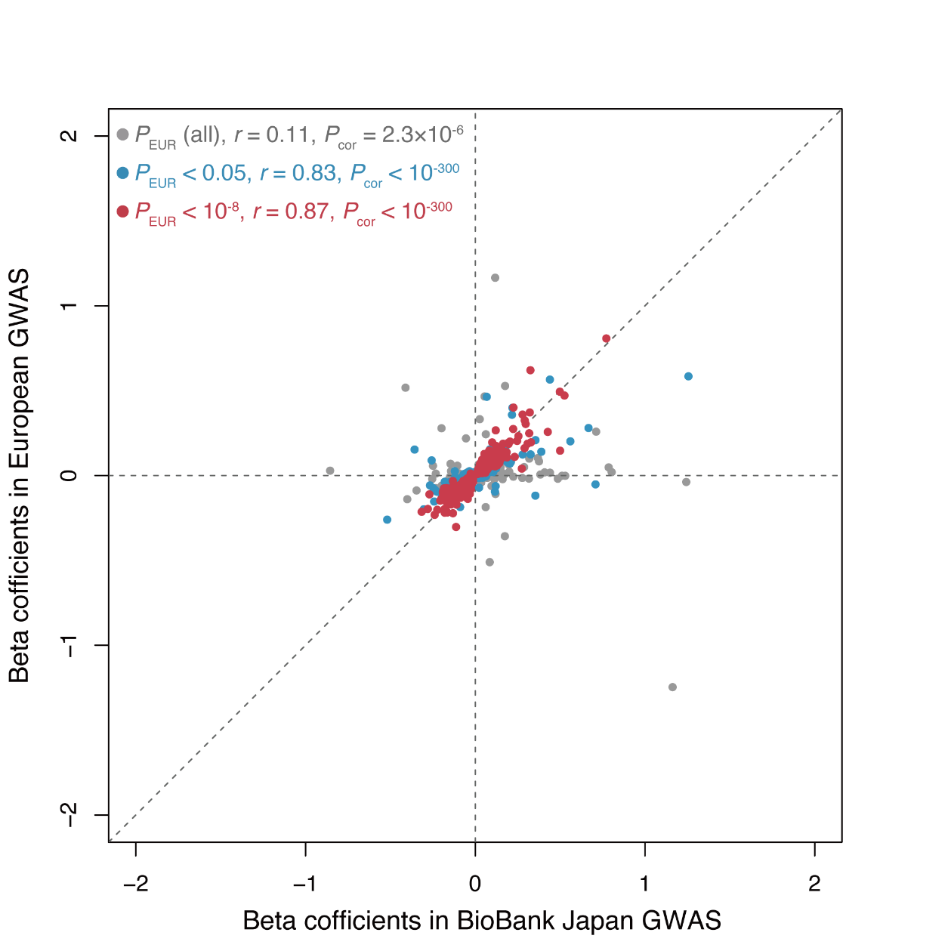
Extended Data Figure 9 | The effect size correlation between BBJ GWAS and European GWAS.
The marginal effect sizes of genome-wide significant variants across traits (diseases and biomarkers) in BBJ are compared with those in European GWAS. Each plot represents a variant, and is colored based on the significance in European GWAS as shown in the left top legend. Pearson’s correlation r and P value between BBJ GWAS and European GWAS are also shown in the legend.

Extended Data Figure 10.
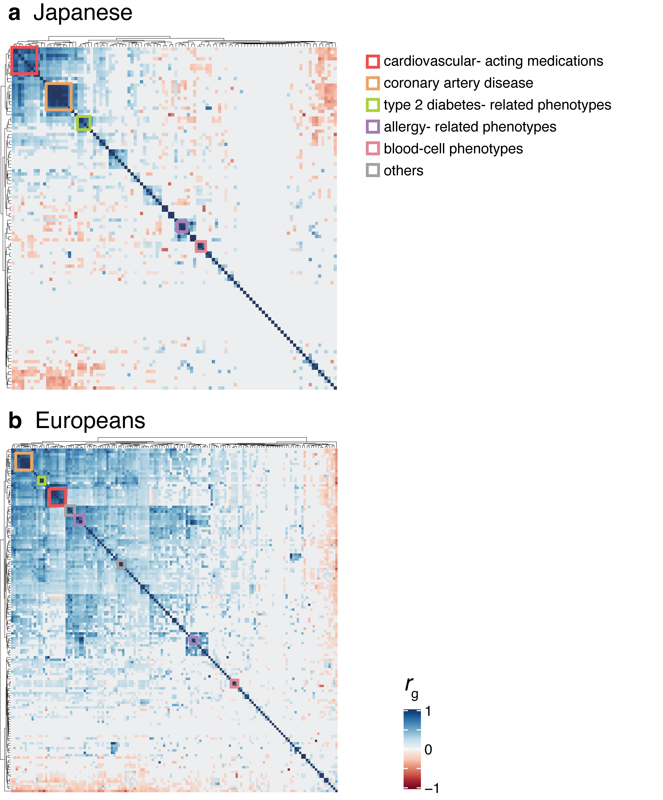
Extended Data Figure 10 | Genetic correlation matrices across populations.
The matrices describe pairwise genetic correlation r_{g}s in Japanese GWAS (a; n = 5,565) and in European GWAS (b; n = 10,878), which were estimated by bivariate LD score regression. A color of the cells indicates the value of r_{g} as shown in a color scale at the bottom. The traits (rows and columns) were hierarchically clustered by hclust library in R, and trait domains are displayed as colored boxes (see Methods).
Extended Data Figure 11.
Extended Data Figure 11 | A scree plot from the decomposition of summary statistics.
A scree plot summarizes cumulative explained variance by the 40 components from TSVD. We calculated variance explained by each component from the “.explained_variance_ratio_” from TruncatedSVD module in python package.

Extended Data Figure 12.
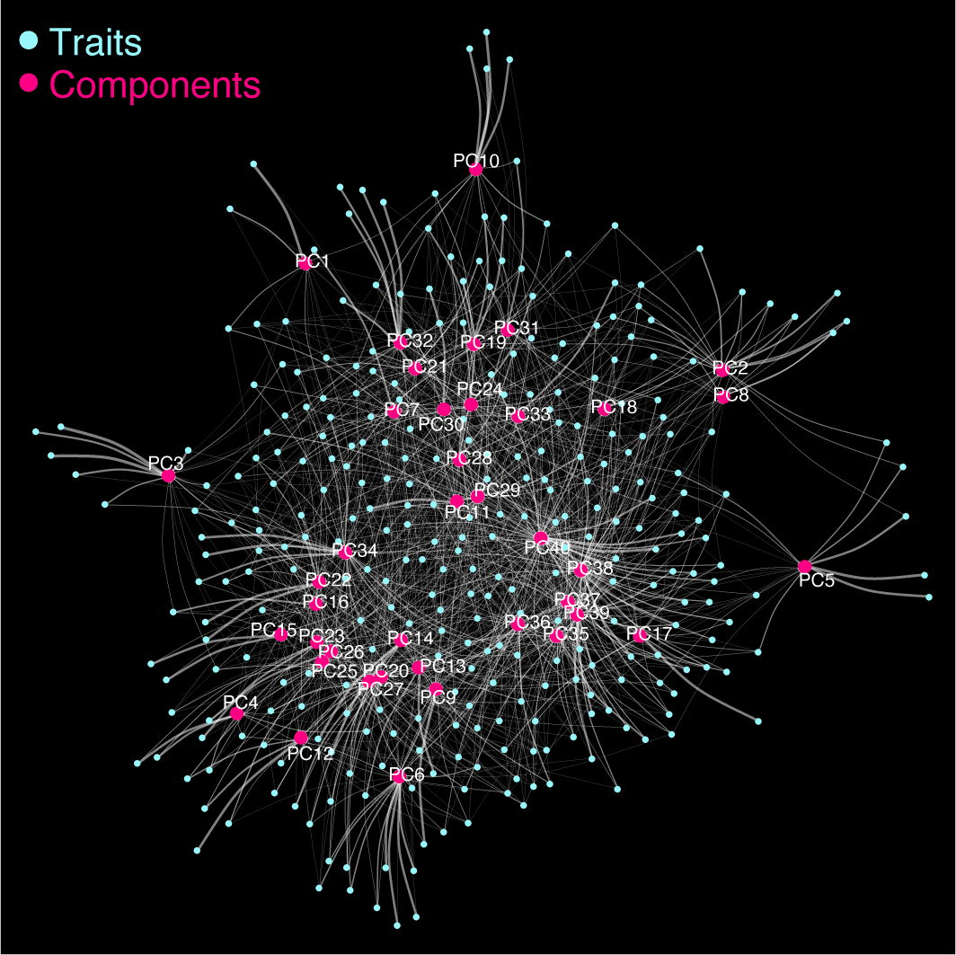
Extended Data Figure 12 | Network representation of the TSVD analysis.
Two-dimensional illustration of interconnection among 159 diseases and 40 latent components. Plots in blue indicate each trait’s statistics, and plots in pink indicate the latent components derived by TSVD. White lines represent the contribution of each phenotype in each component. The width of the lines indicates the strength of the contribution based on the squared cosine score.
Extended Data Figure 13.
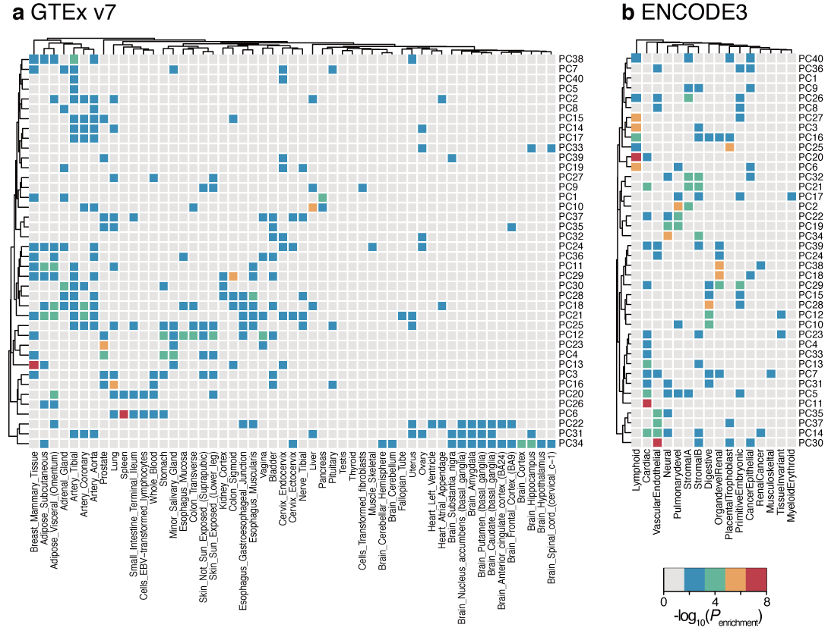
Extended Data Figure 13 | Enrichment analyses of genes explaining each component with tissue specificity.
A heatmap representation of the enrichment analyses of genes explaining each component with tissue-specific genes defined by GTEx expression profile (a) and regulatory vocabulary from ENCODE3 data (b). Each cell is colored based on P_{enrichment} from Fisher’s exact tests to assess the enrichment of the genes comprising each component within each tissue-specific gene set as shown in a color scale at the bottom right.

Extended Data Figure 14.
Extended Data Figure 14 | Heatmap representation of squared cosine scores of diseases to components.
The components (rows) are shown from 1 (top) to 40 (bottom), and the diseases (columns) are sorted based on the contribution of each component to the disease based on the squared cosine score (from component 1 to 40). Each cell is colored based on the squared cosine score of a given trait to a given component, as shown in a color scale at the bottom right.

Extended Data Figure 15.
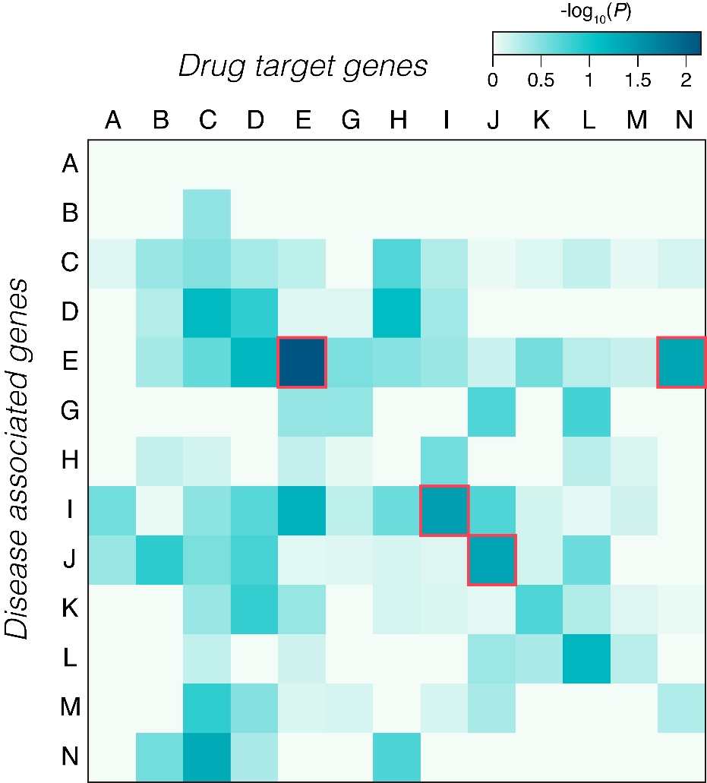

Extended Data Figure 15 | Drug target enrichment analysis.
The enrichment P value from Fisher’s exact test of disease-associated genes against target genes of approved drugs for the disease is illustrated as a heatmap. The color of each cell indicates the –log₁₀(P) value of the enrichment of associated genes with each disease category to target genes of approved medication to a given disease category as shown in the color scale (top right). The disease category is ordered as an alphabetical code of the ICD10 classifications. The enrichment with nominal significance (P < 0.05) is highlighted as a box with a red border.
Supplementary Notes

1. Cohort descriptions
The Biobank Japan
The BioBank Japan (BBJ) Project is a nation-wide hospital-based prospective cohort launched in 2003. The BBJ collaboratively collected serum as well as clinical data of approximately 200,000 participants from 66 hospitals affiliated with 12 medical institutes. Participants were registered to the cohort from June 2003 to March 2008, and their clinical information was collected annually via interviews and medical record reviews until 2013. We collected DNA from all participants at baseline and collected annual serum samples until 2013.

The UK Biobank
The UK Biobank project is a population-based prospective cohort that recruited approximately 500,000 people aged between 40–69 years from 2006 to 2010 from across the United Kingdom. Deep phenotype data, such as electronic medical records, lifestyle indicators and bioassays (e.g., biochemistry, proteomic and metabonomic analyses), and genotype data were available for most of the participants. The detailed characteristics of the cohort were extensively described elsewhere¹.

FinnGen
FinnGen is a public–private partnership project. Six regional and three country-wide Finnish biobanks participate in FinnGen. Additionally, data from previously established population and disease-based cohorts are utilized. Participants’ health outcomes are followed up by linking to the national health registries (1969–2016), which collect information from birth to death. A list of FinnGen contributors is presented below.

The Tohoku Medical Megabank (TMM)
The Tohoku Medical Megabank (TMM) Project was launched for the purpose of reconstruction from the Great East Japan Earthquake on 11 March 2011 and establishment of personalized healthcare and medicine². In the project, an integrated biobank has been established based on two prospective genome cohort studies ("the TMM Community-Based Cohort Study" and "Birth and Three-Generation Cohort Study"). Although the cohort studies recruited residents in Miyagi or Iwate Prefecture, only the participants living in Miyagi Prefecture, whose measurements on metabolites were available, were used in the study.

2. Contributors of FinnGen

Steering Committee
Aarno Palotie Institute for Molecular Medicine Finland, HiLIFE, University of Helsinki, Finland
Mark Daly Institute for Molecular Medicine Finland, HiLIFE, University of Helsinki, Finland

Pharmaceutical companies
Howard Jacob Abbvie, Chicago, IL, United States
Athena Matakidou Astra Zeneca, Cambridge, United Kingdom
Heiko Runz Biogen, Cambridge, MA, United States
Sally John Biogen, Cambridge, MA, United States
Robert Plenge Celgene, Summit, NJ, United States
Mark McCarthy Genentech, San Francisco, CA, United States
Julie Hunkapiller Genentech, San Francisco, CA, United States
Meg Ehm GlaxoSmithKline, Brentford, United Kingdom
Dawn Waterworth GlaxoSmithKline, Brentford, United Kingdom
Caroline Fox Merck, Kenilworth, NJ, United States
Anders Malarstig Pfizer, New York, NY, United States
Kathy Klinger Sanofi, Paris, France
Kathy Call Sanofi, Paris, France

University of Helsinki & Biobanks
Tomi Mäkelä HiLIFE, University of Helsinki, Finland, Finland
Jaakko Kaprio Institute for Molecular Medicine Finland, HiLIFE, Helsinki, Finland, Finland
Petri Virolainen Auria Biobank / Univ. of Turku / Hospital District of Southwest Finland, Turku, Finland
Kari Pulkki Auria Biobank / Univ. of Turku / Hospital District of Southwest Finland, Turku, Finland
Terhi Kilpi THL Biobank / The National Institute of Health and Welfare Helsinki, Finland
Markus Perola THL Biobank / The National Institute of Health and Welfare Helsinki, Finland
Jukka Partanen Finnish Red Cross Blood Service / Finnish Hematology Registry and Clinical Biobank, Helsinki, Finland
Anne Pitkäranta Hospital District of Helsinki and Uusimaa, Helsinki, Finland
Riitta Kaarteenaho Northern Finland Biobank Borealis / University of Oulu / Northern Ostrobothnia Hospital District, Oulu, Finland
Seppo Vainio Northern Finland Biobank Borealis / University of Oulu / Northern Ostrobothnia Hospital District, Oulu, Finland
Kimmo Savinainen Finnish Clinical Biobank Tampere / University of Tampere / Pirkanmaa Hospital District, Tampere, Finland
Veli-Matti Kosma Biobank of Eastern Finland / University of Eastern Finland / Northern Savo Hospital District, Kuopio, Finland
Urho Kujala Central Finland Biobank / University of Jyväskylä / Central Finland Health Care District, Jyväskylä, Finland

Other Experts/ Non-Voting Members
Outi Tuovila Business Finland, Helsinki, Finland
Minna Hendolin Business Finland, Helsinki, Finland
Raimo Pakkanen Business Finland, Helsinki, Finland

Scientific Committee

Pharmaceutical companies
Jeff Waring Abbvie, Chicago, IL, United States
Bridget Riley-Gillis Abbvie, Chicago, IL, United States
Athena Matakidou Astra Zeneca, Cambridge, United Kingdom
Heiko Runz Biogen, Cambridge, MA, United States
Jimmy Liu Biogen, Cambridge, MA, United States
Shameek Biswas Celgene, Summit, NJ, United States
Julie Hunkapiller Genentech, San Francisco, CA, United States
Dawn Waterworth GlaxoSmithKline, Brentford, United Kingdom
Meg Ehm GlaxoSmithKline, Brentford, United Kingdom
Dorothee Diogo Merck, Kenilworth, NJ, United States
Caroline Fox Merck, Kenilworth, NJ, United States
Anders Malarstig Pfizer, New York, NY, United States
Catherine Marshall Pfizer, New York, NY, United States
Xinli Hu Pfizer, New York, NY, United States
Kathy Call Sanofi, Paris, France
Kathy Klinger Sanofi, Paris, France
Matthias Gossel Sanofi, Paris, France

University of Helsinki & Biobanks
Samuli Ripatti Institute for Molecular Medicine Finland, HiLIFE, Helsinki, Finland
Johanna Schleutker Auria Biobank / Univ. of Turku / Hospital District of Southwest Finland, Turku, Finland
Markus Perola THL Biobank / The National Institute of Health and Welfare Helsinki, Finland
Mikko Arvas Finnish Red Cross Blood Service / Finnish Hematology Registry and Clinical Biobank, Helsinki, Finland
Olli Carpen Hospital District of Helsinki and Uusimaa, Helsinki, Finland
Reetta Hinttala Northern Finland Biobank Borealis / University of Oulu / Northern Ostrobothnia Hospital District, Oulu, Finland
Johannes Kettunen Northern Finland Biobank Borealis / University of Oulu / Northern Ostrobothnia Hospital District, Oulu, Finland
Reijo Laaksonen Finnish Clinical Biobank Tampere / University of Tampere / Pirkanmaa Hospital District, Tampere, Finland
Arto Mannermaa Biobank of Eastern Finland / University of Eastern Finland / Northern Savo Hospital District, Kuopio, Finland
Juha Paloneva Central Finland Biobank / University of Jyväskylä / Central Finland Health Care District, Jyväskylä, Finland
Urho Kujala Central Finland Biobank / University of Jyväskylä / Central Finland Health Care District, Jyväskylä, Finland

Other Experts/ Non-Voting Members
Outi Tuovila Business Finland, Helsinki, Finland
Minna Hendolin Business Finland, Helsinki, Finland
Raimo Pakkanen Business Finland, Helsinki, Finland

Clinical Groups

Neurology Group
Hilkka Soininen Northern Savo Hospital District, Kuopio, Finland
Valtteri Julkunen Northern Savo Hospital District, Kuopio, Finland
Anne Remes Northern Ostrobothnia Hospital District, Oulu, Finland
Reetta Kälviäinen Northern Savo Hospital District, Kuopio, Finland
Mikko Hiltunen Northern Savo Hospital District, Kuopio, Finland
Jukka Peltola Pirkanmaa Hospital District, Tampere, Finland
Pentti Tienari Hospital District of Helsinki and Uusimaa, Helsinki, Finland
Juha Rinne Hospital District of Southwest Finland, Turku, Finland
Adam Ziemann Abbvie, Chicago, IL, United States
Jeffrey Waring Abbvie, Chicago, IL, United States
Sahar Esmaeeli Abbvie, Chicago, IL, United States
Nizar Smaoui Abbvie, Chicago, IL, United States
Anne Lehtonen Abbvie, Chicago, IL, United States
Susan Eaton Biogen, Cambridge, MA, United States
Heiko Runz Biogen, Cambridge, MA, United States
Sanni Lahdenperä Biogen, Cambridge, MA, United States
Shameek Biswas Celgene, Summit, NJ, United States
John Michon Genentech, San Francisco, CA, United States
Geoff Kerchner Genentech, San Francisco, CA, United States
Julie Hunkapiller Genentech, San Francisco, CA, United States
Natalie Bowers Genentech, San Francisco, CA, United States
Edmond Teng Genentech, San Francisco, CA, United States
John Eicher Merck, Kenilworth, NJ, United States
Vinay Mehta Merck, Kenilworth, NJ, United States
Padhraig Gormley Merck, Kenilworth, NJ, United States
Kari Linden Pfizer, New York, NY, United States
Christopher Whelan Pfizer, New York, NY, United States
Fanli Xu GlaxoSmithKline, Brentford, United Kingdom
David Pulford GlaxoSmithKline, Brentford, United Kingdom

Gastroenterology Group
Martti Färkkilä Hospital District of Helsinki and Uusimaa, Helsinki, Finland
Sampsa Pikkarainen Hospital District of Helsinki and Uusimaa, Helsinki, Finland
Airi Jussila Pirkanmaa Hospital District, Tampere, Finland
Timo Blomster Northern Ostrobothnia Hospital District, Oulu, Finland
Mikko Kiviniemi Northern Savo Hospital District, Kuopio, Finland
Markku Voutilainen Hospital District of Southwest Finland, Turku, Finland
Bob Georgantas Abbvie, Chicago, IL, United States
Graham Heap Abbvie, Chicago, IL, United States
Jeffrey Waring Abbvie, Chicago, IL, United States
Nizar Smaoui Abbvie, Chicago, IL, United States
Fedik Rahimov Abbvie, Chicago, IL, United States
Anne Lehtonen Abbvie, Chicago, IL, United States
Keith Usiskin Celgene, Summit, NJ, United States
Joseph Maranville Celgene, Summit, NJ, United States
Tim Lu Genentech, San Francisco, CA, United States
Natalie Bowers Genentech, San Francisco, CA, United States
Danny Oh Genentech, San Francisco, CA, United States
John Michon Genentech, San Francisco, CA, United States
Vinay Mehta Merck, Kenilworth, NJ, United States
Kirsi Kalpala Pfizer, New York, NY, United States
Melissa Miller Pfizer, New York, NY, United States
Xinli Hu Pfizer, New York, NY, United States
Linda McCarthy GlaxoSmithKline, Brentford, United Kingdom

Rheumatology Group
Kari Eklund Hospital District of Helsinki and Uusimaa, Helsinki, Finland
Antti Palomäki Hospital District of Southwest Finland, Turku, Finland
Pia Isomäki Pirkanmaa Hospital District, Tampere, Finland
Laura Pirilä Hospital District of Southwest Finland, Turku, Finland
Oili Kaipiainen-Seppänen Northern Savo Hospital District, Kuopio, Finland
Johanna Huhtakangas Northern Ostrobothnia Hospital District, Oulu, Finland
Bob Georgantas Abbvie, Chicago, IL, United States
Jeffrey Waring Abbvie, Chicago, IL, United States
Fedik Rahimov Abbvie, Chicago, IL, United States
Apinya Lertratanakul Abbvie, Chicago, IL, United States
Nizar Smaoui Abbvie, Chicago, IL, United States
Anne Lehtonen Abbvie, Chicago, IL, United States
David Close Astra Zeneca, Cambridge, United Kingdom
Marla Hochfeld Celgene, Summit, NJ, United States
Natalie Bowers Genentech, San Francisco, CA, United States
John Michon Genentech, San Francisco, CA, United States
Dorothee Diogo Merck, Kenilworth, NJ, United States
Vinay Mehta Merck, Kenilworth, NJ, United States
Kirsi Kalpala Pfizer, New York, NY, United States
Nan Bing Pfizer, New York, NY, United States
Xinli Hu Pfizer, New York, NY, United States
Jorge Esparza Gordillo GlaxoSmithKline, Brentford, United Kingdom
Nina Mars Institute for Molecular Medicine Finland, HiLIFE, Helsinki, Finland

Pulmonology Group
Tarja Laitinen Pirkanmaa Hospital District, Tampere, Finland
Margit Pelkonen Northern Savo Hospital District, Kuopio, Finland
Paula Kauppi Hospital District of Helsinki and Uusimaa, Helsinki, Finland
Hannu Kankaanranta Pirkanmaa Hospital District, Tampere, Finland
Terttu Harju Northern Ostrobothnia Hospital District, Oulu, Finland
Nizar Smaoui Abbvie, Chicago, IL, United States
David Close Astra Zeneca, Cambridge, United Kingdom
Steven Greenberg Celgene, Summit, NJ, United States
Hubert Chen Genentech, San Francisco, CA, United States
Natalie Bowers Genentech, San Francisco, CA, United States
John Michon Genentech, San Francisco, CA, United States
Vinay Mehta Merck, Kenilworth, NJ, United States
Jo Betts GlaxoSmithKline, Brentford, United Kingdom
Soumitra Ghosh GlaxoSmithKline, Brentford, United Kingdom

Cardiometabolic Diseases Group
Veikko Salomaa The National Institute of Health and Welfare Helsinki, Finland
Teemu Niiranen The National Institute of Health and Welfare Helsinki, Finland
Markus Juonala Hospital District of Southwest Finland, Turku, Finland
Kaj Metsärinne Hospital District of Southwest Finland, Turku, Finland
Mika Kähönen Pirkanmaa Hospital District, Tampere, Finland
Juhani Junttila Northern Ostrobothnia Hospital District, Oulu, Finland
Markku Laakso Northern Savo Hospital District, Kuopio, Finland
Jussi Pihlajamäki Northern Savo Hospital District, Kuopio, Finland
Juha Sinisalo Hospital District of Helsinki and Uusimaa, Helsinki, Finland
Marja-Riitta Taskinen Hospital District of Helsinki and Uusimaa, Helsinki, Finland
Tiinamaija Tuomi Hospital District of Helsinki and Uusimaa, Helsinki, Finland
Jari Laukkanen Central Finland Health Care District, Jyväskylä, Finland
Ben Challis Astra Zeneca, Cambridge, United Kingdom
Andrew Peterson Genentech, San Francisco, CA, United States
Julie Hunkapiller Genentech, San Francisco, CA, United States
Natalie Bowers Genentech, San Francisco, CA, United States
John Michon Genentech, San Francisco, CA, United States
Dorothee Diogo Merck, Kenilworth, NJ, United States
Audrey Chu Merck, Kenilworth, NJ, United States
Vinay Mehta Merck, Kenilworth, NJ, United States
Jaakko Parkkinen Pfizer, New York, NY, United States
Melissa Miller Pfizer, New York, NY, United States
Anthony Muslin Sanofi, Paris, France
Dawn Waterworth GlaxoSmithKline, Brentford, United Kingdom

Oncology Group
Heikki Joensuu Hospital District of Helsinki and Uusimaa, Helsinki, Finland
Tuomo Meretoja Hospital District of Helsinki and Uusimaa, Helsinki, Finland
Olli Carpen Hospital District of Helsinki and Uusimaa, Helsinki, Finland
Lauri Aaltonen Hospital District of Helsinki and Uusimaa, Helsinki, Finland
Annika Auranen Pirkanmaa Hospital District , Tampere, Finland
Peeter Karihtala Northern Ostrobothnia Hospital District, Oulu, Finland
Saila Kauppila Northern Ostrobothnia Hospital District, Oulu, Finland
Päivi Auvinen Northern Savo Hospital District, Kuopio, Finland
Klaus Elenius Hospital District of Southwest Finland, Turku, Finland
Relja Popovic Abbvie, Chicago, IL, United States
Jeffrey Waring Abbvie, Chicago, IL, United States
Bridget Riley-Gillis Abbvie, Chicago, IL, United States
Anne Lehtonen Abbvie, Chicago, IL, United States
Athena Matakidou Astra Zeneca, Cambridge, United Kingdom
Jennifer Schutzman Genentech, San Francisco, CA, United States
Julie Hunkapiller Genentech, San Francisco, CA, United States
Natalie Bowers Genentech, San Francisco, CA, United States
John Michon Genentech, San Francisco, CA, United States
Vinay Mehta Merck, Kenilworth, NJ, United States
Andrey Loboda Merck, Kenilworth, NJ, United States
Aparna Chhibber Merck, Kenilworth, NJ, United States
Heli Lehtonen Pfizer, New York, NY, United States
Stefan McDonough Pfizer, New York, NY, United States
Marika Crohns Sanofi, Paris, France
Diptee Kulkarni GlaxoSmithKline, Brentford, United Kingdom

Opthalmology Group
Kai Kaarniranta Northern Savo Hospital District, Kuopio, Finland
Joni A Turunen Hospital District of Helsinki and Uusimaa, Helsinki, Finland
Terhi Ollila Hospital District of Helsinki and Uusimaa, Helsinki, Finland
Sanna Seitsonen Hospital District of Helsinki and Uusimaa, Helsinki, Finland
Hannu Uusitalo Pirkanmaa Hospital District, Tampere, Finland
Vesa Aaltonen Hospital District of Southwest Finland, Turku, Finland
Hannele Uusitalo-Järvinen Pirkanmaa Hospital District, Tampere, Finland
Marja Luodonpää Northern Ostrobothnia Hospital District, Oulu, Finland
Nina Hautala Northern Ostrobothnia Hospital District, Oulu, Finland
Heiko Runz Biogen, Cambridge, MA, United States
Erich Strauss Genentech, San Francisco, CA, United States
Natalie Bowers Genentech, San Francisco, CA, United States
Hao Chen Genentech, San Francisco, CA, United States
John Michon Genentech, San Francisco, CA, United States
Anna Podgornaia Merck, Kenilworth, NJ, United States
Vinay Mehta Merck, Kenilworth, NJ, United States
Dorothee Diogo Merck, Kenilworth, NJ, United States
Joshua Hoffman GlaxoSmithKline, Brentford, United Kingdom

Dermatology Group
Kaisa Tasanen Northern Ostrobothnia Hospital District, Oulu, Finland
Laura Huilaja Northern Ostrobothnia Hospital District, Oulu, Finland
Katariina Hannula-Jouppi Hospital District of Helsinki and Uusimaa, Helsinki, Finland
Teea Salmi Pirkanmaa Hospital District, Tampere, Finland
Sirkku Peltonen Hospital District of Southwest Finland, Turku, Finland
Leena Koulu Hospital District of Southwest Finland, Turku, Finland
Ilkka Harvima Northern Savo Hospital District, Kuopio, Finland
Kirsi Kalpala Pfizer, New York, NY, United States
Ying Wu Pfizer, New York, NY, United States
David Choy Genentech, San Francisco, CA, United States
John Michon Genentech, San Francisco, CA, United States
Nizar Smaoui Abbvie, Chicago, IL, United States
Fedik Rahimov Abbvie, Chicago, IL, United States
Anne Lehtonen Abbvie, Chicago, IL, United States
Dawn Waterworth GlaxoSmithKline, Brentford, United Kingdom

FinnGen Teams

Administration Team
Anu Jalanko Institute for Molecular Medicine Finland, HiLIFE, University of Helsinki, Finland
Risto Kajanne Institute for Molecular Medicine Finland, HiLIFE, University of Helsinki, Finland
Ulrike Lyhs Institute for Molecular Medicine Finland, HiLIFE, University of Helsinki, Finland

Communication

Mari Kaunisto Institute for Molecular Medicine Finland, HiLIFE, University of Helsinki, Finland

Analysis Team
Justin Wade Davis Abbvie, Chicago, IL, United States
Bridget Riley-Gillis Abbvie, Chicago, IL, United States
Danjuma Quarless Abbvie, Chicago, IL, United States
Slavé Petrovski Astra Zeneca, Cambridge, United Kingdom
Jimmy Liu Biogen, Cambridge, MA, United States
Chia-Yen Chen Biogen, Cambridge, MA, United States
Paola Bronson Biogen, Cambridge, MA, United States
Robert Yang Celgene, Summit, NJ, United States
Joseph Maranville Celgene, Summit, NJ, United States
Shameek Biswas Celgene, Summit, NJ, United States
Diana Chang Genentech, San Francisco, CA, United States
Julie Hunkapiller Genentech, San Francisco, CA, United States
Tushar Bhangale Genentech, San Francisco, CA, United States
Natalie Bowers Genentech, San Francisco, CA, United States
Dorothee Diogo Merck, Kenilworth, NJ, United States
Emily Holzinger Merck, Kenilworth, NJ, United States
Padhraig Gormley Merck, Kenilworth, NJ, United States
Xulong Wang Merck, Kenilworth, NJ, United States
Xing Chen Pfizer, New York, NY, United States
Åsa Hedman Pfizer, New York, NY, United States
Kirsi Auro GlaxoSmithKline, Brentford, United Kingdom
Clarence Wang Sanofi, Paris, France
Ethan Xu Sanofi, Paris, France
Franck Auge Sanofi, Paris, France
Clement Chatelain Sanofi, Paris, France
Mitja Kurki Institute for Molecular Medicine Finland, HiLIFE, University of Helsinki, Finland / Broad Institute, Cambridge, MA, United States
Samuli Ripatti Institute for Molecular Medicine Finland, HiLIFE, University of Helsinki, Finland
Mark Daly Institute for Molecular Medicine Finland, HiLIFE, University of Helsinki, Finland
Juha Karjalainen Institute for Molecular Medicine Finland, HiLIFE, University of Helsinki, Finland / Broad Institute, Cambridge, MA, United States
Aki Havulinna Institute for Molecular Medicine Finland, HiLIFE, University of Helsinki, Finland
Anu Jalanko Institute for Molecular Medicine Finland, HiLIFE, University of Helsinki, Finland
Kimmo Palin University of Helsinki, Helsinki, Finland
Priit Palta Institute for Molecular Medicine Finland, HiLIFE, University of Helsinki, Finland
Pietro Della Briotta Parolo Institute for Molecular Medicine Finland, HiLIFE, University of Helsinki, Finland
Wei Zhou Broad Institute, Cambridge, MA, United States
Susanna Lemmelä Institute for Molecular Medicine Finland, HiLIFE, University of Helsinki, Finland
Manuel Rivas University of Stanford, Stanford, CA, United States
Jarmo Harju Institute for Molecular Medicine Finland, HiLIFE, University of Helsinki, Finland
Aarno Palotie Institute for Molecular Medicine Finland, HiLIFE, University of Helsinki, Finland
Arto Lehisto Institute for Molecular Medicine Finland, HiLIFE, University of Helsinki, Finland
Andrea Ganna Institute for Molecular Medicine Finland, HiLIFE, University of Helsinki, Finland
Vincent Llorens Institute for Molecular Medicine Finland, HiLIFE, University of Helsinki, Finland
Antti Karlsson Auria Biobank / Univ. of Turku / Hospital District of Southwest Finland, Turku, Finland
Kati Kristiansson THL Biobank / The National Institute of Health and Welfare Helsinki, Finland
Mikko Arvas Finnish Red Cross Blood Service / Finnish Hematology Registry and Clinical Biobank, Helsinki, Finland
Kati Hyvärinen Finnish Red Cross Blood Service / Finnish Hematology Registry and Clinical Biobank, Helsinki, Finland
Jarmo Ritari Finnish Red Cross Blood Service / Finnish Hematology Registry and Clinical Biobank, Helsinki, Finland
Tiina Wahlfors Finnish Red Cross Blood Service / Finnish Hematology Registry and Clinical Biobank, Helsinki, Finland
Miika Koskinen Hospital District of Helsinki and Uusimaa, Helsinki, Finland BB/HUS/Univ Hosp Districts
Olli Carpen Hospital District of Helsinki and Uusimaa, Helsinki, Finland BB/HUS/Univ Hosp Districts
Johannes Kettunen Northern Finland Biobank Borealis / University of Oulu / Northern Ostrobothnia Hospital District, Oulu, Finland
Katri Pylkäs Northern Finland Biobank Borealis / University of Oulu / Northern Ostrobothnia Hospital District, Oulu, Finland
Marita Kalaoja Northern Finland Biobank Borealis / University of Oulu / Northern Ostrobothnia Hospital District, Oulu, Finland
Minna Karjalainen Northern Finland Biobank Borealis / University of Oulu / Northern Ostrobothnia Hospital District, Oulu, Finland
Tuomo Mantere Northern Finland Biobank Borealis / University of Oulu / Northern Ostrobothnia Hospital District, Oulu, Finland
Eeva Kangasniemi Finnish Clinical Biobank Tampere / University of Tampere / Pirkanmaa Hospital District, Tampere, Finland
Sami Heikkinen Biobank of Eastern Finland / University of Eastern Finland / Northern Savo Hospital District, Kuopio, Finland
Arto Mannermaa Biobank of Eastern Finland / University of Eastern Finland / Northern Savo Hospital District, Kuopio, Finland
Eija Laakkonen Central Finland Biobank / University of Jyväskylä / Central Finland Health Care District, Jyväskylä, Finland
Juha Kononen Central Finland Biobank / University of Jyväskylä / Central Finland Health Care District, Jyväskylä, Finland

Sample Collection Coordination
Anu Loukola Hospital District of Helsinki and Uusimaa, Helsinki, Finland

Sample Logistics
Päivi Laiho THL Biobank / The National Institute of Health and Welfare Helsinki, Finland
Tuuli Sistonen THL Biobank / The National Institute of Health and Welfare Helsinki, Finland
Essi Kaiharju THL Biobank / The National Institute of Health and Welfare Helsinki, Finland
Markku Laukkanen THL Biobank / The National Institute of Health and Welfare Helsinki, Finland
Elina Järvensivu THL Biobank / The National Institute of Health and Welfare Helsinki, Finland
Sini Lähteenmäki THL Biobank / The National Institute of Health and Welfare Helsinki, Finland
Lotta Männikkö THL Biobank / The National Institute of Health and Welfare Helsinki, Finland
Regis Wong THL Biobank / The National Institute of Health and Welfare Helsinki, Finland

Registry Data Operations
Kati Kristiansson THL Biobank / The National Institute of Health and Welfare Helsinki, Finland
Hannele Mattsson THL Biobank / The National Institute of Health and Welfare Helsinki, Finland
Susanna Lemmelä Institute for Molecular Medicine Finland, HiLIFE, University of Helsinki, Finland
Tero Hiekkalinna THL Biobank / The National Institute of Health and Welfare Helsinki, Finland
Manuel González Jiménez THL Biobank / The National Institute of Health and Welfare Helsinki, Finland

Genotyping
Kati Donner Institute for Molecular Medicine Finland, HiLIFE, University of Helsinki, Finland

Sequencing Informatics
Priit Palta Institute for Molecular Medicine Finland, HiLIFE, University of Helsinki, Finland
Kalle Pärn Institute for Molecular Medicine Finland, HiLIFE, University of Helsinki, Finland
Javier Nunez-Fontarnau Institute for Molecular Medicine Finland, HiLIFE, University of Helsinki, Finland

Data Management and IT Infrastructure
Jarmo Harju Institute for Molecular Medicine Finland, HiLIFE, University of Helsinki, Finland
Elina Kilpeläinen Institute for Molecular Medicine Finland, HiLIFE, University of Helsinki, Finland
Timo P. Sipilä Institute for Molecular Medicine Finland, HiLIFE, University of Helsinki, Finland
Georg Brein Institute for Molecular Medicine Finland, HiLIFE, University of Helsinki, Finland
Oluwaseun Alexander Dada Institute for Molecular Medicine Finland, HiLIFE, University of Helsinki, Finland
Ghazal Awaisa Institute for Molecular Medicine Finland, HiLIFE, University of Helsinki, Finland
Anastasia Shcherban Institute for Molecular Medicine Finland, HiLIFE, University of Helsinki, Finland
Tuomas Sipilä Institute for Molecular Medicine Finland, HiLIFE, University of Helsinki, Finland

Clinical Endpoint Development
Hannele Laivuori Institute for Molecular Medicine Finland, HiLIFE, University of Helsinki, Finland
Aki Havulinna Institute for Molecular Medicine Finland, HiLIFE, University of Helsinki, Finland
Susanna Lemmelä Institute for Molecular Medicine Finland, HiLIFE, University of Helsinki, Finland
Tuomo Kiiskinen Institute for Molecular Medicine Finland, HiLIFE, University of Helsinki, Finland

Trajectory Team
Tarja Laitinen Pirkanmaa Hospital District, Tampere, Finland
Harri Siirtola University of Tampere, Tampere, Finland
Javier Gracia Tabuenca University of Tampere, Tampere, Finland

Biobank Directors
Lila Kallio Auria Biobank, Turku, Finland
Sirpa Soini THL Biobank, Helsinki, Finland
Jukka Partanen Blood Service Biobank, Helsinki, Finland
Kimmo Pitkänen Helsinki Biobank, Helsinki, Finland
Seppo Vainio Northern Finland Biobank Borealis, Oulu, Finland
Kimmo Savinainen Tampere Biobank, Tampere, Finland
Veli-Matti Kosma Biobank of Eastern Finland, Kuopio, Finland
Teijo Kuopio Central Finland Biobank, Jyväskylä, Finland

Supplementary References
1. Bycroft, C. et al. The UK Biobank resource with deep phenotyping and genomic data. Nature 562, 203–209 (2018).
2. Kuriyama, S. et al. The Tohoku Medical Megabank Project: Design and mission. J. Epidemiol. 26, 493–511 (2016).

