Appendix 7: Latent severity scores compared to original Global Crisis Severity Index (GCSI) scores

We compared the latent severity score derived from our models to the original GCSI score by first plotting the scores relative to each other (Appendix 7 Figure 1A), and then by comparing the density distribution of each score (Appendix 7 Figure 1B and Appendix 7 Figure 1C).

Appendix 7 Figure 1. Comparison of latent crisis severity scores with original GCSI scores. Panel A shows a scatter plot of the scores, color coded by crisis type. Panels B and C are the density plot of the score distribution for each method of derivation, with the median score marked by a dashed line.
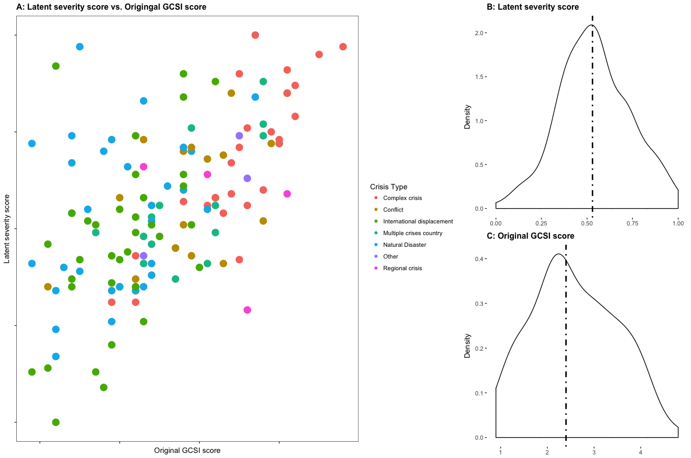

The scatter plot in Appendix 7 Figure 1A shows how well the two derivations of scores are correlated. If highly correlated, which implies they are equivalent metrics, we would expect the values to group along the diagonal (from the bottom left to the top right) of the figure. However, Appendix 7 Figure 1A shows no apparent pattern for most crises, with better correlation for complex crises. This pattern is not surprising when the distributions of severity scores are compared between the two approaches. Appendix 7 Figure 1B shows density plot of the latent severity scores, while Appendix 7 Figure 1C shows the density plot of the original GCSI scores. The latent scores have a near normal distribution, while the original GCSI scores have distribution that skews to the right. In other words, the original GCSI tends to score crises at lower values than the Confirmatory Factor Analysis (CFA) models. Conceptually, we would expect that crisis severity scores to present a normal distribution because the scores are a relative representation of crises. Thus, it is likely that the score derived from the CFA models is a closer representation of severity than those calculated from the GCSI methodology.

