SUPPLEMENT
Supplementary Authors and Affiliations
NHLBI Trans-Omics for Precision Medicine (TOPMed) Consortium Banner Authors:
Namiko Abe¹, Gonçalo Abecasis², Francois Aguet³, Christine Albert⁴, Laura Almasy⁵, Alvaro Alonso⁶, Seth Ament⁷, Peter Anderson⁸, Pramod Anugu⁹, Deborah Applebaum-Bowden¹⁰, Kristin Ardlie³, Dan Arking¹¹, Donna K Arnett¹², Allison Ashley-Koch¹³, Stella Aslibekyan¹⁴, Tim Assimes¹⁵, Paul Auer¹⁶, Dimitrios Avramopoulos¹¹, John Barnard¹⁷, Kathleen Barnes¹⁸, R Graham Barr¹⁹, Emily Barron-Casella¹¹, Lucas Barwick²⁰, Terri Beaty¹¹, Gerald Beck²¹, Diane Becker²², Lewis Becker¹¹, Rebecca Beer²³, Amber Beitelshees⁷, Emelia Benjamin²⁴, Takis Benos²⁵, Marcos Bezerra²⁶, Larry Bielak², Joshua Bis²⁷, Thomas Blackwell², John Blangero²⁸, Eric Boerwinkle²⁹, Donald W Bowden³⁰, Russell Bowler³¹, Jennifer Brody⁸, Ulrich Broeckel³², Jai Broome⁸, Karen Bunting¹, Esteban Burchard³³, Carlos Bustamante³⁴, Erin Buth³⁵, Brian Cade³⁶, Jonathan Cardwell³⁷, Vincent Carey³⁸, Cara Carty³⁹, Richard Casaburi⁴⁰, James Casella¹¹, Peter Castaldi⁴¹, Mark Chaffin³, Christy Chang⁷, Yi-Cheng Chang⁴², Daniel Chasman⁴³, Sameer Chavan³⁷, Bo-Juen Chen¹, Wei-Min Chen⁴⁴, Yii-Der Ida Chen⁴⁵, Michael Cho³⁸, Seung Hoan Choi³, Lee-Ming Chuang⁴⁶, Mina Chung⁴⁷, Ren-Hua Chung⁴⁸, Clary Clish⁴⁹, Suzy Comhair⁵⁰, Matthew Conomos³⁵, Elaine Cornell⁵¹, Adolfo Correa⁵², Carolyn Crandall⁴⁰, James Crapo⁵³, L Adrienne Cupples⁵⁴, Joanne Curran⁵⁵, Jeffrey Curtis², Brian Custer⁵⁶, Coleen Damcott⁷, Dawood Darbar⁵⁷, Sayantan Das², Sean David⁵⁸, Colleen Davis⁸, Michelle Daya³⁷, Mariza de Andrade⁵⁹, Lisa de las Fuentes⁶⁰, Michael DeBaun⁶¹, Ranjan Deka^{62,63}, Dawn DeMeo³⁸, Scott Devine⁷, Qing Duan⁶⁴, Ravi Duggirala⁶⁵, Jon Peter Durda⁵¹, Susan Dutcher⁶⁶, Charles Eaton⁶⁷, Lynette Ekunwe⁹, Adel El Boueiz⁶⁸, Patrick Ellinor⁶⁹, Leslie Emery⁸, Serpil Erzurum¹⁷, Charles Farber⁴⁴, Tasha Fingerlin⁷⁰, Matthew Flickinger², Myriam Fornage²⁹, Nora Franceschini⁷¹, Chris Frazar⁸, Mao Fu⁷, Stephanie M Fullerton⁸, Lucinda Fulton⁶⁶, Stacey Gabriel³, Weiniu Gan²³, Shanshan Gao³⁷, Yan Gao⁹, Margery Gass⁷², Bruce Gelb⁷³, Xiaoqi (Priscilla) Geng², Mark Geraci⁷⁴, Soren Germer¹, Robert Gerszten⁷⁵, Auyon Ghosh³⁸, Richard Gibbs⁷⁶, Chris Gignoux¹⁵, Mark Gladwin²⁵, David Glahn⁷⁷, Stephanie Gogarten⁸, Da-Wei Gong⁷, Harald Goring⁷⁸, Sharon Graw¹⁸, Daniel Grine³⁷, C Charles Gu⁶⁶, Yue Guan⁷, Xiuqing Guo⁴⁵, Namrata Gupta³, Jeff Haessler⁷², Michael Hall⁹, Daniel Harris⁷, Nicola L Hawley^{79,63}, Jiang He⁸⁰, Ben Heavner³⁵, Susan Heckbert⁸, Ryan Hernandez⁸¹, David Herrington⁸², Craig Hersh⁸³, Bertha Hidalgo¹⁴, James Hixson²⁹, Brian Hobbs³⁸, John Hokanson³⁷, Elliott Hong⁷, Karin Hoth⁸⁴, Chao (Agnes) Hsiung⁸⁵, Yi-Jen Hung⁸⁶, Haley Huston⁸⁷, Chii Min Hwu⁸⁸, Marguerite Ryan Irvin¹⁴, Rebecca Jackson⁸⁹, Deepti Jain⁸, Cashell Jaquish²³, Min A Jhun², Jill Johnsen⁹⁰, Andrew Johnson²³, Craig Johnson⁸, Rich Johnston⁶, Kimberly Jones¹¹, Hyun Min Kang⁹¹, Robert Kaplan⁹², Sharon Kardia², Sekar Kathiresan³, Shannon Kelly⁵⁶, Eimear Kenny⁷³, Michael Kessler⁷, Alyna Khan⁸, Wonji Kim⁹³, Greg Kinney³⁷, Barbara Konkle⁸⁷, Charles Kooperberg⁷², Holly Kramer⁹⁴, Christoph Lange⁹⁵, Ethan Lange³⁷, Leslie Lange³⁷, Cathy Laurie⁸, Cecelia Laurie⁸, Meryl LeBoff³⁸, Jiwon Lee³⁸, Seunggeun Shawn Lee², Wen-Jane Lee⁸⁸, Jonathon LeFaive², David Levine⁸, Dan Levy²³, Joshua Lewis⁷, Xiaohui Li⁴⁵, Yun Li⁶⁴, Henry Lin⁴⁵, Honghuang Lin⁹⁶, Keng Han Lin², Xihong Lin⁹⁷, Simin Liu⁹⁸, Yongmei Liu⁹⁹, Yu Liu¹⁰⁰, Ruth J. F. Loos¹⁰¹, Steven Lubitz⁶⁹, Kathryn Lunetta⁹⁶, James Luo²³, Michael Mahaney⁵⁵, Barry Make¹¹, Ani Manichaikul⁴⁴, JoAnn Manson³⁸, Lauren Margolin³, Lisa Martin¹⁰², Susan Mathai³⁷, Rasika Mathias¹¹, Susanne May³⁵, Patrick McArdle⁷, Merry-Lynn McDonald¹⁴, Sean McFarland⁹³, Stephen McGarvey^{67,63}, Daniel McGoldrick⁸, Caitlin McHugh³⁵, Hao Mei⁹, Luisa Mestroni¹⁸, Deborah A Meyers¹⁰³, Julie Mikulla²³, Nancy Min⁹, Mollie Minear²³, Ryan L Minster^{25,63}, Braxton D Mitchell⁷, Matt Moll⁴¹, May E Montasser⁷, Courtney Montgomery¹⁰⁴, Arden Moscati⁷³, Solomon Musani⁵², Stanford Mwasongwe⁹, Josyf C Mychaleckyj⁴⁴, Girish Nadkarni⁷³, Rakhi Naik¹¹, Take Naseri^{105,63}, Pradeep Natarajan¹⁰⁶, Sergei Nekhai¹⁰⁷, Sarah C Nelson³⁵, Bonnie Neltner³⁷, Deborah Nickerson⁸, Kari North⁶⁴, Jeff O'Connell¹⁰⁸, Tim O'Connor⁷, Heather Ochs-Balcom¹⁰⁹, David T Paik¹¹⁰, Nicholette Palmer¹¹¹, James Pankow¹¹², George Papanicolaou²³, Afshin Parsa⁷, Juan Manuel Peralta⁶⁵, Marco Perez¹⁵, James Perry⁷, Ulrike Peters¹¹³, Patricia Peyser², Lawrence S Phillips⁶, Toni Pollin⁷, Wendy Post¹¹⁴, Julia Powers Becker¹¹⁵, Meher Preethi Boorgula³⁷, Michael Preuss⁷³, Bruce Psaty⁸, Pankaj Qasba²³, Dandi Qiao³⁸, Zhaohui Qin⁶, Nicholas Rafaels¹¹⁶, Laura Raffield¹¹⁷, Vasan S Ramachandran⁹⁶, D C Rao⁶⁶, Laura Rasmussen-Torvik¹¹⁸, Aakrosh Ratan⁴⁴, Susan Redline³⁸, Robert Reed⁷, Elizabeth Regan⁵³, Alex Reiner¹¹⁹, Muagututi‘a Sefuiva Reupena¹²⁰, Ken Rice⁸, Stephen Rich⁴⁴, Dan Roden¹²¹, Carolina Roselli³, Jerome Rotter⁴⁵, Ingo Ruczinski¹¹, Pamela Russell³⁷, Sarah Ruuska⁸⁷, Kathleen Ryan⁷, Ester Cerdeira Sabino¹²², Danish Saleheen¹⁹, Shabnam Salimi⁷, Steven Salzberg¹¹, Kevin Sandow¹²³, Vijay G Sankaran¹²⁴, Christopher Scheller², Ellen Schmidt², Karen Schwander⁶⁶, David Schwartz³⁷, Frank Sciurba²⁵, Christine Seidman¹²⁵, Jonathan Seidman¹²⁶, Vivien Sheehan¹²⁷, Stephanie L Sherman¹²⁸, Amol Shetty⁷, Aniket Shetty³⁷, Wayne Hui-Heng Sheu⁸⁸, M Benjamin Shoemaker¹²⁹, Brian Silver¹³⁰, Edwin Silverman³⁸, Jennifer Smith², Josh Smith⁸, Nicholas Smith¹³¹, Tanja Smith¹, Sylvia Smoller⁹², Beverly Snively¹³², Michael Snyder¹⁵, Tamar Sofer³⁸, Nona Sotoodehnia⁸, Adrienne M Stilp⁸, Garrett Storm³⁷, Elizabeth Streeten⁷, Jessica Lasky Su³⁸, Yun Ju Sung⁶⁶, Jody Sylvia³⁸, Adam Szpiro⁸, Carole Sztalryd⁷, Daniel Taliun², Hua Tang¹³³, Margaret Taub¹¹, Kent D Taylor¹³⁴, Matthew Taylor¹⁸, Simeon Taylor⁷, Marilyn Telen¹³, Timothy A Thornton⁸, Machiko Threlkeld¹³⁵, Lesley Tinker⁷², David Tirschwell⁸, Sarah Tishkoff¹³⁶, Hemant Tiwari¹³⁷, Catherine Tong¹³⁸, Russell Tracy¹³⁹, Michael Tsai¹¹², Dhananjay Vaidya¹¹, David Van Den Berg¹⁴⁰, Peter VandeHaar², Scott Vrieze¹⁴¹, Tarik Walker³⁷, Robert Wallace⁸⁴, Avram Walts³⁷, Fei Fei Wang⁸, Heming Wang¹⁴², Karol Watson⁴⁰, Daniel E Weeks^{25,63}, Bruce Weir⁸, Scott Weiss³⁸, Lu-Chen Weng⁶⁹, Jennifer Wessel¹⁴³, Cristen Willer¹⁴⁴, Kayleen Williams³⁵, L Keoki Williams¹⁴⁵, Carla Wilson³⁸, James Wilson¹⁴⁶, Quenna Wong⁸, Joseph Wu¹¹⁰, Huichun Xu⁷, Lisa Yanek¹¹, Ivana Yang³⁷, Rongze Yang⁷, Norann Zaghloul⁷, Maryam Zekavat³, Yingze Zhang¹⁴⁷, Snow Xueyan Zhao⁵³, Wei Zhao¹⁴⁸, Degui Zhi²⁹, Xiang Zhou², Xiaofeng Zhu¹⁴⁹, Michael Zody¹, Sebastian Zoellner²

¹New York Genome Center, New York, New York, 10013, US, ²University of Michigan, Ann Arbor, Michigan, 48109, US, ³Broad Institute, Cambridge, Massachusetts, 2142, US, ⁴Brigham & Women's Hospital, Cedars Sinai, Boston, Massachusetts, 2114, US, ⁵Children's Hospital of Philadelphia, University of Pennsylvania, Philadelphia, Pennsylvania, 19104, US, ⁶Emory University, Atlanta, Georgia, 30322, US, ⁷University of Maryland, Baltimore, Maryland, 21201, US, ⁸University of Washington, Seattle, Washington, 98195, US, ⁹University of Mississippi, Jackson, Mississippi, 38677, US, ¹⁰National Institutes of Health, Bethesda, Maryland, 20892, US, ¹¹Johns Hopkins University, Baltimore, Maryland, 21218, US, ¹²University of Kentucky, Lexington, Kentucky, 40506, US, ¹³Duke University, Durham, North Carolina, 27708, US, ¹⁴University of Alabama, Birmingham, Alabama, 35487, US, ¹⁵Stanford University, Stanford, California, 94305, US, ¹⁶University of Wisconsin Milwaukee, Milwaukee, Wisconsin, 53211, US, ¹⁷Cleveland Clinic, Cleveland, Ohio, 44195, US, ¹⁸University of Colorado Anschutz Medical Campus, Aurora, Colorado, 80045, US, ¹⁹Columbia University, New York, New York, 10027, US, ²⁰LTRC, The Emmes Corporation, Rockville, Maryland, 20850, US, ²¹Quantitative Health Sciences, Cleveland Clinic, Cleveland, Ohio, 44195, US, ²²Medicine, Johns Hopkins University, Baltimore, Maryland, 21218, US, ²³National Heart, Lung, and Blood Institute, National Institutes of Health, Bethesda, Maryland, 20892, US, ²⁴Boston University School of Medicine, Boston University, Massachusetts General Hospital, Boston, Massachusetts, 2114, US, ²⁵University of Pittsburgh, Pittsburgh, Pennsylvania, 15260, US, ²⁶Fundação de Hematologia e Hemoterapia de Pernambuco - Hemope, Recife, 52011-000, BR, ²⁷Cardiovascular Health Research Unit, Department of Medicine, University of Washington, Seattle, Washington, 98195, US, ²⁸Human Genetics, University of Texas Rio Grande Valley School of Medicine, Brownsville, Texas, 78520, US, ²⁹University of Texas Health at Houston, Houston, Texas, 77225, US, ³⁰Department of Biochemistry, Wake Forest Baptist Health, Winston-Salem, North Carolina, 27157, US, ³¹National Jewish Health, National Jewish Health, Denver, Colorado, 80206, US, ³²Medical College of Wisconsin, Milwaukee, Wisconsin, 53226, US, ³³University of California, San Francisco, San Francisco, California, 94143, US, ³⁴Biomedical Data Science, Stanford University, Stanford, California, 94305, US, ³⁵Biostatistics, University of Washington, Seattle, Washington, 98195, US, ³⁶Brigham and Women's Hospital, Brigham & Women's Hospital, Boston, Massachusetts, 2115, US, ³⁷University of Colorado at Denver, Denver, Colorado, 80204, US, ³⁸Brigham & Women's Hospital, Boston, Massachusetts, 2115, US, ³⁹Washington State University, Pullman, Washington, 99164, US, ⁴⁰University of California, Los Angeles, Los Angeles, California, 90095, US, ⁴¹Medicine, Brigham & Women's Hospital, Boston, Massachusetts, 2115, US, ⁴²National Taiwan University, Taipei, 10617, TW, ⁴³Division of Preventive Medicine, Brigham & Women's Hospital, Boston, Massachusetts, 2215, US, ⁴⁴University of Virginia, Charlottesville, Virginia, 22903, US, ⁴⁵Lundquist Institute, Torrance, California, 90502, US, ⁴⁶National Taiwan University Hospital, National Taiwan University, Taipei, 10617, TW, ⁴⁷Cleveland Clinic, Cleveland Clinic, Cleveland, Ohio, 44195, US, ⁴⁸National Health Research Institute Taiwan, Miaoli County, 350, TW, ⁴⁹Metabolomics Platform, Broad Institute, Cambridge, Massachusetts, 2142, US, ⁵⁰Immunity and Immunology, Cleveland Clinic, Cleveland, Ohio, 44195, US, ⁵¹University of Vermont, Burlington, Vermont, 5405, US, ⁵²Medicine, University of Mississippi, Jackson, Mississippi, 38677, US, ⁵³National Jewish Health, Denver, Colorado, 80206, US, ⁵⁴Biostatistics, Boston University, Boston, Massachusetts, 2115, US, ⁵⁵University of Texas Rio Grande Valley School of Medicine, Brownsville, Texas, 78520, US, ⁵⁶Vitalant Research Institute, San Francisco, California, 94118, US, ⁵⁷University of Illinois at Chicago, Chicago, Illinois, 60607, US, ⁵⁸University of Chicago, Chicago, Illinois, 60637, US, ⁵⁹Health Sciences Research, Mayo Clinic, Rochester, Minnesota, 55905, US, ⁶⁰Department of Medicine, Cardiovascular Division, Washington University in St Louis, St. Louis, Missouri, 63110, US, ⁶¹Vanderbilt University, Nashville, Tennessee, 37235, US, ⁶²University of Cincinnati, Cincinnati, Ohio, 45220, US, ⁶³The Samoan Obesity, Lifestyle and Genetic Adaptations Study (OLaGA) Group, ⁶⁴University of North Carolina, Chapel Hill, North Carolina, 27599, US, ⁶⁵University of Texas Rio Grande Valley School of Medicine, Edinburg, Texas, 78539, US, ⁶⁶Washington University in St Louis, St Louis, Missouri, 63130, US, ⁶⁷Brown University, Providence, Rhode Island, 2912, US, ⁶⁸Channing Division of Network Medicine, Harvard University, Cambridge, Massachusetts, 2138, US, ⁶⁹Massachusetts General Hospital, Boston, Massachusetts, 2114, US, ⁷⁰Center for Genes, Environment and Health, National Jewish Health, Denver, Colorado, 80206, US, ⁷¹Epidemiology, University of North Carolina, Chapel Hill, North Carolina, 27599, US, ⁷²Fred Hutchinson Cancer Research Center, Seattle, Washington, 98109, US, ⁷³Icahn School of Medicine at Mount Sinai, New York, New York, 10029, US, ⁷⁴Medicine, Indiana University, Indianapolis, Indiana, 46202, US, ⁷⁵Beth Israel Deaconess Medical Center, Boston, Massachusetts, 2215, US, ⁷⁶Baylor College of Medicine Human Genome Sequencing Center, Houston, Texas, 77030, US, ⁷⁷Yale University, New Haven, Connecticut, 6520, US, ⁷⁸University of Texas Rio Grande Valley School of Medicine, San Antonio, Texas, 78229, US, ⁷⁹Department of Chronic Disease Epidemiology, Yale University, New Haven, Connecticut, 6520, US, ⁸⁰Tulane University, New Orleans, Louisiana, 70118, US, ⁸¹University of California, San Francisco, Montreal, H3A 0G4, CA, ⁸²Wake Forest Baptist Health, Winston-Salem, North Carolina, 27157, US, ⁸³Channing Division of Network Medicine, Brigham & Women's Hospital, Boston, Massachusetts, 2115, US, ⁸⁴University of Iowa, Iowa City, Iowa, 52242, US, ⁸⁵Institute of Population Health Sciences, NHRI, National Health Research Institute Taiwan, Miaoli County, 350, TW, ⁸⁶Tri-Service General Hospital National Defense Medical Center, TW, ⁸⁷Blood Works Northwest, Seattle, Washington, 98104, US, ⁸⁸Taichung Veterans General Hospital Taiwan, Taichung City, 407, TW, ⁸⁹Internal Medicine, DIvision of Endocrinology, Diabetes and Metabolism, Ohio State University Wexner Medical Center, Columbus, Ohio, 43210, US, ⁹⁰Blood Works Northwest, University of Washington, Seattle, Washington, 98104, US, ⁹¹Biostatistics, University of Michigan, Ann Arbor, Michigan, 48109, US, ⁹²Albert Einstein College of Medicine, New York, New York, 10461, US, ⁹³Harvard University, Cambridge, Massachusetts, 2138, US, ⁹⁴Public Health Sciences, Loyola University, Maywood, Illinois, 60153, US, ⁹⁵Biostats, Harvard School of Public Health, Boston, Massachusetts, 2115, US, ⁹⁶Boston University, Boston, Massachusetts, 2215, US, ⁹⁷Harvard School of Public Health, Boston, Massachusetts, 2115, US, ⁹⁸Epidemiology and Medicine, Brown University, Providence, Rhode Island, 2912, US, ⁹⁹Cardiology, Duke University, Durham, North Carolina, 27708, US, ¹⁰⁰Cardiovascular Institute, Stanford University, Stanford, California, 94305, US, ¹⁰¹The Charles Bronfman Institute for Personalized Medicine, Icahn School of Medicine at Mount Sinai, New York, New York, 10029, US, ¹⁰²George Washington University, Washington, District of Columbia, 20052, US, ¹⁰³University of Arizona, Tucson, Arizona, 85721, US, ¹⁰⁴Genes and Human Disease, Oklahoma Medical Research Foundation, Oklahoma City, Oklahoma, 73104, US, ¹⁰⁵Ministry of Health, Government of Samoa, Apia, WS, ¹⁰⁶Broad Institute, Harvard University, Massachusetts General Hospital, Boston, Massachusetts, 2114, US, ¹⁰⁷Howard University, Washington, District of Columbia, 20059, US, ¹⁰⁸University of Maryland, Baltimore, Maryland, 21201, US, ¹⁰⁹University at Buffalo, Buffalo, New York, 14260, US, ¹¹⁰Stanford Cardiovascular Institute, Stanford University, Stanford, California, 94305, US, ¹¹¹Biochemistry, Wake Forest Baptist Health, Winston-Salem, North Carolina, 27157, US, ¹¹²University of Minnesota, Minneapolis, Minnesota, 55455, US, ¹¹³Fred Hutchinson Cancer Research Center, University of Washington, Seattle, Washington, 98195, US, ¹¹⁴Cardiology/Medicine, Johns Hopkins University, Baltimore, Maryland, 21218, US, ¹¹⁵Medicine, University of Colorado at Denver, Denver, Colorado, 80204, US, ¹¹⁶University of Colorado at Denver, Denver, Colorado, 80045, US, ¹¹⁷Genetics, University of North Carolina, Chapel Hill, North Carolina, 27599, US, ¹¹⁸Northwestern University, Chicago, Illinois, 60208, US, ¹¹⁹Fred Hutchinson Cancer Research Center, University of Washington, Seattle, Washington, 98109, US, ¹²⁰Lutia I Puava Ae Mapu I Fagalele, Apia, WS, ¹²¹Medicine, Pharmacology, Biomedicla Informatics, Vanderbilt University, Nashville, Tennessee, 37235, US, ¹²²Faculdade de Medicina, Universidade de Sao Paulo, Sao Paulo, 1310000, BR, ¹²³TGPS, Lundquist Institute, Torrance, California, 90502, US, ¹²⁴Division of Hematology/Oncology, Broad Institute, Harvard University, Cambridge, Massachusetts, 2142, US, ¹²⁵Genetics, Harvard Medical School, Boston, Massachusetts, 2115, US, ¹²⁶Harvard Medical School, Boston, Massachusetts, 2115, US, ¹²⁷Pediatrics, Baylor College of Medicine, Houston, Texas, 77030, US, ¹²⁸Human Genetics, Emory University, Atlanta, Georgia, 30322, US, ¹²⁹Medicine/Cardiology, Vanderbilt University, Nashville, Tennessee, 37235, US, ¹³⁰UMass Memorial Medical Center, Worcester, Massachusetts, 1655, US, ¹³¹Epidemiology, University of Washington, Seattle, Washington, 98195, US, ¹³²Biostatistical Sciences, Wake Forest Baptist Health, Winston-Salem, North Carolina, 27157, US, ¹³³Genetics, Stanford University, Stanford, California, 94305, US, ¹³⁴Institute for Translational Genomics and Populations Sciences, Lundquist Institute, Torrance, California, 90502, US, ¹³⁵University of Washington, Department of Genome Sciences, University of Washington, Seattle, Washington, 98195, US, ¹³⁶Genetics, University of Pennsylvania, Philadelphia, Pennsylvania, 19104, US, ¹³⁷Biostatistics, University of Alabama, Birmingham, Alabama, 35487, US, ¹³⁸Department of Biostatistics, University of Washington, Seattle, Washington, 98195, US, ¹³⁹Pathology & Laboratory Medicine, University of Vermont, Burlington, Vermont, 5405, US, ¹⁴⁰USC Methylation Characterization Center, University of Southern California, University of Southern California, California, 90033, US, ¹⁴¹University of Colorado at Boulder, University of Minnesota, Boulder, Colorado, 80309, US, ¹⁴²Brigham & Women's Hospital, Partners.org, Boston, Massachusetts, 2115, US, ¹⁴³Epidemiology, Indiana University, Indianapolis, Indiana, 46202, US, ¹⁴⁴Internal Medicine, University of Michigan, Ann Arbor, Michigan, 48109, US, ¹⁴⁵Henry Ford Health System, Detroit, Michigan, 48202, US, ¹⁴⁶Cardiology, Beth Israel Deaconess Medical Center, Boston, Massachusetts, 2215, US, ¹⁴⁷Medicine, University of Pittsburgh, Pittsburgh, Pennsylvania, 15260, US, ¹⁴⁸Department of Epidemiology, University of Michigan, Ann Arbor, Michigan, 48109, US, ¹⁴⁹Department of Population and Quantitative Health Sciences, Case Western Reserve University, Cleveland, Ohio, 44106, US

Supplemental Figures
Figure S1. Manhattan and QQ plots for pooled single variant analysis with fasting glucose and fasting insulin in TOPMed. The Manhattan plots show the -log₁₀ P-values for the variants across the chromosomal positions with a threshold of 5×10⁻⁸ plotted in red; the QQ-plots show the observed versus expected -log₁₀ P-values. The plots are stratified by common (MAF>=0.05) and rare (MAF<0.05) variants for all variants with MAC>=20.

- Fasting Glucose, MAF>=0.05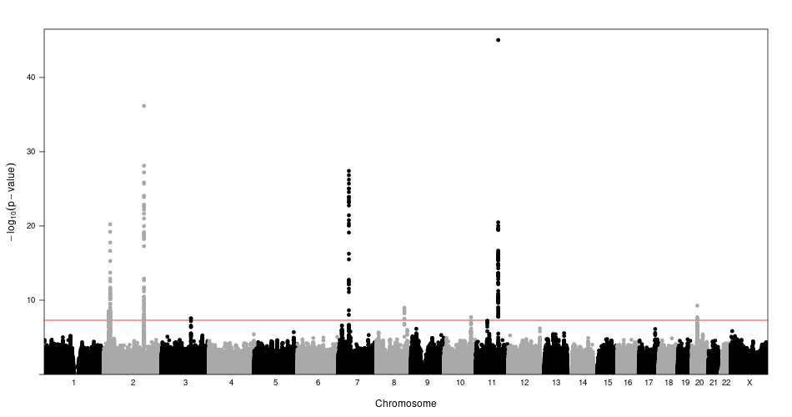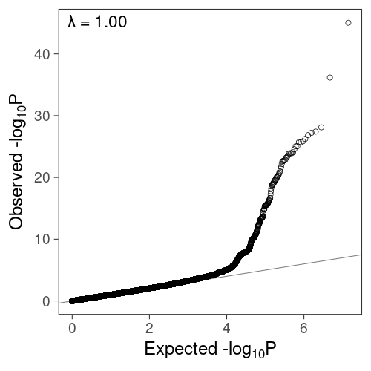

- Fasting Glucose, MAF<0.05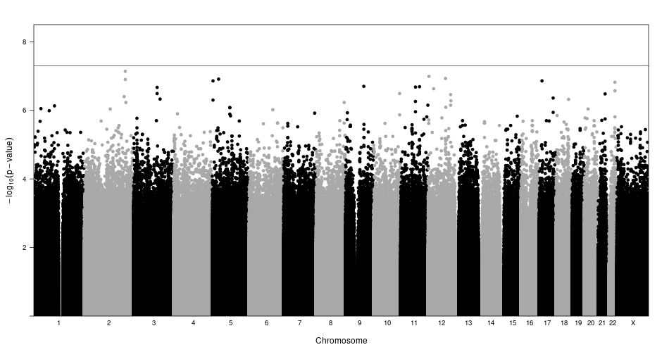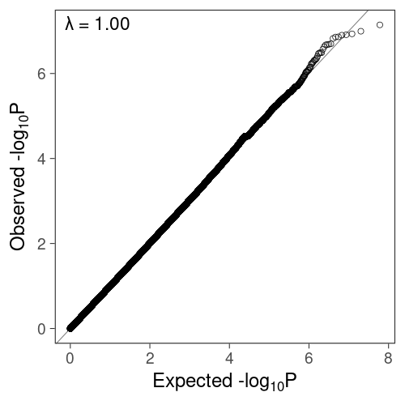

- Fasting Insulin, MAF>=0.05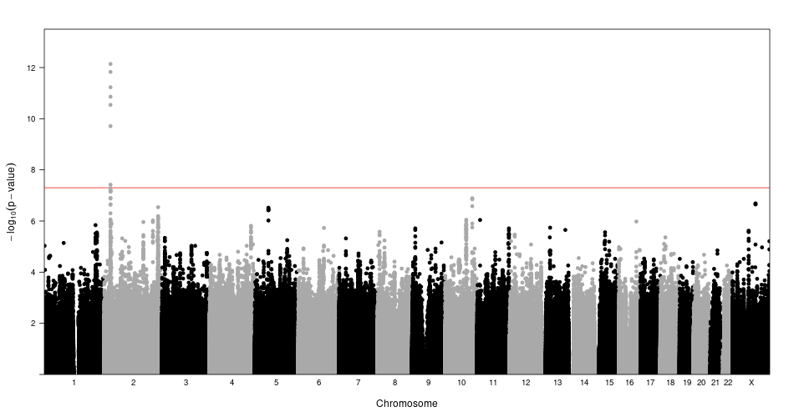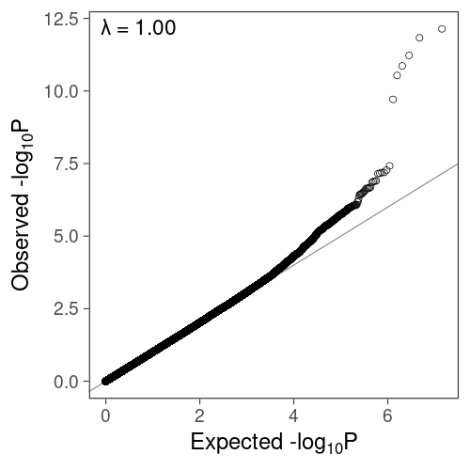

- Fasting Insulin, MAF<0.05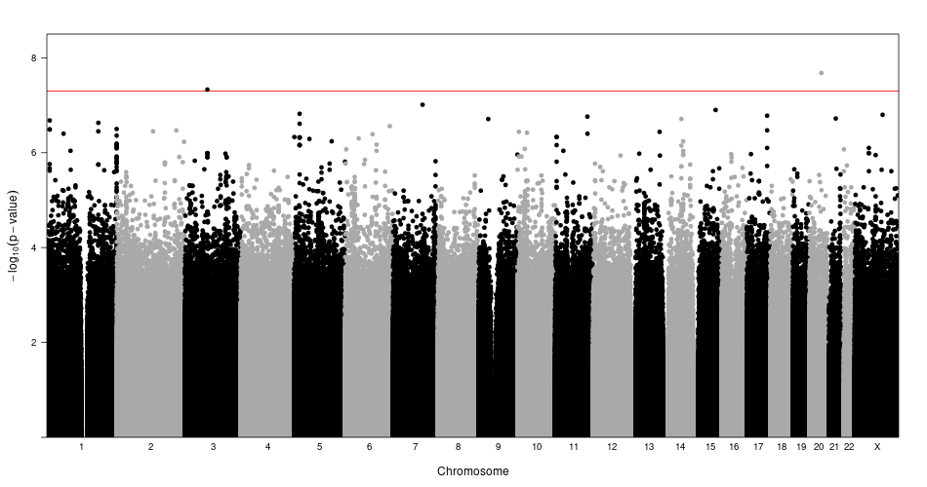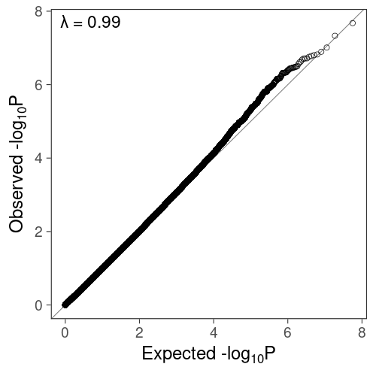

Figure S2. Regional locus plots of the twelve loci significant in pooled analysis with stepwise conditional analysis. The loci associated with FG (a-b. MTNR1B, b. G6PC2, c. GCK, d. GCKR, e. FOX2A, f. SLC30A8, g. APOB, h. TCF7L2, i. ADCY5) and FI (j. GCKR, k. PTPRT, l. ROBO1). The linkage disequilibrium is given with respect to the index variant and was calculated in the TOPMed analysis sample. Plots denoted by rsID and MarkerID (Chromosome:Position(Hg38):Reference-Allele:Alternative-Allele).

- MTNR1B, rs10830963, 11:92975544:C:G
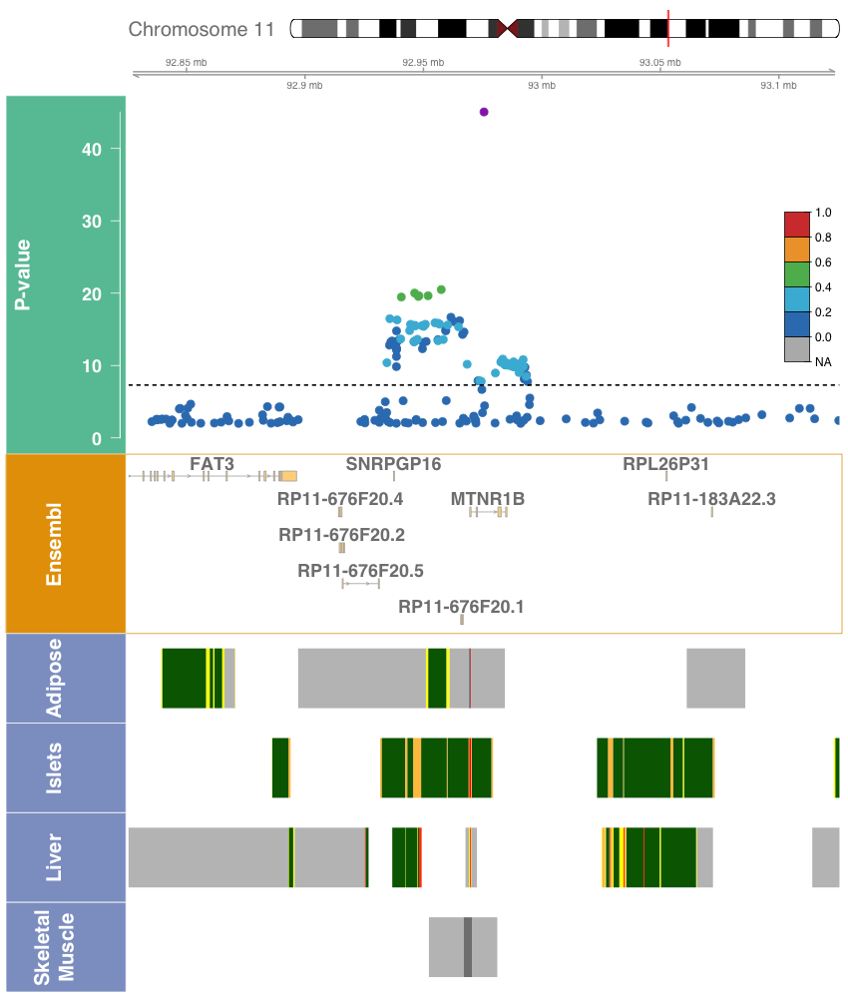

- MTNR1B, rs73560545, 11:92884161:G:A
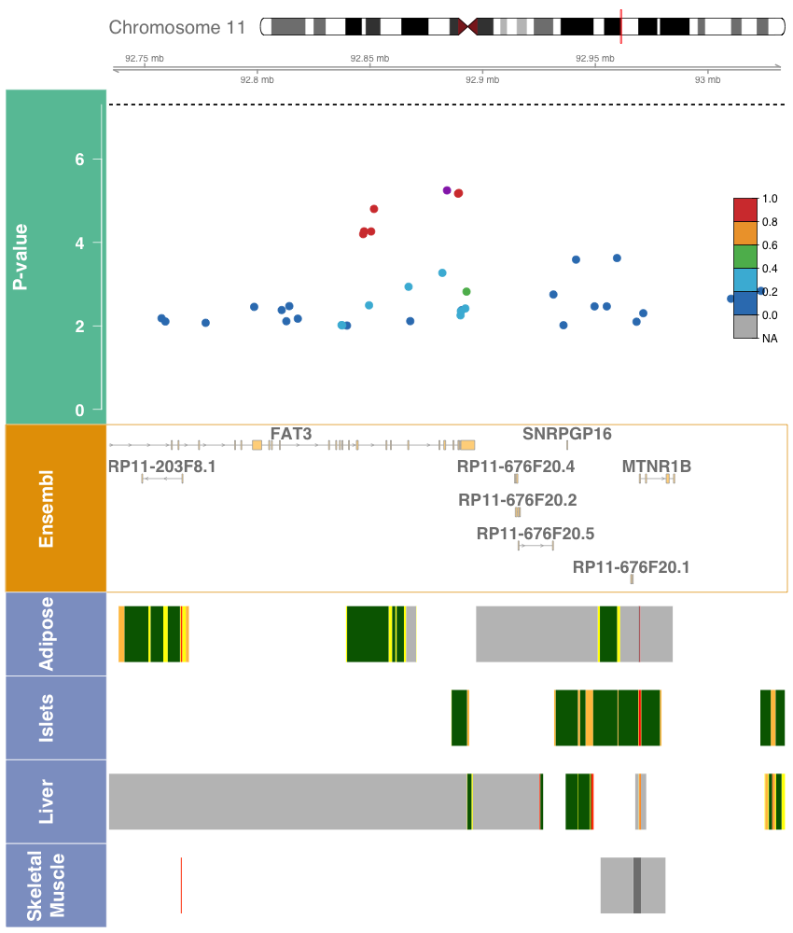

- G6PC2, rs560887, 2:168906638:T:C
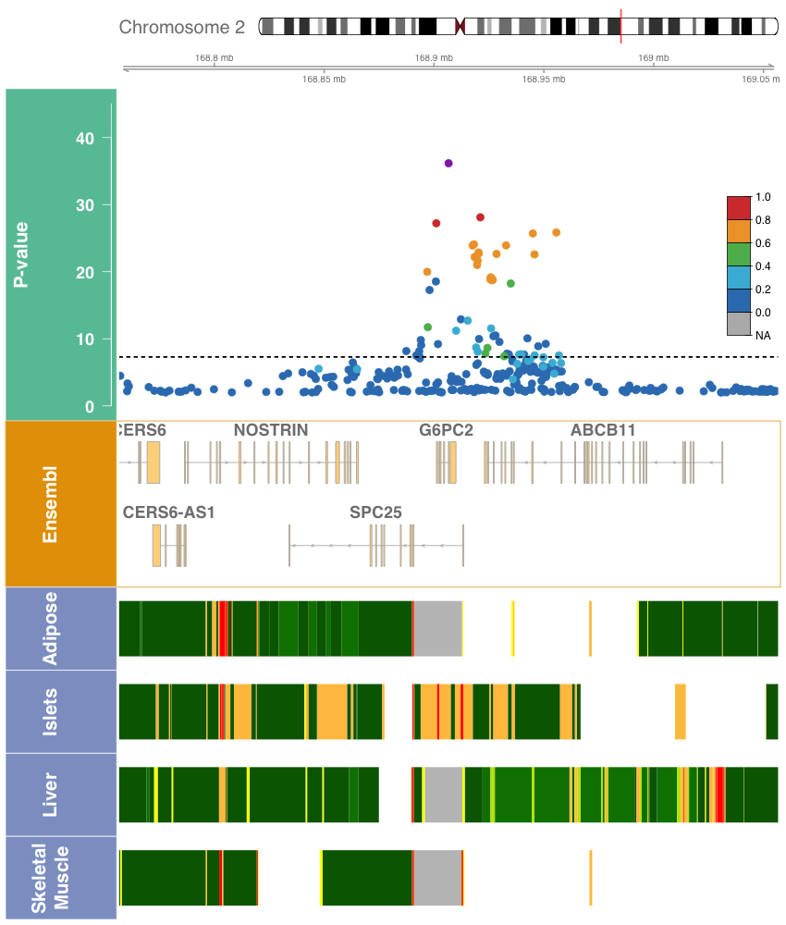

- G6PC2, rs540524, 2:168900420:A:G
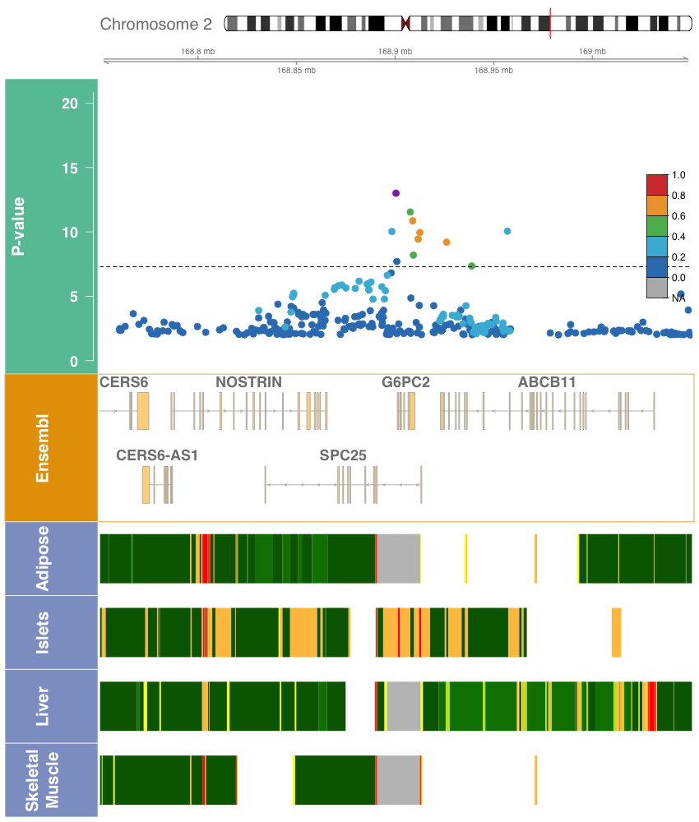

- G6PC2, rs2232326, 2:168907981:T:C
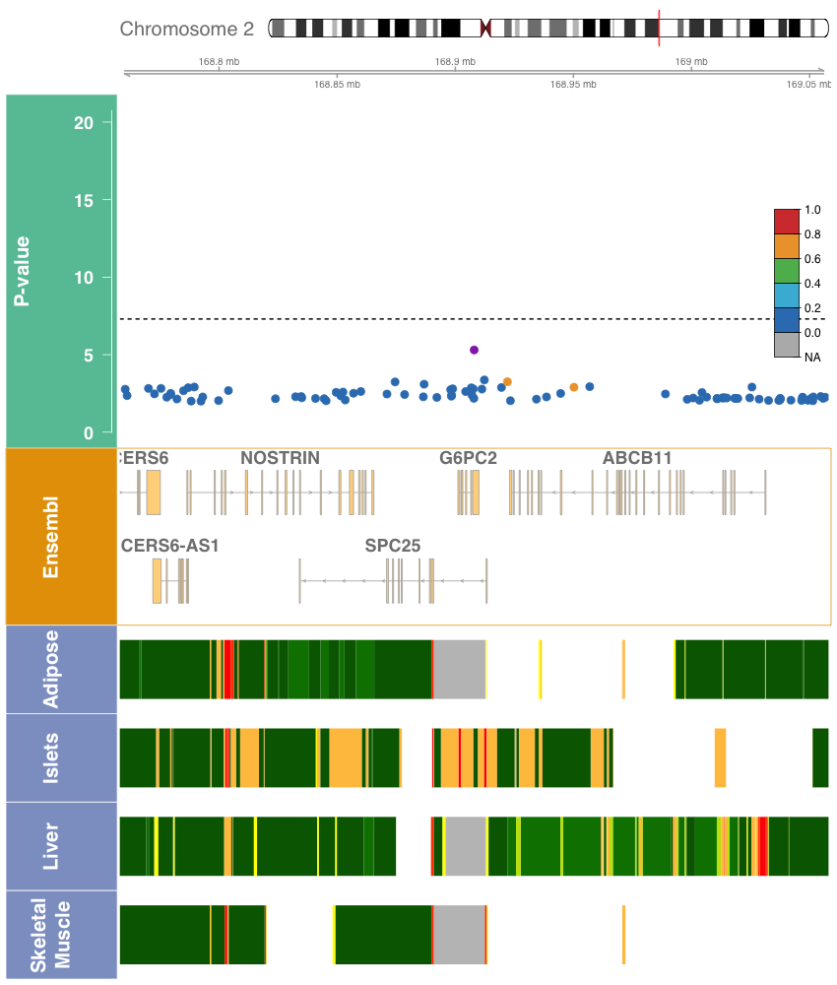

- GCK, rs1799884, 7:44189469:C:T
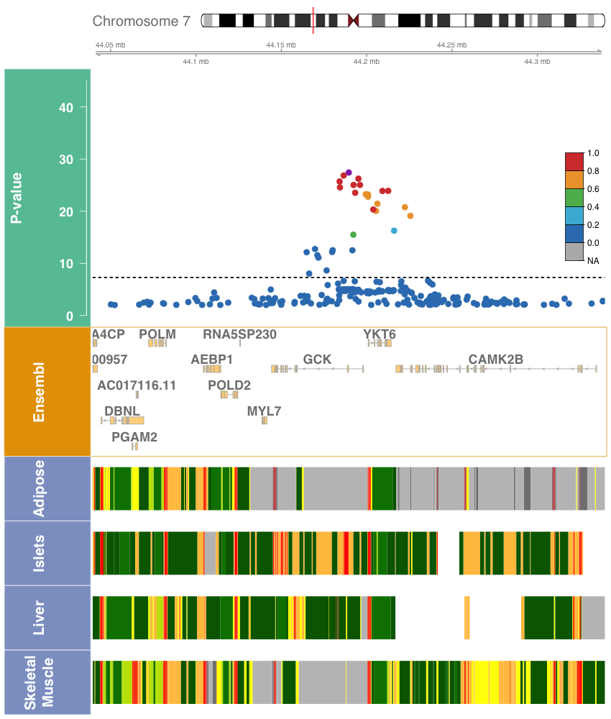

- GCKR, rs1260326, 2:27508073:T:C
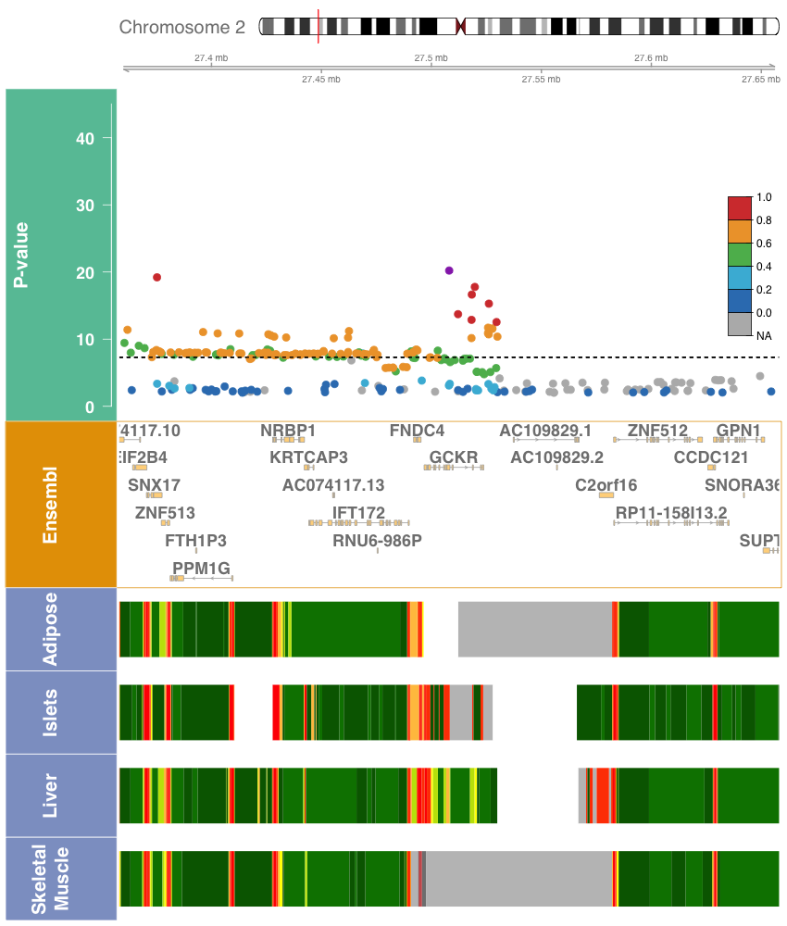

- FOXA2, rs3833331, 20:22581688:A:AG
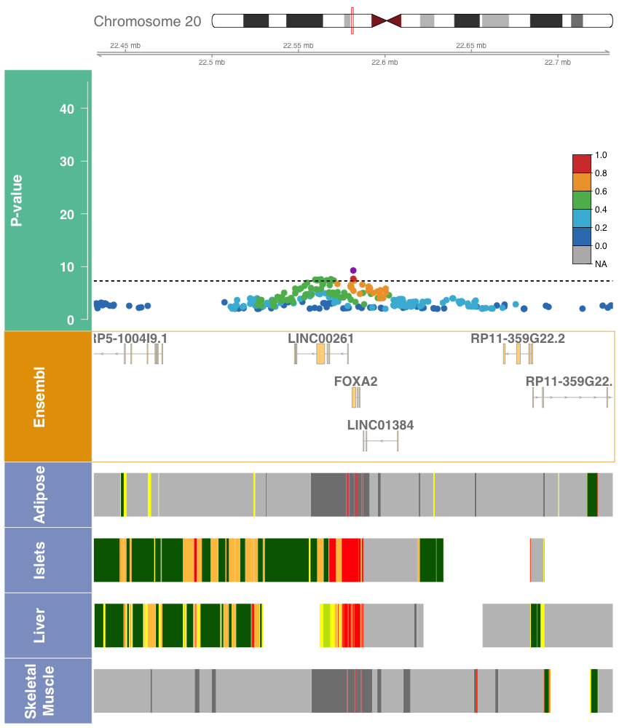

- SLC30A8, rs35859536, 8:117179236:C:T
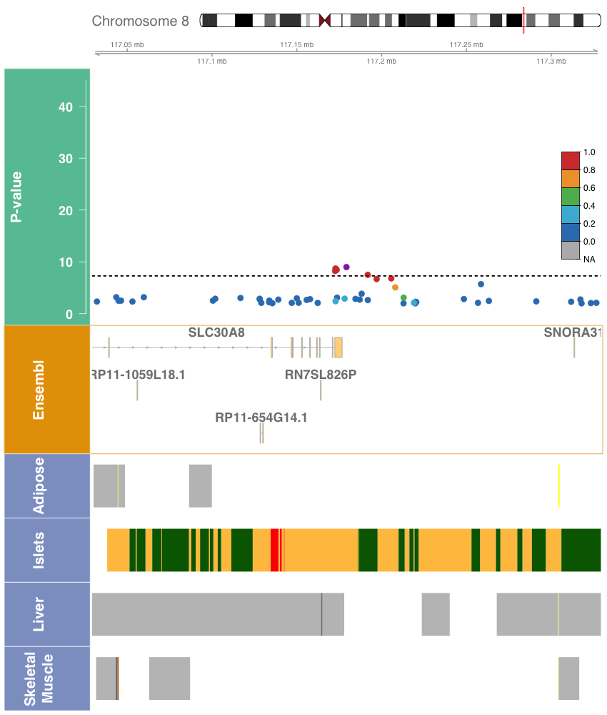

- SLC30A8, rs542965166, 8:117258547:C:T
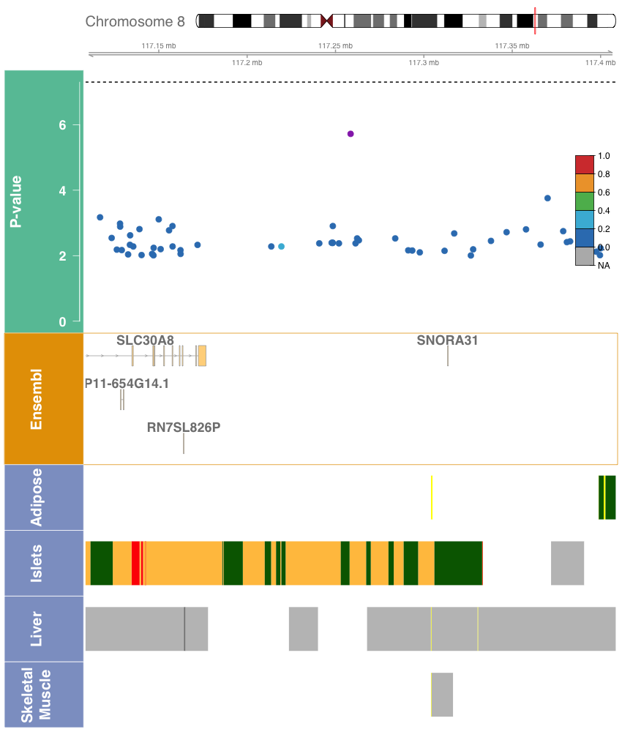

- APOB, rs478588, 2:21074277:A:G
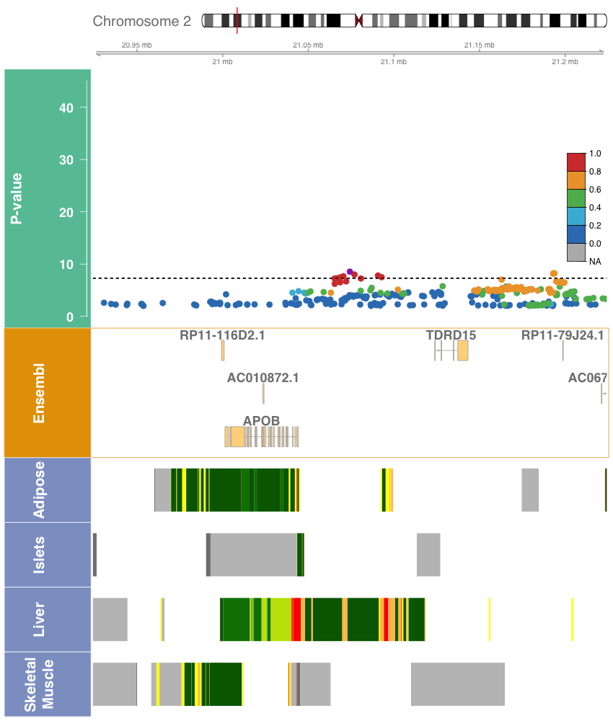

- TCF7L2, rs7903146, 10:112998590:C:T
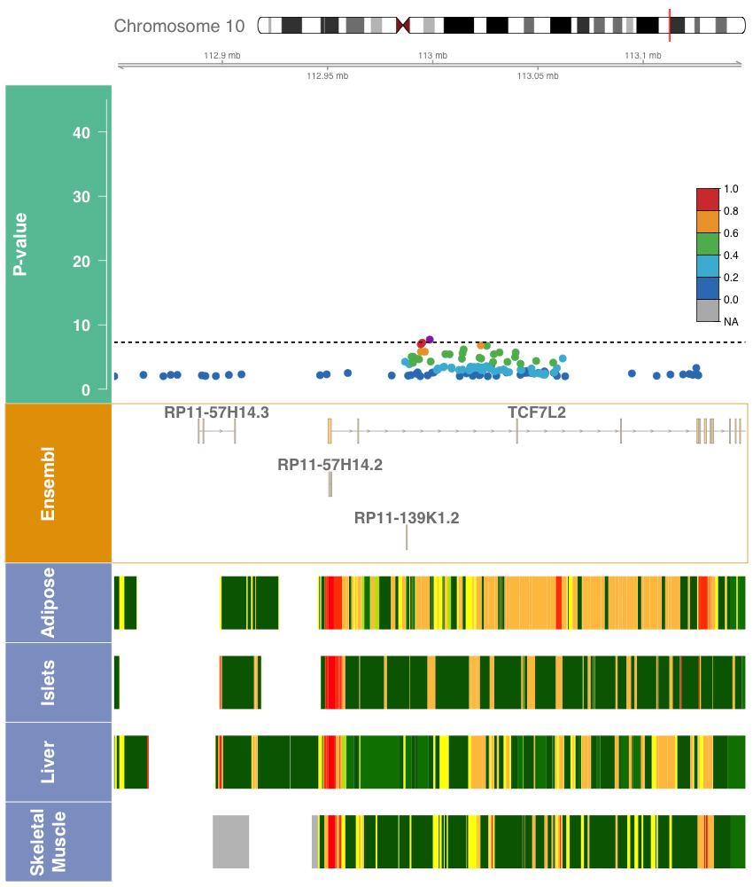

- ADCY5, rs72964564, 3:123335923:A:C
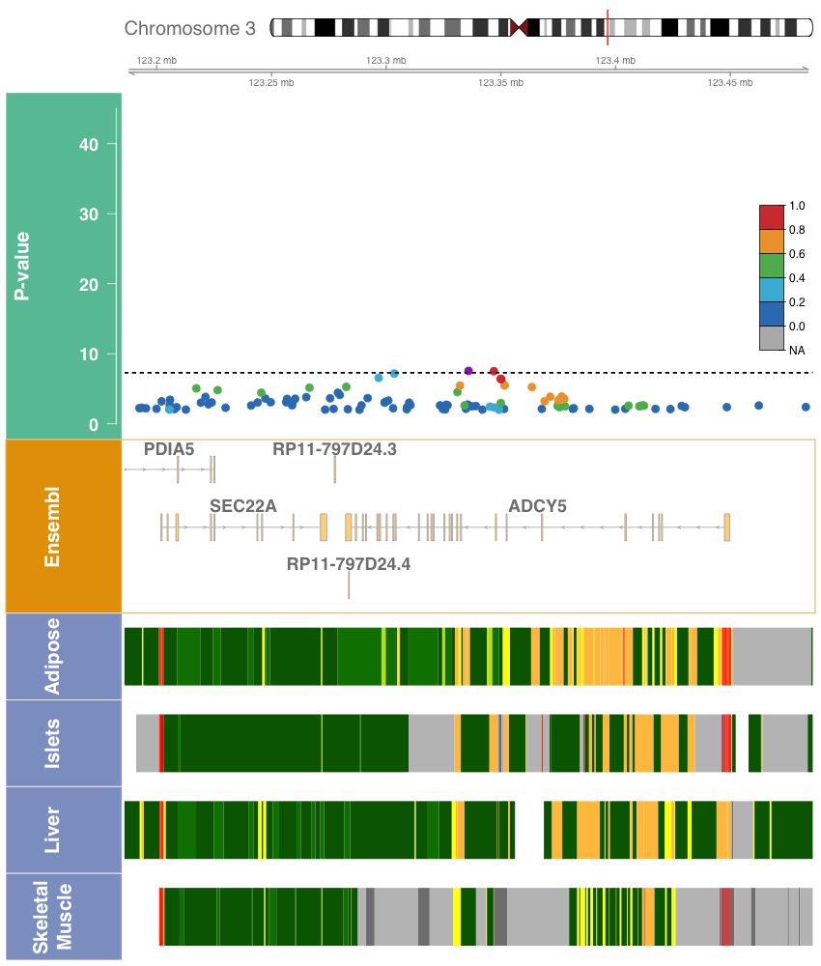

- GCKR, rs1260326, 2:27508073:T:C
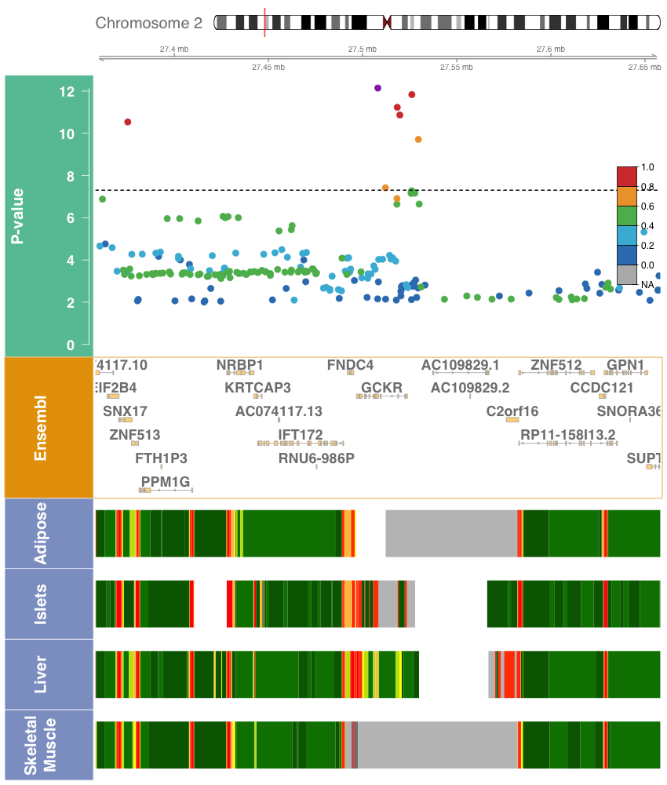

- PTPRT, rs185250851, 20:42752773:G:A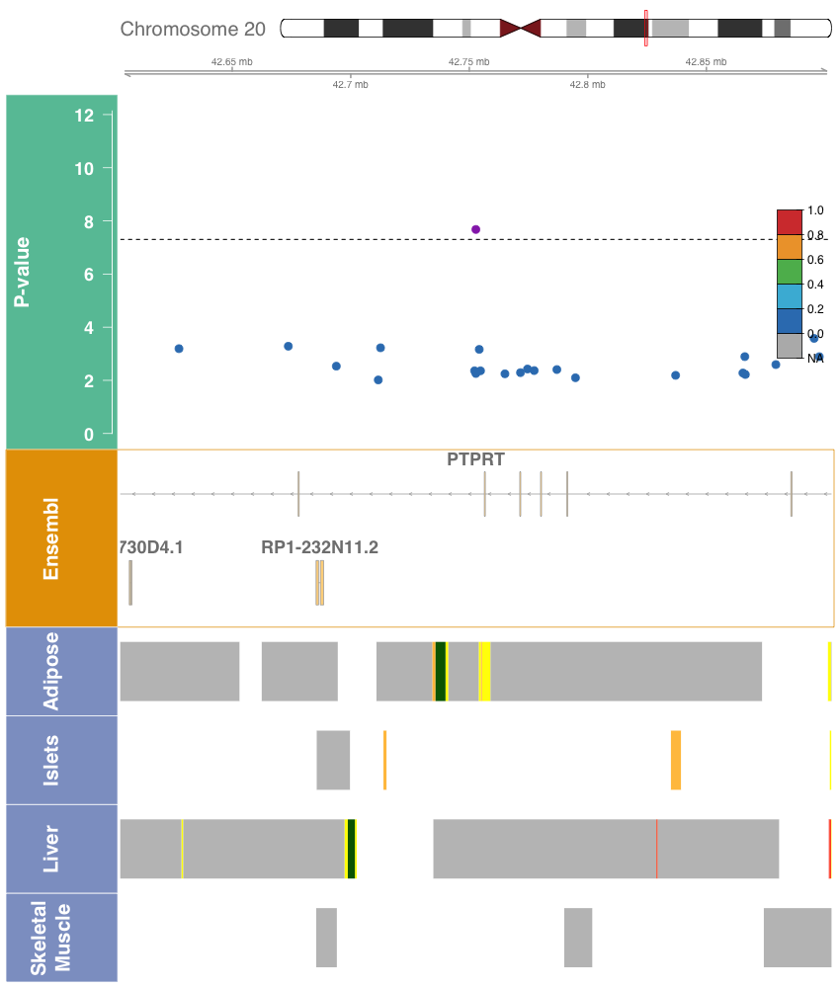

- PTPRT, rs78618809, 20:43230137:C:T
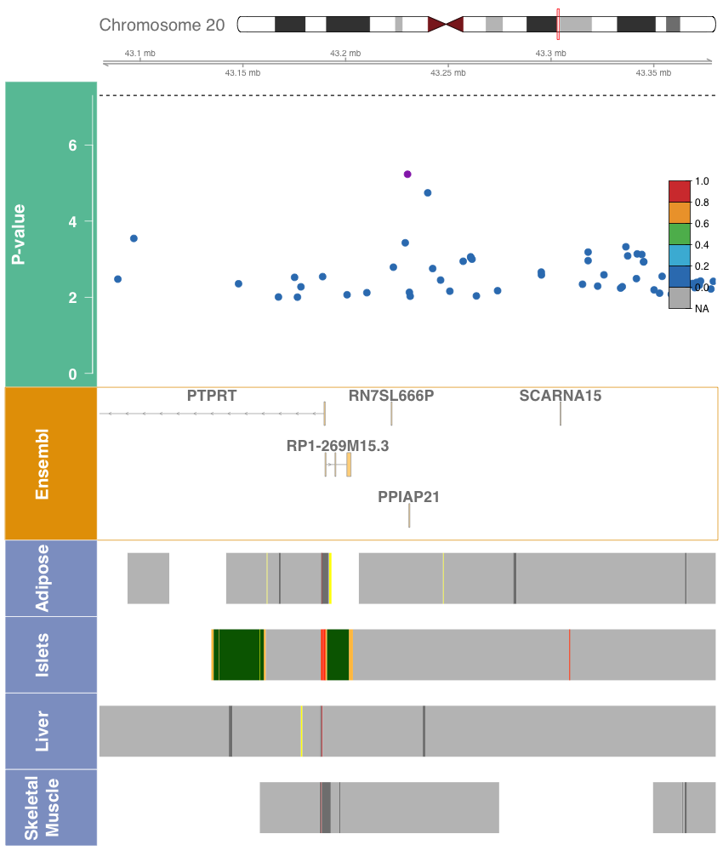

- ROBO1, rs539973028, 3:79812347:C:A

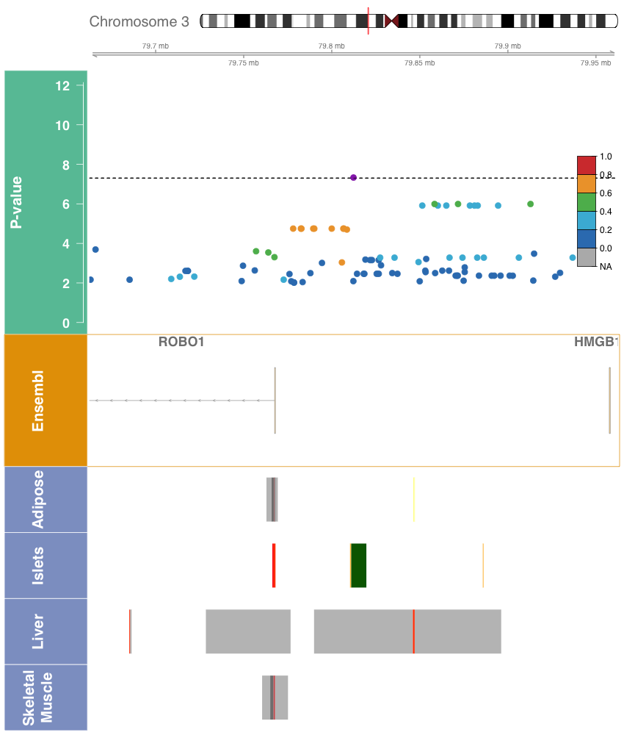

Figure S3. Manhattan plots for pooled region-based rare variant aggregate analysis with fasting glucose (a-d) and fasting insulin (e-h) in TOPMed. The Manhattan plot shows the -log₁₀ P-values for the variant sets plotted at the starting chromosomal positions, using the burden test and the SKAT test.
- Fasting Glucose, SKAT (1,1)
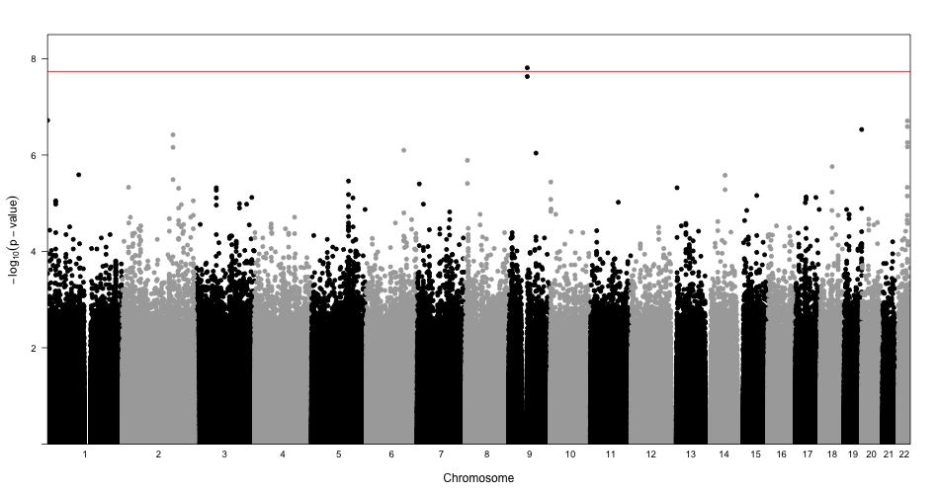
- Fasting Glucose, SKAT (1,25)
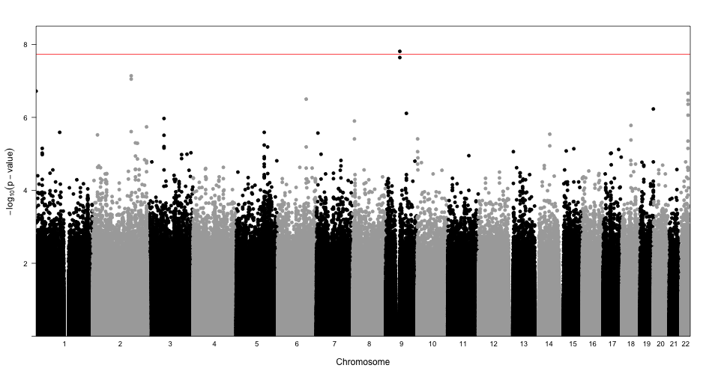

- Fasting Glucose, Burden (1,1)
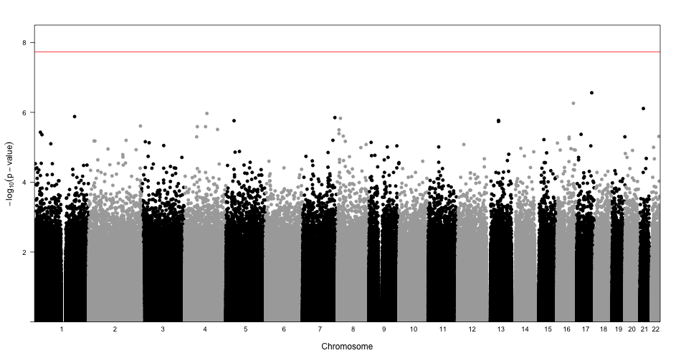
- Fasting Glucose, Burden (1,25)
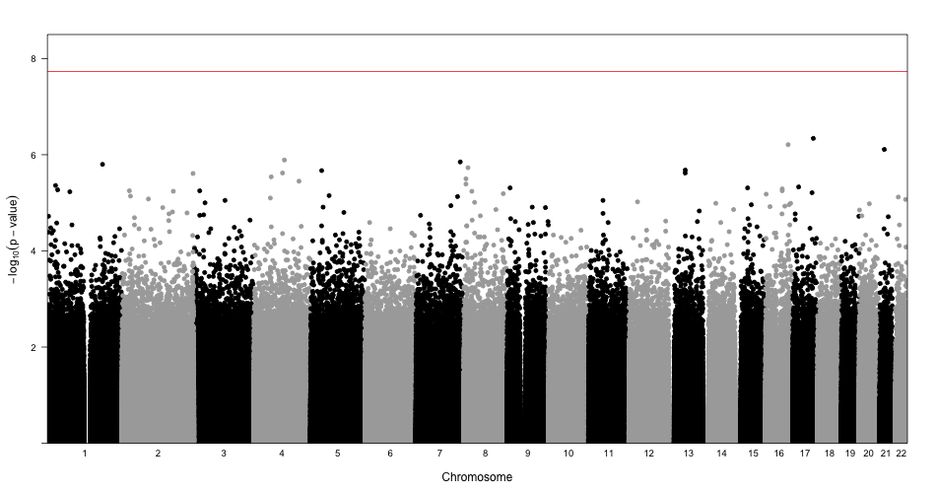

- Fasting Insulin, SKAT (1,1)
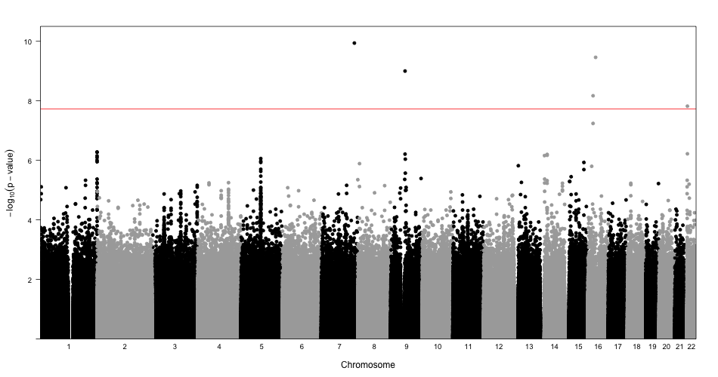
- Fasting Insulin, SKAT (1,25)
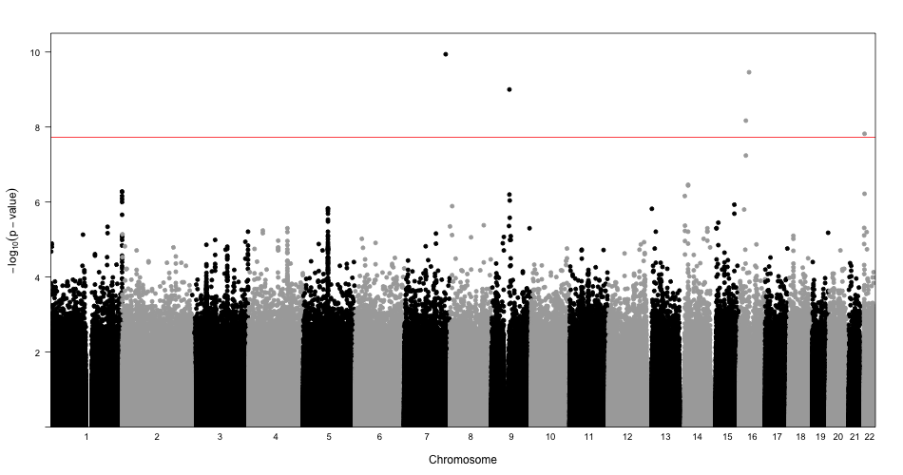

- Fasting Insulin, Burden (1,1)
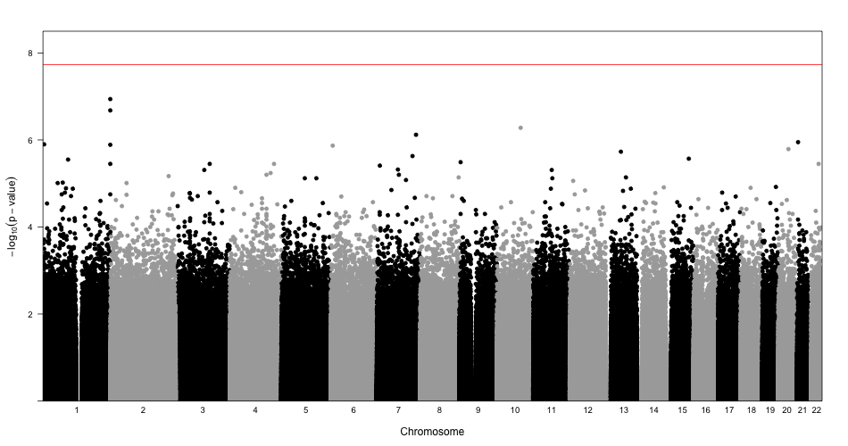
- Fasting Insulin, Burden (1,25)
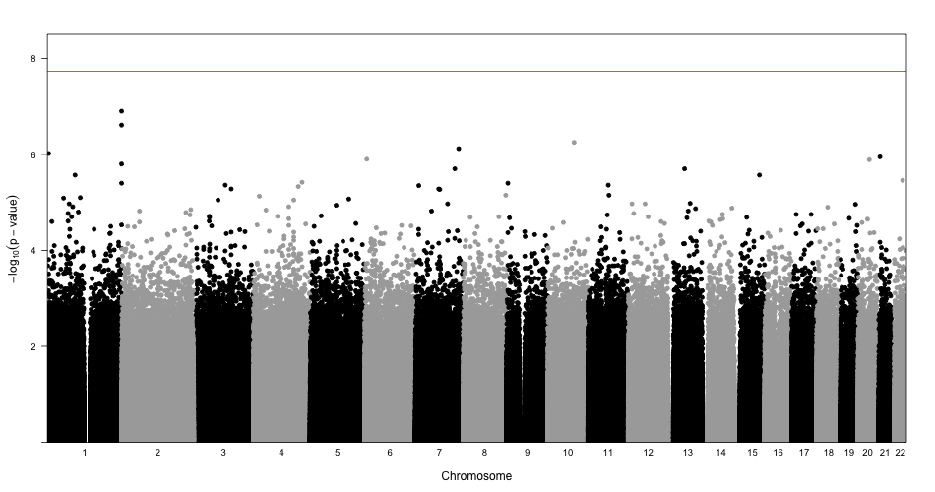

Figure S4. Plot of associations with related traits of identified loci in single variant analysis. The plot shows a black indicator for traits that have been previously identified as associated; see also Table S12.

 | FG | FI | HbA1c | T2D | BMI | WHR | HOMA-B
MTNR1B | ● |  | ● | ● | ● |  | ●
G6PC2 | ● |  | ● |  |  |  | ●
GCK | ● |  | ● | ● |  |  | ●
GCKR | ● | ● |  | ● | ●
FOXA2 | ● |  |  | ●
SLC30A8 | ● |  | ● | ● | ●
APOB
TCF7L2 | ● | ● | ● | ● | ● | ●
ADCY5 | ● |  | ● | ● | ● | ● | ●
PTPRT |  |  |  |  | ● | ●
ROBO1 |  |  |  |  | ● | ●

Abbreviations: FG, fasting glucose; FI, fasting insulin; HbA1c, hemoglobin A1c; T2D, Type 2 Diabetes; BMI, body mass index; WHR, waist-hip ratio; HOMA-B, homeostatic model assessment of beta-cell function.

Supplemental Tables

Table S1. Description of TOPMed studies included in glycemic trait analysis

Table S2. Demographic characteristics of cohorts included in fasting glucose analysis

Table S3. Demographic characteristics of cohorts included in fasting insulin analysis

Table S4. Haplotype analysis of the G6PC2 locus

Table S5. Number of rare variant sets by phenotype and set-type

Table S6. Results of log Fasting Insulin gene-centric rare variant aggregate tests

Table S7. Results of Fasting Glucose gene-centric rare variant aggregate tests

Table S8. Results of log Fasting Insulin genetic-regions rare variant aggregate tests

Table S9. Results of Fasting Glucose genetic-regions rare variant aggregate tests

Table S10. References for previous identification of variants in this study

Table S11. Reference for previous identification of gene regions in this study

Table S12. Lookups in related traits of identified loci in TOPMed projects

Table S13. Validation lookups of novel signals in METSIM cohorts

Table S14. Validation lookups of novel signals in the UKBB

Table S15. Validation lookups of novel signals in the Samoan cohort

Supplemental Subjects and Methods

Whole Genome Sequencing
Whole genome sequencing of blood samples for all participants included deep coverage (>30x on average) sequencing from blood samples provided by the NHLBI TOPMed program. Sequencing was performed across six centers (Broad Institute of MIT and Harvard, Northwest Genomics Center, New York Genome Center, Illumina Genomic Services, Macrogen, and Baylor College of Medicine Human Genome Sequencing Center) as previously described¹. The TOPMed Informatics Research Center at the University of Michigan performed data harmonization and joint variant discovery and genotype calling, requiring DNA sample contamination below 3% and at least 95% of the genome with at least 10x coverage. Freeze 5b was aligned to GRCh38 reads from the 1000 Genomes Project reference sequences². The samples were further processed by a centralized pipeline by the TOPMed Data Coordinating Center at the University of Washington, where further quality control and sample identity resolution were performed, including sex and relatedness concordance and selection of variants with missingness <5% and QUAL>127. After processing, Freeze 5b contained 54,508 samples with 438 million single nucleotide variants (SNVs) and 33 million short insertion-deletion variants.

Population structure principal components were calculated across all Freeze 5b TOPMed participants using PC-AiR; a genetic relatedness matrix was calculated across all Freeze 5b TOPMed participants using PC-Relate accounting for population structure. Race/ethnicity was determined by self-report from each study.

Phenotype Harmonization
Phenotype harmonization proceeded following a protocol defined by the TOPMed Diabetes Working Group for participating TOPMed studies. Duplicated individuals were excluded following the TOPMed Diabetes Working Group protocol. Within a study, monozygotic twins were retained and the duplicate to be kept was chosen based on verification of cohort characteristics, including proper cohort sequencing center designation, and then by highest call rate. Across studies, duplicates were selected by removing missing trait data, prioritizing population-based cohorts, and retaining individual records with the longest follow-up period. All study participants provided informed consent and each study was approved by their respective institutional review boards.

Glycemic traits (fasting glucose (FG) and fasting insulin (FI)) were analyzed for individuals who did not have diabetes at the time of glycemic trait measurement. This subset was defined as those not taking anti-diabetes medication, with fasting glucose <7mmol/l and/or HbA1c<6.5%. For individuals with multiple blood draws, the earliest exam or most complete exam was used. Age, sex, and BMI covariates were reported at the time of glycemic trait measurement. Fasting was defined to be at least 8 hours without food or drink; measurements from blood were converted to plasma values using a 1.13 correction factor³. The units for glucose are mmol/l; units for insulin are pmol/l. Fasting insulin was natural log-transformed prior to analysis in order to address non-normality.

Study Sample and Power
The present analysis included 23,211 (FI) and 26,807 (FG) individuals from the NHLBI TOPMed program. The cohorts included consist of participants of self-reported African American (FI n=6,803; FG n=7,174), East Asian (FI n=572; FG n=2,217), European (FI n=13,281; FG n=14,513), Hispanic/Latinx (FI n=1,641; FG n=1,989), and Samoan (FI n=914; FG n=914) race/ethnicity. Our analysis of fasting insulin included 14 cohorts and fasting glucose included 15 cohorts. The sample is predominantly of European race/ethnicity (FI 57.2%; FG 54.1%) and female (FI 66.5%; FG 65.2%); full cohort descriptions are given in Tables S2-3.

We performed a post-hoc power calculation to evaluate the power to detect genetic signal at the genome-wide threshold for statistical significance of 5x10⁻⁸. Given the study sample size, this analysis was powered to detect 0.54%-4.21% and 0.57-4.21% percent variation in glycemic trait explained by a genotype in race/ethnicity-specific analyses for FG and FI, respectively. The pooled study including all samples was powered to detect 0.16% and 0.17% percent variation in glycemic trait explained by a genotype for FG and FI, respectively.

Single Variant Analysis
We performed single variant analysis in Freeze 5b of TOPMed using race/ethnicity-specific and pooled approaches. We tested 64,675,008 variants for associations with FG and 58,759,883 with FI in both pooled and race/ethnicity-specific analyses, and restricted analysis to variants with minor allele count >= 20. We used linear mixed effects models and adjusted for age, age squared, sex, body mass index, study-race/ethnicity, with heterogeneous variance permitted across study-race/ethnicity groups and empirical kinship for relatedness and population structure. Models were fit using GENetic Estimation and Inference in Structured samples (GENESIS)⁴ in the Analysis Commons cloud-computing platform⁵. Fasting glucose and natural log transformed fasting insulin were used as outcomes in separate models. The genome-wide threshold for statistical significance was defined to be 5x10⁻⁸.

Stepwise conditional analysis was performed at each identified locus, defined to be a 500 kb region centered on the most significant variant, in order to identify distinct signals. This analysis proceeded by first including the most significant variant as a covariate, and repeating until no variants were associated with the phenotype with p-value <1x10⁻⁵. For each distinct signal, a final model was run conditioning on the set of other distinct signals; we report these potentially distinct signals.

Towards fine-mapping the identified loci, we generated 95% credible sets to investigate likely causal variants (LocalZoom). For each locus, we calculated Bayes factors for all variants from their single variant p-value; p-values were taken from conditional analyses on all other identified variants at the locus where multiple distinct signals were identified in the stepwise conditional analysis. We calculated posterior probability of association (PP) of each variant as the proportion contributed to the summation of all BFs in the region. The variants were sorted by descending PP, indicating decreasing probability that the variant is truly associated with the glycemic trait. The 95% credible set was constructed by including variants, starting with the highest PPA, until their cumulative PPA exceeded 0.95.

Rare Variant Analysis
We performed gene-based and genetic region aggregate testing to identify sets of rare variants associated with fasting glucose and log-transformed fasting insulin. We first fit a heteroscedastic linear mixed model for fasting glucose and log-transformed fasting insulin. Both traits were adjusted for age, age², sex, body mass index (BMI), study-race/ethnicity group indicators, and ten population structure principal components. A variance component was included for the empirically derived sparse kinship matrix and residual variances were permitted to be different for study-race/ethnicity groups to account for family relatedness, population structure, and study-race/ethnicity differences.

The heteroscedastic linear mixed model was used to perform variant set analyses for rare variants with MAF < 1%. Sets were defined by genetic regions and gene-centric categories. Genetic regions allowed the complete analysis of the genome, particularly non-coding regions that have not been previously captured by arrays. The regional analysis used 2kb sliding windows to scan the genome with 1kb skip length. The gene-centric analysis examined all protein-coding genes in Ensembl using functionally determined masks to aggregate variants together by coding and noncoding annotations. Coding annotations were used to define three SNV filters categorized by GENCODE based on consequence: (a) putative loss of function (stop gain, stop loss, splicing), (b) missense, and (c) synonymous variants. Leveraging the whole genome sequencing, we used non-coding annotations to test sets of variants that are not protein coding. We constructed masks (d) characterized as promoters given they were within +/- 3kb of a transcription start site with CAGE signal overlay, or (e) characterized as enhancers given they were identified by GeneHancer with CAGE signal overlay.

The burden test and SKAT were used for testing the association of the rare variant sets and FG and FI. In these approaches, a weight based on the MAF can be used to upweight rarer variants. We considered two common weighting schemes based on $w_{j}=Beta\left({MAF}_{j};a_{1},a_{2}\right)$, where $a_{1}=1$ and $a_{2}=25$ or $a_{1}=1$ and $a_{2}=1$.

Statistical significance was defined for each glycemic trait, separately for gene-centric and genetic region analysis. For gene-centric analysis, a threshold was defined by a Bonferroni-corrected significance threshold of $α≈0.05/(120000)=4×{10}^{-7}$, correcting for all five masks and all protein-coding genes when considering the minimum p-value across the burden and SKAT tests (Table S5). The threshold for the genetic region analysis was determined given the total number of 2kb sliding windows tested, yielding a Bonferroni-corrected threshold of $α≈0.05/(2.68×{10}^{6})=1.86×{10}^{-8}$. We report sets that include variant(s) with effective minor allele count greater than five and that are not exclusively composed of singletons; complete results based on the significance threshold are provided in Tables S6-9.

Haplotype Analysis
We performed haplotype analysis for variants associated with fasting glucose. This analysis considered a set of 18,071 unrelated individuals, identified by PC-AiR⁶ by the TOPMed Program with a threshold of third degree relatives. We performed regression of fasting glucose on haplotype using a two-step EM algorithm on the unphased genotypes, as implemented in the haplo.stats R package⁷. The posterior probabilities of haplotypes were computed for variants in the G6PC2 gene; the variants were included based on the variants included in a previous G6PC2 haplotype analysis, variants driving the G6PC2 missense set signal, and distinct G6PC2 signals from the single variant analysis. The association was adjusted for age, age², sex, body mass index, study-race/ethnicity, and ten population structure principal components.

Annotation
In order to characterize the functional impact of associated variants, we assembled functional annotations from multiple publicly available databases. We considered annotations from the Diabetes Epigenome Atlas, FAVOR, and GTEx projects. From the Diabetes Epigenome Atlas, we obtained chromatin states from four tissues relevant to glycemic traits: adipose, islet, liver, and muscle. These were available from two experiments, Parker lab ChromHMM 13-state model under accession TSTSR679993 & AMP-T2D ChromHMM 18-state model under accession TSTSR043890. We also report annotation PCs from the FAVOR database⁸, which are summaries of individual functional annotations across functional categories including conservation, epigenetics, local nucleotide diversity, mutation density, protein function, proximity to TSS/TSE, proximity to coding, and transcription factor binding. The individual annotations contributing to the aPCs are previously described⁹. Annotation PCs are calculated at the variant level and reported as PHRED-scaled scores derived from the first PC from the category’s PCA, providing the interpretation that variants with scores greater than 10 are in the top 10% of category across all TOPMed variants. We obtained tissue-specific signals from the GTEx project (Version 8) to assess colocalization with gene expression at signal variants and those highly linked to signal variants. We reported eQTLs in the following tissues, reported for their importance in glycemic phenotypes: adipose subcutaneous, adipose visceral, muscle skeletal, and pancreas.

Replication
We sought to replicate our findings in the METSIM study¹⁰, using data from 10,058 individuals with fasting glucose, fasting insulin, and TOPMed-imputed genotypes. EMMAX was used to test for associations with fasting glucose or log-transformed fasting insulin at the variants reported in Table 1 with age, age², and BMI as covariates and kinship; sex was not included as a covariate as the study is all males.

We additionally performed replication analysis in a sample from the UK Biobank. A sample of 12,854 European ancestry individuals from the UK Biobank with fasting glucose was selected from all individuals with fasting glucose measurement, excluding individuals with diabetes (Data-field 2443), on diabetes medication (Data-field 6177/6153), or with fasting time less than 8 hours (Data-field 74). Glucose values were taken from variable 30740. The model included age (Data-field 21022), age², sex (Data-field 31), BMI (Data-field 21001) and ten population structure PCs. Association models were run using Scalable and Accurate Implementation of GEneralized mixed model (SAIGE)¹¹ to analyze UKBB phenotype data and the imputed chip genetic data.

We also performed replication analysis of the Samoan-specific association of rs117592405 with fasting insulin in a cohort of 1,401 Samoans without WGS from the Samoan Study. rs117592405 was imputed using a Samoan-specific reference panel that was developed from the WGS of 1,284 Samoans as part of TOPMed. R version 3.6.0 was used to replicate the association with fasting insulin in individuals without a previous diabetes diagnosis or diabetes medication use. Age, age², BMI, and sex were included in the model.

Supplemental Results

MTNR1B
The primary association at the MTNR1B locus, intronic variant rs10830963, has been identified in multiple populations to increase fasting glucose (Table S11), and has posterior probability of one in the present study. This signal has been characterized as amongst the strongest signal for insulin secretion¹². The variant has previously been demonstrated to be expressed in in pancreatic islets; it is near the top 10% of variants genome-wide for APC-epigenetics. The variant is in a weakly transcribed chromatin state in islets, which is further supported by both the distance to TSS/TSE and transcription factor aPCs where it is in the top 5-10% genome-wide. The variant has been identified as a metabolite QTL for glucose^{13; 14}. The variant has further been associated with risk of type 2 diabetes, demonstrating that this trait has further influence on the clinical disease, but with mechanisms still under study.

TCF7L2
This locus has known associations with glycemic traits, and this variant has been identified in previous study to be significantly associated with fasting glucose and type 2 diabetes (Table S11, ClinVar). It is an intronic variant between exons 4 and 5, and while commonly observed across most ancestries it has low frequency in East Asian populations in TOPMed and gNOMAD. This variant is in an active enhancer state in both adipose tissue and islets, designated by GeneHancer and SuperEnhancer, and has a high score for the annotation PC measuring distance to coding. The variant has been annotated to be in accessible chromatin in pancreatic beta cell, islet of Langerhans, and pancreatic alpha cell and to be targeting TCF7L2 by gene prediction annotation derived from chromatin loops in islet of Langerhans. The functionality of this variant has been further studied previously^{15; 16}, with gene’s role hypothesized to be mediating the variant’s association with islet-specific traits¹⁷.

ADCY5
The common, intronic variant rs72964564 had the highest posterior probability at this locus (PP = 0.37); the common variant rs11708067 had posterior probability of 0.34 and has previously been identified as the lead variant at this locus in multiple studies. These variants are highly linked (R2= 0.86 in the present study sample), and have both been designated as GeneHancer and SuperEnhancer variants. Their chromatin states differ, as the previously identified lead variant rs11708067 is in active enhancer 2 and weak enhancer states in islets and skeletal muscle, respectively; rs72964564 is in weakly transcribed states for these tissues. However, rs72964564 is in an active enhancer state for adipose whereas this is in strong transcription for rs72964564. The previously identified rs11708067 is highly conserved, as evidenced by aPC-Conservation score of 20.3, and also is amongst the top 10% for both aPC-Epigenetics and aPC-Transcription Factors.
We identified a single-variant signal at the GCK locus that has been previously associated with FG and related trait HbA1c¹⁸. The rs1799884 variant, which lies 2KB upstream of the gene near the transcription start site and was identified by GeneHancer, significantly increased expression in thyroid tissue of GCK and YKT6 in GTEx. It is in an active enhancer 2 state in islets, while weakly transcribed in liver. It was reported to be in an accessible chromatin state in DGA in numerous tissues, including liver, pancreatic alpha and beta cells, pancreatic progenitors, body of pancreas, pancreatic acinar cell, and islet of Langerhans. It correspondingly has multiple chromatin interaction target genes in tissues including muscle and adipose cells. It has been identified as a metabolite QTL for glucose. Its functional annotations indicate that it is conserved (aPC-Conservation 11.7, LINSIGHT 13.0) and likely deleterious (CADD 11.7.)

The GCKR locus was the only locus significant in both of our FG and FI analyses; the lead variant, rs1260326, has been associated with a large number of traits including glycemic and metabolic. This missense variant in exon 15 of GCKR is associated with higher FG and FI and its active functionality is suggested by its relatively high aPC-Epigenetics and aPC-Transcription Factor values. It is an eQTL with multiple genes, in multiple tissues, including influencing NRBP1 expression in many tissues. It has been associated with multiple proteins as a pQTL, most relevantly with insulin¹⁹. This variant is in an active enhancer 1 region in liver, whereas all other significant variants were in less active states. This liver-specificity is understood as this gene regulates glucose storage and disposal in the liver²⁰. This variant impacts multiple traits by controlling the GCK binding interface²¹.

FOXA2, a glycemic trait-associated locus, was observed to have one FG-associated signal. The variant, rs3833331, is in the 3’ UTR of the gene and is classified as a CAGE promoter, GeneHancer, and SuperEnhancer. This variant (PP=0.78) is moderately linked to previously identified FOXA2 lead variants (rs6048205 upstream near TSS, rs6048216 ncRNA_intronic, rs1209523 downstream near TSE) which each have posterior probability less than 1x10⁻⁴ and are not in the 12-variant 95% credible set; our primary variant rs3833331 is suggested to be the same signal based on conditional analysis. The variant rs3833331 is frequent in African individuals, while it is relatively low frequency in European and Hispanic race/ethnicities. It is active only in islets, as it is in an active TSS state for both pancreas and islet of Langerhans. This variant significantly decreased the expression of both LINC01384 and FOXA2 in thyroid; FOXA2 regulates gene expression ‘for glucose sensing in pancreatic beta cells²².’

Our analysis identified a significant signal at the APOB locus, which has been associated with many lipids traits. Some lipids traits have been studied for their pleiotropic effects with glycemic traits; APOB has not been associated with glycemic traits in previous studies. The FG-associated intergenic variant, rs478588, is common in all populations. The lead variant has posterior probability of 0.27, and is moderately linked with all variants in the credible set. This variant is primary in quiescent regions across tissues but is weakly transcribed in liver. Previous studies have been inconclusive as to the pleiotropic effects of APOB with respect to glycemic traits, and this signal was not replicated in METSIM and UKBB.
Our single-variant analysis identified a secondary variant associated with MTNR1B, having conditioned on the known primary signal, rs10830963, which has a well-replicated association with FG. This secondary, intronic variant, rs73560545, had a posterior probability of 0.21 in the 95% credible set having conditioned on the primary variant; rs73560545 is highly linked (r²>0.98) to the two other variants with a posterior probability >0.1 (rs57569860 PP=0.18; rs73560556 PP=0.18). Each of these three variants are upstream of the primary signal and have an estimated FG lowering effect, in contrast to the primary signal. The secondary variant rs73560545 is in a quiescent low chromatin state for islets, whereas the two linked variants are in weak transcription states in islets, and has aPC-Epigenetics and aPC-Distance to TSS/TSE scores near the top 10% genome-wide (PHRED: 9.6 and 9.7, respectively). We sought to replicate this signal in external datasets, but did not observe significance in METSIM or UKBB (Supplemental Subjects and Methods; Tables S13-14).

Additional References

1. Taliun, D., Harris, D.N., Kessler, M.D., Carlson, J., Szpiech, Z.A., Torres, R., Gagliano Taliun, S.A., Corvelo, A., Gogarten, S.M., Kang, H.M., et al. (2020). Sequencing of 53,831 diverse genomes from the NHLBI TOPMed Program. Nature Accepted.
2. Regier, A.A., Farjoun, Y., Larson, D.E., Krasheninina, O., Kang, H.M., Howrigan, D.P., Chen, B.J., Kher, M., Banks, E., Ames, D.C., et al. (2018). Functional equivalence of genome sequencing analysis pipelines enables harmonized variant calling across human genetics projects. Nat Commun 9, 4038.
3. Haeckel, R., Brinck, U., Colic, D., Janka, H.U., Puntmann, I., Schneider, J., and Viebrock, C. (2002). Comparability of blood glucose concentrations measured in different sample systems for detecting glucose intolerance. Clin Chem 48, 936-939.
4. Gogarten, S.M., Sofer, T., Chen, H., Yu, C., Brody, J.A., Thornton, T.A., Rice, K.M., and Conomos, M.P. (2019). Genetic association testing using the GENESIS R/Bioconductor package. Bioinformatics 35, 5346-5348.
5. Brody, J.A., Morrison, A.C., Bis, J.C., O'Connell, J.R., Brown, M.R., Huffman, J.E., Ames, D.C., Carroll, A., Conomos, M.P., Gabriel, S., et al. (2017). Analysis commons, a team approach to discovery in a big-data environment for genetic epidemiology. Nat Genet 49, 1560-1563.
6. Conomos, M.P., Miller, M.B., and Thornton, T.A. (2015). Robust inference of population structure for ancestry prediction and correction of stratification in the presence of relatedness. Genet Epidemiol 39, 276-293.
7. Lake, S.L., Lyon, H., Tantisira, K., Silverman, E.K., Weiss, S.T., Laird, N.M., and Schaid, D.J. (2003). Estimation and tests of haplotype-environment interaction when linkage phase is ambiguous. Hum Hered 55, 56-65.
8. (2020). The NHGRI Genome Sequencing Program (GSP). Functional Annotation of Variants - Online Resource (FAVOR) Server In., p http://favor.genohub.org.
9. Li, X., Li, Z., Zhou, H., Gaynor, S.M., Liu, Y., Chen, H., Sun, R., Dey, R., Arnett, D.K., Aslibekyan, S., et al. (2020). Dynamic incorporation of multiple in silico functional annotations empowers rare variant association analysis of large whole-genome sequencing studies at scale. Nat Genet 52, 969-983.
10. Laakso, M., Kuusisto, J., Stancakova, A., Kuulasmaa, T., Pajukanta, P., Lusis, A.J., Collins, F.S., Mohlke, K.L., and Boehnke, M. (2017). The Metabolic Syndrome in Men study: a resource for studies of metabolic and cardiovascular diseases. J Lipid Res 58, 481-493.
11. Zhou, W., Nielsen, J.B., Fritsche, L.G., Dey, R., Gabrielsen, M.E., Wolford, B.N., LeFaive, J., VandeHaar, P., Gagliano, S.A., Gifford, A., et al. (2018). Efficiently controlling for case-control imbalance and sample relatedness in large-scale genetic association studies. Nat Genet 50, 1335-1341.
12. Bonnefond, A., and Froguel, P. (2017). The case for too little melatonin signalling in increased diabetes risk. Diabetologia 60, 823-825.
13. Kettunen, J., Tukiainen, T., Sarin, A.P., Ortega-Alonso, A., Tikkanen, E., Lyytikainen, L.P., Kangas, A.J., Soininen, P., Wurtz, P., Silander, K., et al. (2012). Genome-wide association study identifies multiple loci influencing human serum metabolite levels. Nat Genet 44, 269-276.
14. Kettunen, J., Demirkan, A., Wurtz, P., Draisma, H.H., Haller, T., Rawal, R., Vaarhorst, A., Kangas, A.J., Lyytikainen, L.P., Pirinen, M., et al. (2016). Genome-wide study for circulating metabolites identifies 62 loci and reveals novel systemic effects of LPA. Nat Commun 7, 11122.
15. Pang, D.X., Smith, A.J., and Humphries, S.E. (2013). Functional analysis of TCF7L2 genetic variants associated with type 2 diabetes. Nutr Metab Cardiovasc Dis 23, 550-556.
16. Mondal, A.K., Das, S.K., Baldini, G., Chu, W.S., Sharma, N.K., Hackney, O.G., Zhao, J., Grant, S.F., and Elbein, S.C. (2010). Genotype and tissue-specific effects on alternative splicing of the transcription factor 7-like 2 gene in humans. J Clin Endocrinol Metab 95, 1450-1457.
17. Miguel-Escalada, I., Bonas-Guarch, S., Cebola, I., Ponsa-Cobas, J., Mendieta-Esteban, J., Atla, G., Javierre, B.M., Rolando, D.M.Y., Farabella, I., Morgan, C.C., et al. (2019). Human pancreatic islet three-dimensional chromatin architecture provides insights into the genetics of type 2 diabetes. Nat Genet 51, 1137-1148.
18. Sarnowski, C., Leong, A., Raffield, L.M., Wu, P., de Vries, P.S., DiCorpo, D., Guo, X., Xu, H., Liu, Y., Zheng, X., et al. (2019). Impact of Rare and Common Genetic Variants on Diabetes Diagnosis by Hemoglobin A1c in Multi-Ancestry Cohorts: The Trans-Omics for Precision Medicine Program. Am J Hum Genet 105, 706-718.
19. Strawbridge, R.J., Dupuis, J., Prokopenko, I., Barker, A., Ahlqvist, E., Rybin, D., Petrie, J.R., Travers, M.E., Bouatia-Naji, N., Dimas, A.S., et al. (2011). Genome-wide association identifies nine common variants associated with fasting proinsulin levels and provides new insights into the pathophysiology of type 2 diabetes. Diabetes 60, 2624-2634.
20. Beer, N.L., Tribble, N.D., McCulloch, L.J., Roos, C., Johnson, P.R., Orho-Melander, M., and Gloyn, A.L. (2009). The P446L variant in GCKR associated with fasting plasma glucose and triglyceride levels exerts its effect through increased glucokinase activity in liver. Hum Mol Genet 18, 4081-4088.
21. Zelent, B., Raimondo, A., Barrett, A., Buettger, C.W., Chen, P., Gloyn, A.L., and Matschinsky, F.M. (2014). Analysis of the co-operative interaction between the allosterically regulated proteins GK and GKRP using tryptophan fluorescence. Biochem J 459, 551-564.
22. Wang, H., Gauthier, B.R., Hagenfeldt-Johansson, K.A., Iezzi, M., and Wollheim, C.B. (2002). Foxa2 (HNF3beta ) controls multiple genes implicated in metabolism-secretion coupling of glucose-induced insulin release. J Biol Chem 277, 17564-17570.

