Article

Hexosylceramides and glycerophosphatidylcholine GPC(36:1) increase in Multi-Organ Dysfunction Syndrome patients with Pediatric Intensive Care Unit Admission over 8-day hospitalization

Leimanis-Laurens, Mara L.1,2*, Wolfrum, Emily3, Ferguson, Karen1, Grunwell, Jocelyn R.4, Sanfilippo, Dominic1,2, Prokop, Jeremy W2,5, Lydic, Todd A.6, Rajasekaran, Surender1,2*

|  |
| --- |
|  |

1Pediatric Critical Care Unit, Helen DeVos Children’s Hospital, Grand Rapids, MI, 49503, United States.

2Department of Pediatric and Human Development, College of Human Medicine, Michigan State University, Life Sciences Bldg. 1355 Bogue Street, East Lansing MI 48824.

3Van Andel Institute, Bioinformatics & Biostatistics Core, Grand Rapids, MI, United States.

4Emory University & Children’s Healthcare of Atlanta, Atlanta, GA, 30322 United States.

5Department of Pharmacology and Toxicology, Michigan State University, East Lansing, MI 48824 USA.

6Department of Physiology, Collaborative Mass Spectrometry Core, East Lansing, MI, United States.

* Correspondence: mara.leimanis@spectrumhealth.org; Tel.: (+1 616-267-0106)

|  |  |  |  |  |  |  |  |
| --- | --- | --- | --- | --- | --- | --- | --- |
| **Supplemental Table 1.** Kendall Correlations between Lipid Value and Percent of Total Calories | | | | | | | |
| Group | Time | Total dhSM | Total SM | Total Cer | Total 2-hydroxy  Cer | Total Hex-Cer | Total Lac-Cer | |
| ECMO | Day 1 | 0.499 | 0.262 | 0.577 | 0.000 | 0.157 | -0.052 | |
| ECMO | Day 3 | 0.158 | 0.293 | 0.000 | 0.586 | 0.293 | -0.350 | |
| ECMO | Day 8 | 0.200 | -0.200 | 0.467 | -0.333 | 0.067 | 0.067 | |
| MODS | Day 1 | N/A | N/A | N/A | N/A | N/A | N/A | |
| MODS | Day 3 | N/A | N/A | N/A | N/A | N/A | N/A | |
| MODS | Day 8 | N/A | -0.429 | -0.214 | -0.182 | -0.214 | -0.071 | |
| Notes: 2-hyroxy Cer: 2-hydroxy ceramide; Cer: ceramide; dhSM: dihydrosphingomyelin; Hex-Cer: hexosylceramides; Lac-Cer: lactosylceramides; SM: Sphingomyelin. | | | | | | | | |
|  |  |  |  |  |  |  |  | |

|  |  |  |  |  |  |  |  |  |  |
| --- | --- | --- | --- | --- | --- | --- | --- | --- | --- |
| **Supplemental Table 2:** Correlations between lipid values and viral infection (yes/no) in patients over time; not adjusted for age or sex | | | | | | | | | |
| Group | Time | Infection | Total dhSM | Total SM | Total Cer | Total hydroxy-Cer | Total Lac-Cer |  |
| MODS | Day 1 | Bacterial | N/A | 0.024 | 0.189 | N/A | 0.450 |  |
| MODS | Day 3 | Bacterial | N/A | -0.159 | -0.106 | 0.447 | 0.080 |  |
| MODS | Day 8 | Bacterial | N/A | -0.436 | -0.109 | 0.111 | -0.109 |  |
| MODS | Day 1 | Viral | N/A | -0.382 | -0.209 | N/A | -0.247 |  |
| MODS | Day 3 | Viral | N/A | 0.559 | 0.206 | -0.309 | 0.118 |  |
| MODS | Day 8 | Viral | N/A | 0.000 | -0.109 | 0.056 | 0.000 |  |
| ECMO | Day 1 | Viral | 0.361 | 0.049 | -0.049 | -0.447 | -0.146 |  |
| ECMO | Day 3 | Viral | 0.136 | 0.252 | 0.504 | 0.378 | -0.065 |  |
| ECMO | Day 8 | Viral | -0.086 | -0.086 | -0.086 | 0.430 | 0.086 |  |

Notes: 2-hyroxy Cer: 2-hydroxy ceramide; Cer: ceramide; dhSM: dihydrosphingomyelin; Hex-Cer: hexosylceramides; Lac-Cer: lactosylceramides; SM: Sphingomyelin.

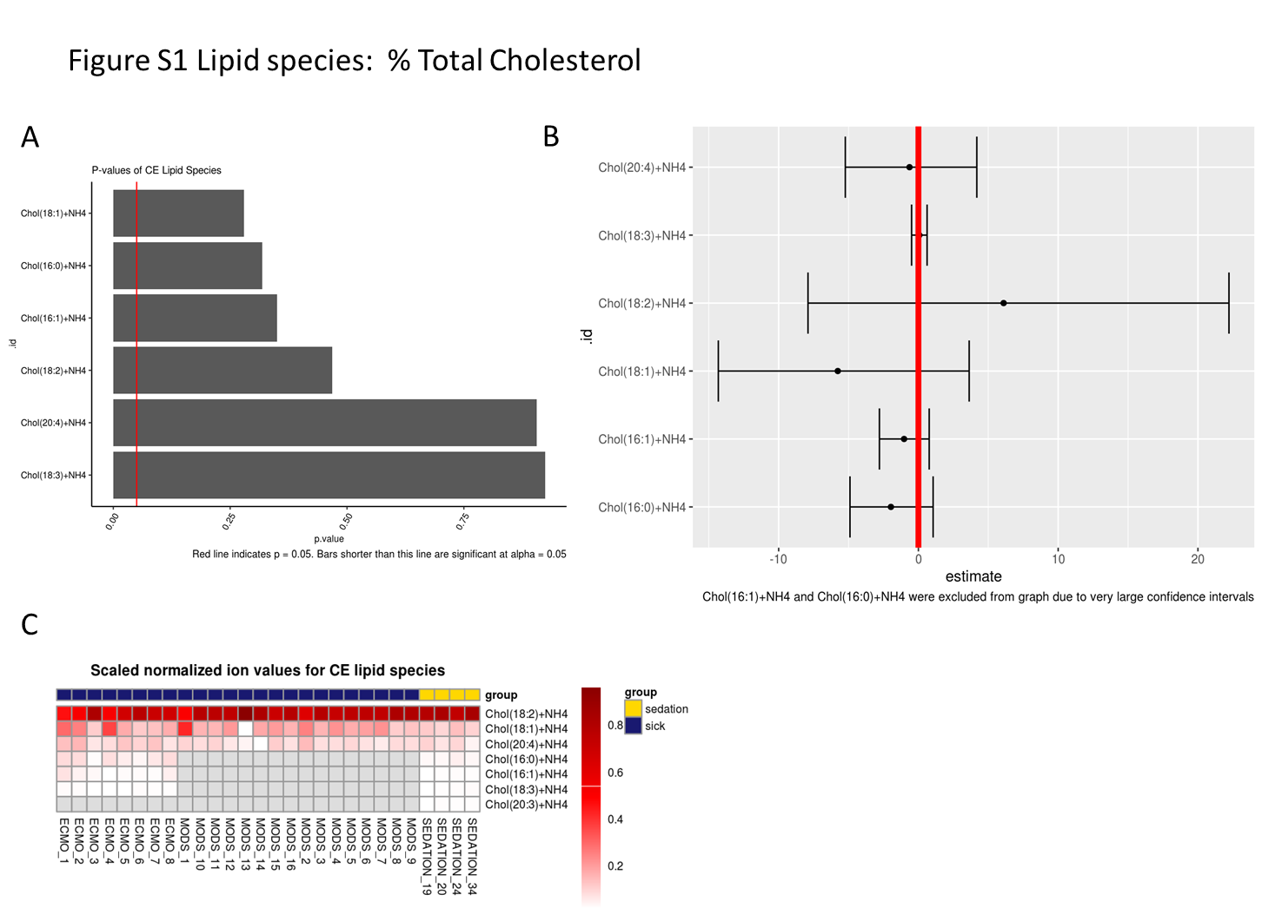**Figure S1.** Percent total cholesterol lipid species

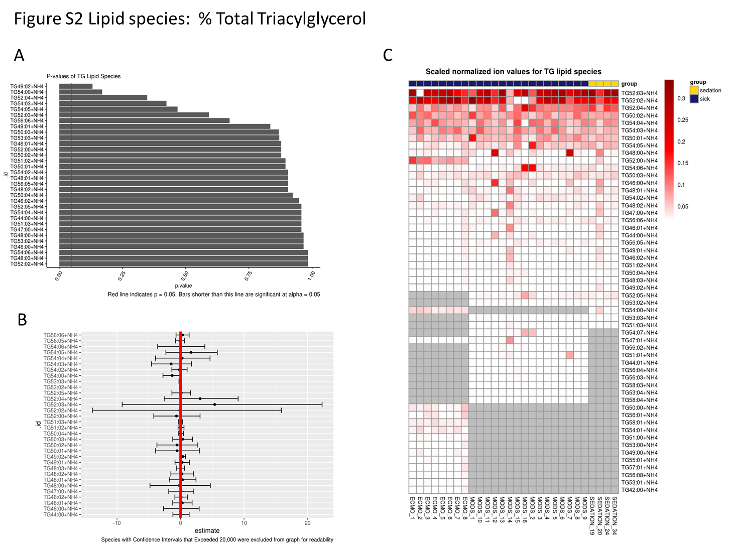**Figure S2.** Percent total triacylglycerol lipid species

**Figure S3.** Percent total diacylglycerol lipid species

