Supplementary Materials

Table of Contents
S1 Supplementary tables 2
Table S1.1. The source of COVID-19 vaccine efficacy data as of March 1, 2021 2
Table S1.2. List of selected key mutations in spike (S) protein of SARS-CoV-2 3
S2 Supplementary figure 4
Figure S2. Map of high-frequency mutations in RBD in the countries running clinical trials. 4
References 5

S1 Supplementary tables

Table S1.1. The source of COVID-19 vaccine efficacy (VE) data as of March 1, 2021
No. | Developers | Vaccine platform | Type of candidate vaccine | Countries | Clinical studies | VE source
1 | BioNTech / Pfizer + Fosun Pharma | RNA based vaccine | BNT162 (3 LNP-mRNAs) | Argentina, Brazil, US* | Phase 3 clinical trial | [1]
 |  |  |  | Israel | Observational study | [2]
2 | Moderna + National Institute of Allergy and Infectious Diseases (NIAID) | RNA based vaccine | mRNA-1273 | US | Phase 3 clinical trial | [3]
3 | Sinopharm + China National Biotec Group Co + Beijing Institute of Biological Products | Inactivated virus | Inactivated SARS-CoV-2 vaccine (Vero cell) | Argentina, Bahrain, Egypt, Jordan and Peru | Phase 3 clinical trial | [4]
 |  |  |  | UAE** | Phase 3 clinical trial | [5]
4 | Sinovac Research and Development Co. Ltd | Inactivated virus | SARS-CoV-2 vaccine (Inactivated) | Brazil | Phase 3 clinical trial | [6]
 |  |  |  |  | Observational study | [7]
 |  |  |  | Chile | Observational study | [8]
 |  |  |  | Indonesia | Phase 3 clinical trial | [9]
 |  |  |  | Turkey | Phase 3 clinical trial | [10]
5 | Novavax | Protein subunit | SARS-CoV-2 rS/Matrix M1-Adjuvant (Full length recombinant SARS-CoV-2 glycoprotein nanoparticle vaccine adjuvanted with Matrix M) | South Africa | phase 2b clinical trial | [11]
 |  |  |  | UK*** | Phase 3 clinical trial
6 | AstraZeneca + University of Oxford | Viral vector (Non-replicating)  (ChAdOx1) | ChAdOx1-S - (AZD1222) (Covishield) | Brazil, UK | Phase 3 clinical trial | [12]
 |  |  |  | South Africa | phase 2 clinical trial | [13]
7 | CanSino Biological Inc./Beijing Institute of Biotechnology | Viral vector (Non-replicating) | Recombinant novel coronavirus vaccine (Adenovirus type 5 vector) | Argentina, Chile, Mexico and Russia | Phase 3 clinical trial | [14]
 |  |  |  | Pakistan | Phase 3 clinical trial | [15]
8 | Gamaleya Research Institute; Health Ministry of the Russian Federation | Viral vector (Non-replicating) | Gam-COVID-Vac Adeno-based (rAd26-S+rAd5-S) | Russia | Phase 3 clinical trial | [16]
9 | Janssen Pharmaceutical | Viral vector (Non-replicating) | Ad26.COV2.S | Argentina, Chile, Colombia, Mexico, Peru,  Brazil,  South Africa,  US | Phase 3 clinical trial | [17]
*US: United States of America; **UAE: United Arab Emirates; ***UK: United Kingdom.

Table S1.2. List of selected key mutations in spike (S) protein of SARS-CoV-2
No. | Codon | Genomic region | Substitution | Location of identification | Previously reported
1 | 18 | N-terminal domain, S1 subunit | L18F | Brazil | [18]
2 | 20 | N-terminal domain, S1 subunit | T20N | Brazil | [18]
3 | 26 | N-terminal domain, S1 subunit | P26S | Brazil | [18]
4 | 138 | N-terminal domain, S1 subunit | D138Y | Brazil | [18]
5 | 190 | N-terminal domain, S1 subunit | R190S | Brazil | [18]
6 | 417 | Receptor-binding domain, S1 subunit | K417T/N | Brazil, South Africa | [18]
7 | 484 | Receptor-binding domain, S1 subunit | E484K | Brazil, South Africa | [18, 19]
8 | 501 | Receptor-binding domain, S1 subunit | N501Y | Brazil, South Africa, UK* | [18, 20]
9 | 570 | S1 subunit | A570D | UK | [20]
10 | 614 | S1 subunit | D614G | Brazil, South Africa, UK | [18, 19]
11 | 655 | S1 subunit | H655Y | Brazil | [18]
12 | 701 | S2 subunit | A701V | South Africa | [19]
13 | 716 | S2 subunit | T716I | UK | [20]
14 | 982 | Heptapeptide repeat sequence 1, S2 subunit | S982A | UK | [20]
15 | 1027 | S2 subunit | T1027I | Brazil | [18]
16 | 1118 | S2 subunit | D1118H | UK | [20]
*UK: United Kingdom.

S2 Supplementary figure

Figure S2. Map of high-frequency mutations in RBD in the countries running clinical trials.
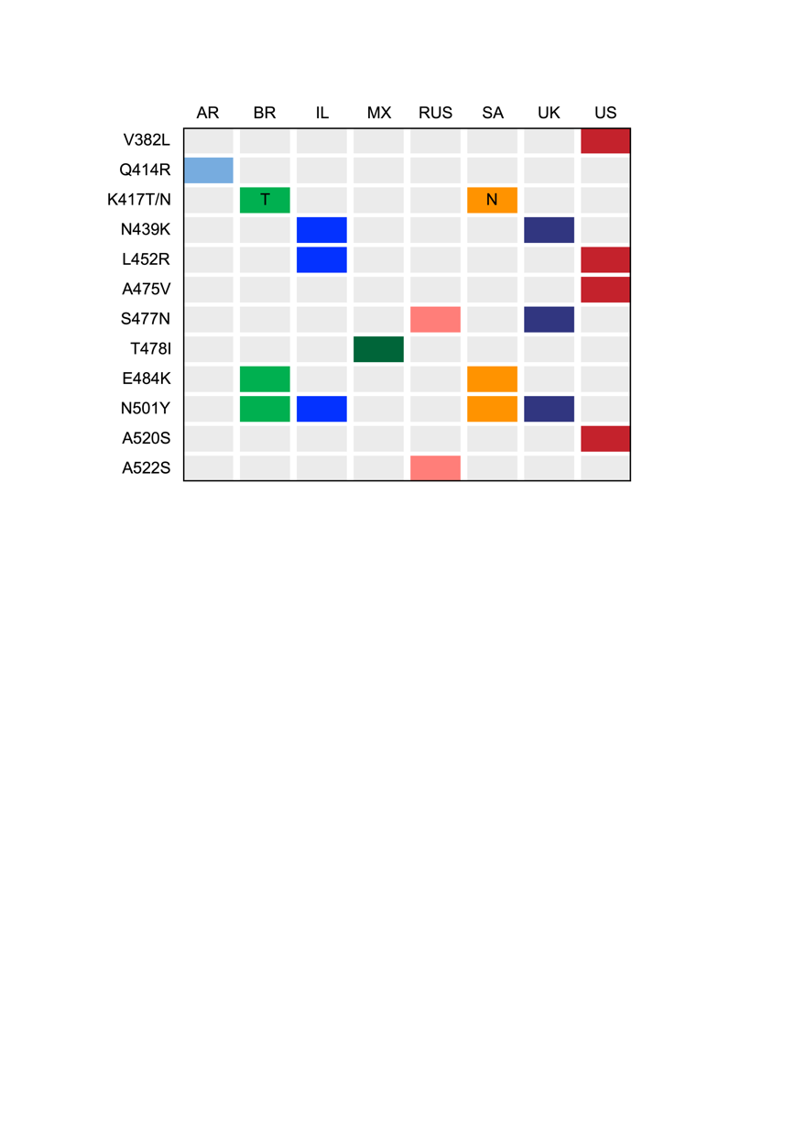
Legend: High-frequency mutations in RBD are listed in the first column. The first row is target countries included in this study. Each row on the map represents the country where the mutation was detected. AR: Argentina; BR: Brazil; IL: Israel; MX: Mexico; RUS: Russia; SA: South Africa; UK: United Kingdom; US: United States of America.

References
1. Polack FP, Thomas SJ, Kitchin N, et al. Safety and Efficacy of the BNT162b2 mRNA Covid-19 Vaccine. N Engl J Med 2020; 383(27): 2603-15.
2. Azad A. Pfizer-BioNTech vaccine sharply reduces symptomatic Covid-19 in the real world, Israeli researchers say. Available at: https://edition.cnn.com/2021/02/15/health/pfizer-biontech-covid-vaccine-reduces-infections-israel-study-intl/index.html. Accessed March 1, 2021.
3. Baden LR, El Sahly HM, Essink B, et al. Efficacy and Safety of the mRNA-1273 SARS-CoV-2 Vaccine. N Engl J Med 2021; 384(5): 403-16.
4. Staff R. Sinopharm's COVID-19 vaccine 79% effective, seeks approval in China. Available at: https://www.reuters.com/article/health-coronavirus-china-vaccine-int-idUSKBN2940CA. Accessed March 1, 2021.
5. Staff R. UAE says Sinopharm vaccine has 86% efficacy against COVID-19. Available at: https://www.reuters.com/article/health-coronavirus-emirates/uae-says-sinopharm-vaccine-has-86-efficacy-against-covid-19-idUKKBN28J0G4. Accessed March 1, 2021.
6. Sinovac. Summary of Clinical Trial Data of Sinovac’s COVID-19 Vaccine (CoronaVac®). Available at: http://www.sinovac.com/?optionid=754&auto_id=927. Accessed April 22, 2021.
7. Hitchings M, Ranzani OT, Torres MS, et al. Effectiveness of CoronaVac in the setting of high SARS-CoV-2 P. 1 variant transmission in Brazil: A test-negative case-control study. medRxiv 2021.
8. China’s Sinovac COVID-19 vaccine 67% effective in preventing symptomatic infection - Chile govt report. Available at: https://www.reuters.com/business/healthcare-pharmaceuticals/chinas-sinovac-covid-19-vaccine-67-effective-preventing-symptomatic-infection-2021-04-16/. Accessed April 22, 2021.
9. Widianto S. Indonesia approves China's Sinovac vaccine as infections surge. Available at: https://www.reuters.com/article/health-coronavirus-indonesia/indonesia-approves-chinas-sinovac-vaccine-says-65-3-effective-in-trial-idINKBN29G0TA?edition-redirect=in. Accessed March 1, 2021.
10. Sinovac. Sinovac Announces Phase III Results of Its COVID-19 Vaccine. Available at: http://www.sinovac.com/?optionid=754&auto_id=922. Accessed March 1, 2021.
11. Novavax COVID-19 Vaccine Demonstrates 89.3% Efficacy in UK Phase 3 Trial. Available at: https://ir.novavax.com/news-releases/news-release-details/novavax-covid-19-vaccine-demonstrates-893-efficacy-uk-phase-3. Accessed March 1, 2021.
12. Voysey M, Clemens SAC, Madhi SA, et al. Safety and efficacy of the ChAdOx1 nCoV-19 vaccine (AZD1222) against SARS-CoV-2: an interim analysis of four randomised controlled trials in Brazil, South Africa, and the UK. Lancet 2021; 397(10269): 99-111.
13. Madhi SA, Baillie V, Cutland CL, et al. Efficacy of the ChAdOx1 nCoV-19 Covid-19 Vaccine against the B.1.351 Variant. N Engl J Med 2021.
14. Peshimam GN, Farooq U. CanSinoBIO's COVID-19 vaccine 65.7% effective in global trials, Pakistan official says. Available at: https://www.reuters.com/article/us-health-coronavirus-vaccine-pakistan/cansinobios-covid-19-vaccine-657-effective-in-global-trials-pakistan-official-says-idUSKBN2A81N0. Accessed March 1, 2021.
15. China's 1-dose COVID-19 vaccine 74.8% effective in late-stage trial. Available at: https://news.cgtn.com/news/2021-02-09/CanSinoBIO-s-COVID-19-vaccine-74-8-effective-in-Pakistan-trials-XJrVtCspNu/index.html. Accessed March 1, 2021.
16. Logunov DY, Dolzhikova IV, Shcheblyakov DV, et al. Safety and efficacy of an rAd26 and rAd5 vector-based heterologous prime-boost COVID-19 vaccine: an interim analysis of a randomised controlled phase 3 trial in Russia. Lancet 2021; 397(10275): 671-81.
17. FDA. Janssen Ad26.COV2.S Vaccine for the Prevention of COVID-19. Available at: https://www.fda.gov/media/146217/download. Accessed March 1, 2021.
18. Toovey OTR, Harvey KN, Bird PW, Tang JWW. Introduction of Brazilian SARS-CoV-2 484K.V2 related variants into the UK. J Infect 2021.
19. West Jr AP, Barnes CO, Yang Z, Bjorkman PJ. SARS-CoV-2 lineage B. 1.526 emerging in the New York region detected by software utility created to query the spike mutational landscape. bioRxiv 2021.
20. SA Kemp, RP Datir, DA Collier, et al. Recurrent emergence and transmission of a SARS-CoV-2 Spike deletion ΔH69/ΔV70. bioRxiv 2021.

