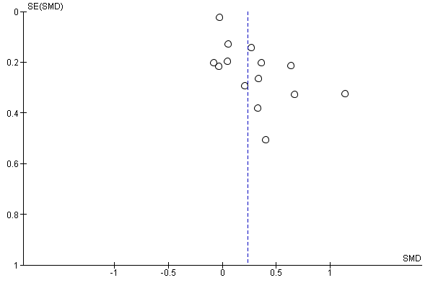
Figure 1: Funnel plot for studies reporting MPV in severe and non-severe COVID-19 patients

