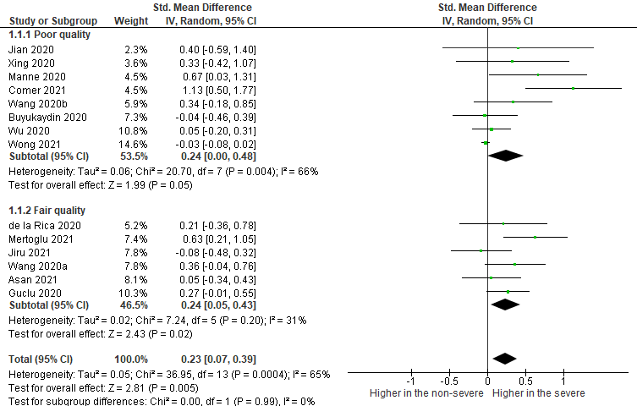

Figure 1: Poor and fair-quality subgroup analysis of the pooled mean differences for MPV in studies of non-severe and severe patients

Figure 2: Outcome subgroup analysis of the pooled mean differences for MPV in studies of non-severe and severe patients