Supplementary Appendix: Additional Figures and Table
Figure A1: Overview of 3 state Markov model

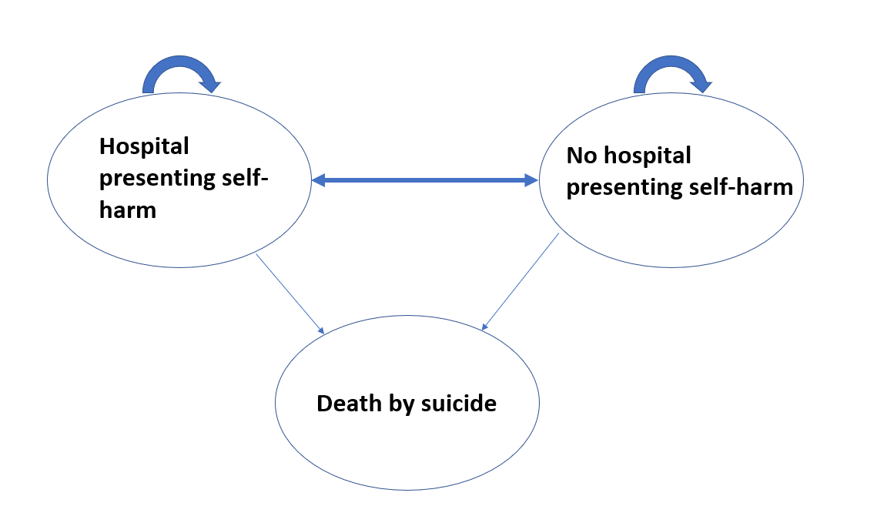
Figure A2: Detailed excerpt of model structure
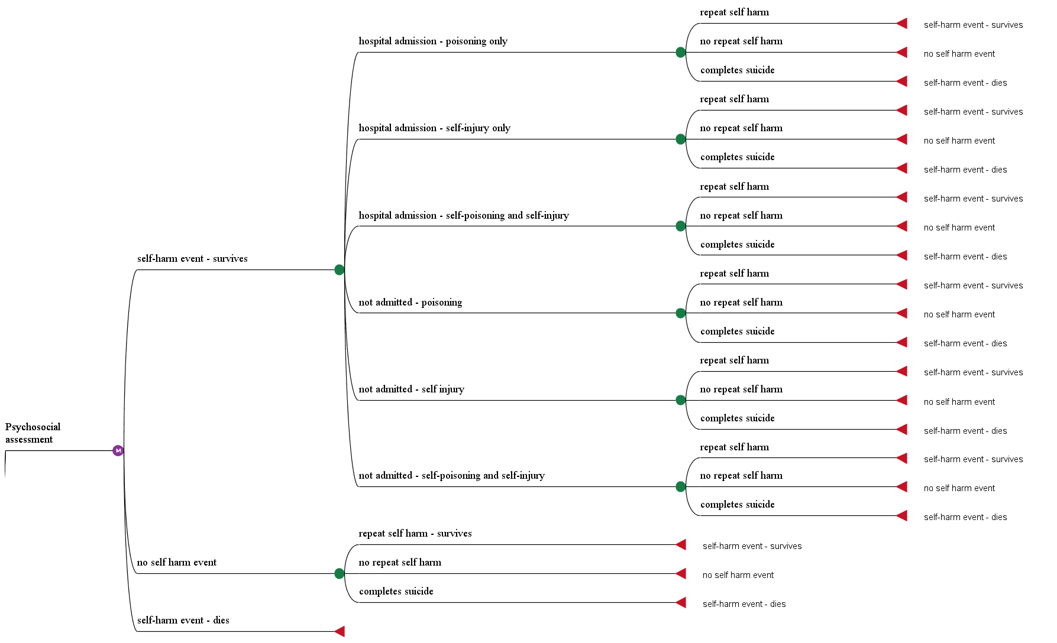
Note: Model structure is the same for the no intervention pathway (not shown)
Figure A3: Net monetary benefit probability distribution (NHS perspective 10,000 bootstraps)
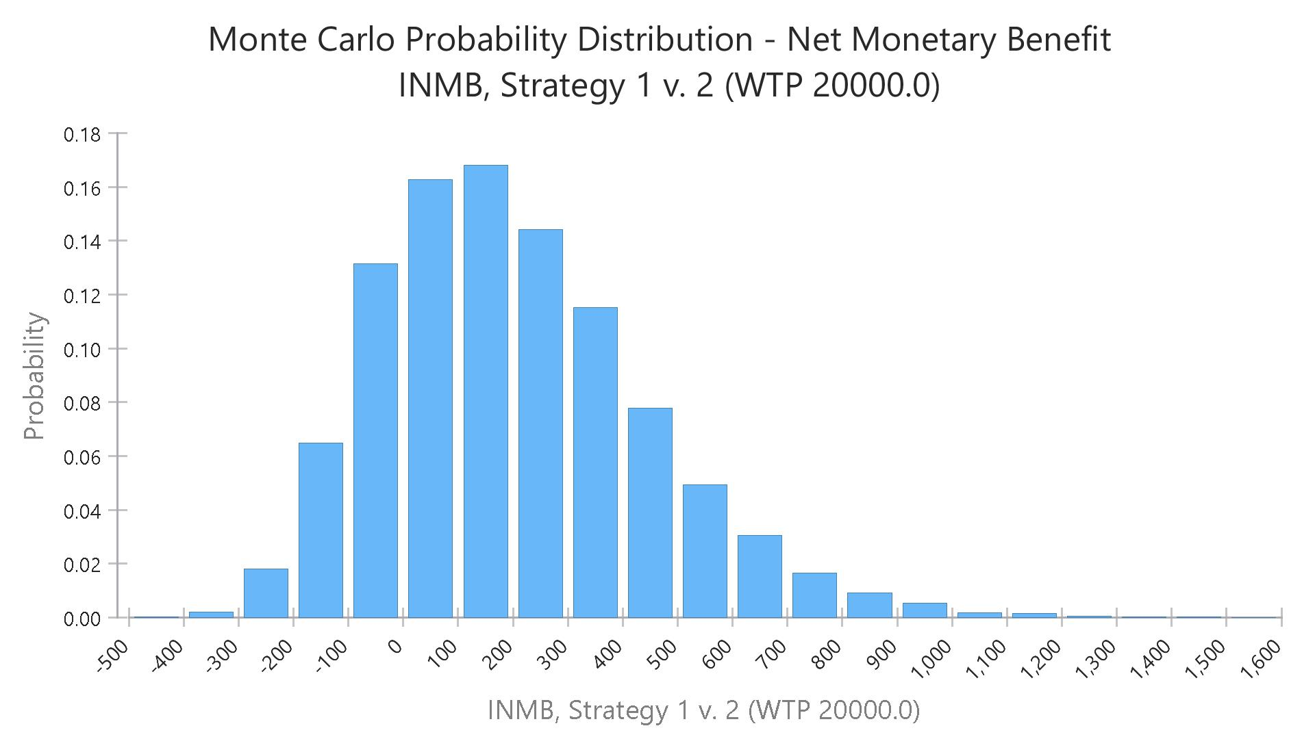
Mean NMB: £200
(95% CI -£189, £758)

Figure A4: Cost effectiveness acceptability curve (NHS perspective)
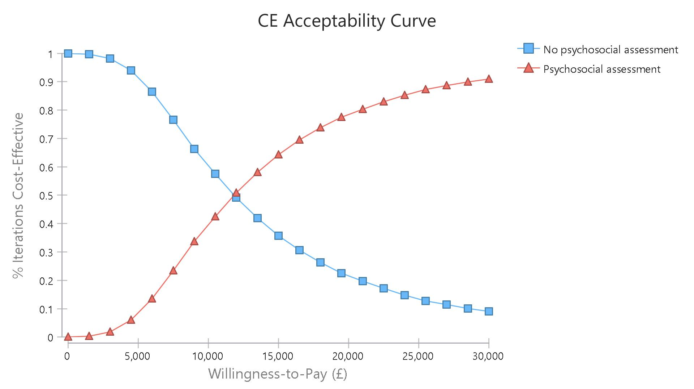
£11,900

Figure A5: Net monetary benefit probability distribution (Societal perspective 10,000 bootstraps)

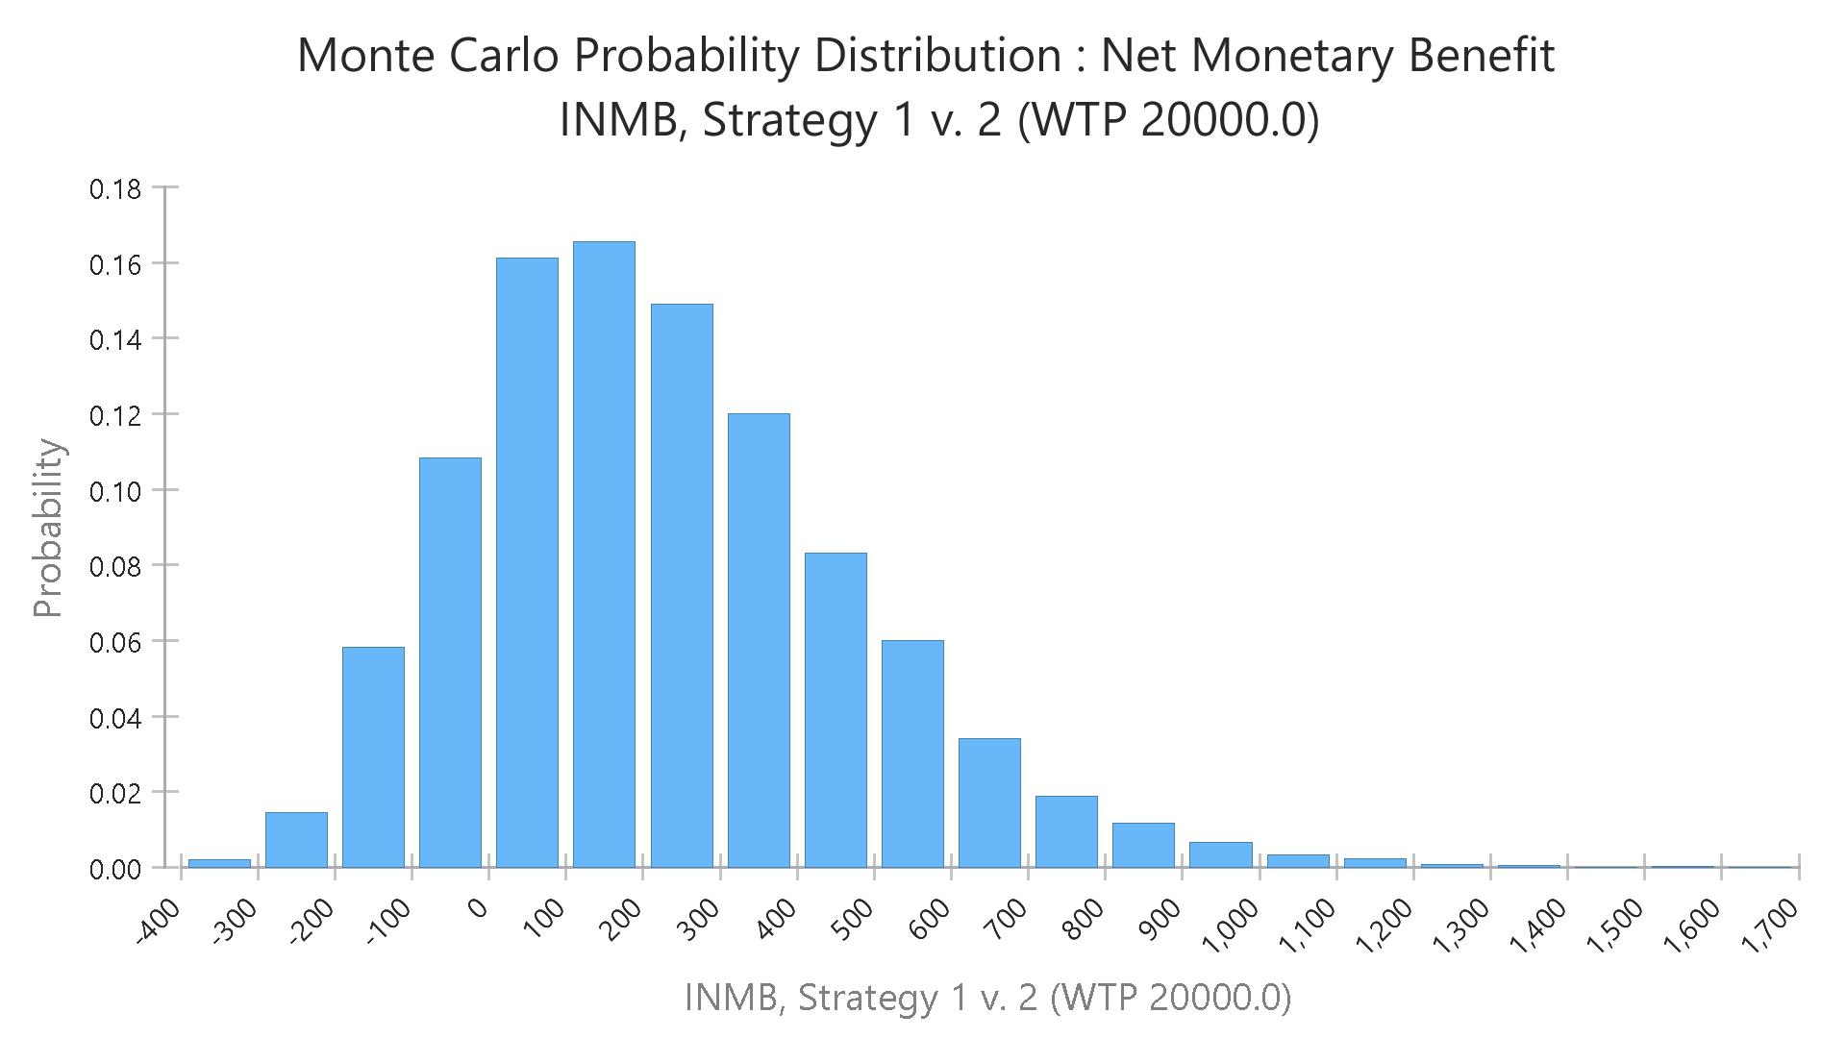
Mean NMB: £224
(95% CI -£180, £801)

Figure A6: Cost effectiveness acceptability curve (societal perspective)
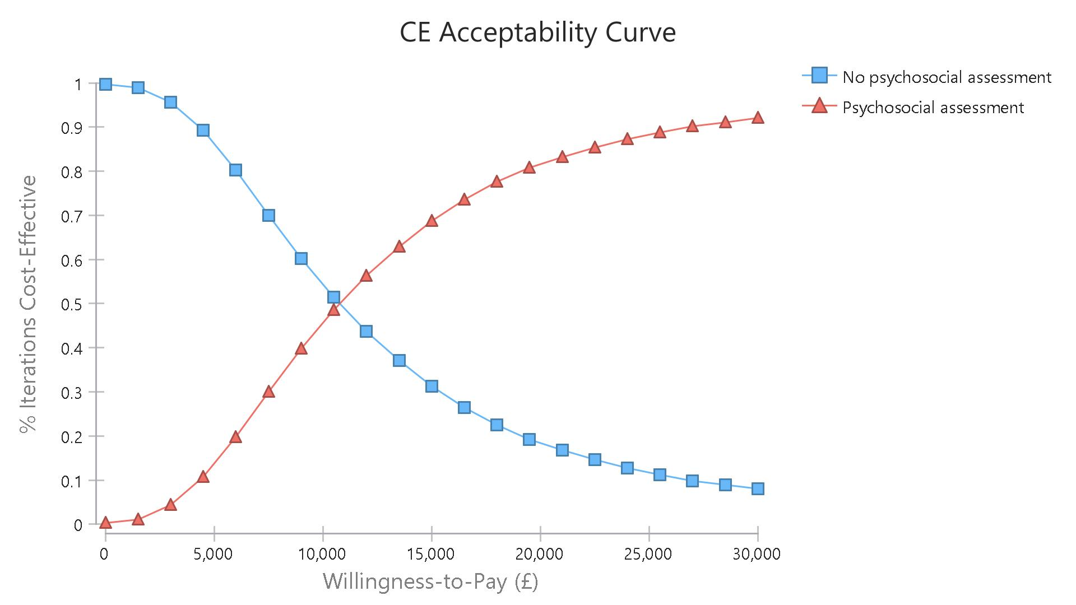
£11,000

