**Appendix A: Spinal Cord Analysis**

Of all the structures investigated, the cervical spinal cord had the worst overall performance across most metrics, regardless of the algorithm used (**Figure 2 of main text**). Therefore, we further inspected these cases to determine if these propagated segmentations were still clinically acceptable and to determine where algorithms failed to improve overlap with the ground truth. Examples of performance of the best algorithm (ADMIRE_Skiplinear) compared to the implicit rigid registration and the corresponding ground truth on the diffusion-weighted image for three cases are shown in **Figure A1**. We categorized the cases as low, medium, and high, corresponding to DSC performance that was below, equal to, and above the mean performance of all cases. For the low DSC performance case, there was a clear advantage to using the ADMIRE_Skiplinear method, as more voxels were able to overlap correctly in the superior region of the spinal cord. However, the algorithm had difficulties near the inferior portions of the spinal cord where a greater degree of curvature was present. The differences between the ADMIRE_Skiplinear algorithm and implicit rigid registration were less dramatic for the medium and high DSC performance cases, where there was minimal curvature in the spinal cord.

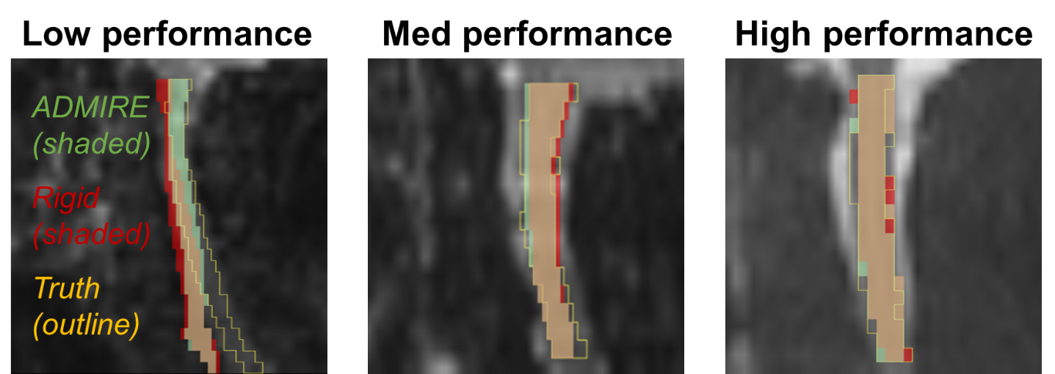

**Figure A1.** Examples of performance of the best algorithm (ADMIRE_Skiplinear) compared to the implicit rigid registration and the corresponding ground truth on the diffusion-weighted image for three cases (low, medium, and high DSC performance). The ADMIRE algorithm structure is shaded in green, the implicit rigid structure is shaded in red, and the ground truth structure is outlined in yellow. The overlapping areas of the ADMIRE algorithm and implicit rigid registration are shaded in tan. DSCs of the ADMIRE algorithm and implicit rigid registration were 0.556 and 0.335 (respectively) for the low performance case, 0.752 and 0.718 (respectively) for the medium performance case, and 0.876 and 0.815 (respectively) for the high performance case.