**Post-traumatic stress symptoms in cancer patients during the COVID-19 pandemic: a one-year longitudinal study**

**Supplementary Tables and Figures**

Etienne Bastien,1 Sophie Lefèvre‐Arbogast, PhD,2,3 Justine Lequesne, PhD,3 corresponding author, François Gernier, MSc,3 François Cheriffi, PhD,1 Olivier Rigal, MD,4 , 5 Lydia Guittet, MD, PhD,2 Jean‐Michel Grellard, MSc,3 Giulia Binarelli, MSc,2,3 Marie Lange, PhD,2,3 Marie Fernette,3 Laure Tron, PhD,2 Adeline Morel, MD,1 Doriane Richard, PhD,5 Bénédicte Griffon, PhD,3 Alexandra Leconte, MSc,3 Florian Quilan, MSc,1 Louis‐Ferdinand Pépin, MD,5 Fabrice Jardin, MD, PhD,5,6 Marianne Leheurteur, MD,4 Audrey Faveyrial, MD,1 Bénédicte Clarisse, PharmD, PhD,3 and Florence Joly, MD, PhD.1, 2, 3

**Affiliations**

1 Medical Oncology Department, François Baclesse Center, Caen France,

2 Anticipe (Interdisciplinary Research Unit for the Prevention and Treatment of Cancer), INSERM Unit 1086, Caen France,

3 Clinical Research, François Baclesse Center, Caen France,

4 Medical Oncology, Henri Becquerel Center, Rouen France,

5 Clinical Research, Henri Becquerel Center, Rouen France,

6 Hematology, Henri Becquerel Center, Rouen France

**Supplementary Table 1: Fit of latent class models identifying distinct trajectory classes of IES-R evolution**

|  |  |  |  |  |  |  |  |  |  |  |  |
| --- | --- | --- | --- | --- | --- | --- | --- | --- | --- | --- | --- |
| Model with n classes | loglik | AIC | BIC | SABIC | entropy | Class 1,  N | Class 2,  N | Class 3,  N | Class 4,  N | Class 5,  N | Class 6,  N |
| 1 | -6044.58 | 12103.16 | 12130.85 | 12108.64 | 1 | 386 |  |  |  |  |  |
| 2 | -5972.70 | 11971.39 | 12022.82 | 11981.57 | 0.8959 | 358 | 28 |  |  |  |  |
| 3 | -5945.90 | 11929.80 | 12004.96 | 11944.68 | 0.8672 | 21 | 327 | 38 |  |  |  |
| 4 | -5912.71 | 11875.43 | **11974.32** | 11895.00 | 0.8521 | 23 | 63 | 5 | 295 |  |  |
| 5 | -5900.56 | 11863.11 | 11985.74 | 11887.38 | 0.8648 | 36 | 298 | 34 | 5 | 13 |  |
| 6 | -5893.40 | 11860.80 | 12007.16 | 11889.77 | 0.5964 | 9 | 0 | 15 | 14 | 280 | 68 |

**Supplementary Table 2: Clinical characteristics of patients retained in the longitudinal analysis and the initial population available at baseline**

|  |  |  |
| --- | --- | --- |
|  | **Sample retained in longitudinal analysis (n=386)** | **Sample available at baseline (n=565)** |
| Age, median (min-max) | 63 (28-87) | 63 (24-87) |
| Age, No. (%) |  |  |
| <70 | 287 (74%) | 419 (74%) |
| ≥70 | 99 (26%) | 146 (26%) |
| Sex, No. (%) |  |  |
| Male | 94 (24%) | 155 (27%) |
| Female | 292 (76%) | 410 (73%) |
| Study center, No. (%) |  |  |
| François Baclesse center | 296 (77%) | 465 (82%) |
| Henri Becquerel center | 90 (23%) | 100 (18%) |
| ECOG performance status, No. (%) |  |  |
| 0 or 1 | 366 (95%) | 531 (94%) |
| >1 | 20 (5%) | 34 (6%) |
| Months since diagnosis, median (min-max) | 14 (0.67-410) | 15 (0.48-410) |
| Type of cancer |  |  |
| Breast cancer | 193 (50%) | 252 (45%) |
| Digestive cancer | 44 (11%) | 94 (17%) |
| Lung, head and neck cancer | 64 (17%) | 109 (19%) |
| Urologic and gynecologic cancer | 71 (18%) | 85 (15%) |
| Other solid and hematologic cancer | 14 (4%) | 25 (4%) |
| Metastatic cancer, No. (%) |  |  |
| Yes | 203 (54%) | 328 (59%) |
| No | 174 (46%) | 227 (41%) |
| *Not applicable / Missing* | 9 | 10 |
| History of anxiety-depression |  |  |
| Yes | 32 (8%) | 46 (8%) |
| No | 354 (92%) | 519 (92%) |
| Adapted cancer treatment or care during first lockdown |  |  |
| Yes | 112 (29%) | 149 (26%) |
| No | 274 (71%) | 416 (74%) |

**Supplementary Table 3: Multivariable analysis of post-traumatic stress disorder (PTSD) symptoms (N=357 in complete case analysis)**

|  |  |  |  |  |  |  |  |
| --- | --- | --- | --- | --- | --- | --- | --- |
|  | **Association at baseline** | | **Association with change over follow-up** | | | | |
|  | **βM0 (OR)** | **p** | **βM3** | **βM6** | **βM9** | **βM12** | **p** |
| **Sex** |  | 0.005 |  |  |  |  |  |
| Male | ref |  |  |  |  |  |  |
| Female | 0.87 (2.40). |  |  |  |  |  |  |
| **Feeling of social isolation during first lockdown** |  | 0.008 |  |  |  |  |  |
| No/not much | ref |  |  |  |  |  |  |
| Moderate/Severe | 0.62 (1.86) |  |  |  |  |  |  |
| **Fear of COVID-19 infection** |  | <0.001 |  |  |  |  |  |
| No/not much | ref |  |  |  |  |  |  |
| Moderate/Severe | 1.25 (3.48) |  |  |  |  |  |  |
| **Increased use of psychotropic drugs during first lockdown** |  | <0.001 |  |  |  |  |  |
| No | ref |  |  |  |  |  |  |
| Yes | 0.87 (2.40) |  |  |  |  |  |  |
| **Current occupation status** |  | 0.13 |  |  |  |  | 0.080 |
| In activity | ref |  |  |  |  |  |  |
| Retired | 0.65 (1.92) |  | -0.21 | 0.10 | -0.13 | 1.41 |  |
| Not active | 0.10 (1.10) |  | -0.11 | 0.85 | 0.80 | 1.69 |  |
| **Adapted cancer treatment or care during first lockdown** |  | 0.17 |  |  |  |  | 0.006 |
| No | ref |  |  |  |  |  |  |
| Yes | 0.42 (1.52) |  | -0.85 | 0.04 | -1.00 | 0.39 |  |

Multivariable logistic mixed model including factors associated with baseline PTSD symptoms or change with p<0.10 in univariable analysis and adjusted for study center and progressive disease at M6.

* If the factor was associated with PTSD at baseline but not with PTSD change at p<0.10, only the association at baseline was included. In this case, the factor is associated at baseline and consistently over the follow-up, i.e., with same trajectory of change.
* If the factor was associated with PTSD change at p<0.10 but not baseline PTSD symptoms, both the association with change and the association at baseline were included in the model. In this case, there is no association/difference at baseline, but there are different trajectories of change over follow-up according to this factor.
* If the factor was associated with both baseline PTSD symptoms and PTSD change at p<0.10, both the association at baseline and the association with change were included in the model. In this case, there is an association/difference at baseline, and there are different trajectories of change over follow-up, i.e. the baseline association either decrease (and possibly disappear) or increase over follow-up.

**Supplementary Table 4: Multivariable associations between patient’s characteristics and post-traumatic stress symptoms trajectory classes**

|  |  |  |  |
| --- | --- | --- | --- |
|  | **RRR Class 2 vs Class 1**  **(Increased moderate IES-R**  **vs Stable low IES-R)** | **RRR Class 3 vs Class 1**  **(Decreased moderate IES-R**  **vs Stable low IES-R)** | **p** |
| **Sex** |  |  | 0.045 |
| Male | ref | ref |  |
| Female | 1.06 | 7.48 |  |
| **Months from diagnostic (for 24-mo increase)** | 1.06 | 1.09 | 0.24 |
| **Current occupation status** |  |  | 0.48 |
| In activity | ref | ref |  |
| Retired | 1.36 | 1.24 |  |
| Not active | 2.17 | 1.48 |  |
| **Feeling of social isolation during first lockdown** |  |  | 0.032 |
| No/not much | ref | ref |  |
| Moderate/Severe | 2.14 | 1.93 |  |
| **Fear of COVID-19 infection** |  |  | <0.001 |
| No/not much | ref | ref |  |
| Moderate/Severe | 2.64 | 12.69 |  |
| **Increased use of psychotropic drugs during first lockdown** |  |  | 0.011 |
| No | ref | ref |  |
| Yes | 1.75 | 3.93 |  |

Relative risk ratio (RRR) are from multivariable multinomial logistic regression adjusted for study center and progressive disease at M6 and including factors with p<0.10 in univariate analysis

**Supplementary Figure 1: Four trajectory classes of IES-R change over time**

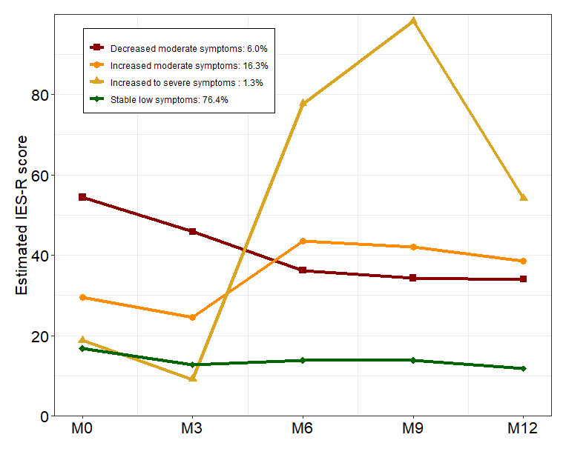

We identified distinct trajectories of IES-R using latent class mixed models, which account for heterogeneity in patterns of change. The optimal number of latent classes from 2 to 6 was chosen according to the Bayesian information criterion. The latent class model that provided best statistical fit identified four trajectory groups. The smallest trajectory class colored in yellow (n=5) was combined a posteriori with the trajectory class colored in orange (n=63) as the “Increased moderate IES-R” group.