Figures S1 to S4 illustrate the process used by the study members to ideate and prioritize system requirements based on the literature review and interviews.

Figure S1. Cross-sectional screen shot of initial themes identified for dashboard application from providers’ perspectives

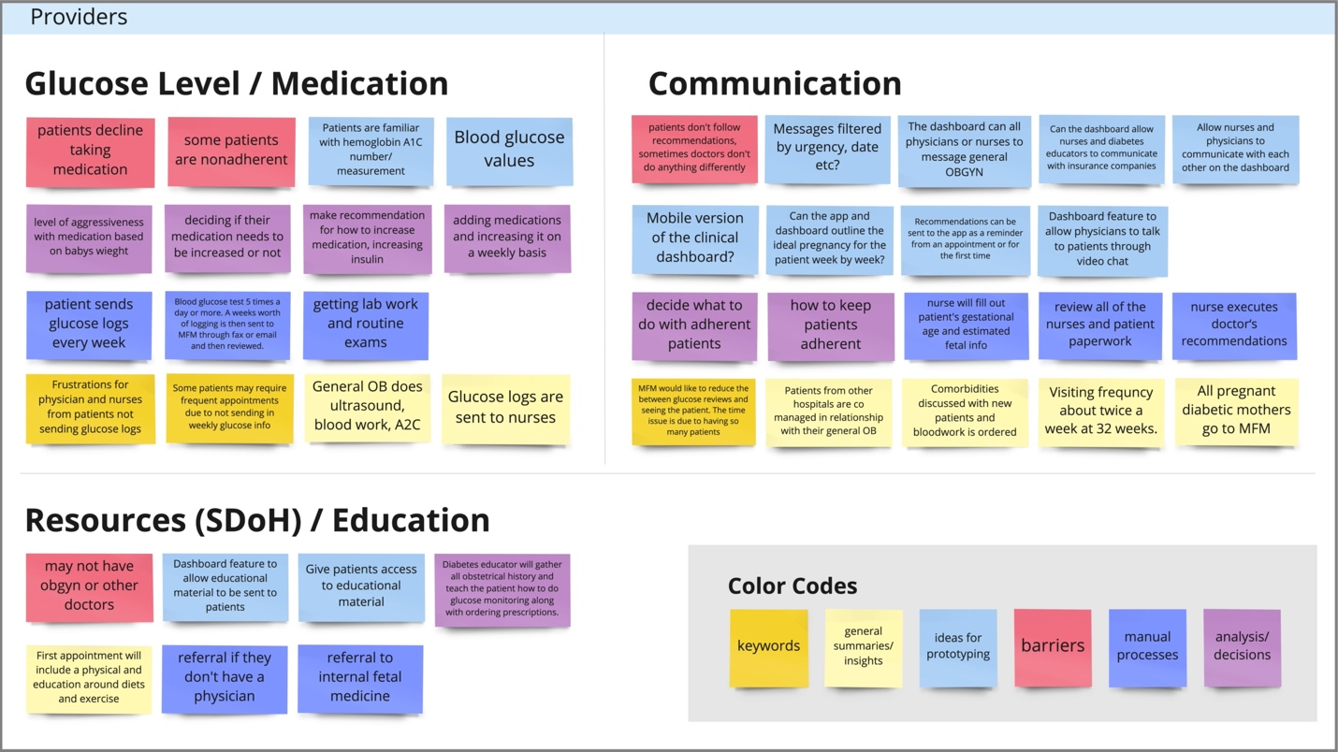

Figure S2. Cross-sectional screen shot of initial themes identified for mHealth application from patients’ perspectives – Cluster 1. Data Tracking

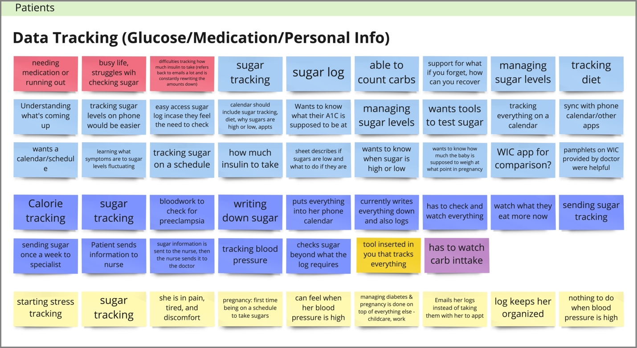

Figure S3. Cross-sectional screen shot of initial themes identified for mHealth application from patients’ perspectives – Cluster 2. Communication

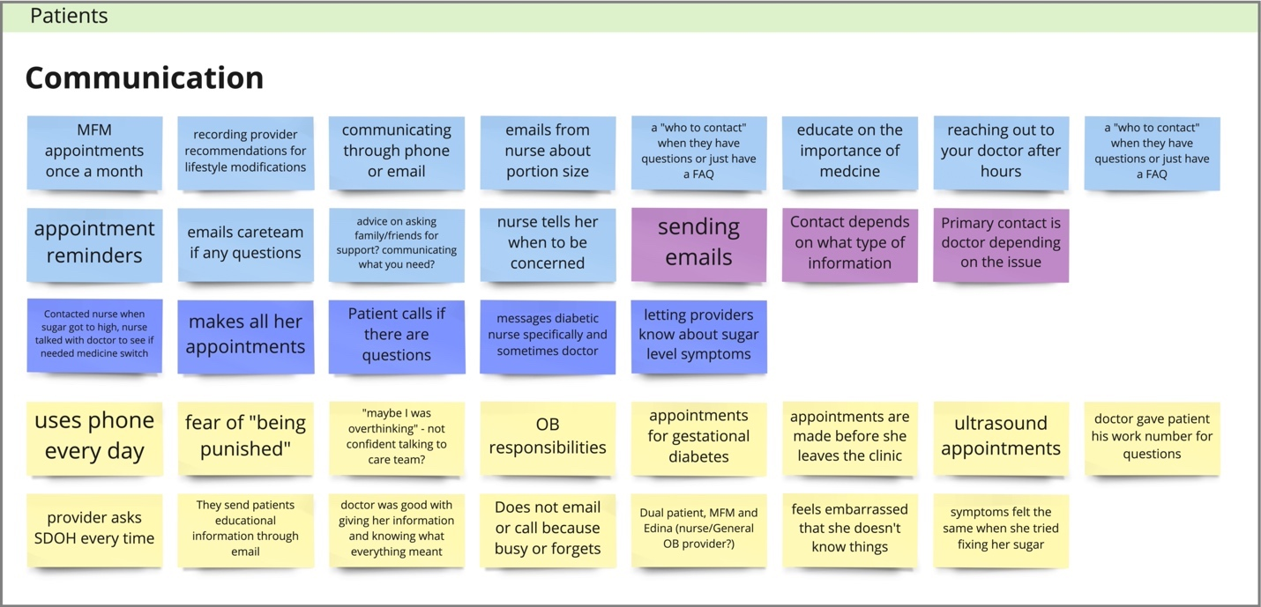

Figure S4. Cross-sectional screen shot of initial themes identified for mHealth application from patients’ perspectives – Cluster 3. Resources

