Supplementary file 3. PRISMA Flowcharts

Figure S3.1
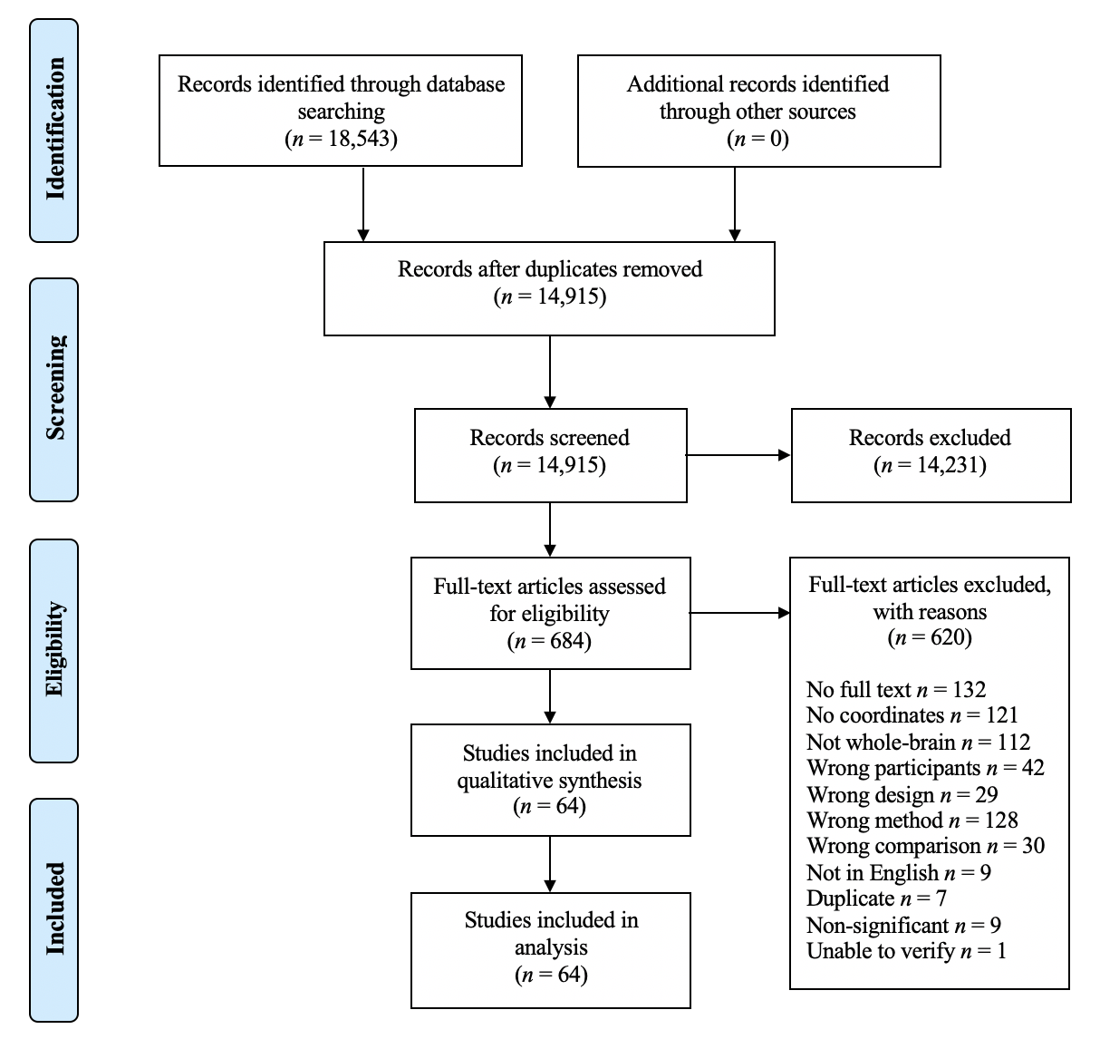
PRISMA Systematic Literature Search Decision Flowchart for Parkinson’s disease.

Note. The reason ‘Wrong method’ combines: wrong imaging technique (113) and wrong analysis (15). ‘Duplicate’ combines: duplicate records (6) and duplicated samples (3) published papers using the same participant cohorts, where possible the largest appropriate sample has been chosen.

Figure S3.2
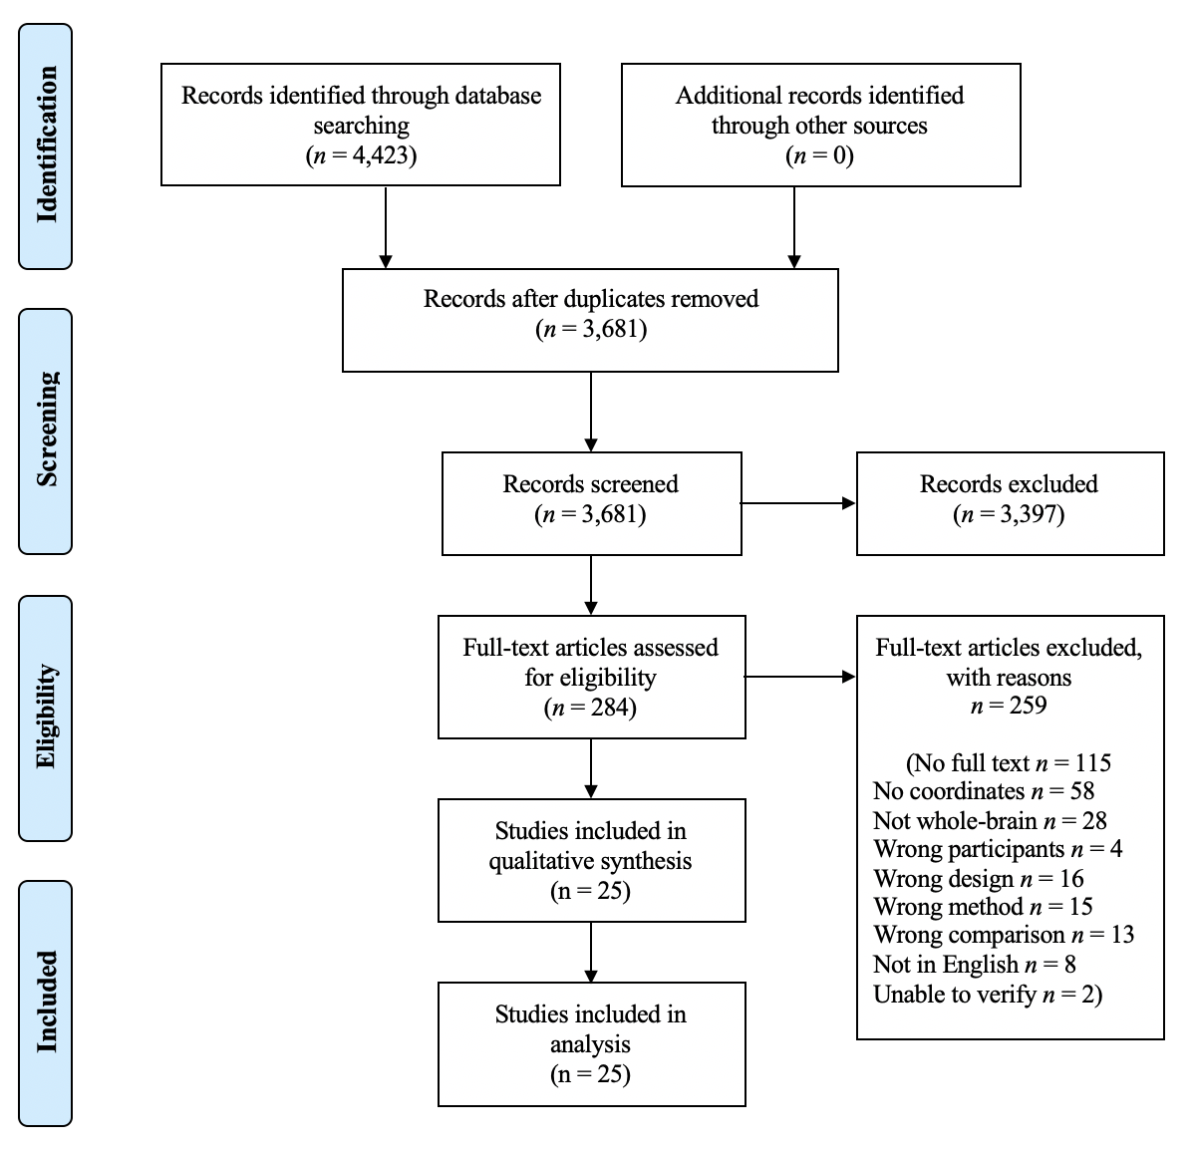
PRISMA Systematic Literature Search Flowchart for progressive supranuclear palsy

Note. The reason ‘Wrong method’ combines: Wrong imaging technique (9); Results correlated with a task/symptom/effect (1) and Wrong analysis (5).

Figure S3.3
PRISMA Systematic Literature Search Flowchart for corticobasal degeneration
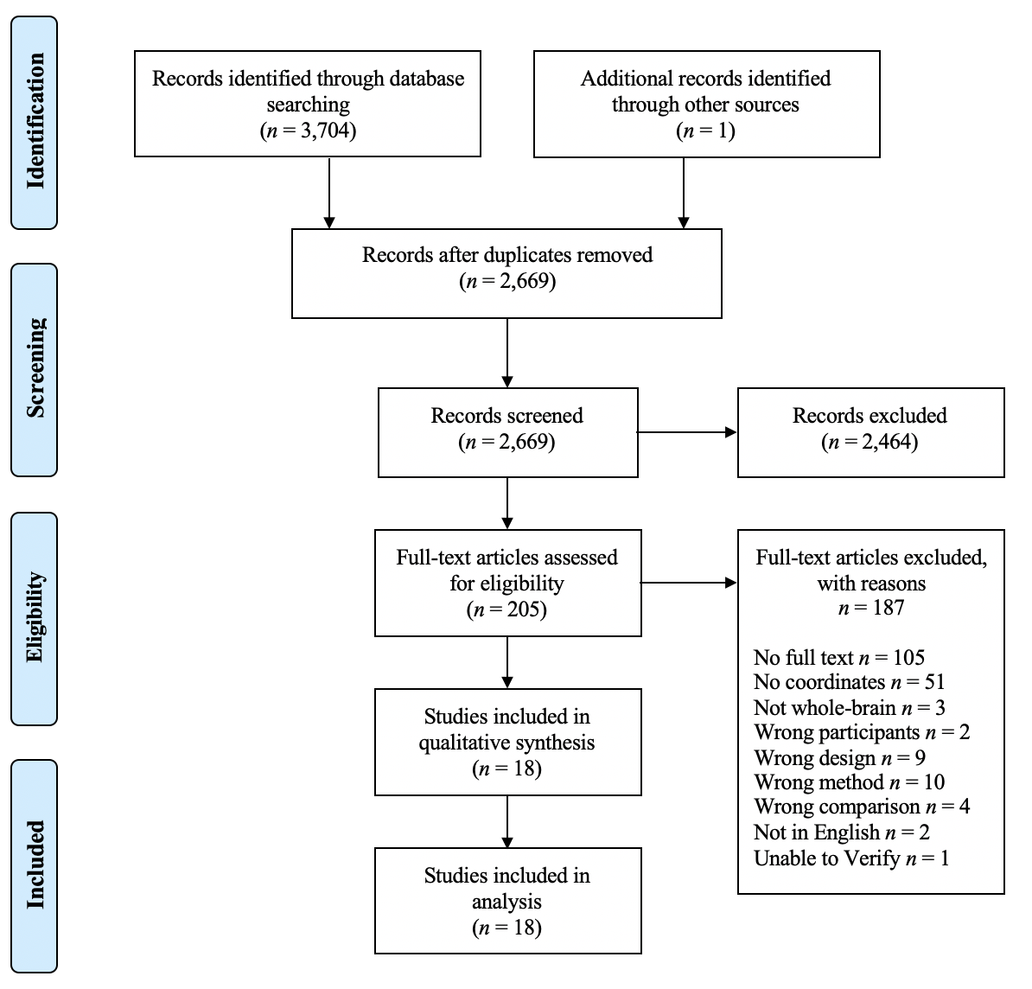
Note. The reason ‘Wrong method’ combines: Wrong imaging technique (3); Results correlated with a task/symptom/effect (7).

Figure S3.4
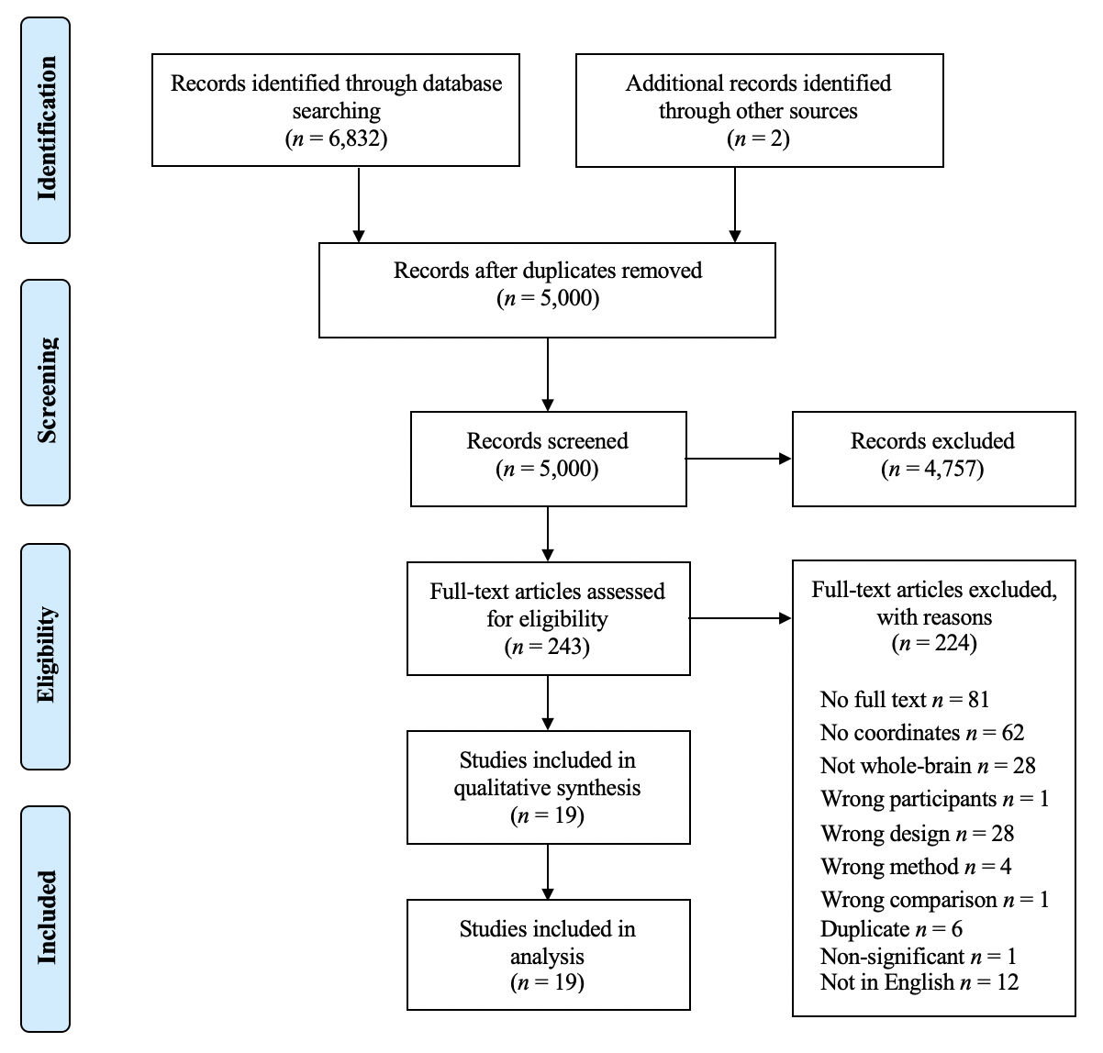
PRISMA Systematic Literature Search Flowchart for multiple system atrophy
Note. The reason ‘Duplicate’ combines: duplicate records (4) and duplicate samples (2) papers that have published using the same participant cohorts, where possible the largest appropriate sample has been chosen.

