**Supplements**

**Quantitative longitudinal natural history of eight gangliosidoses – conceptual framework and baseline data of the German 8-in-1 disease registry. A cross-sectional analysis.**

Markus Ries1,2,3*, Grecia Mendoza4, Laila Arash-Kaps4, Yasmina Amraoui4, Folker Quack5, Brigitte Hardt5, Stefan Diederich6, Michael Beck4, Eugen Mengel4

1 Pediatric Neurology and Metabolic Medicine, Center for Pediatrics and Adolescent Medicine, University Hospital Heidelberg, Heidelberg, Germany

2 Center for Rare Disorders, University Hospital Heidelberg, Heidelberg, Germany

3 Center for Virtual Patients, Faculty of the Heidelberg University, Heidelberg, Germany

4 SphinCS - Institute for Clinical Research in Lysosomal Storage Disorders, Hochheim, Germany

5 Hand in Hand against Tay-Sachs and Sandhoff disease in Germany, Würzburg, Germany

6 Institute for Human Genetics, University Medical Center, Mainz, Germany

Supplemental Table 1

Summary of the conditions by disease group, their respective OMIM phenotype numbers, their underlying biochemical deficiencies, and their incidences. The 8-in-1 registry is intended to capture data on the following eight diseases out of two major groups:

the GM1-gangliosidosis / sialidosis group comprises the following conditions: 1) GM1-gangliosidosis, 2) Morquio B variant, 3) sialidosis, 4) galactosialidosis.

Likewise, the GM2-gangliosidosis group includes: 5) Tay-Sachs disease, 6) Tay-Sachs B1 variant disease, 7) Sandhoff disease, 8) GM2-activator deficiency

|  |  |  |  |  |  |
| --- | --- | --- | --- | --- | --- |
| Disease group | Disease number | Disease | OMIM Number (Orpha number) | Deficiency | Prevalence (P); Incidence (I); Birth prevalence (BP) 1 |
| GM1- gangliosidosis / sialidosis group | 1 | GM1- gangliosidosis | # 230500  (infantile)  # 230600  (juvenile)  #230650  (adult) | Beta-galactosidase | 0,75/ 100.000¹  BP* |
|  | 2 | Morquio B variant | #253010 | Beta-galactosidase | NA |
|  | 3 | Sialidosis | # 256550 | Neuraminidase | 0,05/100.000¹  BP* |
|  | 4 | Galactosialidosis | # 256540 | Protective protein /cathepsin A | NA (100 published cases)¹ |
| GM2- gangliosidosis group | 5 | Tay-Sachs disease | # 272800 | Hexosaminidase A | 5/100.000¹ P* |
|  | 6 | Tay-Sachs B1 variant | # 272800 | Hexosaminidase A |
|  | 7 | Sandhoff disease | # 268800 | Hexosaminidase A&B |
|  | 8 | GM2-activator deficiency | # 272750 | GM2-activator | NA (10 published cases)¹ |

* An asterisk indicates European data

Supplemental Table 2

8-in-1 score: individual items and attributed point ratings

|  |  |
| --- | --- |
| Participation | Score |
| Unrestricted | 0 |
| Occasional assistance (in kindergarten, school, work) | 1 |
| Constant assistance (in kindergarten, school, work, e.g. by individual helpers or integration force) | 2 |
| Special facility (kindergarten/school/work for intellectually/physically disabled, sheltered workshop) | 3 |
| No participation (no kindergarten, no school, no work/ no sheltered workshop) | 4 |
| Care/Independency | **Score** |
| No impairment of independency, no assistance for hygiene / everyday activities | 0 |
| Slight impairment of independency, little assistance for hygiene / everyday activities | 1 |
| Considerable impairment of independency, often assistance for hygiene / everyday activities | 2 |
| Severe impairment of independency, constant assistance for hygiene / everyday activities, i.a. additional assistance by nursing staff | 3 |
| Most severe impairment of independency, care is carried out entirely by caregiver/ nursing staff (24-hour care) | 4 |
| Ambulation | **Score** |
| Unrestricted | 0 |
| Conspicuous gait ("clumsy", stumbling, falls), no walking assistance | 1 |
| Walking distance ≥ 20 m without assistance | 2 |
| Walking distance < 20 m without assistance | 3 |
| No walking, no steps (wheelchair-dependent, bedridden) | 4 |
| Dexterity/ Fine motor skills | **Score** |
| Unrestricted | 0 |
| Clumsy (self-dependence preserved) | 1 |
| Slight limitations (occasional assistance, e.g. when eating or for other fine motor activities) | 2 |
| Moderate limitations (constant assistance, e.g. when eating or for other fine motor activities) | 3 |
| Severe limitations, functionless (no fine motor skills) | 4 |
| Speech | **Score** |
| Unrestricted | 0 |
| Unclear, but easy to understand | 1 |
| Unclear, difficult to understand | 2 |
| Incomprehensible, vocalization, nonverbal communication | 3 |
| Anarthria, complete loss of speech | 4 |
| Swallowing | **Score** |
| Unrestricted | 0 |
| Conspicuous, slow swallowing or occasional dysphagia | 1 |
| Constant dysphagia with liquids | 2 |
| Constant dysphagia with liquids and solids (i.a. partial enteral nutrition) | 3 |
| Severe dysphagia, complete enteral nutrition | 4 |
| Epilepsy | **Score** |
| No | 0 |
| < 2 seizures per week, controlled with a medication, mostly seizure-free | 1 |
| Frequent seizures (≥ 2 seizures per week, not daily), controlled with 1-2 medications, not seizure-free | 2 |
| Daily seizures, controlled only with 2-3 medications, partial therapy response | 3 |
| Uncontrolled seizures despite drugs, complete resistance to therapy | 4 |
| Cognition | **Score** |
| Unrestricted | 0 |
| Mild intellectual disability (adults: intellectual age 9-12 years, children: learning difficulties at school) | 1 |
| Moderate intellectual disability (adults: intellectual age 6-9 years; children: distinct developmental delay, school for intellectually disabled; adults/ children: reading and writing possible) | 2 |
| Severe intellectual disability (adults: intellectual age 3-6 years; children: distinct developmental delay, special school for intellectually disabled; adults/ children: no reading and writing, incapable of schooling, but educable for practical life, permanent support) | 3 |
| Most severe intellectual disability (adults: intellectual age under 3 years; children: most severe developmental disorder; adults/children: development support no longer possible, incapable of schooling, not educable for practical life, extensive support) | 4 |
| Total score |  |

Supplemental Table 3 (separate document)

Synopsis of the study population and study results.

* - Two patients could not be clearly attributed to a phenotype. According to the classification item "first motor symptom", the two patients would be considered as infantile respectively late infantile 2, whereas according the classification item "best motor performance", they would be considered late infantile, and, respectively, juvenile.2 We considered one of them late infantile and the other one juvenile according to their best motor performance, because this was most consistent with their observed disease trajectory.3

Precise definitions of 8-in-1 subscores are listed in Supplemental Table 2

# - denotes novel mutation

**- Patients 3 and patients 21-23 were previously mentioned in the published literature.4,5

nd: not done

na: not available

Supplemental Figures

Supplemental Figure 1

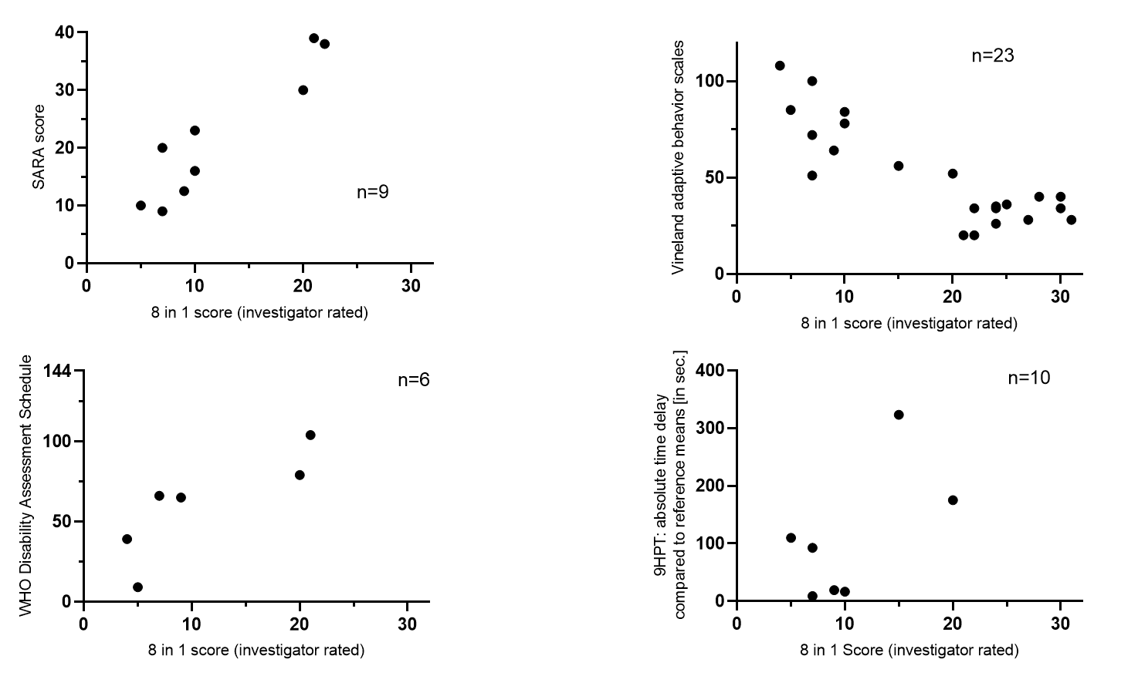

Correlation of 8 in 1 scores with previously validated instruments of a. cognitive development, b. ataxia, c. dexterity, and d overall disability.

Correlation of disease severity (assessed by investigator rated 8 in 1 scores) with validated instruments for **A.** development (Vineland adaptive behavioral scales, Pearsons' r = -0.5312; p=0.0110), **B.** ataxia (SARA scores, Pearsons' r = 0.6806; p=0.0117), **C.** manual dexterity (9 hole peg test, Pearsons' r = 0.4293; p=NS), and **D.** overall disability (WHO disability assessment schedule 2.0, (Pearsons' r = 0.6929; p=NS)

Higher scores indicate more severe disease in 8-in-1 scores, SARA scores, 9 hole peg test performance delay, and WHODAS 2.0 scores. In contrast, higher Vineland scores indicate better overall development in given patient.

1. Orphanet. Prevalence and incidence of rare diseases: Bibliographic data, Number 1, January 2021 Available at <https://www.orpha.net/orphacom/cahiers/docs/GB/Prevalence_of_rare_diseases_by_alphabetical_list.pdf>. Accessed 13 Oct 2021.

2. Toro C, Shirvan L, Tifft C. HEXA Disorders. Available at <https://www.ncbi.nlm.nih.gov/pubmed/20301397>. Accessed 7 April 2022.

3. Regier DS, Tifft CJ, Rothermel CE, 2013. GLB1-Related Disorders. <https://www.ncbi.nlm.nih.gov/pubmed/24156116>. Accessed 07 April 2022.

4. Arash-Kaps L, Komlosi K, Seegraber M, et al. The Clinical and Molecular Spectrum of GM1 Gangliosidosis. J Pediatr*.* 2019;215:152-157 e153.

5. Holzer HT, Boschann F, Hennermann JB, et al. Cerebellar atrophy on top of motor neuron compromise as indicator of late-onset GM2 gangliosidosis. J Neurol*.* 2021;268(6):2259-2262.