30th May 2022

Dear Sir/ Madam

**Re Submission of Manuscript**

# Thank you for the opportunity to submit our manuscript ‘Public attitudes to sharing government data with private industry: A scoping review’

to your journal for consideration. We look forward to your feedback.

Yours sincerely

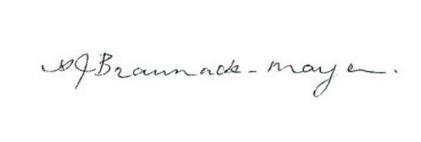

Prof Annette Braunack-Mayer