Supplemental Figure 3. Mortality Forest Plot of R-L shunt vs. no shunt ARDS patients
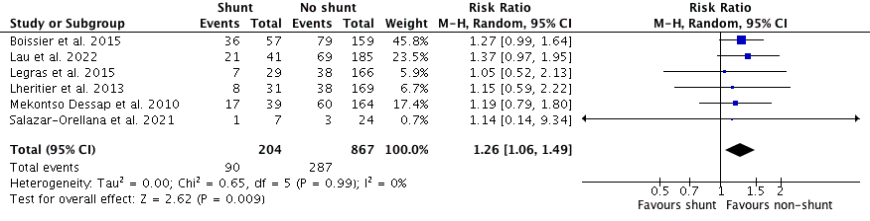
ARDS: acute respiratory distress syndrome; COVID-19: coronavirus disease-2019; R-L: right-to-left-shunt

