Supplementary Material
Table S1. Lexicon of body systems and conditions that are described in liver and abdomen imaging reports but are irrelevant to findings of hepatocellular carcinoma
Body systems and conditions | Conditions
Gallbladder | Gallstone
Spleen | Splenomegaly
Kidney/renal | Hydronephrosis
Lung
Lumbar spine
Pancreas
Pelvis
Urinary bladder
Common bile duct or CBD
Biliary tree

Table S2. Regular expressions of medical terms of interest
Medical terms | Regular expressions
HCC  (along with modifiers) | ['hcc'] = re.compile(r"((?<=^)|(?<= ))(hcc|hepatocellular carcinoma|hepatomas?)(?=\W|$)", re.I | re.M)  ['modifier_probable'] = re.compile(r"(probable|suspicious|likely|possible|may)")
Benign tumours | ["hemangiomas"] = re.compile(r"((?<=^)|(?<= ))(ha?emangioma(ta|s)?)(?=\W|$)" , re.I | re.M)  ["cyst"] = re.compile(r"((?<=^)|(?<= ))(cyst(s|ic)?)(?=\W|$)" , re.I | re.M)  ["cholecystitis"] = re.compile(r"((?<=^)|(?<= ))(cholecystitis)(?=\W|$)" , re.I | re.M)
Haematoma | re.compile(r"((?<=^)|(?<= ))(ha?ematoma)(?=\W|$)", re.I | re.M)
Metastasis | re.compile(r"((?<=^)|(?<= ))(metastas(i|e)s|metastatic|metastasize)(?=\W|$)", re.I | re.M)
Liver lesion/tumour  (along with modifiers) | re.compile(r"((?<=^)|(?<= ))((focal\s|enhancing\s|mass\s)?(liver\s)?(lesions?|tumours?|mass(es)?))(?=\W|$)" , re.I | re.M)  ['modifier_enlarge'] = re.compile(r"[^(no)] enlarged?|large|increased?", re.I | re.M)  ['modifier_unchanged'] = re.compile(r"not? changed?|not? changes?|unchanged?|unchanges?|stable|no enlarges?|no enlarged?", re.I | re.M)  ['modifier_small'] = re.compile(r"small|tiny|little", re.I | re.M)
APHE | re.compile(r"((?<=^)|(?<= ))(((hyper)?enhancement.*\sarterial(\sphase)?)|(arterial(\sphase)?.*\s(hyper)?enhancement)|APHE|(arterial(\sphase)? hypervascular(ity)?))(?=\W|$)", re.I | re.M)
Washout | re.compile(r"((?<=^)|(?<= ))((non(-| )?peripheral )?washout)(?=\W|$)", re.I | re.M)
Capsule  (along with modifiers) | ['capsule'] = re.compile(r"((?<=^)|(?<= ))(((non-?)?enhancing )?capsule)(?=\W|$)", re.I | re.M)  ['modifier_enhancing'] = re.compile(r"((?<=^)|(?<= ))enhancing(?= capsule)", re.I | re.M)  ['modifier_nonenhancing'] = re.compile(r"((?<=^)|(?<= ))non(-| )?enhancing(?= capsule)", re.I | re.M)
observation size | re.compile(r"((?<=^)|(?<= ))(liver|mass|tumour|lesion|nodule)(\s|\w)+(\d)+(\.\d+)?(\s)?(cm|mm)(?=\W|$)", re.I | re.M)
Size increase | re.compile( r"((?<=^)|(?<= ))(liver.+(increase in size))|((increase in size).+liver)(?=\W|$)", re.I | re.M)
Normal examination | re.compile( r"((?<=^)|(?<= ))(normal|stable|unremarkable|unchanged|asymptomatic)(?=\W|$)", re.I | re.M)
Hypervascular lesion | re.compile(r"((?<=^)|(?<= ))(hypervascular(ity)?( lesion(s)?| nodule(s)?)?)(?=\W|$)", re.I | re.M)
Nodules | re.compile(r"((?<=^)|(?<= ))(nodules?)(?=\W|$)", re.I | re.M)

Table S3. Running time* of data preprocessing and report labelling by the proposed rule-based model for the development set and validation set
Dataset | Total running time for data preprocessing | Total running time for report labelling
Development set (Site 1, 655 reports) | 0.18 mins | 1.77 mins
Validation set (Site 2, 485 reports) | 0.10 mins | 1.25 mins
* The programs were running on a computing environment with CPU memory of 32 GB.

Table S4. Inconsistent identifications (compared to original labels) and reasons for site 1
Reasons resulting in inconsistent classification | Note
Reasons for five HCC-labelled reports being identified as non-HCC:  1 report: no obvious focal lesion  1 report: no mass lesions  1 report: liver is normal in size, no focal mass  1 report: possible haemangioma  1 report: wrong identification by the algorithm (liver lesion in segment VIII has enlarged slightly, no evidence of distant metastases) | data error  data error  data error  data error  false negative

Table S5. Inconsistent identifications (compared to original labels) and reasons for site 2
Reasons resulting in inconsistent classification | Note
Reasons for one HCC-labelled report being identified as non-HCC:  1 report: hepatic haematoma, which is non-HCC case | data error
Reasons for three non-HCC-labelled reports being identified as HCC:  1 report: highly suspicious of a diffuse hepatocellular carcinoma  1 report: equivocal (a questionable 2.6 cm high density lesion, may be an HCC or regenerative nodule)  1 report: equivocal (may represent regenerating nodules or haemangiomata but focal hepatomas cannot be excluded) | data error  equivocal  equivocal

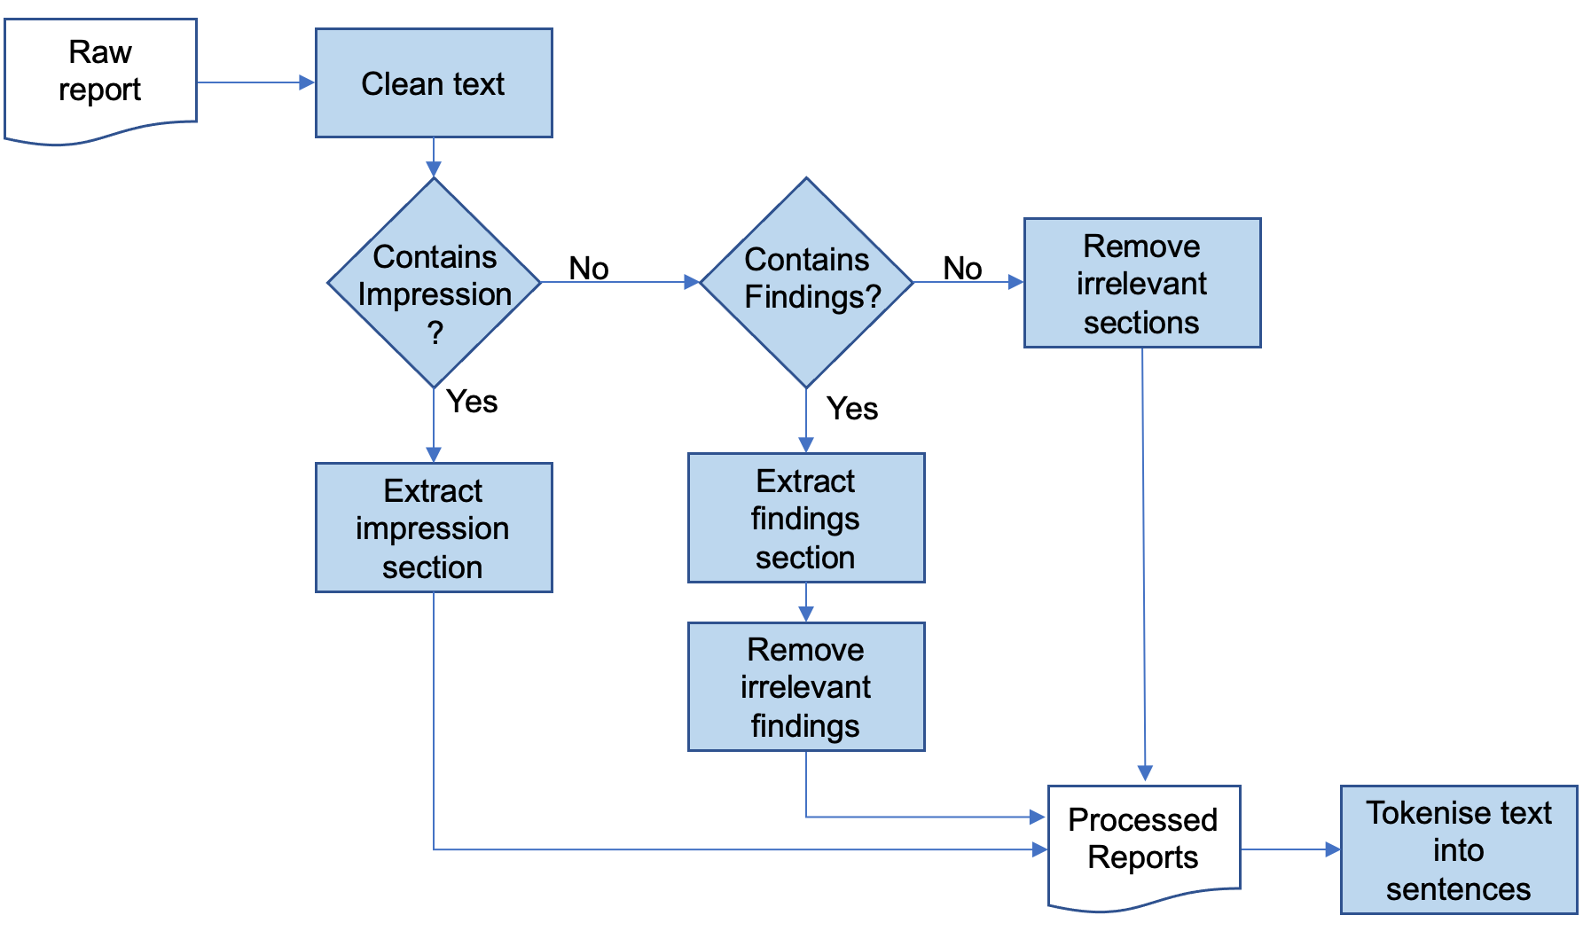
Figure S1. The text pre-processing pipeline for imaging reports

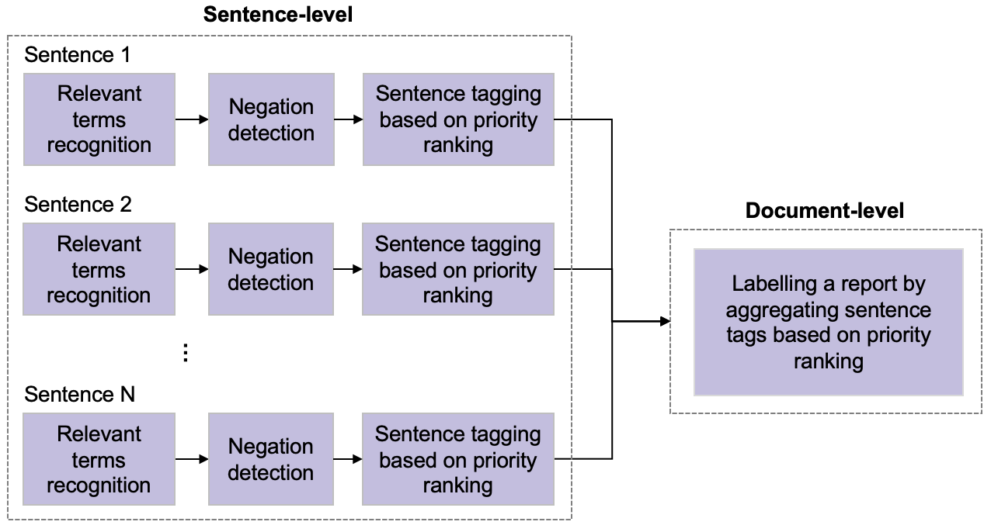
Figure S2. The logical process of labelling a report by the proposed rule-based NLP algorithm

