Supplementary Figure 2. Distribution of AOD500 as measured by the Reference Grader.
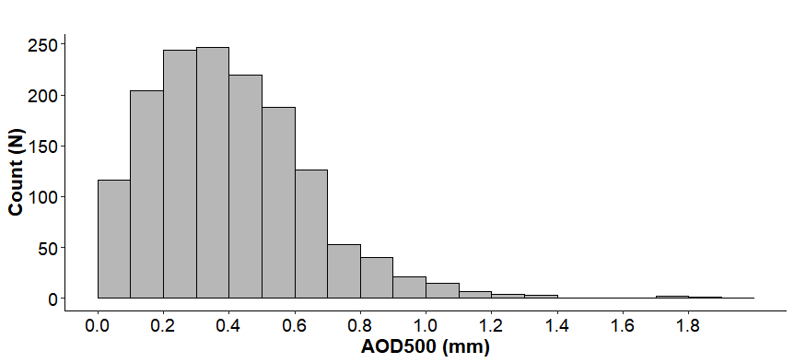
AOD500, Anterior Opening Distance 500 μm from the scleral spur.

