Supplementary Materials
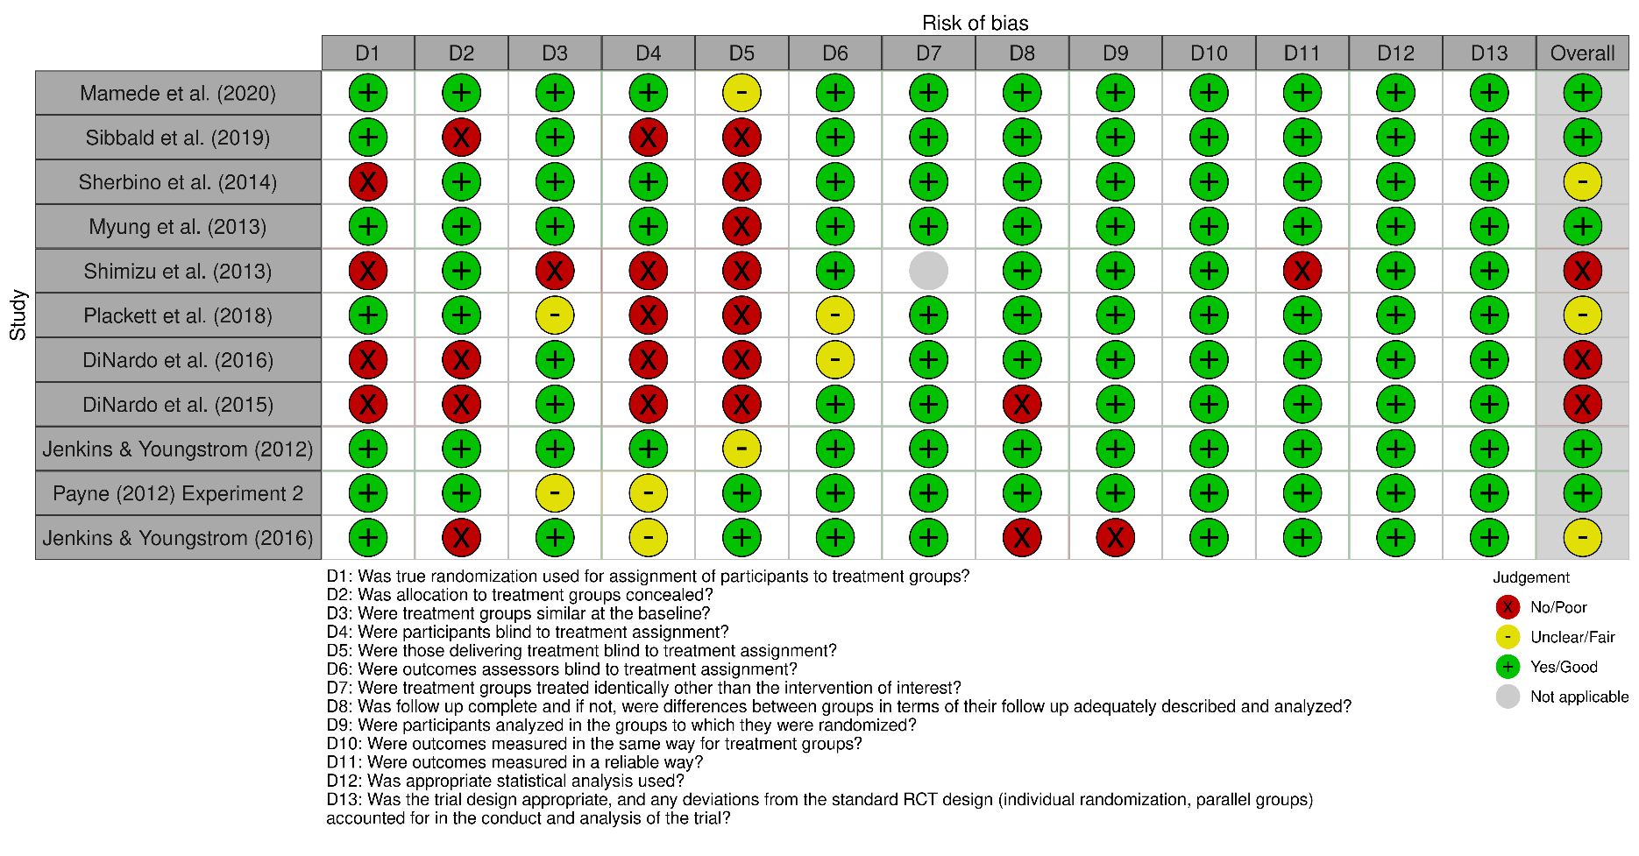
Figure S1. Randomized control trials risk of bias assessments

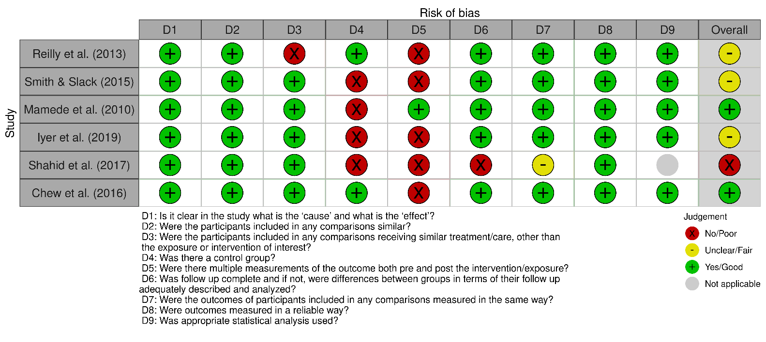
Figure S2. Quasi-experimental studies risk of bias assessments

Search Strategy
Ovid MEDLINE: Epub Ahead of Print, In-Process & Other Non-Indexed Citations, Ovid MEDLINE® Daily and Ovid MEDLINE® <1946-Present>

1 Cognitive bias.mp. 1744
2 premature closure.mp. 814
3 exp Heuristics/ or heuristics.mp. 4117
4 exp Bias/ or anchoring bias.mp. 73700
5 overconfidence.mp. 608
6 fallacy.mp. 1797
7 exp Prejudice/ or prejudice.mp. 37695
8 1 or 2 or 3 or 4 or 5 or 6 or 7 119367
9 diagnostic error.mp. or exp Diagnostic Errors/ 122423
10 misdiagnosis.mp. 17068
11 exp Delayed Diagnosis/ or exp Diagnosis/ or diagnosis.mp. or exp Missed Diagnosis/ 10681337
12 9 or 10 or 11 10683801
13 8 and 12 61328
14 debias.mp. 30
15 debiasing strategy.mp. 10
16 medical education.mp. or exp Education, Medical/ 200243
17 educational initiative.mp. 385
18 bias mitigation.mp. 30
19 debiasing.mp. 193
20 14 or 15 or 16 or 17 or 18 or 19 200742
21 13 and 20 959
22 limit 21 to ("review" or "scientific integrity review" or "systematic review") 49
23 21 not 22 910

Embase Classic+Embase <1947 to 2022 April 22>

1 Cognitive bias.mp. 4002
2 premature closure.mp. 1335
3 exp Heuristics/ or heuristics.mp. 5142
4 exp Bias/ or anchoring bias.mp. 37939
5 overconfidence.mp. 716
6 fallacy.mp. 2256
7 exp Prejudice/ or prejudice.mp. 8895
8 1 or 2 or 3 or 4 or 5 or 6 or 7 59454
9 diagnostic error.mp. or exp Diagnostic Errors/ 117433
10 misdiagnosis.mp. 25135
11 exp Delayed Diagnosis/ or exp Diagnosis/ or diagnosis.mp. or exp Missed Diagnosis/ 9923600
12 9 or 10 or 11 9925150
13 8 and 12 22435
14 debias.mp. 25
15 debiasing strategy.mp. 11
16 medical education.mp. or exp Education, Medical/ 381660
17 educational initiative.mp. 692
18 bias mitigation.mp. 27
19 debiasing.mp. 212
20 14 or 15 or 16 or 17 or 18 or 19 382401
21 13 and 20 453
22 limit 21 to ("review" or "scientific integrity review" or "systematic review") 46
23 21 not 22 407

APA PsycInfo <1806 to April Week 3 2022>

1 Cognitive bias.mp. 5317
2 premature closure.mp. 133
3 exp Heuristics/ or heuristics.mp. 7026
4 exp Bias/ or anchoring bias.mp. 66
5 overconfidence.mp. 1316
6 fallacy.mp. 2277
7 exp Prejudice/ or prejudice.mp. 22661
8 1 or 2 or 3 or 4 or 5 or 6 or 7 38054
9 diagnostic error.mp. or exp Diagnostic Errors/ 182
10 misdiagnosis.mp. 2304
11 exp Delayed Diagnosis/ or exp Diagnosis/ or diagnosis.mp. or exp Missed Diagnosis/ 363569
12 9 or 10 or 11 364085
13 8 and 12 1425
14 debias.mp. 52
15 debiasing strategy.mp. 13
16 medical education.mp. or exp Education, Medical/ 21855
17 educational initiative.mp. 121
18 bias mitigation.mp. 18
19 debiasing.mp. 346
20 14 or 15 or 16 or 17 or 18 or 19 22352
21 13 and 20 28
22 limit 21 to ("review" or "scientific integrity review" or "systematic review") 0
23 21 not 22 28

Ovid Healthstar <1966 to March 2022>

1 Cognitive bias.mp. 996
2 premature closure.mp. 426
3 exp Heuristics/ or heuristics.mp. 2407
4 exp Bias/ or anchoring bias.mp. 67213
5 overconfidence.mp. 370
6 fallacy.mp. 1146
7 exp Prejudice/ or prejudice.mp. 33589
8 1 or 2 or 3 or 4 or 5 or 6 or 7 105232
9 diagnostic error.mp. or exp Diagnostic Errors/ 100430
10 misdiagnosis.mp. 9660
11 exp Delayed Diagnosis/ or exp Diagnosis/ or diagnosis.mp. or exp Missed Diagnosis/ 6267940
12 9 or 10 or 11 6268699
13 8 and 12 55978
14 debias.mp. 15
15 debiasing strategy.mp. 6
16 medical education.mp. or exp Education, Medical/ 179162
17 educational initiative.mp. 316
18 bias mitigation.mp. 18
19 debiasing.mp. 111
20 14 or 15 or 16 or 17 or 18 or 19 179506
21 13 and 20 936
22 limit 21 to ("review" or "scientific integrity review" or "systematic review") 49
23 21 not 22 887

