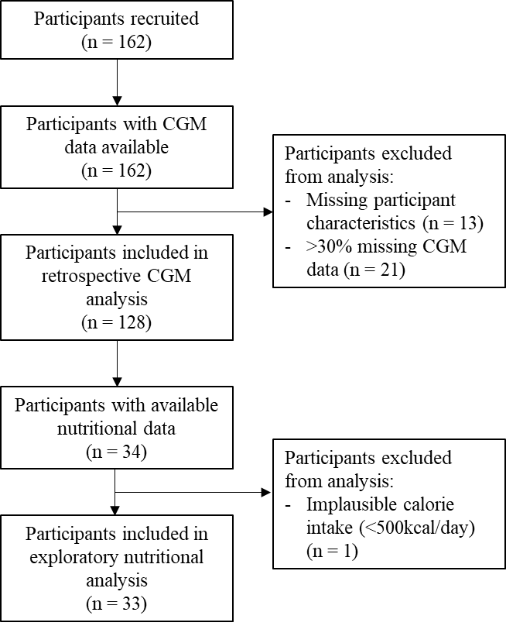

**Supplementary figure 1.** Participant flowchart