Cadoná et al., Supplementary Information

- Supplementary Figures

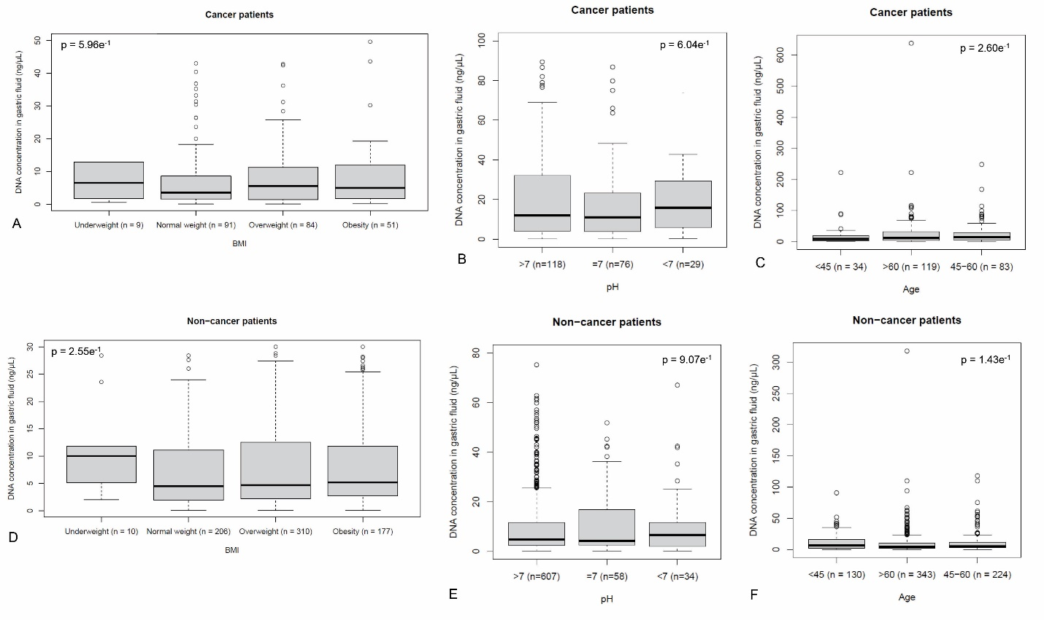
Supplementary Figure 1 - gfDNA variation according to BMI, pH of the gastric fluids and age-groups for GC-patients (A-C) and non-cancer patients (D-F).

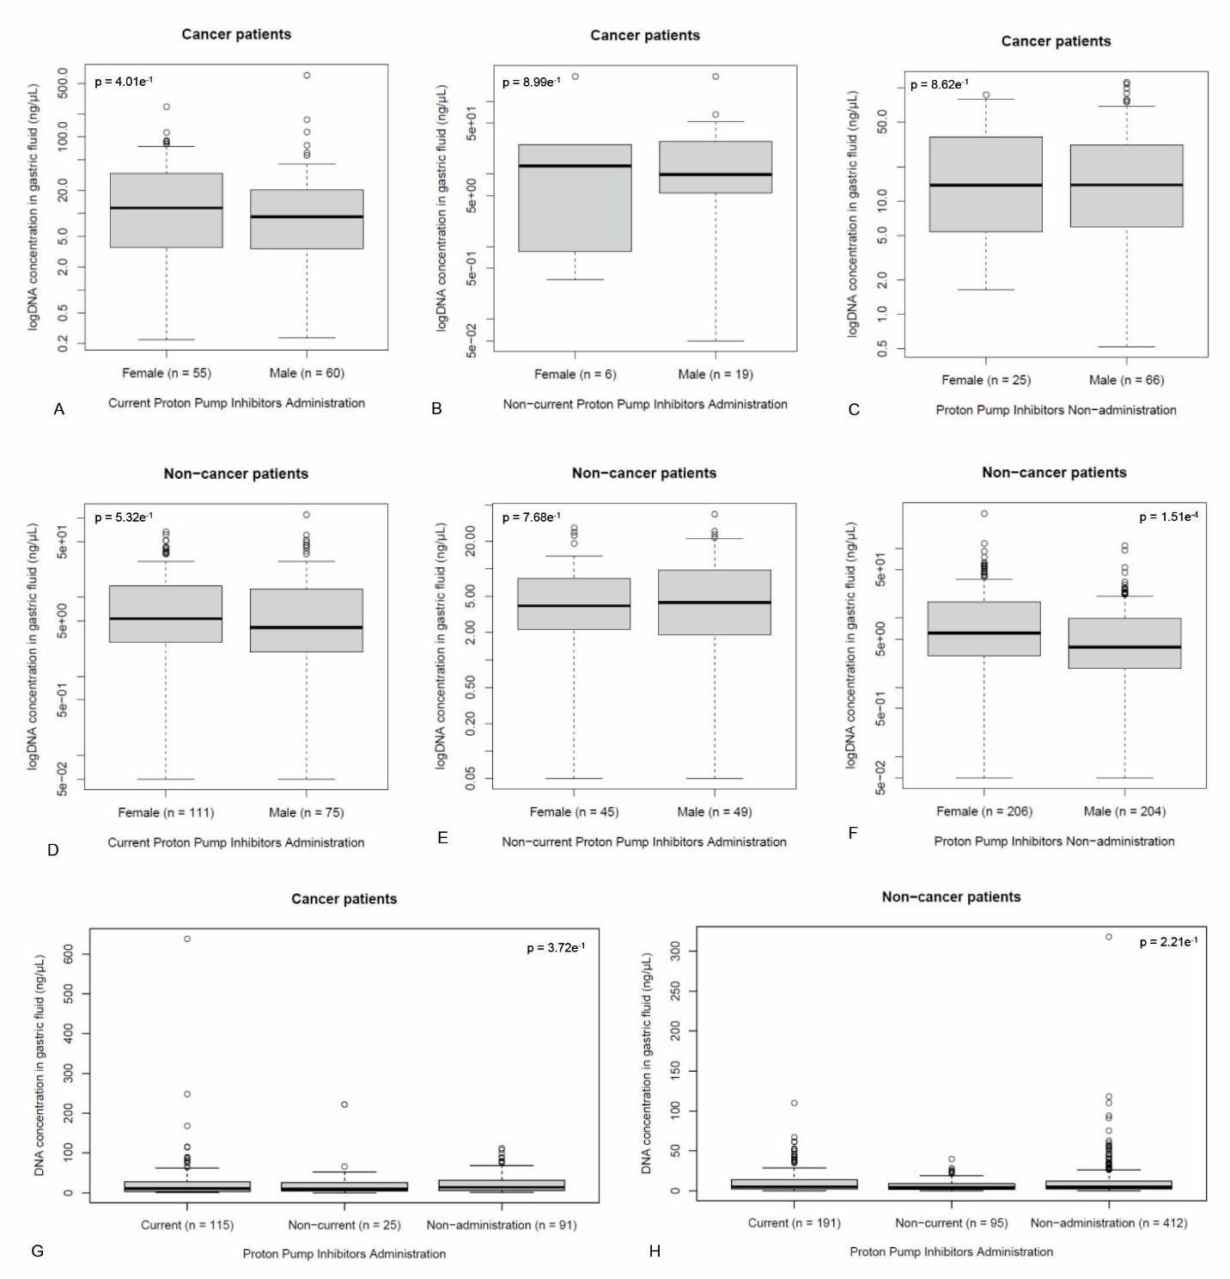

Supplementary Figure 2 – gfDNA concentration according to the use of proton pump inhibitors (current, previous or no-administration) and gender, for GC-cases (A, B, C) or non-cancer subjects (D, E, F), according to PPI-use status (current, previous or no-administration) (GH). Gender-independent analysis of gfDNA concentration according to PPI-use for GC (E) or non-GC controls (F).

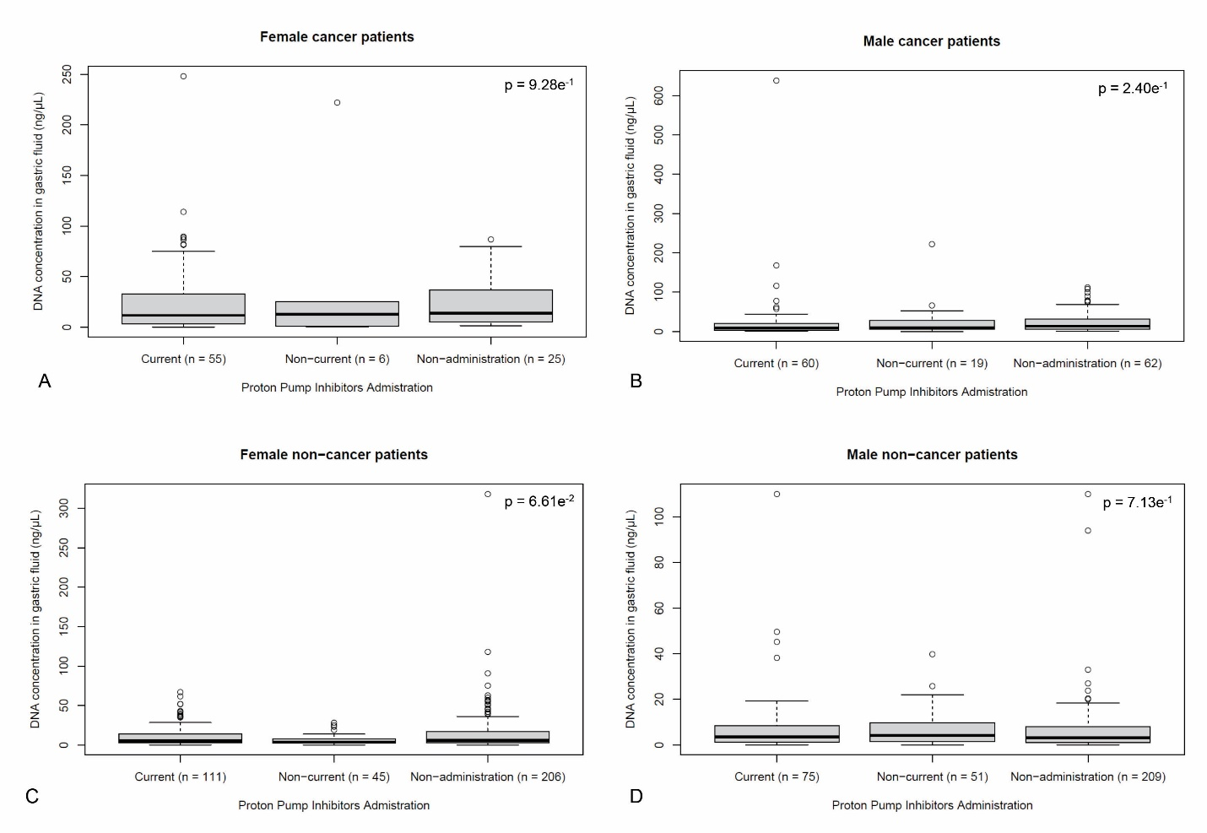
Supplementary Figure 3 – gfDNA concentrations for subjects reporting current, previous or no use of PPIs, for females with (A) or without GC (B) as well as for males (C) or without GC diagnosis (D).

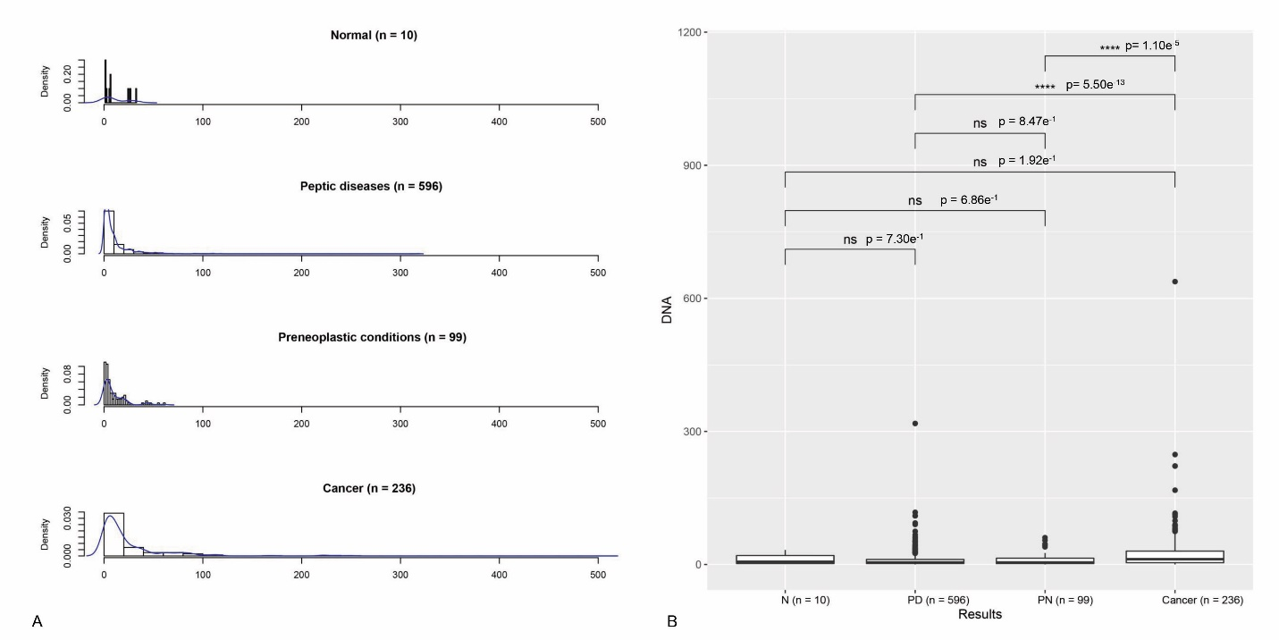

Supplementary Figure 4 - A) gfDNA concentration (ng/µL) in patients with no findings after endoscopic examination (Normal), peptic diseases, preneoplastic conditions, and cancer. B) Comparison of gfDNA concentrations (ng/µL) in gastric fluids of patients with the normal (N) results, peptic diseases (PD), preneoplastic conditions (PN), and cancer diagnosis. Statistical significance was determined by simple regression, considering as significant p-values <0.05.

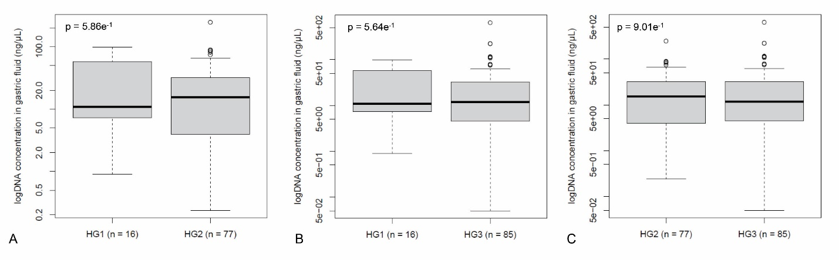

Supplementary Figure 5. gfDNA concentrations (ng/µL) observed for patients with different tumor histological grades (HG1, HG2, and HG3). A) gfDNA concentrations (ng/µL) comparison between patients with HG1 and HG2. B) gfDNA concentrations (ng/µL) comparison between patients with HG1 and HG3. C) gfDNA concentrations (ng/µL) comparison between patients with HG2 and HG3.

- Supplementary Tables

Supplementary Table 1 – Analysis of CT values for bacteria and human target genes
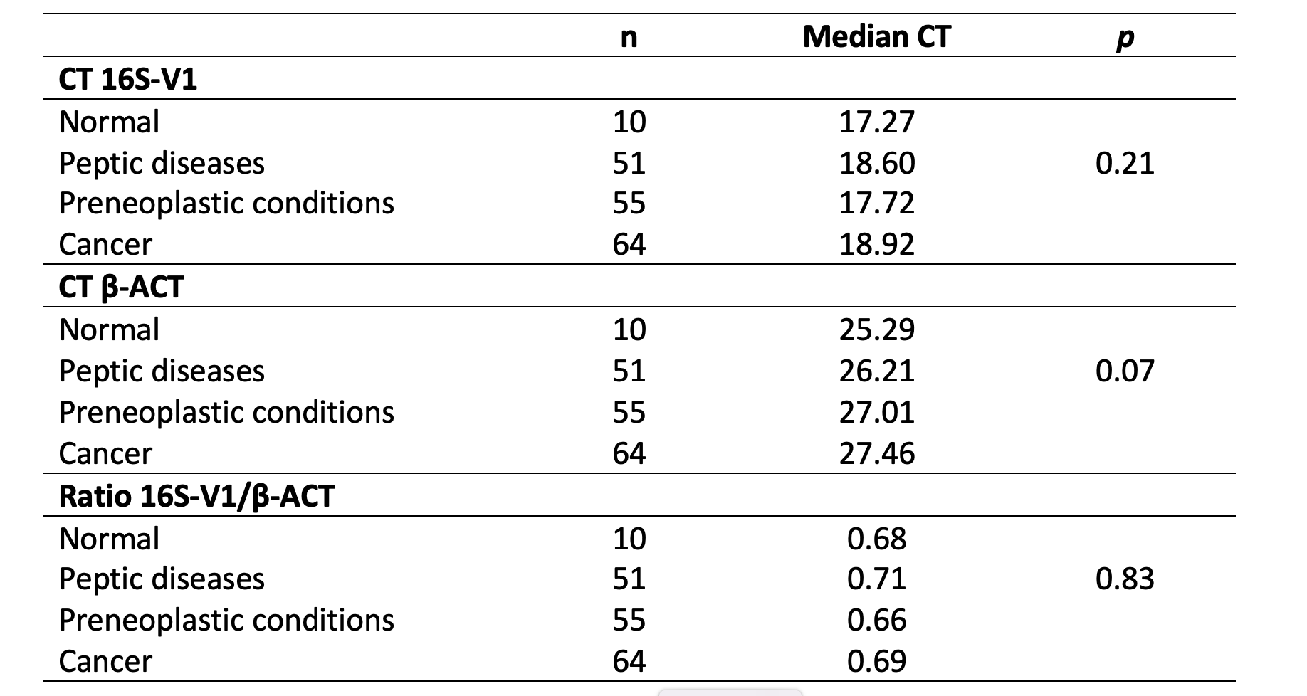

Supplementary Table 2 – gfDNA concentration and intensity of inflammatory cell infiltrates

