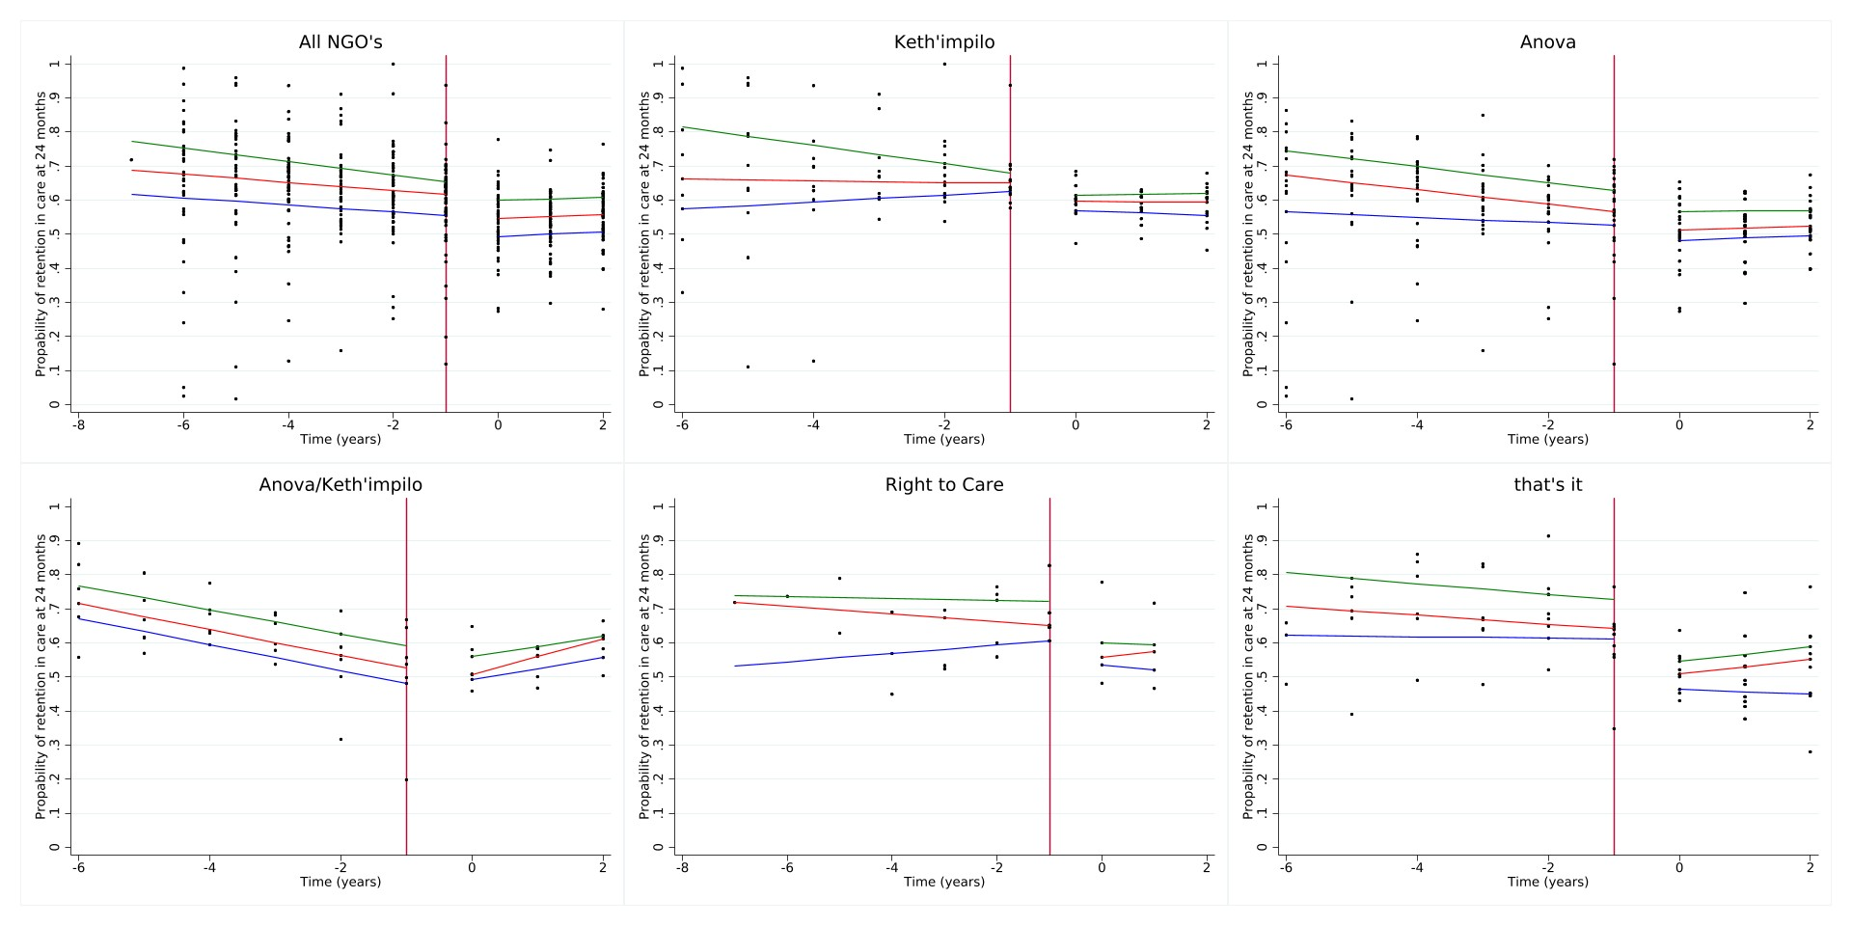
Supplemental Figure 1a-1f. Quantile regression estimates for 24-month retention stratified by NGO

