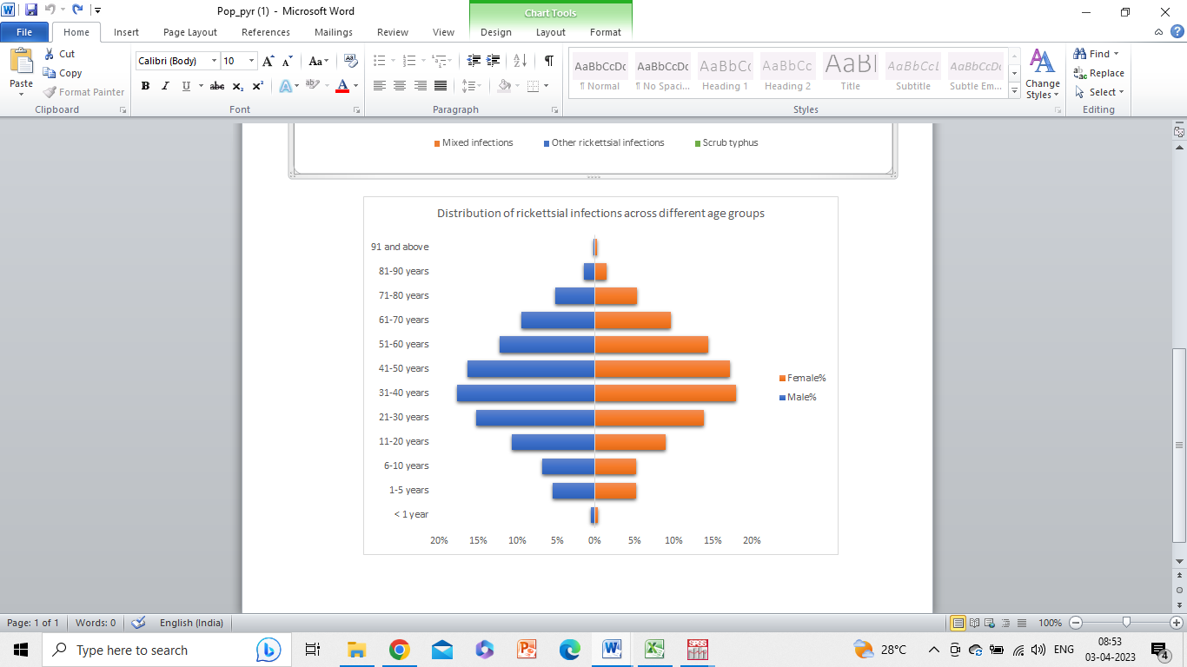**Supplementary Figure 1.** **Distribution of rickettsial infections across different age groups**