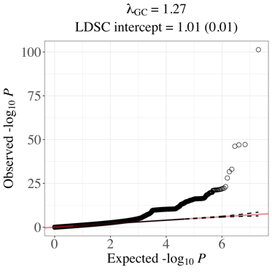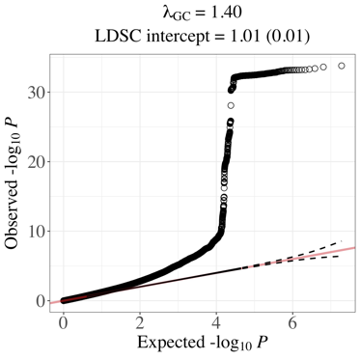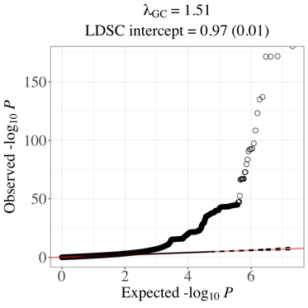

A.

B.

C.

**Figure S1. Q-Q plots for GenomicSEM indicator GWAS meta-analyses***.* These results have not been adjusted for genomic control inflation factors (λGC). **(A)** 23andMe + Linnér et al. risk taking meta-analysis. **(B)** UK Biobank + Million Veteran Program AUDIT-C meta-analysis. **(C)** 23andMe + GWAS & Sequencing Consortium of Alcohol and Nicotine use (GSCAN) drinks per week meta-analysis.