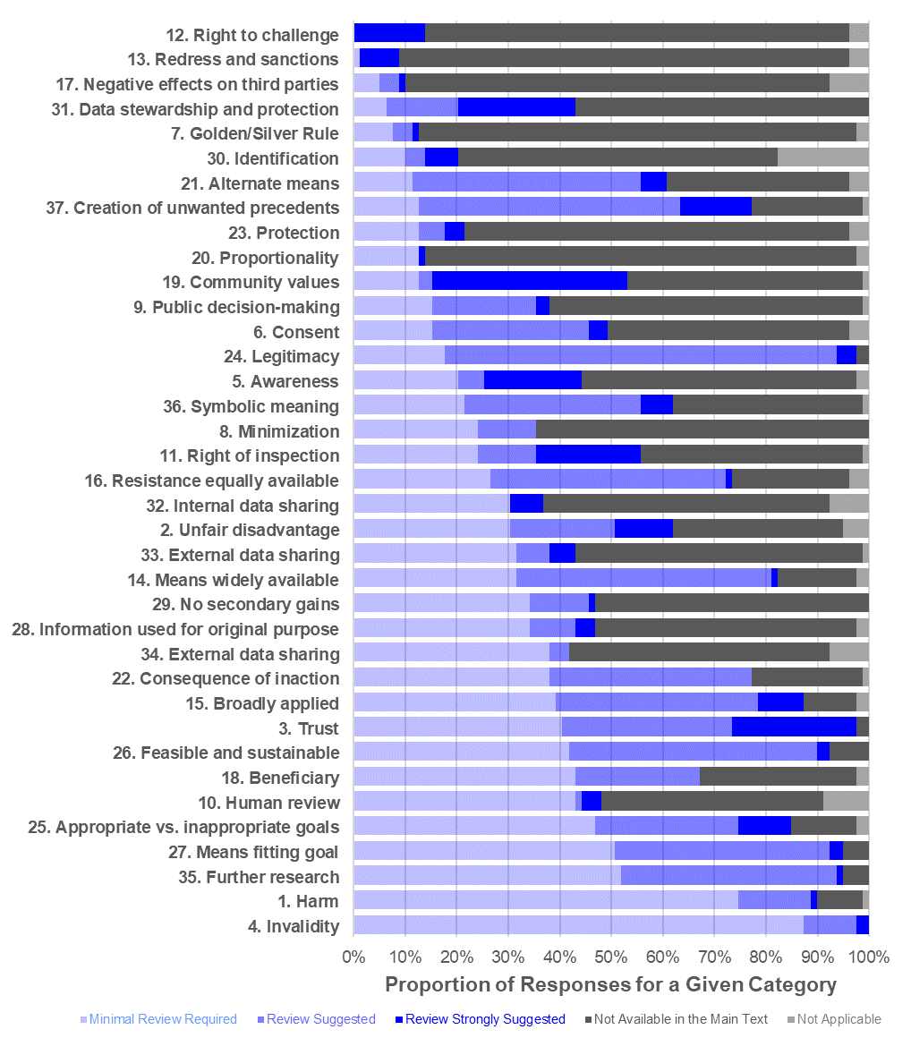
Supplemental Figure 1. The distribution of assigned flags (“minimal review required”, “review suggested”, “review strongly suggested”, “not available in the main text”, “not applicable”) for each structured ethical review category represented as a fraction percent of all publications analyzed (n=53) with multiple reviewers providing reports for select individual studies, resulting in more reviews than studies (n=79) ^{1,33–37,40–89}. The categories are sorted by ascending proportion of “mnimal review required”.

