Supplementary Material

**Effect of cannabigerol on sleep and quality of life in Veterans: A decentralized, randomized, placebo-controlled trial**

**Authors:** Chris R Emerson 1, Courtney E Webster 2*, Eric J Daza3,Brett G Klamer4, MeghasyamTummalacherla5

**Affiliations**

1 Metta Medical dba LEVEL, San Francisco, CA, USA

2 nymbly, Seattle, WA, USA

3 Freelance Consultant, Santa Mateo, CA, USA

4 Freelance Consultant, c/o nymbly, Seattle, WA, USA

5 Freelance Consultant, c/o nymbly, Seattle, WA, USA

**\*Corresponding author**

Courtney Webster, nymbly, Seattle, WA, USA

Email: [courtney@nymbly.work](mailto:courtney@nymbly.work)

**Contents**

**Supplementary Table 1. Inclusion and Exclusion Criteria** 2

**Supplementary Figure 1. Culturally-competent Clinical Research Coordinator Training (Excerpt)** 3

**Supplementary Figure 2. Schedule of assessments throughout the study** 4

**Supplementary Table 1. Inclusion and Exclusion Criteria**

**Inclusion Criteria**

* + Veteran status
  + MOS Sleep Problems Index II > 30
  + California resident
  + Age 21 or over
  + Participants must own their own device to use for the study. Devices must meet the following criteria:
    - * Apple iOS 12.2 or higher
      * Android OS 7.0 or higher
  + Participants must be comfortable reading study instructions in English and communicating with study team in English
  + Be willing to commit to study dosing, completing evaluation instruments, and following study protocol activities.
  + If female and of childbearing potential, agree to use an effective form of birth control during study participation; defined as those which result in a low failure rate (i.e., less than 1% per year) when used consistently and correctly such as implants, injectables, oral contraceptives, IUDs, or a vasectomized partner.
  + If using sleep medications, medication and dosage have not been changed in the past month and will remain unchanged for the duration of the study
  + If using other psychotropic medications, medication and dosage have not been changed in the past 2 months, and will remain unchanged for the duration of the study.
  + If diagnosed with sleep apnea (participant reported), participant must be currently using a CPAP with at least four weeks of prior CPAP use
  + If prior observation that the participant has stopped breathing or observed choking/gasping during their sleep, participant must be currently using a CPAP with at least four weeks of prior CPAP use

**Exclusion Criteria**

* + Currently in a Cognitive Behavioral Therapy for Insomnia (CBTI) program
  + Women who are currently pregnant, trying to become pregnant, or breastfeeding

# **Supplementary Figure 1. Culturally-competent Clinical Research Coordinator Training (Excerpt)**

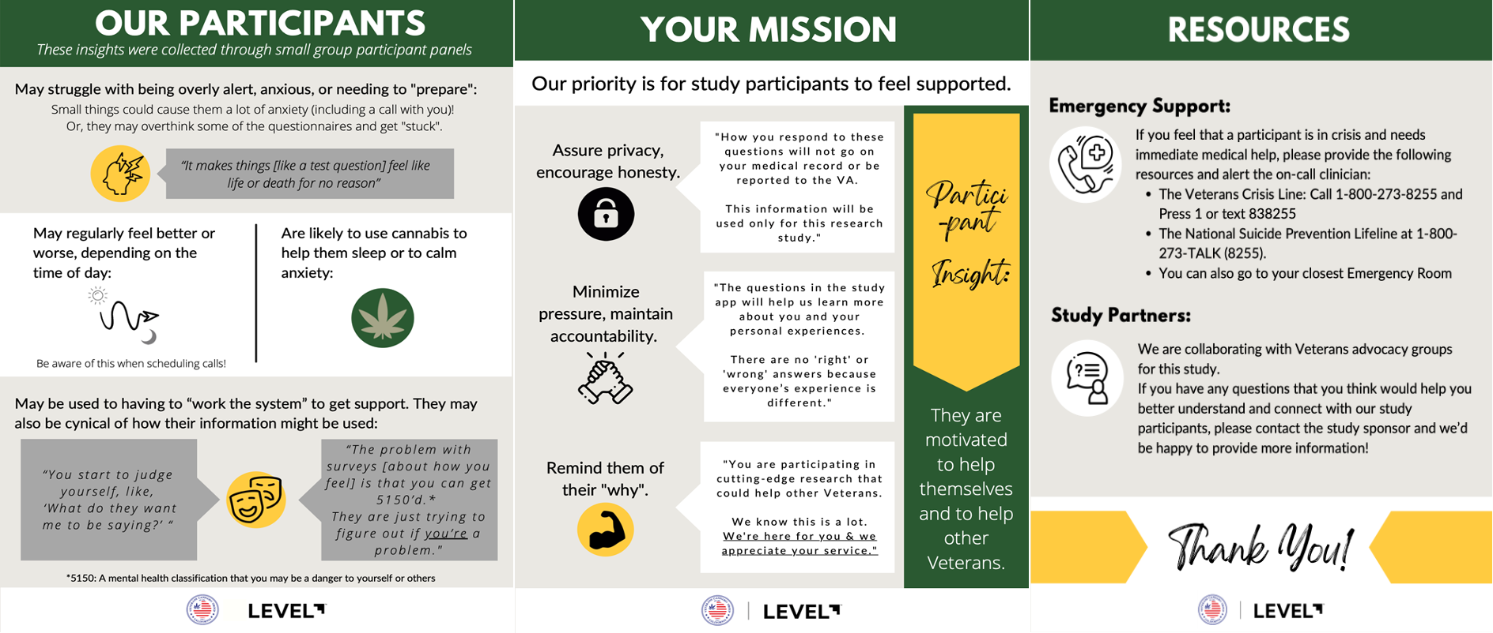

# **Supplementary Figure 2. Schedule of assessments throughout the study**

