Supplementary fig.1. Analysis of gene clusters. The branches in the dendrogram represent groups of clustered samples.

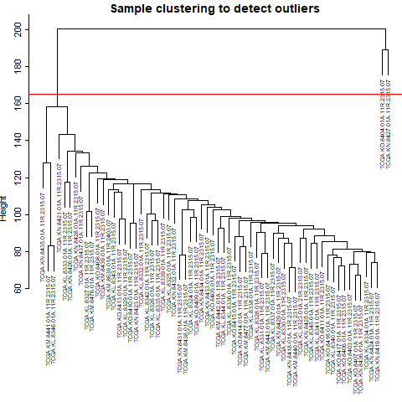

Supplementary table.1. Different output genes’ cure rate expression in Compertz model with Cox model

|  |  |  |  |  |  |  |
| --- | --- | --- | --- | --- | --- | --- |
|  | Gene_name | Beta | P_Value | Cure Min exp | Cure Max exp | HR |
| ENSG00000213923.13 | CSNK1E | -1.386 | 0.0478 | 0.68 | 0.91 | 3.998689 |
| ENSG00000039560.14 | RAI14 | 0.933 | 0.0460 | 0.94 | 0.28 | 0.393403 |
| ENSG00000122970.16 | IFT81 | 0.855 | 0.000022 | 0.91 | 0.70 | 0.304178 |
| ENSG00000169504.15 | CLIC4 | 0.760 | 0.0486 | 0.90 | 0.67 | 0.467447 |