**Circulating blood circular RNA in Parkinson’s Disease; a systematic study**

Aleksandra Beric1,2, Yichen Sun1,2, Santiago Sanchez1,2, Charissa Martin1,2, Tyler Powell1,2, Jose Adrian Pardo3, Jessie Sanford1,2, Juan A. Botia3, Carlos Cruchaga1,2,4,5,6,7, Laura Ibanez1,2,4

1. Department of Psychiatry, Washington University in Saint Louis School of Medicine
2. NeuroGenomics and Informatics Center, Washington University in Saint Louis School of Medicine
3. Departamento de Ingeniería de la Información y las Comunicaciones; Universidad de Murcia, Murcia, Spain.
4. Department of Neurology, Washington University in Saint Louis School of Medicine
5. Hope Center for Neurological Disorders, Washington University in Saint Louis School of Medicine
6. The Charles F. and Joanne Knight Alzheimer Disease Research Center, Washington University in Saint Louis
7. Department of Genetics, Washington University in Saint Louis School of Medicine

**Correspondence:**

Laura Ibanez, PhD

Washington University in Saint Louis School of Medicine

4444 Forest Park Ave

Campus Box 8134

Saint Louis, MO 63110

Tel: 314-273-3641

ibanezl@wustl.edu

**Supplemental Figure 1:** Quality control summary for circular RNA count processing. Upset plots indicate number of circRNAs common across visits in **A.** PDBP, and **B.** PPMI. Only those common across all visits and present in both studies were kept for analyses. Scatter plots show the principal components for **C.** PDBP and **D.** PPMI calculated using the 500 most variable circRNA transcripts prior to quality control. Individuals outside three-standard deviation (marked with the dashed square) were removed from further analyses.

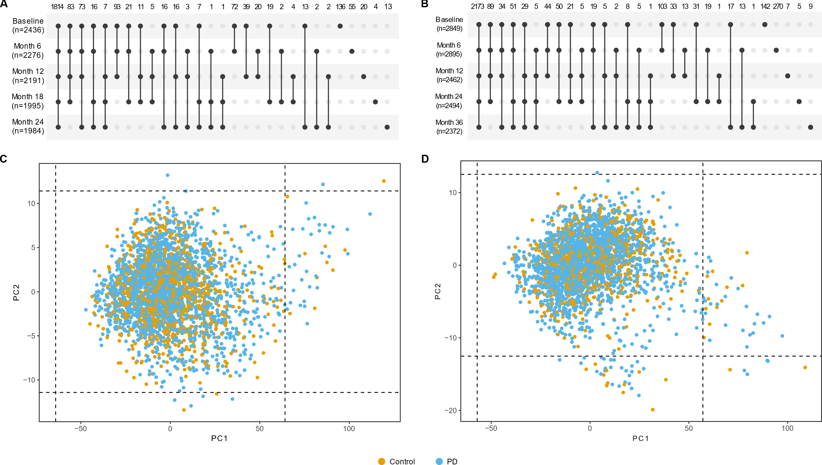

**Supplemental Figure 2.** Violin plots showing levels of the three circRNAs that associated with medication; **A.** *circTGAX;* **B.** *circNCF1;* and **C.** *circPADI4.* Color coded is the normalized count distribution for non-medicated PD cases, yellow, medicated PD cases, brown, and controls, light brown.Asterisks denote p-value: **=0.01, ***=0.001

**Supplemental Figure 3.** Scatter plot of significant (p-value<10-3) cross-sectional and longitudinal analyses effect sizes in PDBP dataset; due to the nature of the data (normalized transcript counts), all intercepts from the mixed model were positive, so absolute values were used for cross-sectional effect sizes

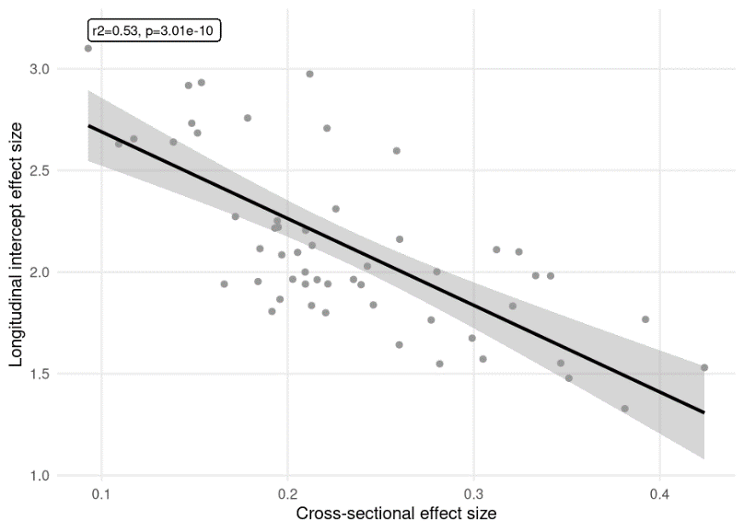

**Supplemental Figure 4.** Violin plots representing the levels of the five differentially expressed circRNAs (circ*AFF2*, circ*ETFA*, circ*FAM13B*, circ*SPI1*, and circ*SUZ12*) in different subgroups of the PPMI population. **A.** Heathy controls (brown), at risk (yellow), and symptomatic (grey) participants, **B.** at risk participants broken down by mutation carrier status, and **C.** symptomatic participants broken down by mutation carrier status; asterisks denote p-value: *=0.05, **=0.01, ***=0.001

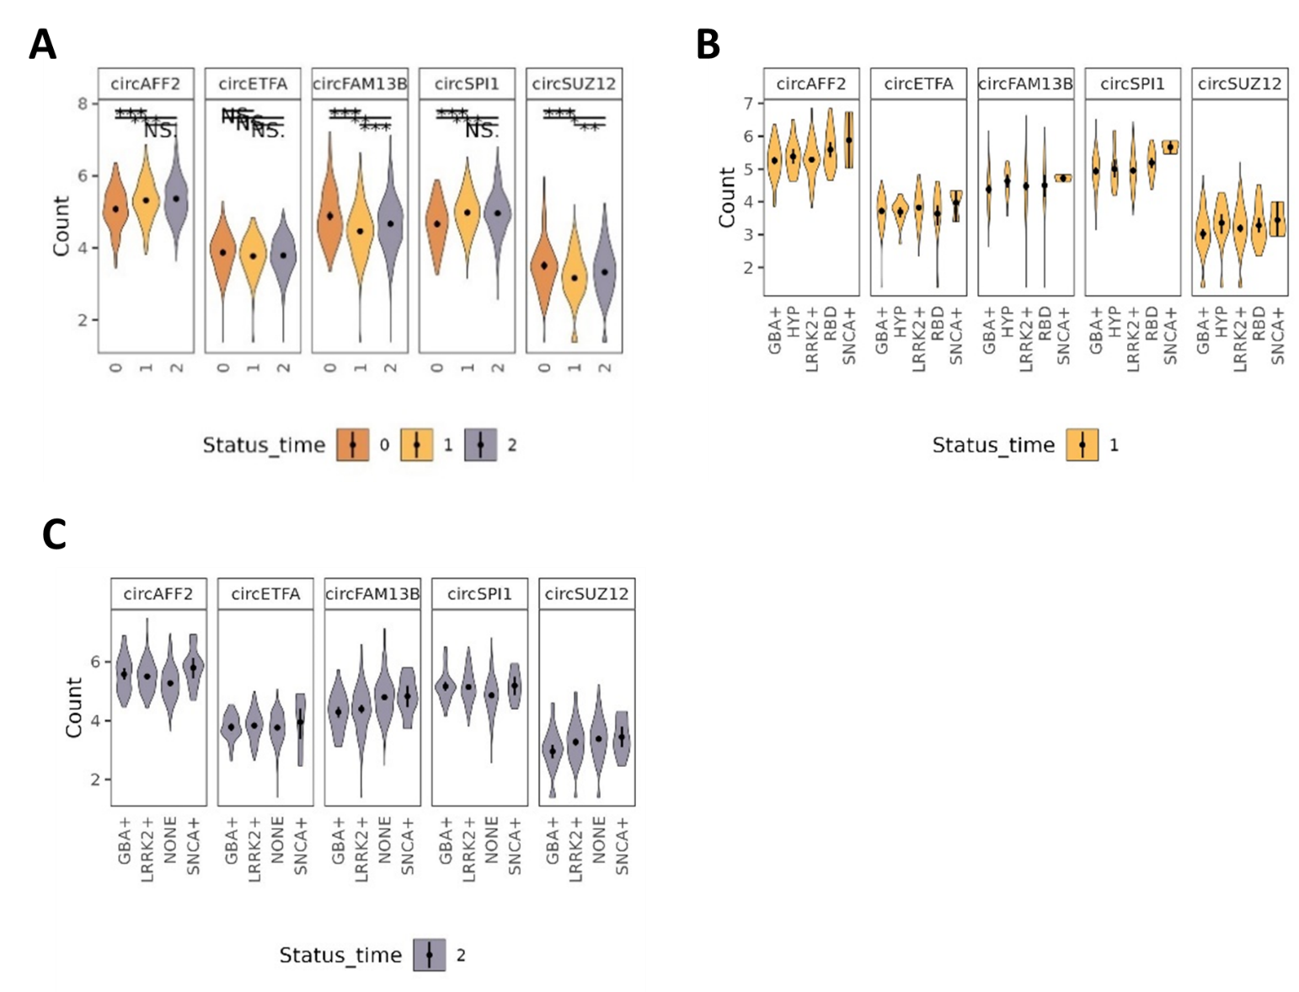

**Supplemental Figure 5.**