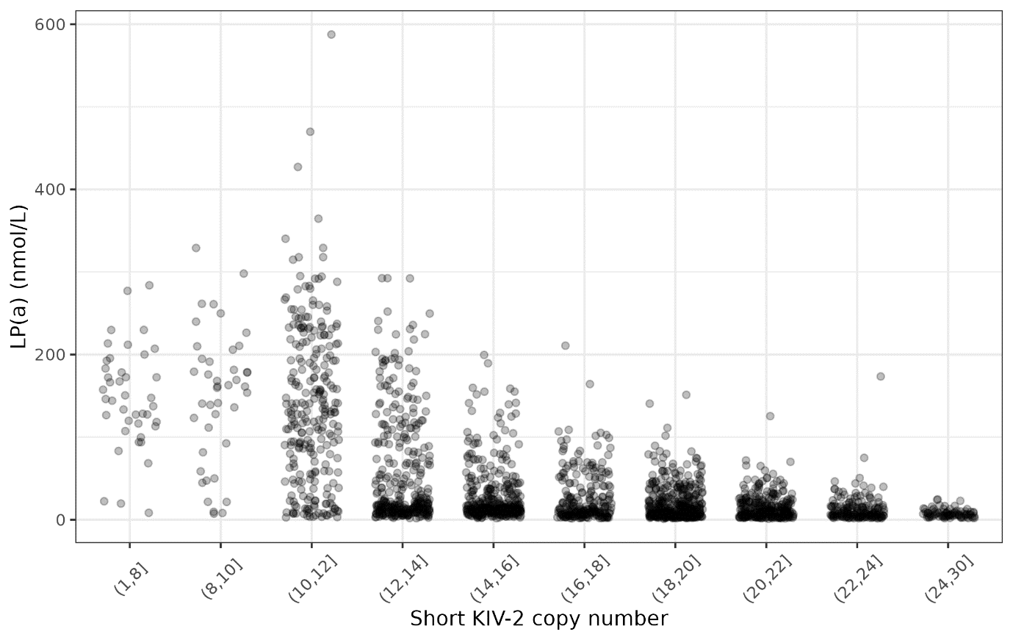
Figure S1. Scatterplot for LP(a) and number of KIV-2 repeats on the short allele (n = 4861). Number of KIV-2 repeats were binned so that there are at least 30 samples in each bin. Horizontal jittering was added to prevent overlapping between points.
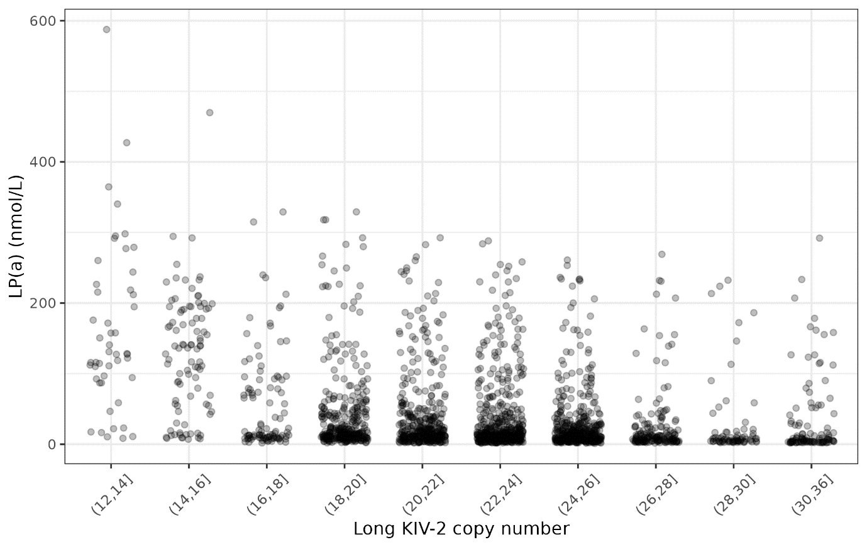
Figure S2. Scatterplot for LP(a) and number of KIV-2 repeats on the long allele (n = 4861). Number of KIV-2 repeats were binned so that there are at least 30 samples in each bin. Horizontal jittering was added to prevent overlapping between points.
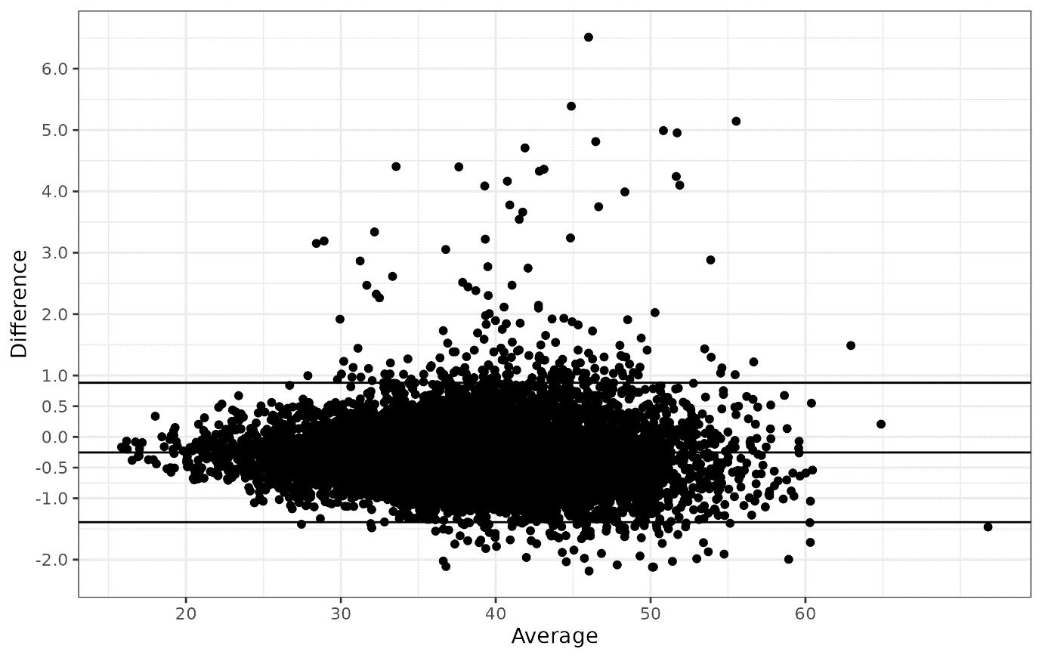 Figure S3. Bland-Altman plot with mean and 95% confidence interval for total number of KIV-2 repeats estimated by the DRAGEN LPA Caller and read depth based CN estimator (CNE) (n = 8351).
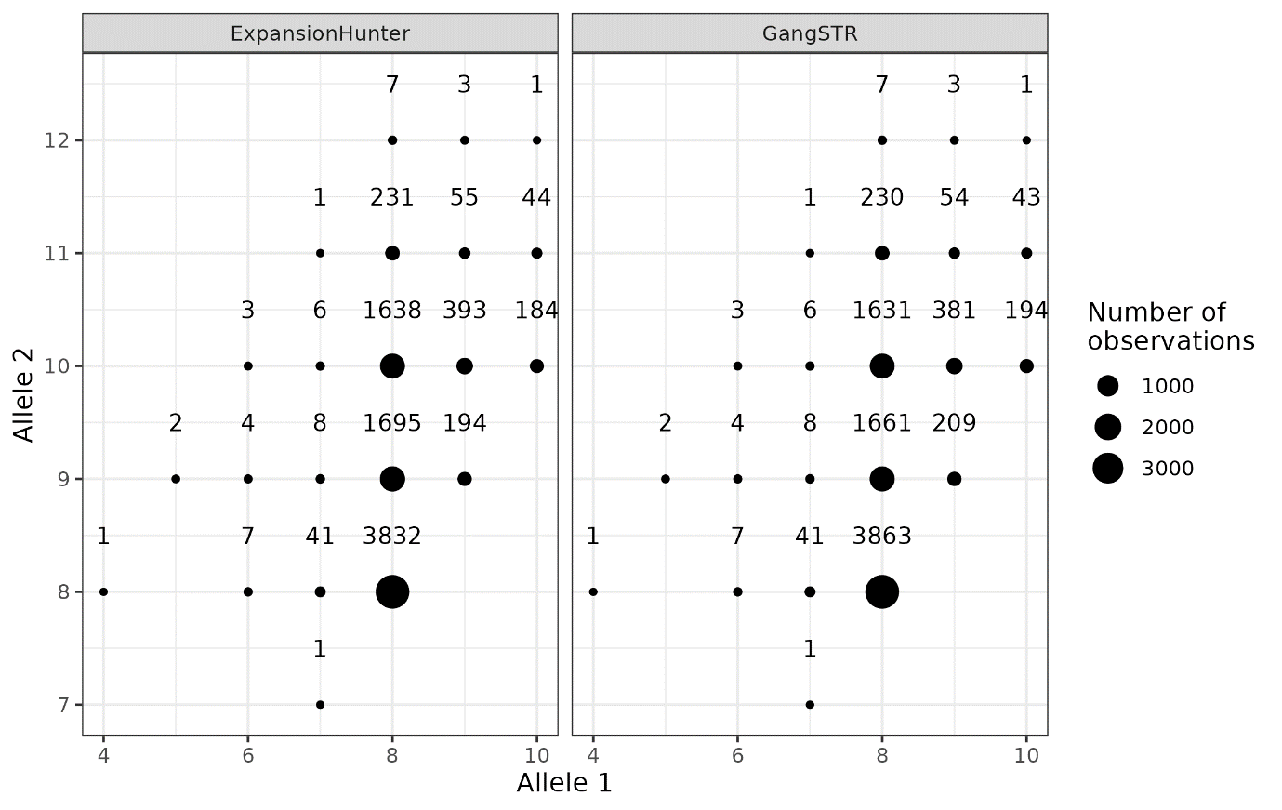
Figure S4. Dotplot per number of subjects per genotype estimated by ExpansionHunter and GangSTR.
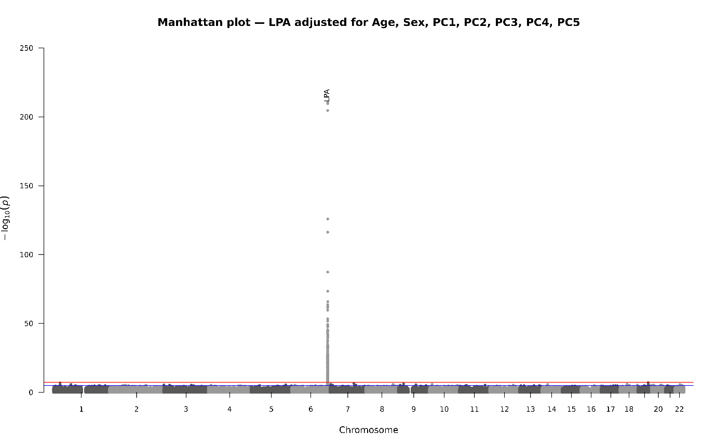
Figure S5. Manhattan plot from genome-wide association analysis (GWAS) for LP(a) concentration.
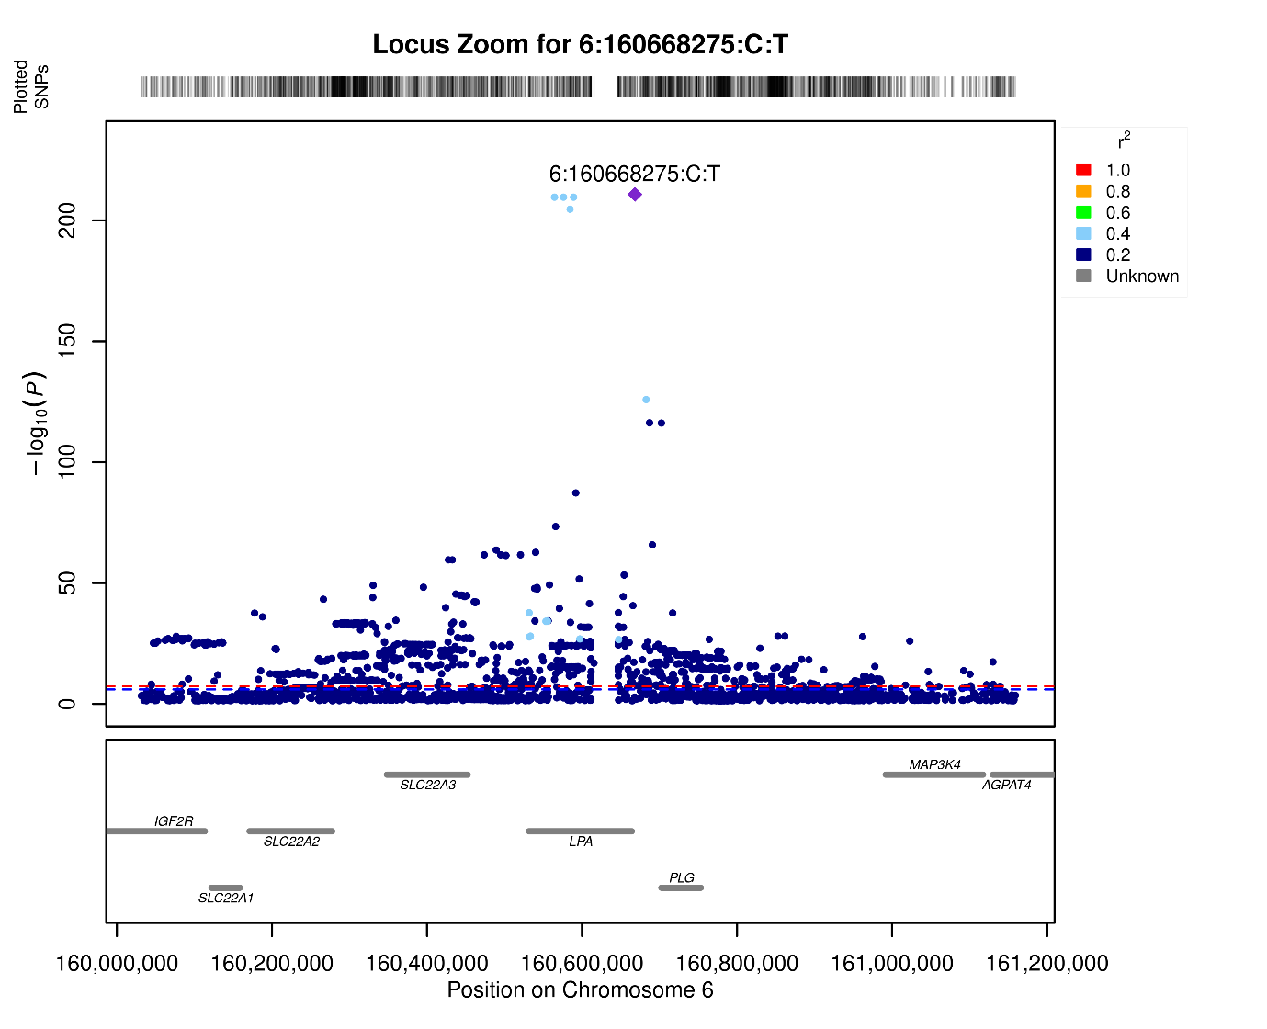 Figure S6. Locus-zoom plot for the LPA gene with 500kb padding.

