Supplementary data: Personalized CZA-ATM dosing against an XDR E. coli in liver transplant patients; the application of the in vitro hollow fibre infection model (HFIM)
Zahra Sadouki ^{1, 2},^{ǂ} Emmanuel Q. Wey ^{2, 3 ǂ}, Sateesh Iype⁴, David Nasralla⁴, Jonathan Potts ⁵, Mike Spiro ^{7,8} Alan Williams⁶ Timothy D. McHugh ², Frank Kloprogge¹
1 Institute for Global Health, University College London, UK
2 Centre of Clinical Microbiology, University College London, UK
3 Department of Infection, Royal Free London NHS Trust, UK
4 Department of HPB and Liver Transplant Surgery Royal Free Hospital
5 Department of Hepatology, Sheila Sherlock Liver Unit, Royal Free London
6 Department of Infection Sciences, Health Services Laboratories, London, UK,
7 Department of Surgical biotechnology, UCL
8 Department of Intensive care medicine Royal Free London
^{ǂ} Both authors contributed equally
Corresponding author: Dr Emmanuel Wey, Department of Infection, Consultant and Honorary Associate Professor in Infection, Royal Free London NHS Trust, Centre for Clinical Microbiology, Division of Infection & Immunity, University College London
emmanuel.wey@nhs.net
Table of Contents
Mean inhibitory concentrations (MICs) observed 3
MICs observed against BSI isolate 3
MICs observed against all cultures isolated from the liver transplant patient 4
CZA-ATM concentrations simulated in the HFIM 6
HFIM methodology 7

Mean inhibitory concentrations (MICs) observed

MICs observed against BSI isolate
Table S1. MICs observed for XDR E. coli isolate and NCTC® 12241 type E. coli versus EUCAST clinical breakpoints and EUCAST quality control (QC) ranges. MICs achieved for antibiotic/s tested are presented in columns one (XDR E. coli) and three (NCTC E. coli). MICs are shaded in red to represent resistant clinical breakpoints category ranges for Enterobacterales. All MICs for the reference laboratory E. coli strain (ATCC® 25922) fell within EUCAST quality control ranges.
Antibiotic/s | E. coli XDR isolate modal MIC  mg/L | EUCAST clinical breakpoint  mg/L | E. coli ATCC 25922® modal MIC mg/L | EUCAST ATCC 25922® QC ranges  mg/L
CAZ | >80 | R (>4) | 0.16 | 0.06-0.5
AVI | >14 | - | >14 | n/a
ATM | >120 | R (>4) | 0.125 | 0.06-0.25
CZA* | >32/4 | R (>8/4) | 0.25/4 | 0.06-0.5
ATM-AVI* | 2/4 | - | 0.125/4 | n/a
CZA-ATM | 2.5/0.44/3.8 | - | <0.31/0.05/0.47 | n/a
*Avibactam concentration fixed at 4 µg/mL. CAZ: ceftazidime, ATM: aztreonam, AVI: avibactam

MICs observed against all cultures isolated from the liver transplant patient
Table S3. MICs μg/mL observed against cultures isolated from the liver transplant patient. Red represents isolates in the resistant category and green represents isolates in sensitive category as per EUCAST clinical breakpoints for Enterobacterales. Isolate ‘HFIM_1_BSI E. coli’ was used in the HFIM experiments presented in Figure 1.
Antibiotic | HFIM_1_BSI | HFIM_2_Drain | HFIM_3_Drain | HFIM_4_Drain | HFIM_5_Abscess
 | E. coli | E. coli | E. coli | M. morganii | E. coli
Ampicillin | >8 | >8 | >8 | >8 | >8
Amikacin | <=4 | <=4 | 8 | <=4 | 8
Aztreonam | >16 | 8 | >16 | 4 | >16
Co-Amoxiclav | >32/2 | >32/2 | >32/2 | >32/2 | >32/2
Ceftazidime | >16 | >16 | >16 | 2 | >16
Cefixime | >2 | >2 | >2 | >2 | >2
Ciprofloxacin | >1 | >1 | >1 | >1 | >1
Colistin | <=1 | <=1 | <=1 | >4 | <=1
Cephalexin | >16 | >16 | >16 | >16 | >16
Ceftriaxone | >4 | >4 | >4 | >4 | >4
Cefuroxime | >8 | >8 | >8 | >8 | >8
Ertapenem | >1 | <=0.25 | >1 | <=0.25 | <=0.25
Cefepime | >16 | <=1 | >16 | 2 | >16
Nitrofurantoin | <=16 | <=16 | <=16 | 128 | <=16
Fosfomycin | <=16 | <=16 | <=16 | 64 | 32
Gentamicin | >4 | 2 | >4 | >4 | -
Imipenem | >8 | <=0.25 | >8 | 8 | 2
Levofloxacin | >2 | >2 | >2 | >2 | 1
Mecillinam | >8 | <=2 | >8 | - | >2
Meropenem | >8 | <=0.125 | >8 | 0.25 | 0.25
Nalidixic acid | >16 | >16 | >16 | >16 | >16
Tobramycin | >4 | 2 | >4 | >4 | >4
Piperacillin | >8 | >64 | >8 | >8 | >8
Norfloxacin | >64 | >2 | >64 | - | >64
Co-trimoxazole | >4/76 | >4/76 | >4/76 | >4/76 | <=1/19
Temocillin | >32 | 16 | >32 | - | >32
Tigecycline | 1 | <=0.5 | 1 | 2 | 1
Ticarcillin/clavulanate | >64/2 | >64/2 | >64/2 | >64/2 | >64/2
Trimethoprim | >4 | >4 | >4 | >4 | >4
Piperacillin/tazobactam | >64/4 | <=4/4 | >64/4 | <=4/4 | >64/4

CZA-ATM concentrations simulated in the HFIM
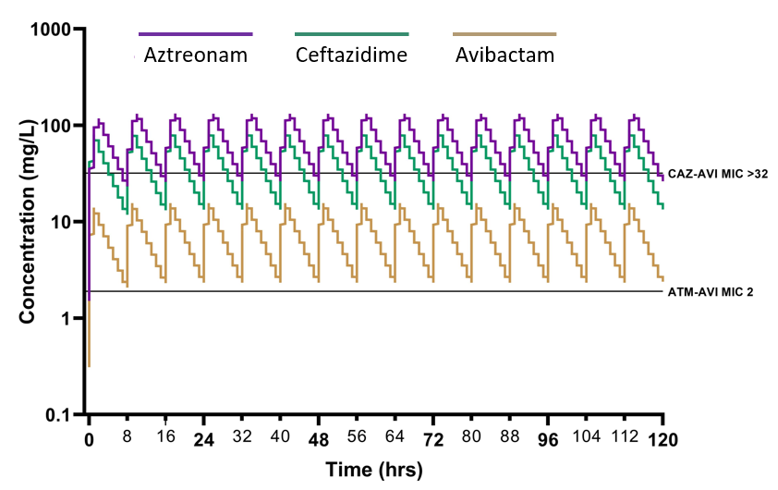
Figure S1. HFIM simulated concentrations of CZA-ATM
Dynamic concentrations of aztreonam (ATM), ceftazidime (CAZ) and avibactam (AVI) simulated in the HFIM experiments using in vivo PK data. Solid lines on the y axis represent the MIC for each antibiotic/combination tested in static microbroth dilution.

HFIM methodology
Table S2. HFIM experimental set up including technical and microbiological specifications
Section | HFIM feature | Further explanation
Descriptive specifications | Primary aim | Mimic antibiotic combination therapy proposed for patient
 | Microbial species | XDR E. coli inoculated into extra-capillary space (ECS)
 | Antimicrobial/s | Ceftazidime + avibactam + aztreonam
 | Duration | 120 hours (5 days)
Technical specifications | Mimicked dose | 2.5g CZA over 2hr + 2g ATM over 1hr
 | System volume | 150 mL (central 80 mL + cartridge 70 mL)
 | C_{max} | Ceftazidime 80 µg/L (∴ administered 7.8 µg/L)  Avibactam 14 µg/L (∴ administered 1.4 µg/L)  Aztreonam 120 µg/L (∴ administered 1.4 µg/L)
 | T_{1/2} | 2.48 hours
 | Τ | 8 hours dosing interval
 | Drug administration | Syringe infusion (automated driver pump)
 | Cartridge source | FibreCell Systems Cartridge C2011
 | Fibre type | High flux polysulfone
 | Pump model | FiberCell Systems® Inc duet pump at ~100 mL/min  Gilson pump set at 0.699 mL/min (5.92 rpm)
Microbiological specifications | Media | Mueller Hinton Broth 2, Cation-Adjusted (Sigma; 90922)
 | Control | Drug free experiment conducted in duplicate
 | Contamination | Sampling of ECS and reservoirs on CBA (VWR; 89407-240)
 | Inoculum | Initial OD600 for approximation then CFU/mL quantified
 | CFUs | CFUs quantified on MHA (VWR; 100611ZA)
 | Biological repeat | Duplicates
 | Technical repeat | Duplicates

