Supplementary Information
Table of Contents
6 Supplementary Information 1
6.1 Imaging Data Description 2
6.2 XCell Immunological Clusters 4
6.3 Risk Stratification 14
6.3.1 Model 1: Clinical-Only Variables 14
6.3.2 Model 2: Clinical Variables + Radiomics: Clinicoradiomic Model 16
6.3.3 Model 3: Clinical Variables + Radiomics + Molecular Subtypes 19

Imaging Data Description
Supplemental Table 1. Summary of demographics and clinical characteristics of the pLGG patients included in the imaging cohort (collected through the CBTN data repository)
Variable | Value | # of Patients
Age Range (months) | 4.3 – 280.73; Mean, 108.07 | 201
Sex | Female | 97
 | Male | 104
 | Not Reported
Tumor Location | Basal Ganglia | 2
 | Brainstem | 10
 | Cerebellar | 86
 | Intraventricular | 5
 | Lobar (frontal, parietal, temporal, or occipital lobes) | 44
 | Multifocal | 14
 | Suprasellar | 34
 | Thalamus | 6
NF1 Disease | With NF1 disease | 8
 | Without NF1 disease | 193
Extent of Tumor Resection | Gross or near total resection | 109
 | Partial resection | 58
 | Biopsy | 27
 | Not Reported/Unavailable | 7
Treatment | Radiotherapy | 10
 | Chemotherapy | 46
 | None or Not Available | 149
Molecular Subtypes | LGG, KIAA1549-BRAF | 68
 | LGG, BRAF V600E | 14
 | LGG, CDKN2A/B | 4
 | LGG, wildtype | 19
 | LGG, IDH | 1
 | LGG, NF1 | 8
 | LGG, RTK | 11
 | LGG, other MAPK | 11
 | LGG, MYB/MYBL1 | 1
 | GNG, KIAA1549-BRAF | 3
 | GNG, wildtype | 5
 | Other LGG or GNG | 5
 | Not Available | 51
Progression-Free Survival Range (months) | 2.83 – 133.37  Mean, 39.88 | 201
Number of Treatments for Progressed Tumors | Zero or one | 31
 | More than one treatment | 30

XCell Immunological Clusters
We observed a significant negative correlation between immune score and estimates of tumor purity derived from copy number (ABSOLUTE) [87], expression (ESTIMATE) [88], and methylation-based assessments (LUMP) [89] (Supplementary Figure 1).
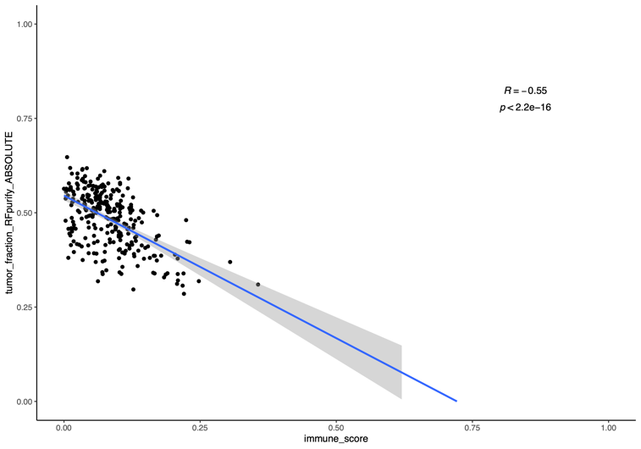 | 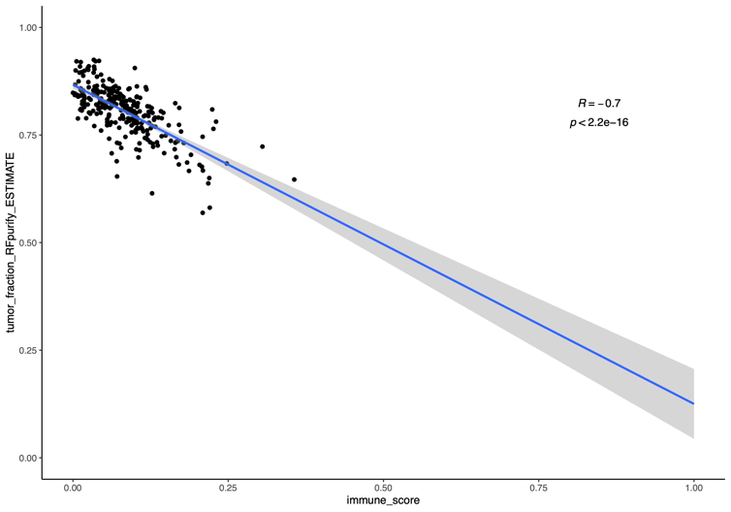
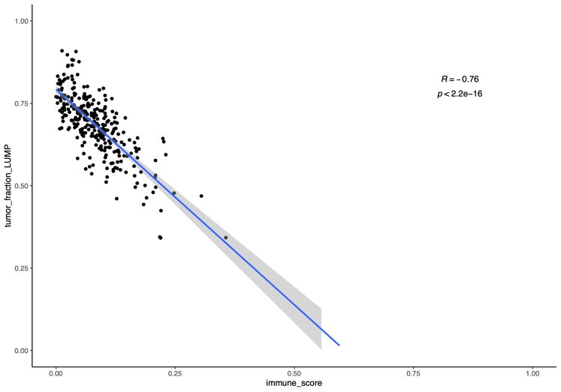

Supplemental Figure 1. Tumor purity obtained using ABSOLUTE, ESTIMATE, and LUMP, plotted against immune score.

Supplemental Table 2. The Cox effect results for the analysis of progression-free survival
 | coef | exp(coef) | se(coef) | z | Pr(>|z|)
age_at_diagnosis_days | -0.0001129 | 0.99988714 | 3.02E-05 | -3.7424565 | 0.00018223
reported_genderMale | 0.01036621 | 1.01042012 | 0.11006651 | 0.09418132 | 0.92496512
raceAsian | 0.46689584 | 1.59503526 | 0.70135233 | 0.66570798 | 0.50559777
raceBlack or African American | 0.34875673 | 1.41730436 | 0.63098567 | 0.55271736 | 0.58045697
raceMore Than One Race | -0.3151572 | 0.72967416 | 0.85511459 | -0.3685555 | 0.71245906
raceNative Hawaiian or Other Pacific Islander | 4.02664876 | 56.0726828 | 1.23658708 | 3.25625977 | 0.0011289
raceReported Unknown | -0.2903477 | 0.74800341 | 0.62580974 | -0.4639553 | 0.64267977
raceWhite | -0.0591466 | 0.9425686 | 0.61640544 | -0.095954 | 0.9235571
CNS_regionMidline | 0.28999767 | 1.33642438 | 0.2413468 | 1.20158078 | 0.22952599
CNS_regionMixed | 0.40111046 | 1.49348223 | 0.19765785 | 2.02931713 | 0.042426
CNS_regionOptic pathway | -0.0865064 | 0.91712964 | 0.44250286 | -0.1954935 | 0.84500662
CNS_regionOther | 0.33205425 | 1.39382846 | 0.57129883 | 0.5812269 | 0.56108754
CNS_regionPosterior fossa | 0.11129102 | 1.11772014 | 0.16613339 | 0.66988954 | 0.50292821
CNS_regionSpine | -0.1032594 | 0.90189296 | 0.37048277 | -0.2787159 | 0.78046285
CNS_regionSuprasellar | 0.43204445 | 1.54040359 | 0.32432297 | 1.33214262 | 0.18281333
CNS_regionVentricles | 0.44623032 | 1.56241128 | 0.32673308 | 1.36573352 | 0.17202262
molecular_subtypeGNG, MYB/MYBL1 | 1.37374301 | 3.95010835 | 0.81972593 | 1.67585648 | 0.09376631
molecular_subtypeGNG, other MAPK | 0.76562168 | 2.15033077 | 0.64556099 | 1.18597884 | 0.23563066
molecular_subtypeGNG, to be classified | 0.08704222 | 1.09094274 | 0.84451776 | 0.10306737 | 0.91790951
molecular_subtypeGNG, wildtype | 0.53513131 | 1.70767246 | 0.45890701 | 1.16609967 | 0.24357415
molecular_subtypeGNT, KIAA1549-BRAF | 0.63261592 | 1.88252869 | 1.0861798 | 0.58242284 | 0.5602819
molecular_subtypeGNT, other MAPK | 0.00184952 | 1.00185123 | 1.13558941 | 0.00162869 | 0.9987005
molecular_subtypeGNT, wildtype | 1.05593068 | 2.87464928 | 1.08180781 | 0.97607973 | 0.32902495
molecular_subtypeLGG_CDKN2A/B | 0.59495645 | 1.81295198 | 0.48489504 | 1.22697985 | 0.21983017
molecular_subtypeLGG_IDH | 0.67410583 | 1.96227758 | 0.5504056 | 1.22474377 | 0.22067178
molecular_subtypeLGG_NF1 | 0.09630276 | 1.10109238 | 0.4578858 | 0.21032048 | 0.83341755
molecular_subtypeLGG_RTK | 0.35382055 | 1.42449954 | 0.41504 | 0.85249747 | 0.39393804
molecular_subtypeLGG, BRAF V600E | 0.43084801 | 1.53856168 | 0.42088349 | 1.02367523 | 0.3059887
molecular_subtypeLGG, H3, other MAPK | 0.19335371 | 1.21331188 | 1.08547977 | 0.17812742 | 0.85862291
molecular_subtypeLGG, KIAA1549-BRAF | 0.30041245 | 1.35041567 | 0.4023964 | 0.74655849 | 0.45533011
molecular_subtypeLGG, KIAA1549-BRAF, other MAPK | 1.4846357 | 4.41335735 | 0.70614106 | 2.10246336 | 0.03551271
molecular_subtypeLGG, MYB/MYBL1 | 0.38898619 | 1.47548417 | 0.63249974 | 0.61499818 | 0.53855592
molecular_subtypeLGG, other MAPK | 0.89592262 | 2.4495948 | 0.44944005 | 1.99341963 | 0.04621552
molecular_subtypeLGG, To be classified | -0.6311619 | 0.53197337 | 1.08667639 | -0.5808186 | 0.56136272
molecular_subtypeLGG, wildtype | 0.53212698 | 1.70254974 | 0.40427322 | 1.31625582 | 0.18808819
molecular_subtypeSEGA, wildtype | -0.4663222 | 0.62730511 | 0.57104384 | -0.8166137 | 0.4141492
clusterID2 | 0.49963731 | 1.64812341 | 0.13462076 | 3.71144314 | 0.00020608
clusterID3 | 0.10565895 | 1.11144276 | 0.1511455 | 0.69905456 | 0.48451793

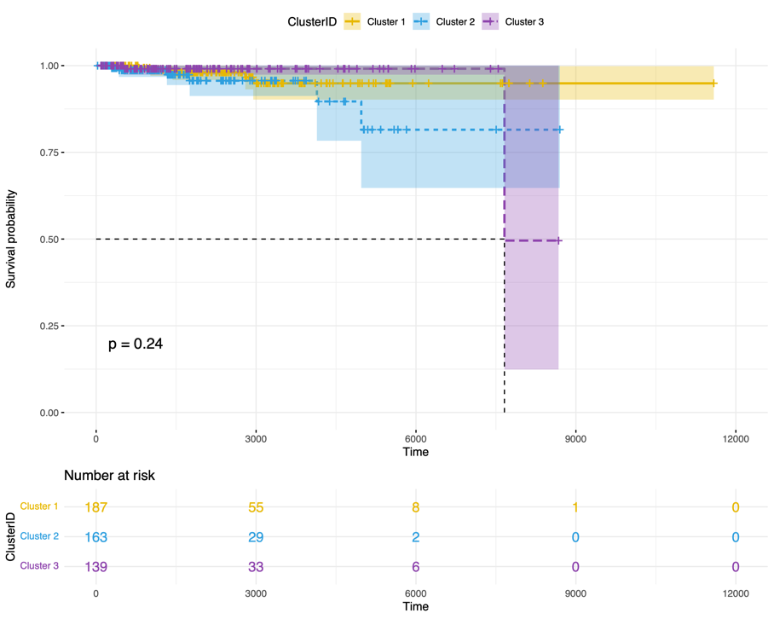 | 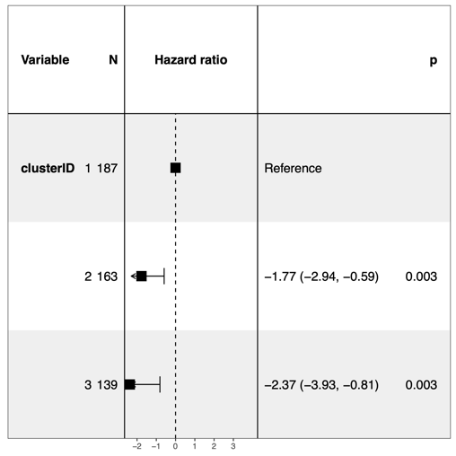
Supplemental Figure 2. Kaplan-Meier curves presenting the overall survival probability for patients in the three xCell clusters along with the forest plot.

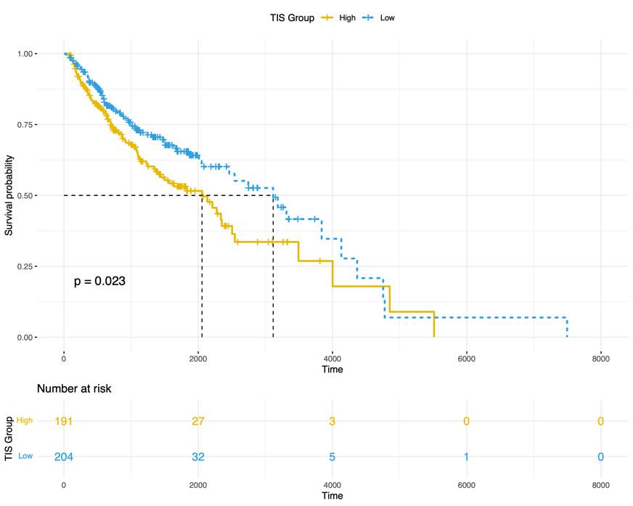  (A) | 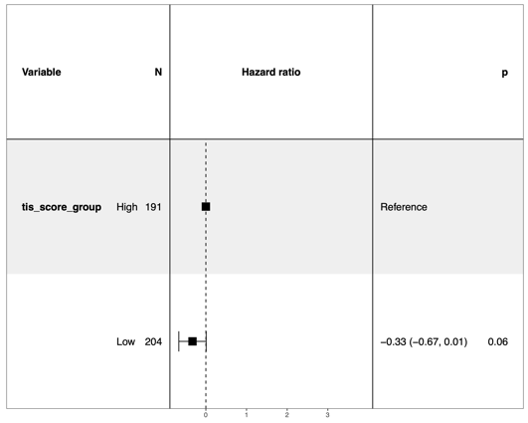  (B)
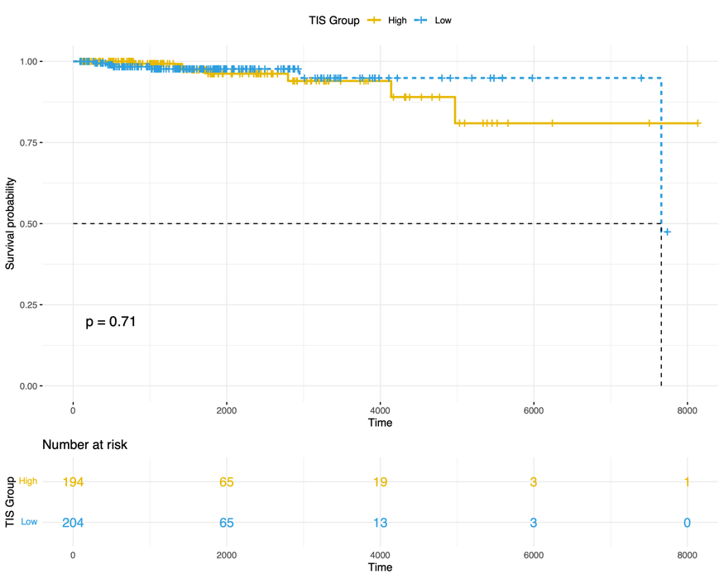  (C) | 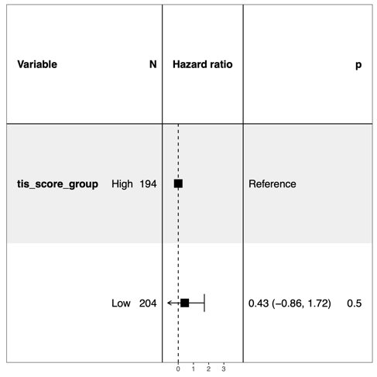  (D)
Supplemental Figure 3. Kaplan-Meier curves indicating progression-free survival probability (Top Row) and overall survival (Bottom Row) for the patients with high versus low levels of Tumor Inflammation Signature (TIS), along with the associated forest plots.

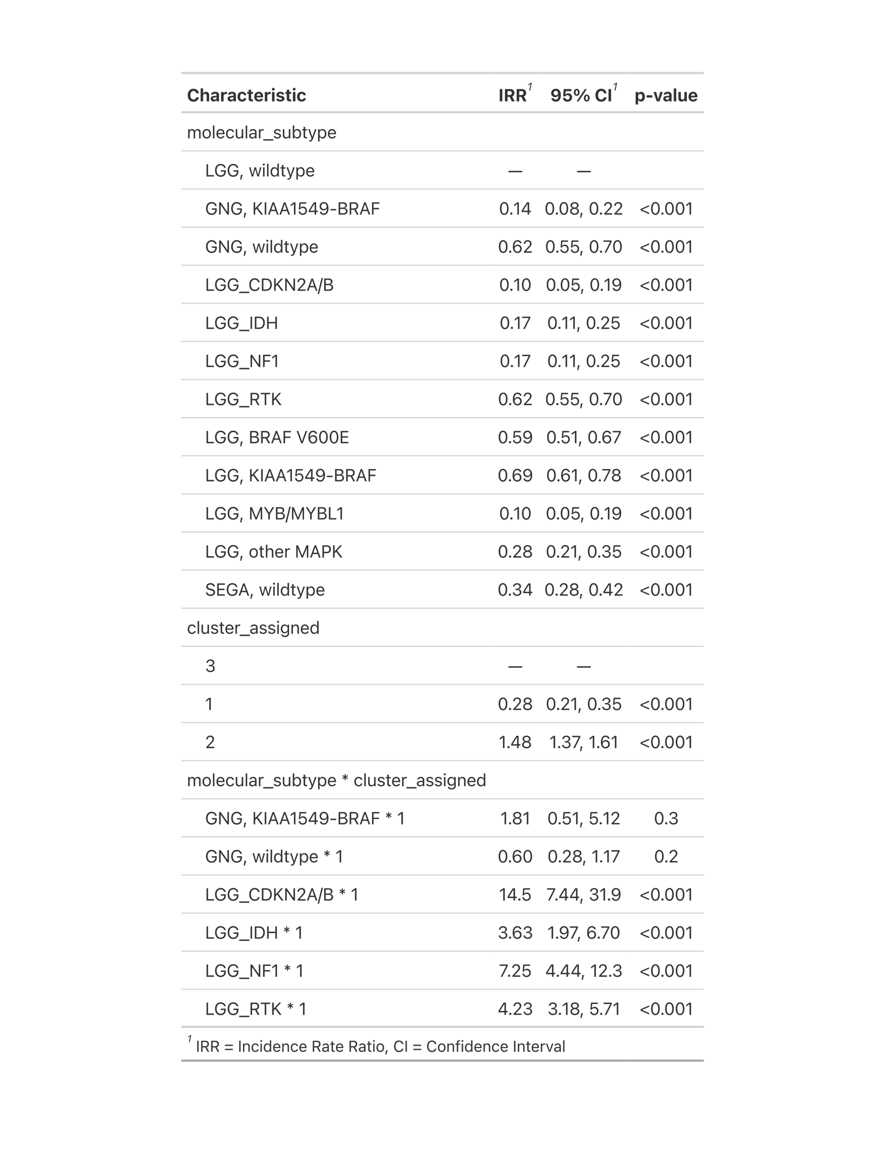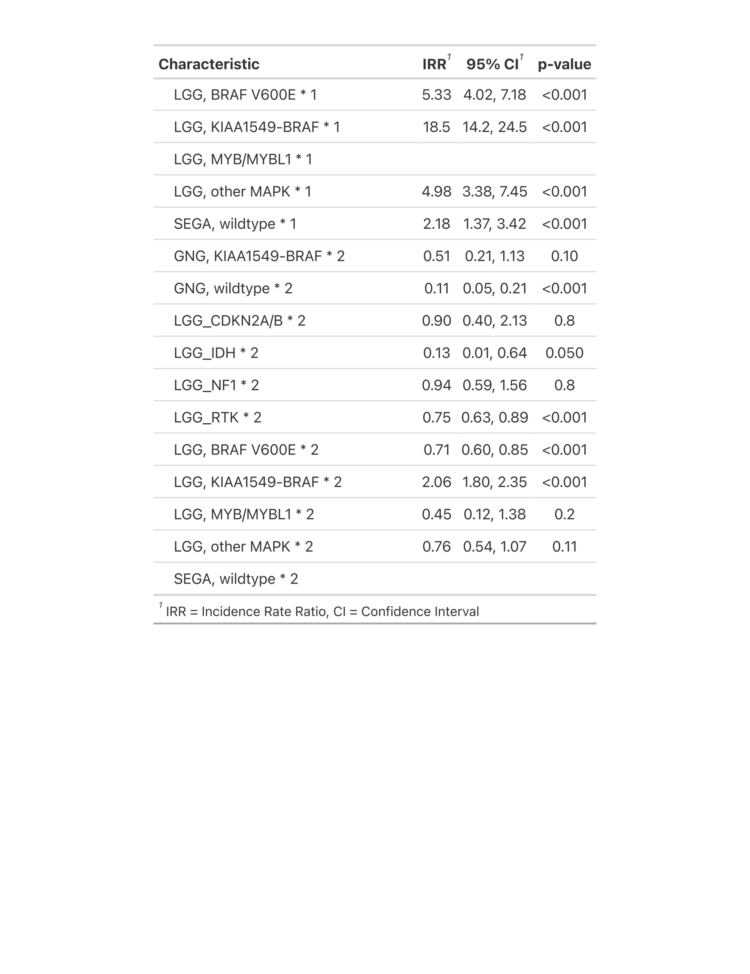
Supplemental Figure 4. Summary of Poisson generalized linear model parameters comparing counts across pLGG XCell clusters and molecular subtypes.
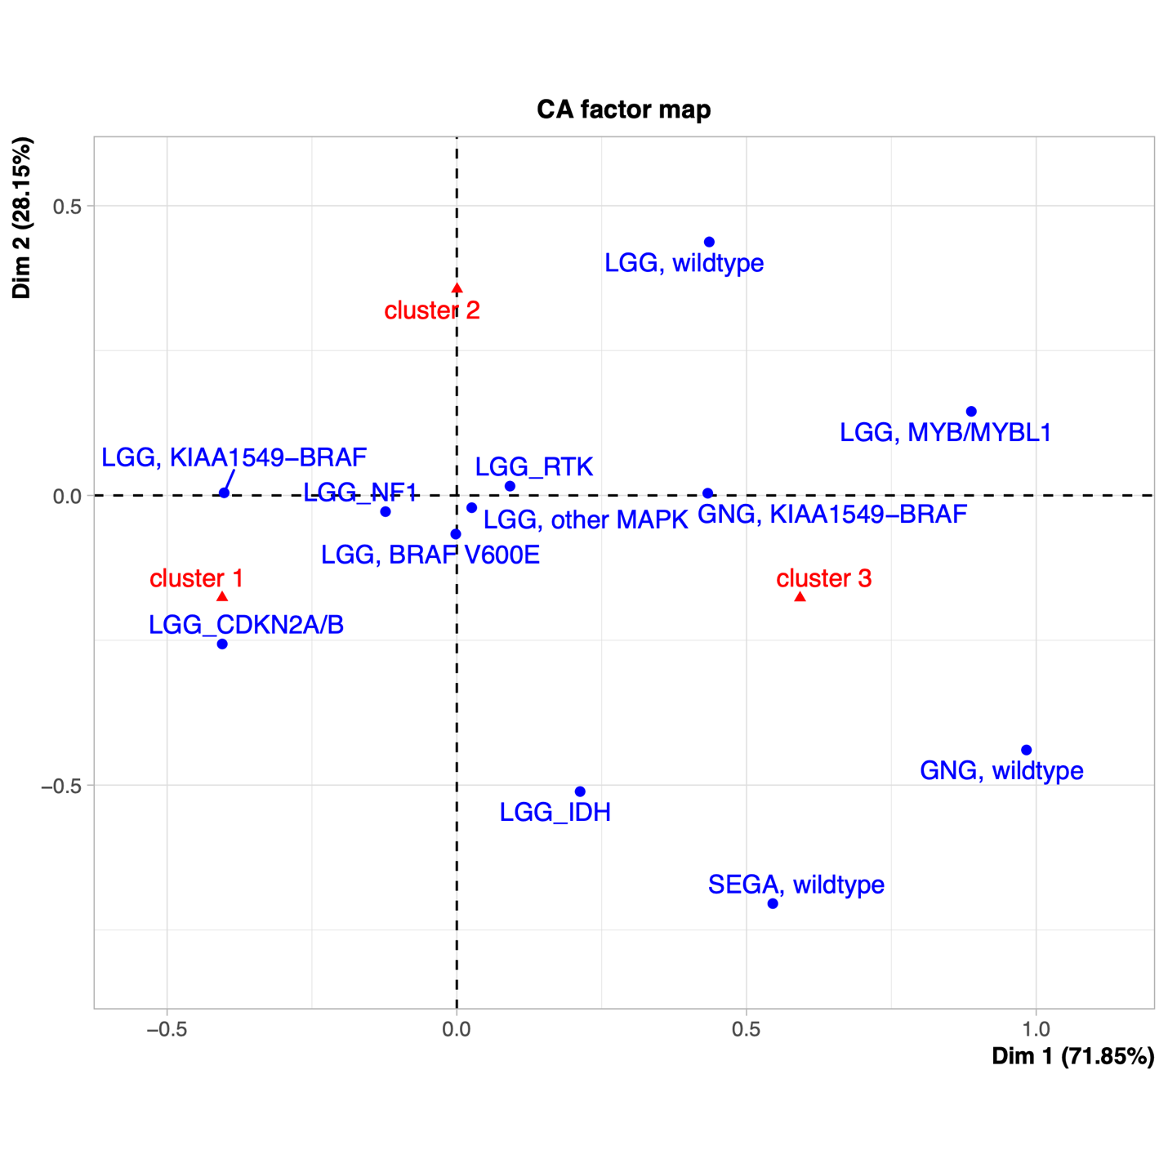
Supplemental Figure 5. Correspondence analysis of Pearson residuals from Poisson generalized linear model showing the association between pLGG molecular subtypes and XCell clusters.

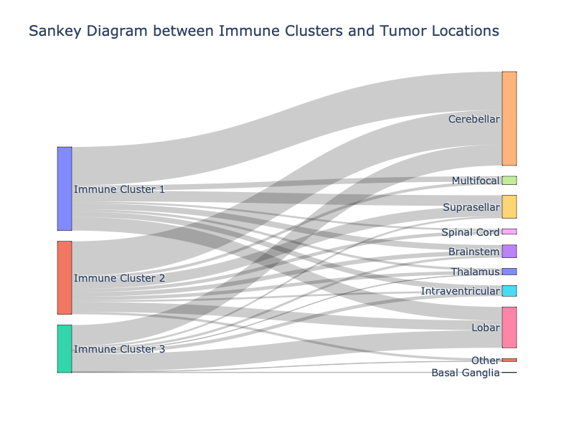
Supplemental Figure 6. Sankey plot of the association of imaging clusters (described in Section 2.2), immunological clusters, and tumor locations.

Risk Stratification

Model 1: Clinical-Only Variables
We first investigated the performance of a Cox-PH model trained using clinical-only features. The included clinical variables were sex, age, NF1 disease, tumor location, extent of tumor resection, chemotherapy, and radiation. The forest plot of the trained Cox-PH model, and Kaplan-Meier curves of the stratified risk groups, as well as performance metrics on a discovery set of 160 patients are illustrated in the following figures and table.
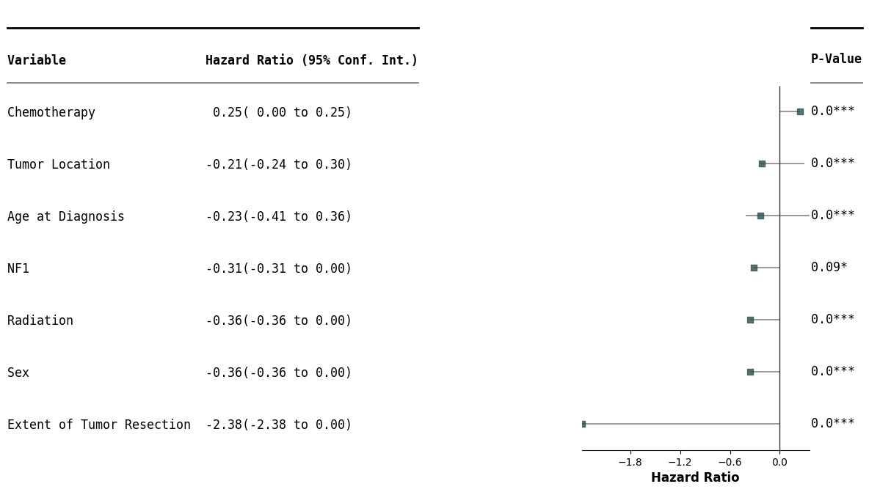
Supplemental Figure 7. Forest plot of the features in the clinical-only model.
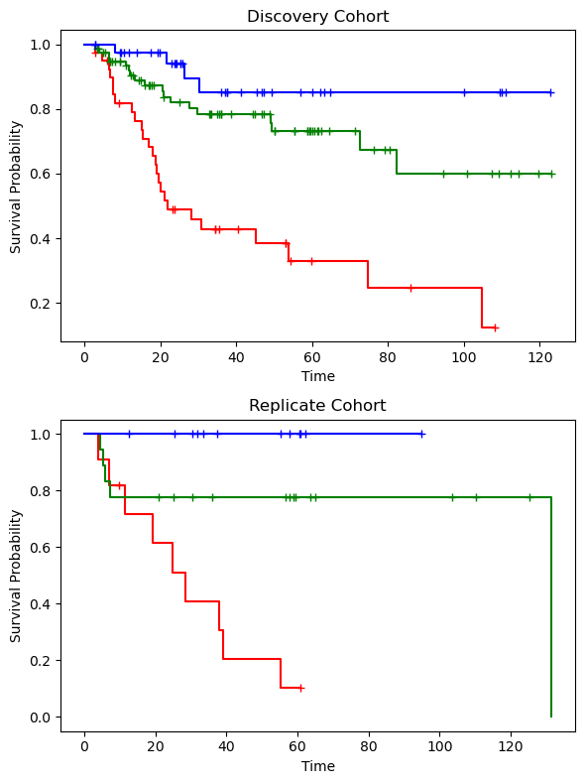
Supplemental Figure 8. Kaplan-Meier curves illustrating the risk categories for the model for clinical-only features and molecular subtypes.

Supplemental Table 3. Model performance metrics for the clinical-only model.
Cohort | HAR | UNO | IBS
Discovery | 0.74 [95% CI: 0.67, 0.80] | 0.75 [95% CI: 0.67, 0.82] | 0.20 [95% CI: 0.16, 0.22]
Replicate | 0.76 | 0.79 | 0.16

Model 2: Clinical Variables + Radiomics: Clinicoradiomic Model
We further investigated the performance of a Cox-PH model trained on a combination of clinical and radiomic features. As described in the Methods section, the clinical variables were not penalized, but regularization was applied to the radiomic feature set to reduce the dimensionality. The following plots and table depict the selected features for this model, Kaplan-Meier curves of the stratified risk groups and performance metrics. While the performance of the clinicoradiomic model on the unseen replication set was approximately similar to that of clinical-only model, the risk groups, especially the low-risk group from the medium and high-risk categories, are better differentiated as evidenced by the ANOVA p-value.
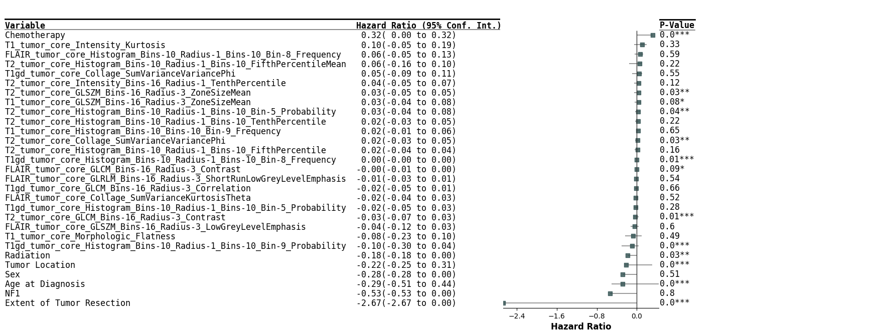
Supplemental Figure 9. Forest plot of the features in the clinicoradiomic model.

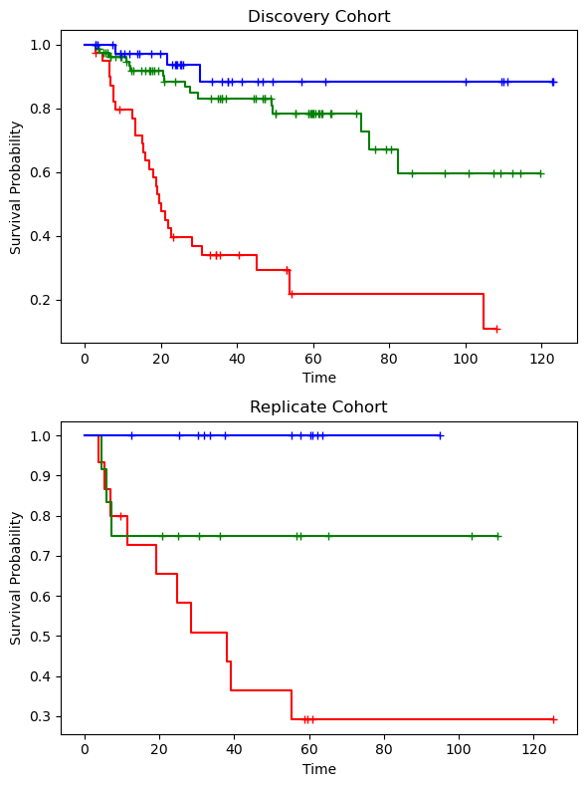
Supplemental Figure 10. Kaplan-Meier curves illustrating the risk categories for the model for clinicoradiomic features and molecular subtypes.

Supplemental Table 4. Model performance metrics for the clinicoradiomic model.
Cohort | HAR | UNO | IBS
Discovery | 0.71 [95% CI: 0.63, 0.79] | 0.72 [95% CI: 0.64, 0.80] | 0.24 [95% CI: 0.19, 0.29]
Replicate | 0.77 | 0.80 | 0.16

Comparative Analysis of Clinicoradiomic and Clinical-Only Models
The forest plots for the clinical-only (Supplemental Figure 6) and clinicoradiomic (Supplemental Figure 8) models demonstrate that the extent of tumor resection is a critical predictive factor for tumor progression in pLGG, with patients undergoing gross/near-total resection exhibiting the most favorable prognosis. To evaluate the effectiveness of our clinicoradiomic model versus the clinical-only model in patients who did not receive gross/near-total resection, we conducted a focused subgroup analysis. This involved assessing the performance of the previously described clinical-only and clinicoradiomic models (Models 1 and 2, respectively) exclusively in patients who had not undergone gross/near-total tumor resection, intentionally excluding those who had. The results indicate that the clinicoradiomic model surpasses the clinical-only model in predicting progression-free survival for these patients.
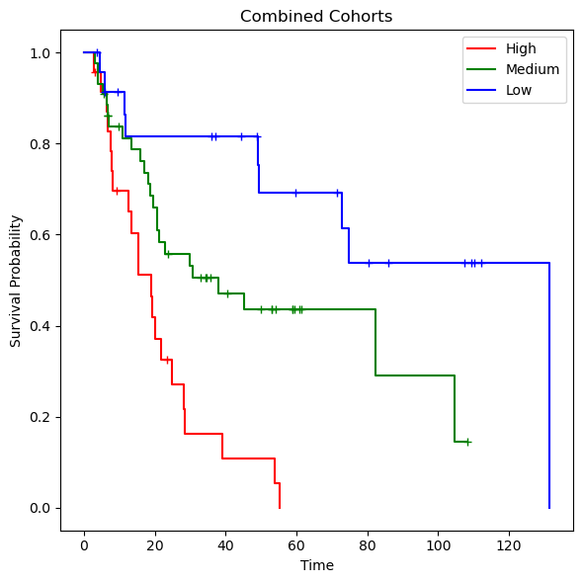
Supplemental Figure 11. Kaplan-Meier curves illustrating the risk categories for the model for clinicoradiomic features and molecular subtypes specifically on the subjects who did not undergo total/near-total resection.

Supplemental Table 5. Comparison of the performances of Model 1 (clinical-only) and Model 2 (clinicoradiomic) in a subgroup of patients who did not receive gross/near-total resection.
Model | HAR | UNO | IBS
Model 1: Clinical-only | 0.55 | 0.57 | 0.24
Model 2: Clinicoradiomic | 0.70 | 0.70 | 0.18

Model 3: Clinical Variables + Radiomics + Molecular Subtypes
We further explored the predictive power of adding molecular subtypes, as a categorical variable, to the clinicoradiomic model. The performance of this model on the replication set is lower than the clinicoradiomic model, possibly due to smaller training cohort size.
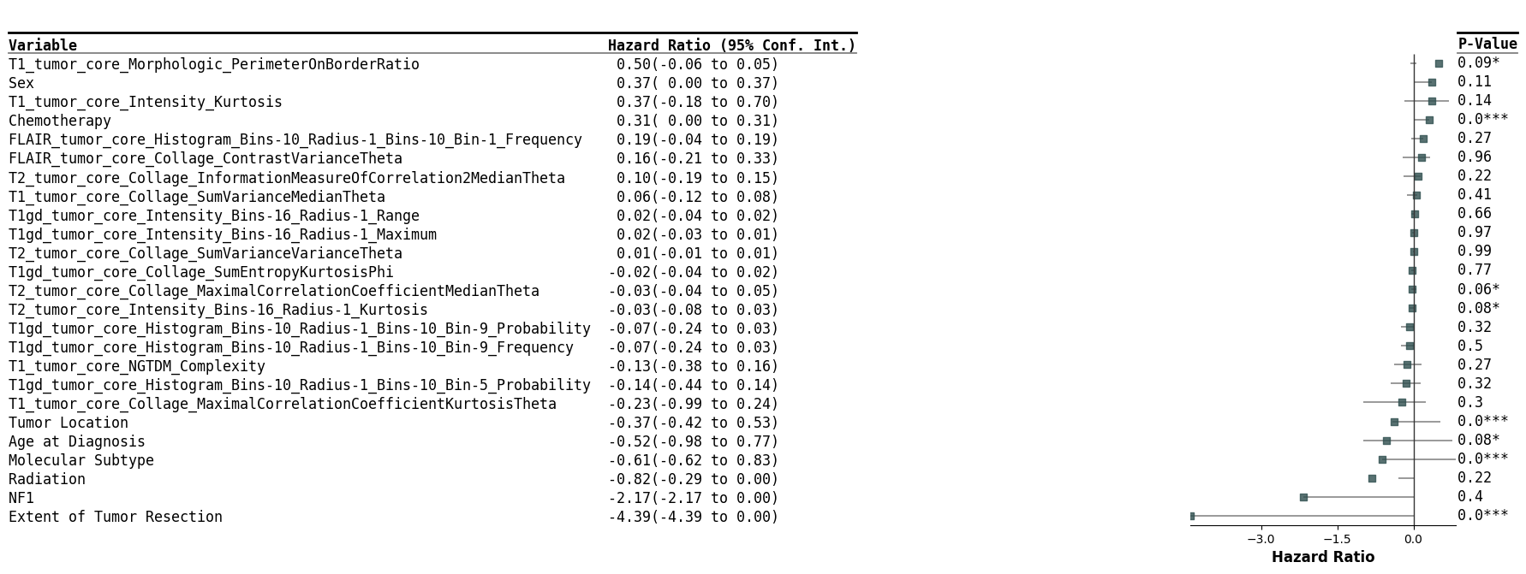
Supplemental Figure 12. Forest plot of the model comprised of clinicoradiomic features and molecular subtypes.

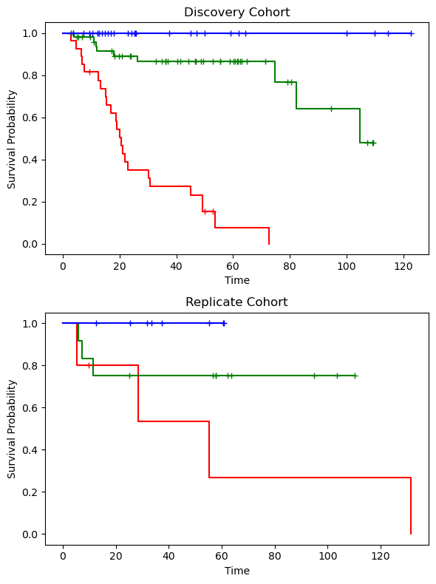
Supplemental Figure 13. Kaplan-Meier curves illustrating the risk categories for the model for clinicoradiomic features and molecular subtypes.

Supplemental Table 6. Model performance metrics for a combination of clinicoradiomic features and molecular subtypes.
Cohort | HAR | UNO | IBS
Discovery | 0.74 [95% CI: 0.65, 0.83] | 0.74 [95% CI: 0.65, 0.84] | 0.21 [95% CI: 0.14, 0.27]
Replicate | 0.69 | 0.74 | 0.18

