Supplementary materials
Title:
BRCA-DIRECT digital pathway for diagnostic germline genetic testing within a UK breast oncology setting: a randomised, non-inferiority trial
Authors:
B. Torr¹, C. Jones², G. Kavanaugh¹, M. Hamill¹, S. Allen¹, S. Choi¹, A. Garrett^{1,3}, M. Valganon-Petrizan⁴, S. MacMahon⁴, L. Yuan⁴, R. Way¹, H. Harder⁵, R. Gold⁶, A. Taylor⁷, R. Gabe⁸, A. Lucassen⁹, R. Manchanda^{8,10,11}, L. Fallowfield⁵, V. Jenkins⁵, A. Gandhi^{12,13}, D.G. Evans^{14,15}, A. George^{1,16}, M. Hubank⁴, Z. Kemp^{1,16,17}, S. Bremner², and C. Turnbull^{1,16}
Affiliations
- Institute of Cancer Research, Division of Genetics and Epidemiology, Sutton, UK
- Brighton and Sussex Clinical Trials Unit, Brighton and Sussex Medical School, Brighton, UK
- Department of Clinical Genetics, St Georges Hospital NHS Trust, London, UK
- Clinical Genomics Department, Centre for Molecular Pathology, NIHR Cancer Biomedical Research Centre, Royal Marsden NHS Foundation Trust, Sutton, UK
- Sussex Health Outcomes Research and Education in Cancer (SHORE-C), Brighton and Sussex Medical School, Brighton, UK
- BRCA Journey, Patient Representative, Leeds, UK
- Clinical Genetics, East Anglian Medical Genetics Service, Cambridge, UK
- Wolfson Institute of Population Health, Queen Mary’s University of London, London, UK
- Nuffield Department of Medicine, University of Oxford, Oxford, UK
- Department of Gynaecological Oncology, Barts Health NHS Trust, London, UK
- Department of Health Services Research, Faculty of Public Health & Policy, London School of Hygiene and Tropical Medicine, London, UK
- School of Cancer Sciences, Faculty of Biology, Medicine and Health, University of Manchester, Manchester Academic Health Science Centre, Manchester, UK
- Prevent Breast Cancer Centre, Wythenshawe Hospital Manchester Universities Foundation Trust, Manchester, UK
- Nightingale and Genesis Breast Cancer Centre, Manchester University Hospitals NHS Foundation Trust, Manchester, UK
- Division of Evolution, Infection, and Genomic Sciences, The University of Manchester, Manchester, UK
- Cancer Genetics Unit, Royal Marsden NHS Foundation Trust, London, UK
- Breast Oncology Unit, Royal Marsden NHS Foundation Trust, London, UK
Corresponding author:
Prof Clare Turnbull, Division of Genetics and Epidemiology, Institute of Cancer Research, London SM2 5NG, UK; clare.turnbull@icr.ac.uk
Contents
Supplementary Figure 1: Adjusted differences between the fully-digital arm compared to the partially-digital arm. 3
(a) uptake of genetic testing 3
(b) mean knowledge score 3
(c) mean anxiety scores 3
(d) mean satisfaction scores 4
Supplementary Table 1: Methods of evaluating outcomes for assessing non-inferiority of digital information with the timepoints of assessment. 5
Supplementary Table 2: Non-inferiority margin assumptions 6
Supplementary Table 3: Sensitivity and subgroup analyses 7
(a) Genetic test uptake 7
(b) Knowledge 8
(c) Anxiety 9
(d) Satisfaction 10
References 12

Supplementary Figure 1: Adjusted differences between the fully-digital arm compared to the partially-digital arm.
δ Indicates the non-inferiority margin.

(a) uptake of genetic testing
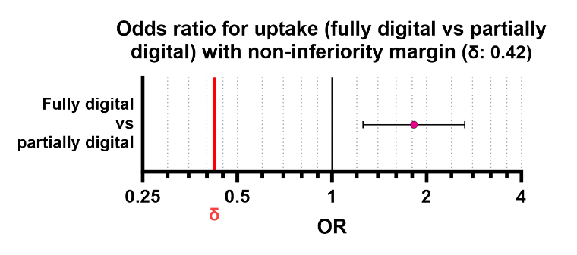
OR = Odds ratio
(b) mean knowledge score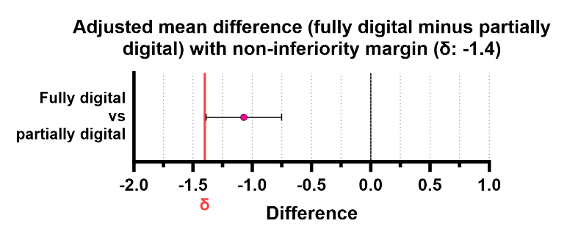

(c) mean anxiety scores
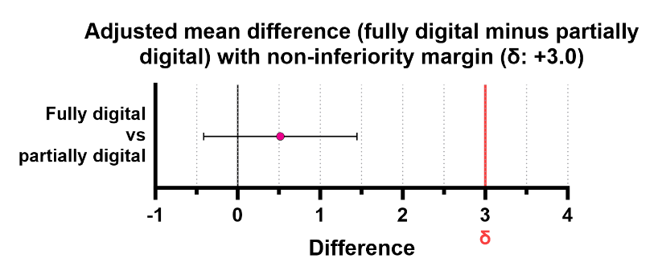
(d) mean satisfaction scores 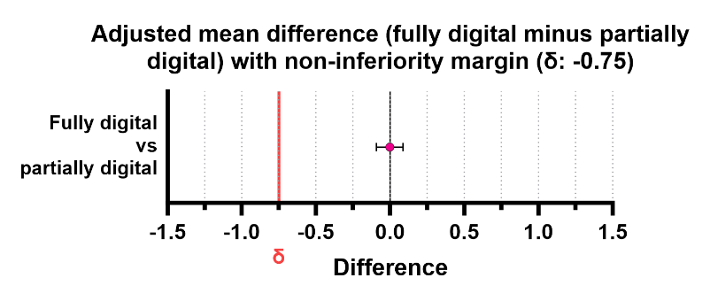
T1 = 1-day post genetic test consent
T2 = 7-days post genetic test results
T3 = 28-days post genetic test results
Supplementary Figure 2: Baseline and adjusted mean knowledge scores in the fully- and partially-digital arms over time

Supplementary Figure 3: Baseline and adjusted mean anxiety scores in the fully- and partially-digital arms over time

Supplementary Table 1: Methods of evaluating outcomes for assessing non-inferiority of digital information with the timepoints of assessment.
Outcome | Measure | Timepoint of assessment |  |  |  | Non-inferiority Margin (sample size required for 80% power)
 |  | Baseline | 1-day after genetic test consent (T1) | 7-days after receiving the genetic test result (T2) | 28-days after receiving the genetic test result (T3)
Genetic test uptake | Proportion of participants consenting to genetic testing | N/A |  |  |  | -5.5%  (934)
Anxiety | State Trait Anxiety Inventory  20-item validated survey, producing state and trait scores between 20 and 80, with higher scores reflecting greater anxiety. ¹⁹ | - Trait and state anxiety | - State anxiety | - State anxiety | - State anxiety | +3  (636)
Intolerance of uncertainty
²⁰
Knowledge | 14-item study specific questionnaire, with true or false answers. Participants could also answer ‘don’t know’. Scores reflected total correct answers out of a possible 14. |  |  |  |  | -1.4  (56)
Participant satisfaction | 10-item study specific survey.  Focussed question on satisfaction with the method of receiving pre-test information Scored on a 5-point Likert scale (1- very unsatisfied; 5 – very satisfied). |  |  | (invited at T2 with reminder at T3 if incomplete) |  | -0.75  (38)

Supplementary Table 2: Non-inferiority margin assumptions and power

 | Attrition | Predicted available participants (following attrition) | Assumptions  (reference *) | Power | Sample size required for 80% power (digital: clinician = 1:1) | Significance level (one-sided) | Non-inferiority margin | Notes
Test uptake | 0% | 1000 | 90% test uptake in both groups | 80-85% with 1000 participants | 892 | 0.05 | 5% | Calculated using http://www.hwasoon.kim/NISSC/#!/binary
STAI state T1 | 0% | 1000 | Mean 43.2, SD 13.5 ¹  (range 0 – 100) | >95% with 1000 participants | 500 | 0.05 | 3 | Calculated using http://www.hwasoon.kim/NISSC/#!/continuous
STAI state T2 | 10% | 900 | Mean 43.2, SD 13.5 ¹  (range 0 – 100) | >95% with 900 participants | 500 | 0.05 | 3
STAI state T3 | 20% | 800 | Mean 43.2, SD 13.5 ¹  (range 0 – 100) | 90-95% with 800 participants | 500 | 0.05 | 3
Patient satisfaction | 20% | 800 | Mean 3.75, SD 1  (out of 5 – Likert scale)  ² | >95% with 800 participants | 44 | 0.05 | 0.75
Knowledge score T1 | 20% | 800 | Mean 5.71, SD 1.55  (out of a possible 10) ³ | >95% with 800 participants | 30 | 0.05 | 1.40

Supplementary Table 3: Sensitivity and subgroup analyses

Genetic test uptake
 |  | Category representation (all participants) |  | subgroup#intervention interaction |  |  |  | Intervention effect in subgroup
 |  | n | % | estimate | 95% CI | p-value | model n | estimate | 95% CI | p-value
Reported breast cancer history in first degree relatives | No | 789 | 74.57 | Reference category |  |  |  | No effect observed
 | Yes | 269 | 25.43 | 0.62 | 0.18 to 2.18 | 0.455 | 1058
 | Total | 1058 | 100.00
Reported breast cancer history in second degree relatives | No | 707 | 66.82 | Reference category |  |  |  | No effect observed
 | Yes | 351 | 33.18 | 0.34 | 0.09 to 1.34 | 0.124 | 1058
 | Total | 1058 | 100.00
Reported other cancer history in relatives | No | 886 | 83.74 | Reference category |  |  |  | No effect observed
 | Yes | 172 | 16.26 | 0.47 | 0.07 to 3.22 | 0.445 | 1058
 | Total | 1058 | 100.00
Breast cancer status | Newly diagnosed | 667 | 58.61 | Reference category |  |  |  | No effect observed
 | In follow up | 400 | 35.15 | 1.41 | 0.64 to 3.07 | 0.392 | 1138
 | Metastatic | 71 | 6.24 | 0.44 | 0.10 to 1.98 | 0.286 | 1138
 | Total | 1138 | 100.00
Genetic test result | Negative | 969 | 97.00 | Not modelled
 | Pathogenic | 30 | 3.00
 | Total | 999 | 100.00
Method of receiving result from genetic test | Digitally | 942 | 94.29 | Not modelled
 | Telephone appointment | 57 | 5.71
 | Total | 999 | 100.00

Knowledge
 |  |  | Category representation (all participants) |  |  | subgroup#intervention interaction |  |  |  | Intervention effect in subgroup
 |  |  | n |  | % | estimate | 95% CI | p-value | model n | estimate | 95% CI | p-value
Reported breast cancer history in first degree relatives | No | 789 |  | 74.57 |  | Reference category |  |  |  | No effect observed
 | Yes | 269 |  | 25.43 |  | -0.45 | -1.17 to 0.28 | 0.225 | 989
 | Total | 1058 |  | 100.00
Reported breast cancer history in second degree relatives | No | 707 |  | 66.82 |  | Reference category |  |  |  | No effect observed
 | Yes | 351 |  | 33.18 |  | 0.23 | -0.44 to 0.90 | 0.496 | 989
 | Total | 1058 |  | 100.00
Reported other cancer history in relatives | No | 886 |  | 83.74 |  | Reference category |  |  |  | No effect observed
 | Yes | 172 |  | 16.26 |  | 0.74 | -0.12 to 1.59 | 0.093 | 989
 | Total | 1058 |  | 100.00
Breast cancer status | Newly diagnosed | 667 |  | 58.61 |  | Reference category |  |  |  | No effect observed
 | In follow up | 400 |  | 35.15 |  | 0.30 | -0.38 to 0.98 | 0.382 | 989
 | Metastatic | 71 |  | 6.24 |  | 0.45 | -0.92 to 1.82 | 0.520
 | Total | 1138 |  | 100.00
Test result | Negative | 969 |  | 97.00 |  | Reference category |  |  |  | No effect observed
 | Pathogenic | 30 |  | 3.00 |  | 1.20 | -0.64 to 3.05 | 0.202 | 987
 | Total | 999 |  | 100.00
Method of receiving result | Digitally | 942 |  | 94.29 |  | Reference category |  |  |  | No effect observed
 | Telephone appointment | 57 |  | 5.71 |  | 0.77 | -0.58 to 2.12 | 0.266 | 987
 | Total | 999 |  | 100.00

Anxiety
 |  | Category representation (all participants) |  |  | subgroup#intervention interaction |  |  |  | Intervention effect in subgroup
 |  | n | % | estimate |  | 95% CI | p-value | model n | estimate | 95% CI | p-value
Reported breast cancer history in first degree relatives | No | 789 | 74.57 | Reference category |  |  |  |  | No effect observed
 | Yes | 269 | 25.43 | 0.13 |  | -2.00 to 2.25 | 0.908 | 995
 | Total | 1058 | 100.00
Reported breast cancer history in second degree relatives | No | 707 | 66.82 | Reference category |  |  |  |  | No effect observed
 | Yes | 351 | 33.18 | -0.09 |  | -2.05 to 1.87 | 0.929 | 995
 | Total | 1058 | 100.00
Reported other cancer history in relatives | No | 886 | 83.74 | Reference category |  |  |  |  | No effect observed
 | Yes | 172 | 16.26 | -0.34 |  | -2.83 to 2.15 | 0.79 | 995
 | Total | 1058 | 100.00
Breast cancer status | Newly diagnosed | 667 | 58.61 | Reference category |  |  |  |  | No effect observed
 | In follow up | 400 | 35.15 | -2.10 |  | -4.07 to -0.12 | 0.038 | 995
 | Metastatic | 71 | 6.24 | -1.73 |  | -5.74 to 2.28 | 0.399
 | Total | 1138 | 100.00
Test result | Negative | 969 | 97.00 | Reference category |  |  |  |  | No effect observed
 | Pathogenic | 30 | 3.00 | -1.06 |  | -6.43 to 4.30 | 0.698 | 993
 | Total | 999 | 100.00
Method of receiving result | Digitally | 942 | 94.29 | Reference category |  |  |  |  | No effect observed
 | Telephone appointment | 57 | 5.71 | -0.56 |  | -4.51 to 3.38 | 0.779 | 993
 | Total | 999 | 100.00

Satisfaction
 |  | Category representation (all participants) |  | subgroup#intervention interaction |  |  |  | Intervention effect in subgroup
 |  | n | % | estimate | 95% CI | p-value | model n | estimate | 95% CI | p-value
Reported breast cancer history in first degree relatives | No | 789 | 74.6 | Reference category |  |  |  | No effect observed
 | Yes | 269 | 25.4 | -0.14 | -o.34 to 0.07 | 0.198 | 908
 | Total | 1058 | 100.0
Reported breast cancer history in second degree relatives | No | 707 | 66.8 | Reference category |  |  |  | No effect observed
 | Yes | 351 | 33.2 | 0.06 | -0.12 to 0.24 | 0.511 | 908
 | Total | 1058 | 100.0
Reported other cancer history in relatives | No | 886 | 83.7 | Reference category |  |  |  | No effect observed
 | Yes | 172 | 16.3 | 0.10 | -0.15 to 0.34 | 0.441 | 908
 | Total | 1058 | 100.0
Breast cancer status | Newly diagnosed | 667 | 58.6 | Reference category |  |  |  | No effect observed
 | In follow up | 400 | 35.2 | 0.10 | -0.10 to 0.29 | 0.330 | 908
 | Metastatic | 71 | 6.2 | -0.02 | -0.43 to 0.38 | 0.909 | 908
 | Total | 1138 | 100.0
Test result | Negative | 969 | 97.0 | Reference category |  |  |  | No effect observed
 | Pathogenic | 30 | 3.0 | -0.28 | -0.80 to 0.24 | 0.292 | 908
 | Total | 999 | 100.0
Method of receiving result | Digitally | 942 | 94.3 | Reference category |  |  |  | No effect observed
 | Telephone appointment | 57 | 5.7 | -0.21 | -0.59 to 0.17 | 0.276 | 908
 | Total | 999 | 100.0

References
1 Mansel RE, Fallowfield L, Kissin M et al. Randomized multicenter trial of sentinel node biopsy versus standard axillary treatment in operable breast cancer: the ALMANAC Trial. J Natl Cancer Inst 2006; 98 (9): 599-609.
2 Ware JE, Jr., Hays RD. Methods for measuring patient satisfaction with specific medical encounters. Medical care 1988; 26 (4): 393-402.
3 Meisel SF, Freeman M, Waller J et al. Impact of a decision aid about stratified ovarian cancer risk-management on women’s knowledge and intentions: a randomised online experimental survey study. BMC public health 2017; 17 (1): 882.

