Supplementary File 3. Incidence rate ratio results per database with numeric values

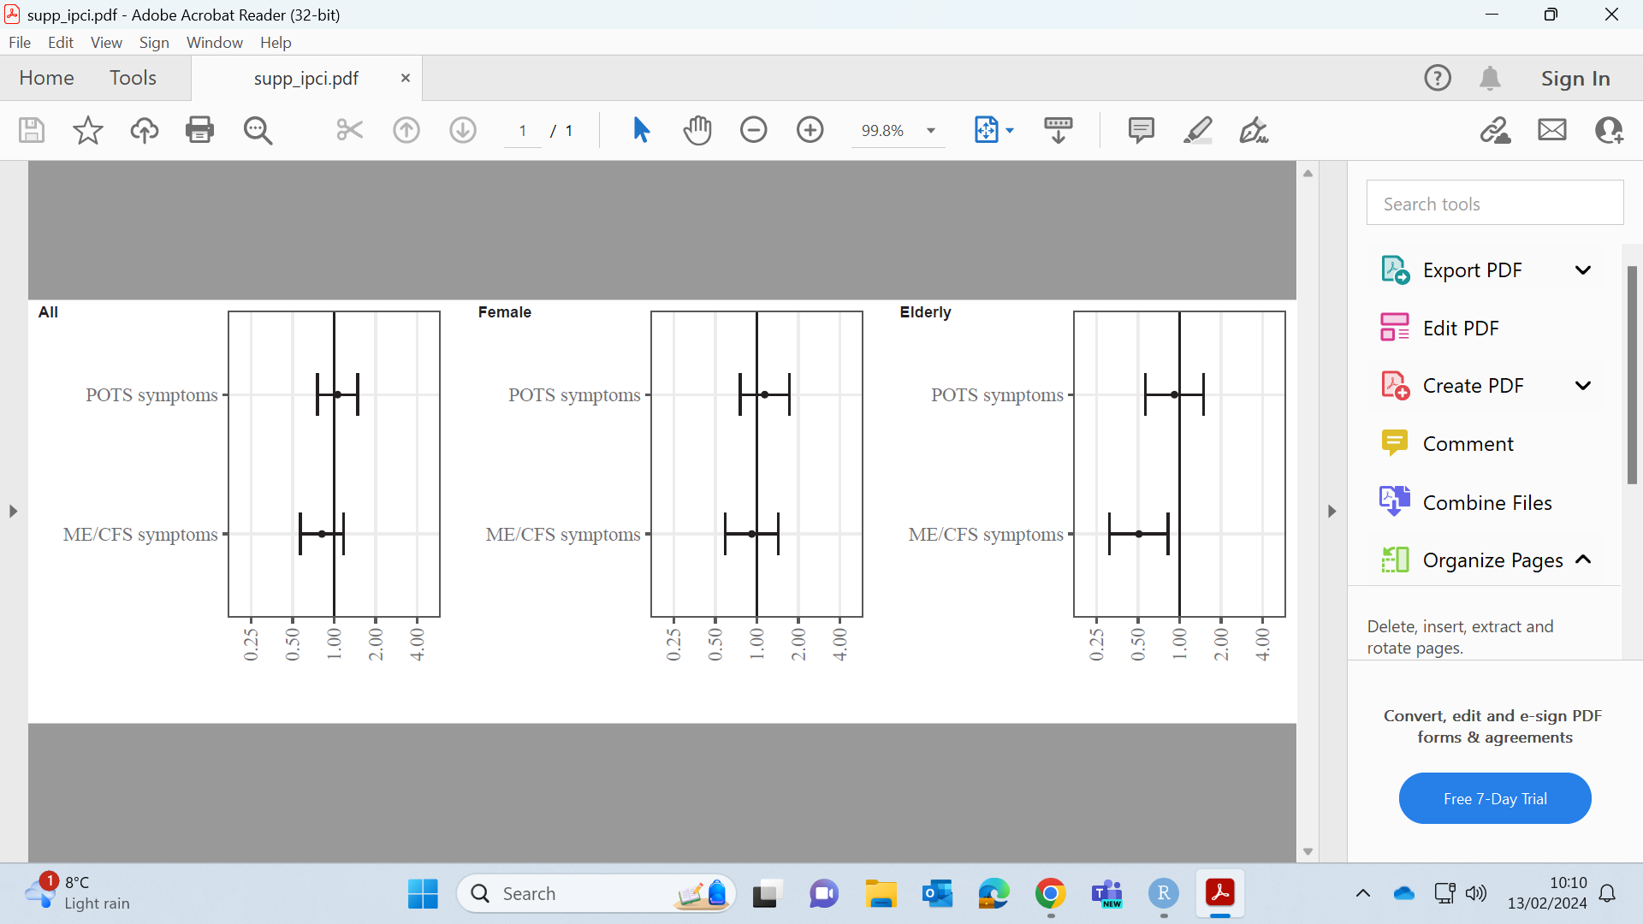

Supplementary Figure 1. Incidence rate ratio results in IPCI database.
Numeric values available in Supplementary Table 3.

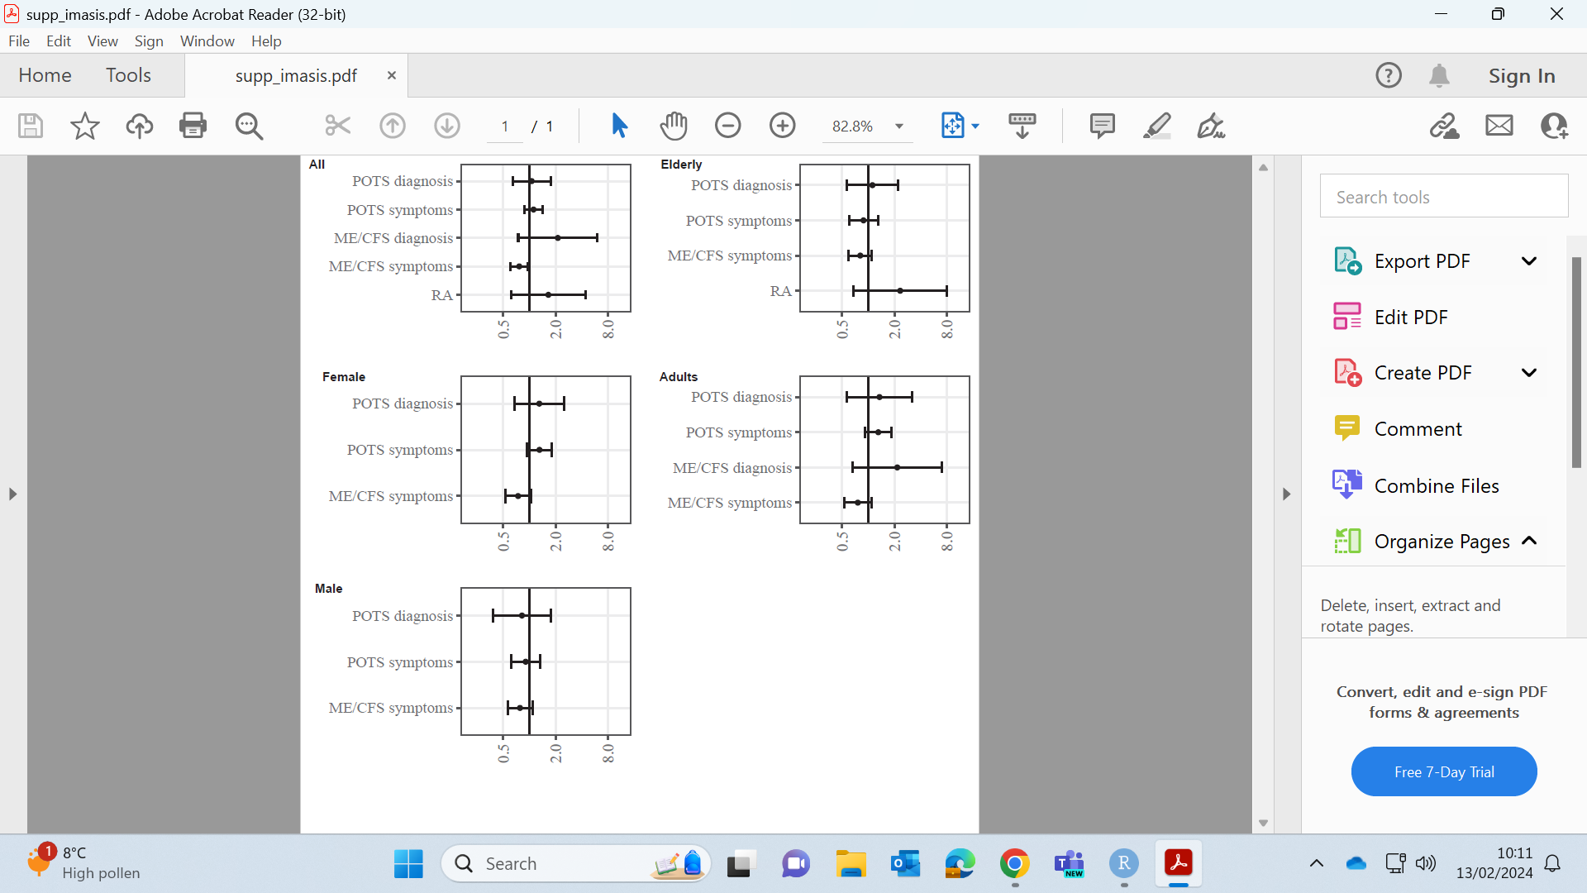

Supplementary Figure 2. Incidence rate ratio results in IMASIS database.
Numeric values available in Supplementary Table 3

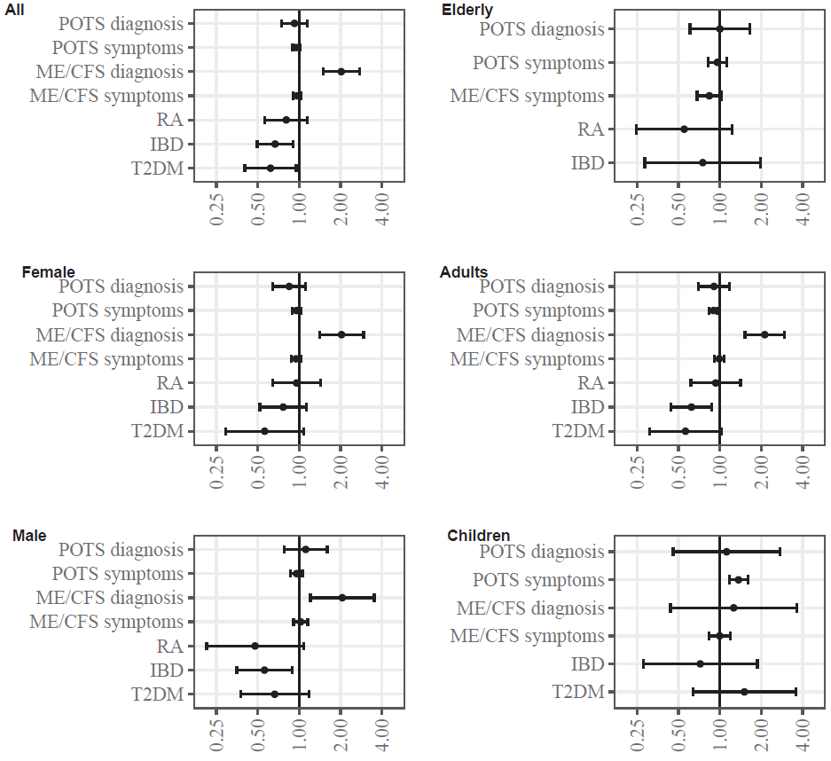

Supplementary Figure 3. Incidence rate ratio results in CPRD GOLD database.
Numeric values available in Supplementary Table 3

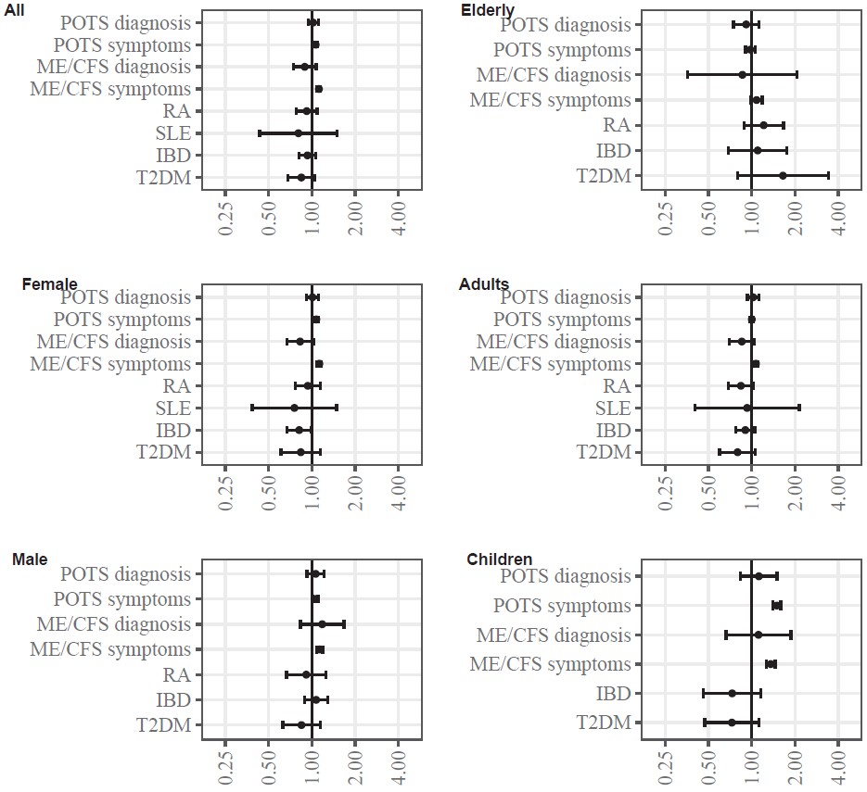

Supplementary Figure 4. Incidence rate ratio results in CPRD Aurum database.
Numeric values available in Supplementary Table 3

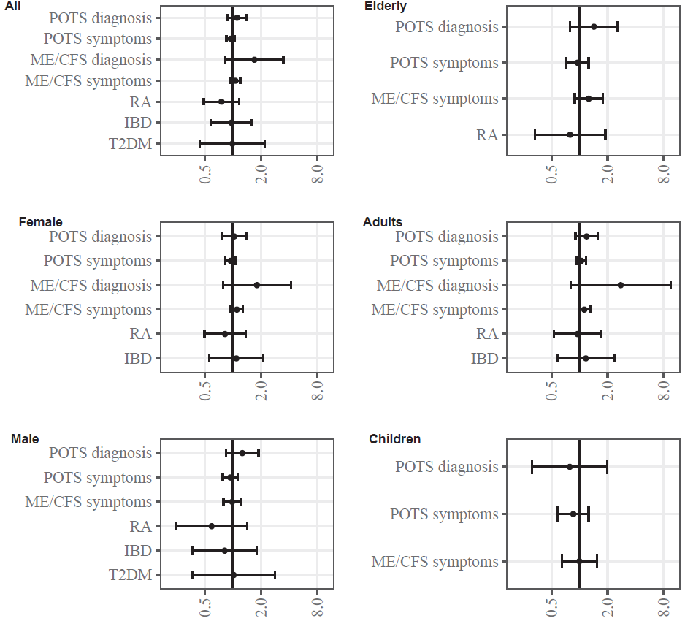

Supplementary Figure 5. Incidence rate ratio results in CORIVA database.
Numeric values available in Supplementary Table 3

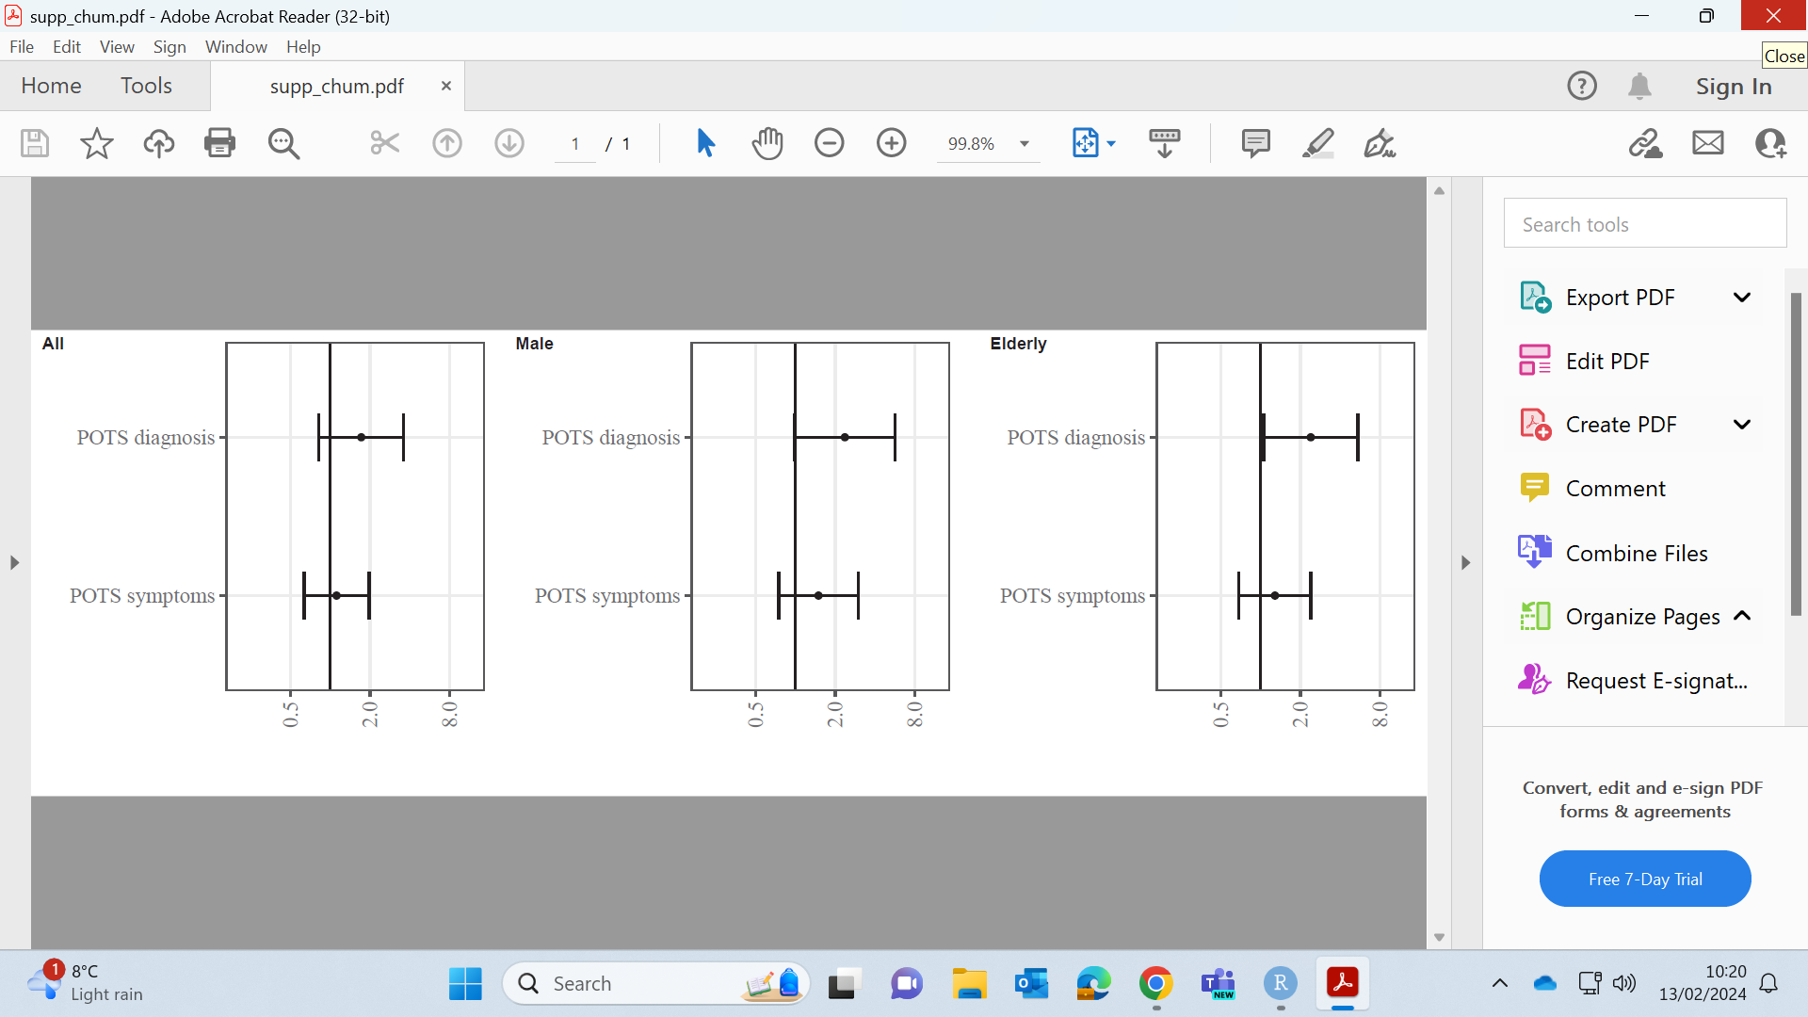

Supplementary Figure 6. Incidence rate ratio results in CHUM database.
Numeric values available in Supplementary Table 3

AUSOM had too few counts for individual results.

Supplementary Table 3. Numeric values of incidence rate ratios with 95% confidence intervals corresponding to Supplementary Figures 1-6
Outcomes per database | All | Female | Male | Elderly  (>64 years | Adults  (19-64 years) | Children  (<19 years)
IPCI
POTS symptoms | 1.06 (0.76-1.49) | 1.14 (0.76-1.72) | NA | 0.92 (0.57-1.49) | NA | NA
ME/CFS symptoms | 0.82 (0.57-1.17) | 0.92 (0.59-1.43) | NA | 0.51 (0.31-0.83) | NA | NA
IMASIS
POTS symptoms | 1.11 (0.87-1.42) | 1.3 (0.94-1.8) | 1.3 (0.94-1.8) | 0.88 (0.6-1.29) | 1.3 (0.92-1.83) | NA
ME/CFS diagnosis | 2.12 (0.74-6.04) | NA | NA | NA | 2.15 (0.66-7.04) | NA
ME/CFS symptoms | 0.76 (0.6-0.96) | 0.74 (0.53-1.04) | 0.74 (0.53-1.04) | 0.81 (0.59-1.1) | 0.76 (0.52-1.09) | NA
RA | 1.65 (0.61-4.42) | NA | NA | 2.32 (0.67-8.01) | NA | NA
POTS diagnosis | 1.06 (0.64-1.75) | 1.3 (0.67-2.5) | 1.3 (0.67-2.5) | 1.11 (0.56-2.21) | 1.34 (0.57-3.18) | NA
CPRD GOLD
POTS symptoms | 0.95 (0.9-1.01) | 0.96 (0.89-1.03) | 0.96 (0.87-1.06) | 0.96 (0.82-1.12) | 0.9 (0.84-0.96) | 1.36 (1.17-1.59)
IBD | 0.67 (0.5-0.9) | 0.77 (0.52-1.13) | 0.56 (0.35-0.89) | 0.75 (0.28-1.98) | 0.62 (0.44-0.87) | 0.72 (0.28-1.87)
ME/CFS diagnosis | 2.03 (1.5-2.74) | 2.04 (1.41-2.94) | 2.06 (1.21-3.52) | NA | 2.12 (1.52-2.95) | 1.26 (0.44-3.63)
ME/CFS symptoms | 0.96 (0.9-1.03) | 0.95 (0.87-1.03) | 1.03 (0.91-1.16) | 0.84 (0.68-1.03) | 0.99 (0.91-1.07) | 0.99 (0.84-1.18)
RA | 0.81 (0.56-1.15) | 0.96 (0.64-1.43) | 0.48 (0.21-1.08) | 0.55 (0.25-1.22) | 0.93 (0.62-1.41) | NA
POTS diagnosis | 0.93 (0.74-1.15) | 0.85 (0.65-1.11) | 1.12 (0.78-1.6) | 1 (0.61-1.65) | 0.9 (0.7-1.17) | 1.12 (0.46-2.74)
DM | 0.62 (0.4-0.95) | 0.56 (0.29-1.08) | 0.66 (0.37-1.18) | NA | 0.56 (0.31-1.03) | 1.51 (0.63-3.57)
CPRD Aurum
POTS symptoms | 1.06 (1.04-1.09) | 1.07 (1.04-1.11) | 1.06 (1.02-1.11) | 0.98 (0.9-1.05) | 1 (0.97-1.03) | 1.49 (1.4-1.59)
IBD | 0.93 (0.82-1.07) | 0.82 (0.67-0.99) | 1.07 (0.89-1.29) | 1.1 (0.69-1.75) | 0.9 (0.78-1.05) | 0.73 (0.46-1.16)
ME/CFS diagnosis | 0.89 (0.74-1.07) | 0.83 (0.67-1.03) | 1.18 (0.83-1.68) | 0.86 (0.36-2.06) | 0.85 (0.7-1.04) | 1.11 (0.66-1.87)
ME/CFS symptoms | 1.12 (1.09-1.15) | 1.13 (1.09-1.17) | 1.13 (1.08-1.19) | 1.08 (0.98-1.18) | 1.07 (1.04-1.1) | 1.35 (1.26-1.45)
RA | 0.92 (0.78-1.09) | 0.94 (0.77-1.14) | 0.91 (0.67-1.25) | 1.21 (0.88-1.66) | 0.84 (0.69-1.02) | NA
SLE | 0.81 (0.43-1.5) | 0.76 (0.38-1.49) | NA | NA | 0.93 (0.4-2.14) | NA
POTS diagnosis | 1.02 (0.94-1.11) | 1.01 (0.91-1.12) | 1.06 (0.93-1.22) | 0.91 (0.74-1.12) | 1.02 (0.93-1.12) | 1.12 (0.84-1.5)
DM | 0.85 (0.68-1.05) | 0.84 (0.61-1.15) | 0.85 (0.63-1.15) | 1.65 (0.8-3.4) | 0.8 (0.6-1.06) | 0.73 (0.47-1.12)
CORIVA
POTS symptoms | 0.94 (0.85-1.05) | 0.94 (0.83-1.07) | 0.93 (0.78-1.12) | 0.95 (0.72-1.25) | 1.04 (0.92-1.18) | 0.86 (0.59-1.25)
IBD | 0.96 (0.58-1.59) | 1.09 (0.56-2.12) | 0.81 (0.37-1.79) | NA | 1.17 (0.58-2.37) | NA
ME/CFS diagnosis | 1.7 (0.83-3.47) | 1.81 (0.78-4.17) | NA | NA | 2.77 (0.8-9.56) | NA
ME/CFS symptoms | 1.06 (0.94-1.2) | 1.1 (0.95-1.28) | 0.98 (0.79-1.21) | 1.26 (0.89-1.78) | 1.13 (0.98-1.3) | 1 (0.65-1.53)
RA | 0.75 (0.48-1.17) | 0.82 (0.49-1.37) | 0.59 (0.24-1.42) | 0.79 (0.33-1.9) | 0.95 (0.53-1.7) | NA
POTS diagnosis | 1.1 (0.87-1.4) | 1.03 (0.76-1.39) | 1.26 (0.84-1.88) | 1.43 (0.79-2.57) | 1.19 (0.9-1.57) | 0.79 (0.31-1.99)
DM | 0.98 (0.44-2.2) | NA | 1.02 (0.37-2.82) | NA | NA | NA
CHUM
POTS symptoms | 1.12 (0.63-1.97) | NA | 1.5 (0.75-2.99) | 1.29 (0.69-2.41) | NA | NA
POTS diagnosis | 1.72 (0.82-3.61) | NA | 2.37 (0.99-5.67) | 2.4 (1.06-5.47) | NA | NA
IBD: inflammatory bowel disease; ME/CFS: myalgic encephalomyelitis / chronic fatigues syndrome; NA: results suppressed because less than 5 outcomes; POTS: postural orthostatic tachycardia syndrome; RA: rheumatoid arthritis; SLE: systemic lupus erythematosus; DM: diabetes mellitus

