Supplementary material

Long-Term Impact of Digital Media on Brain Development in Children

Authors: Samson Nivins PhD^{1*}, Bruno Sauce PhD², Magnus Liebherr PhD³, Nicholas Judd PhD¹, Torkel Klingberg PhD^{1*}

¹ Department of Neuroscience, Karolinska Institutet, Stockholm, Sweden
² Department of Biological Psychology, Vrije Universiteit Amsterdam, Amsterdam, The Netherlands
³ Department of General Psychology: Cognition, University Duisburg-Essen, Duisburg, Germany

Tables

eTable 1. AIC BIC values for linear and quadratic models to describe the relationship between age and brain regions

 | Models
Brain regions | Linear |  | Quadratic
 | AIC | BIC | AIC | BIC
Total cortical surface area | 13538 | 13888 | 13356 | 13714
Striatum | 16566 | 16916 | 16450 | 16808
Cerebellum | 13809 | 14160 | 13069 | 13427
Abbreviations: AIC, Akaike Information Criterion; BIC, Bayesian Information Criterion. The model with lower AIC and BIC values was considered a better fit (at least by 10 points less than the other model).
eTable 2 Sex-specific effect on brain development

Brain regions | Age |  | Age² |  | Age x sex |  | Age² x sex
 | β (SE) | P | β (SE) | p | β (SE) | P | β (SE) | P
Global cortical surface area (mm²) | 0.39  (0.02) | < 0.001 | -0.02  (0.001) | < 0.001 | -0.21  (0.03) | < 0.001 | -0.01  (0.001) | < 0.001
Striatum volume (mm³) | 0.07  (0.03) | 0.009 | -0.004  (0.001) | 0.002 | -0.05  (0.03) | 0.11 | 0.002  (0.001) | 0.14
Cerebellum volume (mm³) | 0.22  (0.02) | < 0.001 | -0.01  (0.001) | < 0.001 | -0.36  (0.03) | < 0.001 | 0.02  (0.001) | < 0.001
P values presented are uncorrected for multiple comparisons.
eTable 3 Absolute brain sizes at different timepoints in boys and girls

Brain regions | Boys | Girls
 | mean (SD) | mean (SD)
Global cortical surface area (mm²)  T₀  T₂  T₄ | 198453 (16690)  198779 (16745)  198617 (16966) | 181951 (15266)  181829 (15234)  179961 (14969)
Cerebellum volume (mm³)  T₀  T₂  T₄ | 152279 (13319)  154307 (12210)  156495 (16581) | 140407 (11993)  142075 (12210)  141433 (12286)

eTable 4 Association between sex-specific individual digital media exposure and brain outcomes in children aged 9-11 years with 4 years of follow-ups.

Brain regions | Social media usage |  | Time  (linear) |  | Time  (Quadrant) |  | Social media usage x Time x Sex |  | Social media usage x Time² x Sex
 | β (SE) | p | β (SE) | P | β (SE) | P | β (SE) | P | β (SE) | P
Global cortical surface area (mm²) | 0.001  (0.02) | 0.91 | 0.08  (0.02) | < 0.001 | -0.07  (0.01) | <0.001 | 0.03  (0.01) | 0.006 | -0.02  (0.006) | 0.01
Striatum  Volume (mm³) | -0.001  (0.02) | 0.94 | -0.01  (0.01) | 0.24 | -0.005  (0.01) | 0.69 | -0.004  (0.01) | 0.70 | 0.003  (0.01) | 0.62
Cerebellum  Volume (mm³) | 0.02  (0.01) | 0.05 | 0.15  (0.01) | <0.001 | -0.04  (0.008) | <0.001 | 0.03  (0.009) | 0.001 | -0.01  (0.006) | 0.08
 | Playing video games |  | Time  (linear) |  | Time  (Quadrant) |  | Playing video games x Time x Sex |  | Playing video games x Time² x Sex
 | β (SE) | p | β (SE) | P | β (SE) | P | β (SE) | P
Global cortical surface area (mm²) | -0.04  (0.02) | <0.001 | 0.04  (0.01) | 0.001 | -0.06  (0.001) | <0.001 | 0.01  (0.01) | 0.42 | -0.001  (0.006) | 0.77
Striatum  Volume (mm³) | -0.008  (0.02) | 0.59 | 0.003  (0.01) | 0.80 | -0.007  (0.007) | 0.33 | -0.004  (0.01) | 0.72 | 0.007  (0.007) | 0.32
Cerebellum  Volume (mm³) | 0.004  (0.01) | 0.74 | 0.13  (0.01) | <0.001 | -0.03  (0.006) | <0.001 | -0.004  (0.01) | 0.96 | 0.006  (0.006) | 0.32
 | Watching television |  | Time  (linear) |  | Time  (Quadrant) |  | Watching television x Time x Sex |  | Watching television x Time² x Sex
 | β (SE) | p | β (SE) | p | β (SE) | P | β (SE) | P | β (SE) | P
Global cortical surface area (mm²) | -0.03  (0.01) | 0.01 | 0.05  (0.02) | 0.005 | -0.06  (0.009) | <0.001 | 0.002  (0.008) | 0.50 | 0.001  (0.004) | 0.72
Striatum  Volume (mm³) | -0.01  (0.01) | 0.33 | -0.02  (0.02) | 0.25 | 0.006  (0.01) | 0.53 | -0.004  (0.009) | 0.63 | 0.007  (0.005) | 0.19
Cerebellum  Volume (mm³) | 0.01  (0.01) | 0.31 | 0.11  (0.01) | <0.001 | -0.02  (0.008) | 0.03 | 0.001  (0.007) | 0.79 | 0.004  (0.004) | 0.28
P values presented are uncorrected for multiple comparisons.

eTable 5 Association between average social media/video gaming exposure of first two time points (T₀ and T₁) and changes in cerebellum volumes between T₂ and T₄ in the overall cohort

Brain regions | Social media usage at T_{avg01} |  | Time |  | SES |  | cogPGS |  | Social media usage at T_{avg01} x Time
 | β (SE) | P | β (SE) | P | β (SE) | P | β (SE) | P | β (SE) | P
Cerebellum  Volume (mm³) | 0.02  (0.01) | 0.07 | 0.09  (0.01) | < 0.001 | 0.03  (0.02) | 0.08 | -0.02  (0.01) | 0.30 | -0.01  (0.004) | 0.10
 | Playing video games at T_{avg01} |  | Time |  | SES |  | cogPGS |  | Playing video games at T_{avg01} x Time
 | β (SE) | P | β (SE) | P | β (SE) | P | β (SE) | P | β (SE) | P
Cerebellum  Volume (mm³) | -0.02  (0.01) | 0.14 | 0.06  (0.01) | < 0.001 | 0.04  (0.02) | 0.07 | -0.03  (0.02) | 0.09 | 0.02  (0.01) | < 0.001
Abbreviations: SES, socioeconomic status; cogPGS, polygenic scores for cognitive performance. T_{avg01} = average of social media/playing video games atT₀ and T₁

P values presented are uncorrected for multiple comparisons.

eTable 6 Association between social media usage at T₀ and total change in cerebellum volumes (delta) adjusting for covariates

Brain regions | Social media usage at T₀ |  | SES |  | PGS
 | β (SE) | p | β (SE) | P | β (SE) | P
Cerebellum (T₄ – T₀) (mm³) | -0.03  (0.02) | 0.16 | 0.06  (0.03) | 0.02 | 0.04  (0.02) | 0.08
Model: Delta (T₄ – T₀) ~ social media at T₀ + age + SES + PGS + 20PCs + Total brain volumes at T₀ + (1| sites)

Abbreviations: SES, socioeconomic status; cogPGS, polygenic scores for cognitive performance.

eTable 7 Association between social media/video gaming exposure and cerebellum volumes in children aged 9-11 years with 4 years of follow-ups in the overall cohort excluding children born preterm or with ADHD diagnosis

Brain regions | Social media usage |  | Time  (linear) |  | Time  (Quadrant) |  | SES |  | cogPGS |  | Social media usage x Time |  | Social media usage x Time²
 | β (SE) | P | β (SE) | P | β (SE) | p | β (SE) | P | β (SE) | P | β (SE) | P | β (SE) | P
Cerebellum  Volume (mm³) | 0.03  (0.01) | 0.04 | 0.07  (0.009) | <0.001 | 0.02  (0.006) | 0.003 | 0.04  (0.02) | 0.07 | -0.01  (0.02) | 0.47 | 0.02  (0.003) | <0.001 | -0.02  (0.004) | <0.001
 | Playing video games |  | Time  (linear) |  | Time  (Quadrant) |  | SES |  | cogPGS |  | Playing video games x Time |  | Playing video games x Time²
 | β (SE) | P | β (SE) | P | β (SE) | P | β (SE) | P | β (SE) | P | β (SE) | P
Cerebellum  Volume (mm³) | 0.002  (0.01) | 0.86 | 0.11  (0.009) | <0.001 | -0.02  (0.006) | <0.001 | 0.06  (0.02) | 0.006 | -0.004  (0.02) | 0.81 | -0.01  (0.01) | 0.13 | 0.01  (0.003) | 0.001
P values presented are uncorrected for multiple comparisons. Abbreviations: SES, socioeconomic status; cogPGS, polygenic scores for cognitive performance.

eTable 8 Association between social media/video gaming exposure and cerebellum volumes in children aged 9-11 years with 4 years of follow-ups in children with MRI data available across all three visits (n=1462)

Brain regions | Social media usage |  | Time  (linear) |  | Time  (Quadrant) |  | SES |  | cogPGS |  | Social media usage x Time |  | Social media usage x Time²
 | β (SE) | P | β (SE) | P | β (SE) | p | β (SE) | P | β (SE) | P | β (SE) | P | β (SE) | P
Cerebellum  Volume (mm³) | 0.03  (0.02) | 0.16 | 0.08  (0.01) | <0.001 | 0.01  (0.006) | 0.02 | 0.02  (0.04) | 0.62 | -0.03  (0.03) | 0.42 | 0.01  (0.01) | 0.09 | -0.01  (0.004) | 0.002
 | Playing video games |  | Time  (linear) |  | Time  (Quadrant) |  | SES |  | cogPGS |  | Playing video games x Time |  | Playing video games x Time²
 | β (SE) | P | β (SE) | P | β (SE) | P | β (SE) | P | β (SE) | P | β (SE) | P
Cerebellum  Volume (mm³) | -0.02  (0.02) | 0.34 | 0.13  (0.01) | <0.001 | -0.03  (0.007) | <0.001 | 0.06  (0.04) | 0.12 | -0.06  (0.03) | 0.10 | -0.02  (0.007) | 0.001 | 0.02  (0.004) | <0.001
P values presented are uncorrected for multiple comparisons. Abbreviations: SES, socioeconomic status; cogPGS, polygenic scores for cognitive performance.
Figures

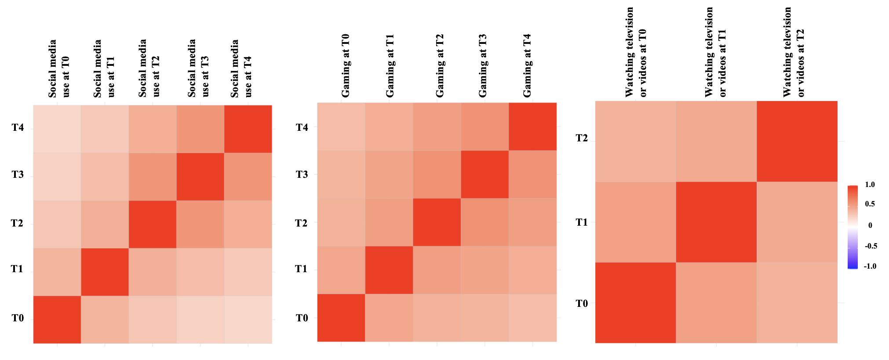

eFigure 1 Correlation between individual digital media (i.e., social media usage, playing video games, or watching television/videos) usage across four different waves of follow-up

