S1 Fig. Additional pressure pathline profiles of CFD simulations. 0-, 20-, 50-, and 70-degree positions shown. Peak pressure recorded in ANSYS software for use in CFD calibration curve (Fig 3B).
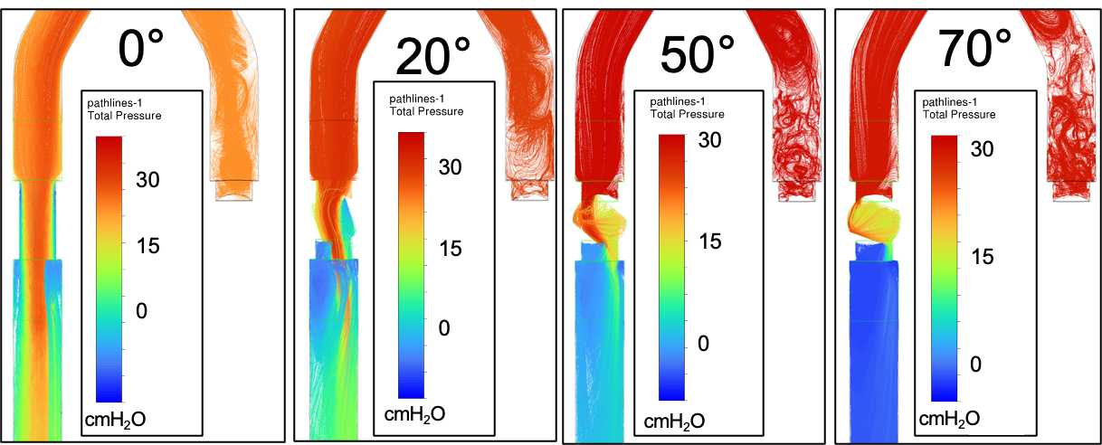

S2 Fig. Full ventilator screen readout at various volume combinations. Full pressure, flow, and tidal volume waveforms output by the ventilator during time-multiplexed co-ventilation as seen in Fig 5A. Ventilator set to respiratory rate of 30 bpm (I:E = 1:1; Patient RR = 15bpm, I:E 1:3). Expiratory flow and volume waveforms are driven by internal algorithms and reliance on their data is not possible with the device as constructed. Volume combinations of 575-283, 574-495, 566-615 shown with test lung 1 and 2 respectively.
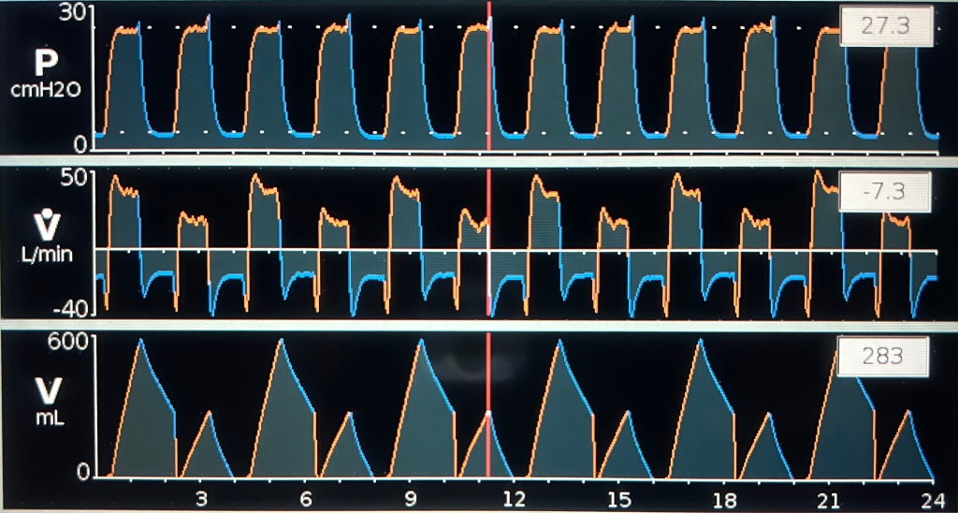
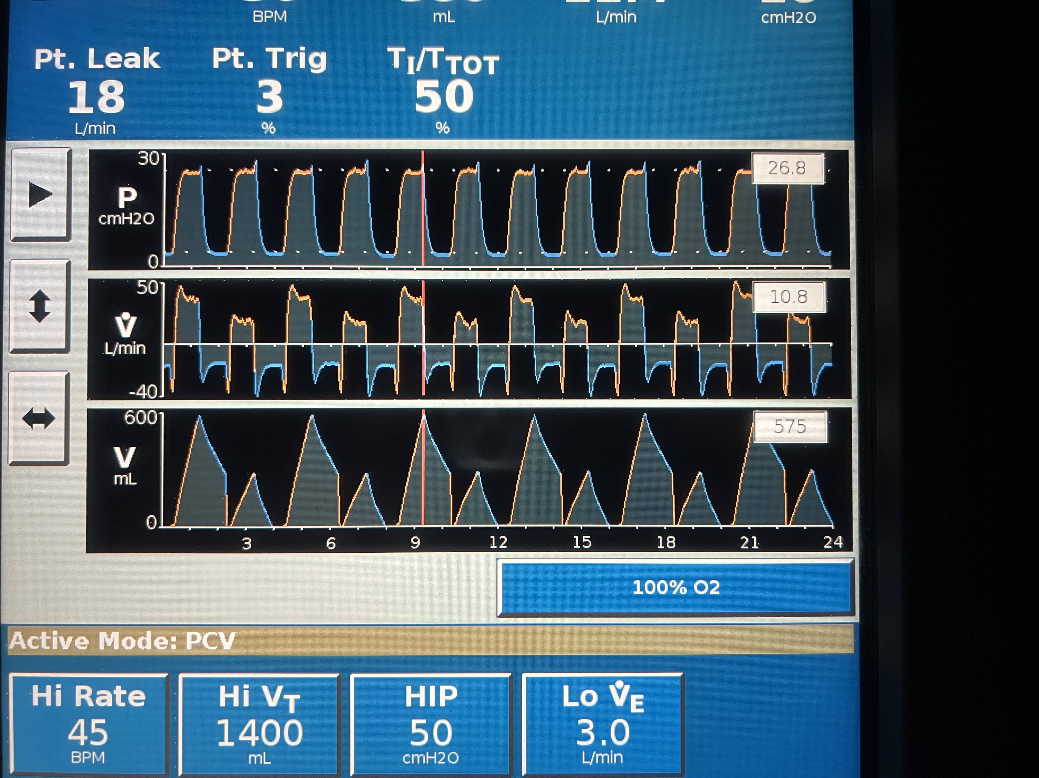

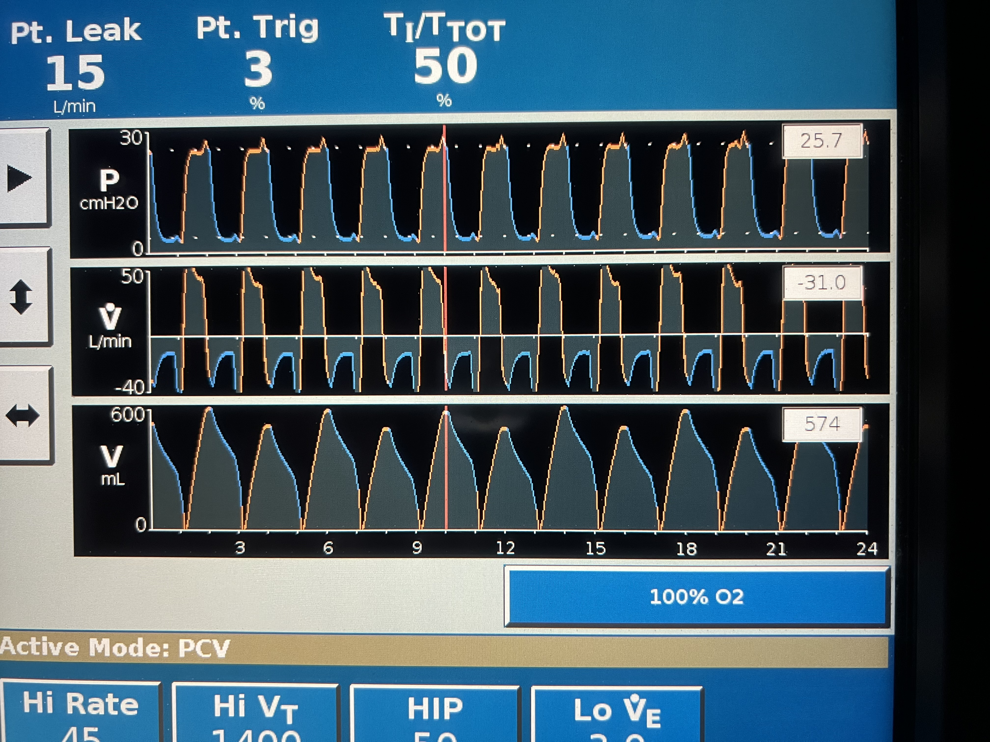
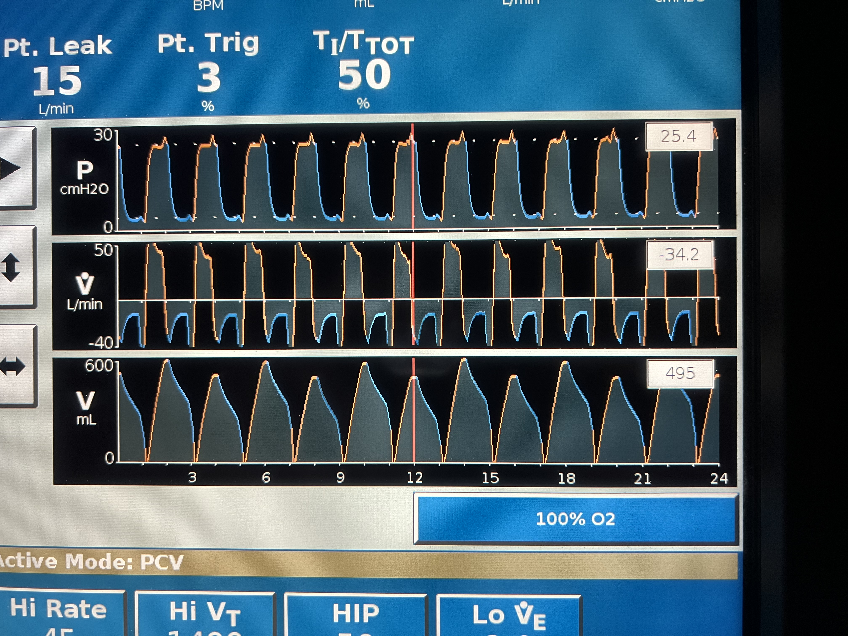

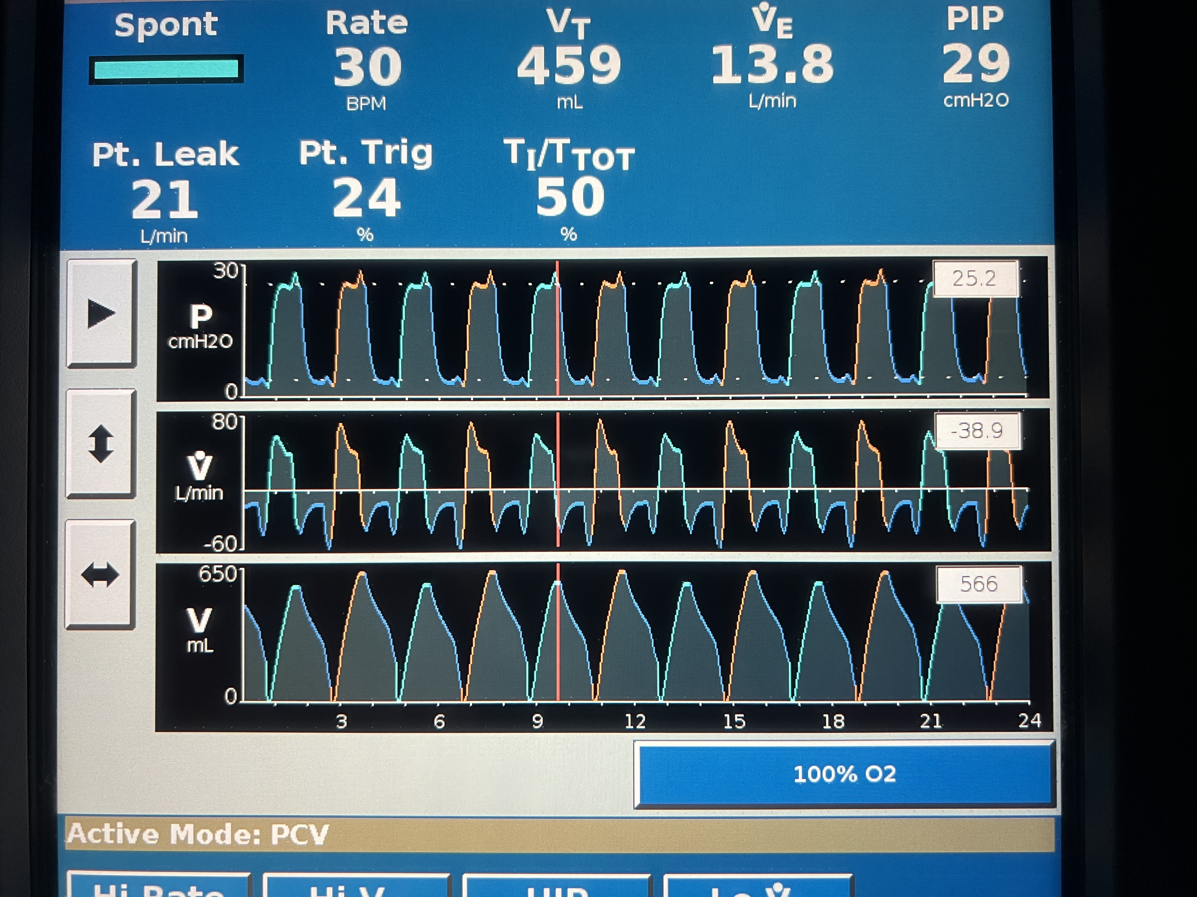

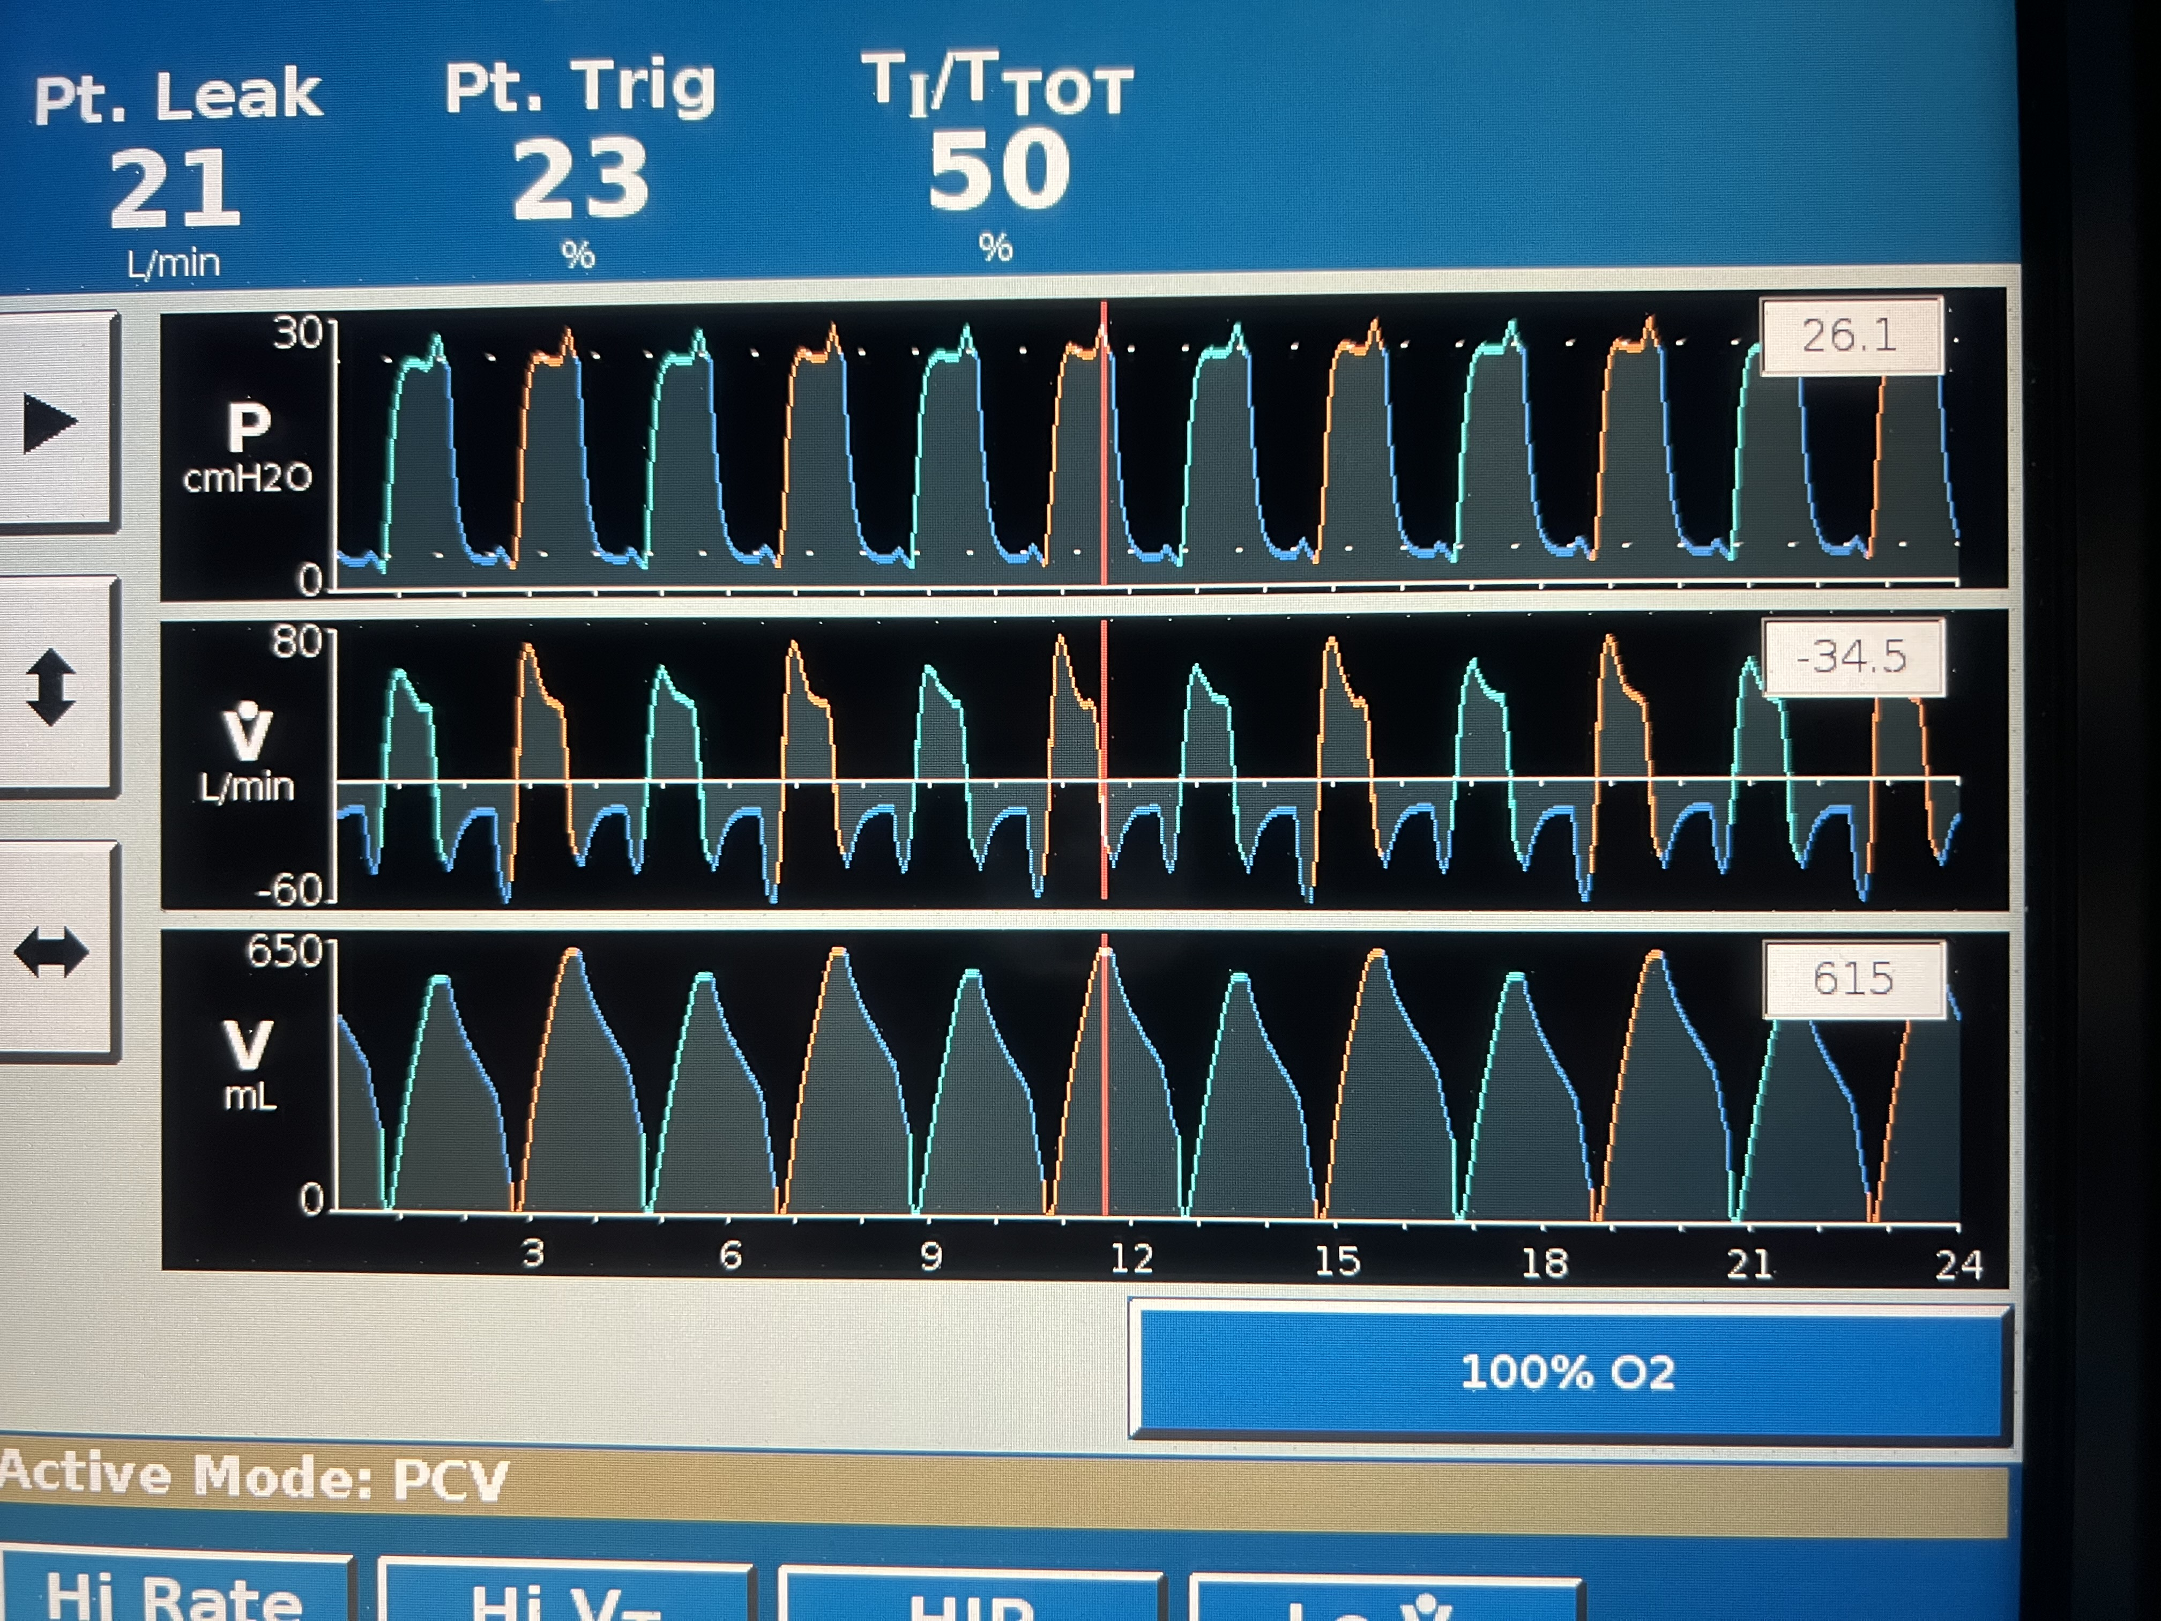
S3 Fig. Mismatched I:E ratio combinations that do not temporally overlap with time-multiplexed co-ventilation. Potential combinations were limited to a respiratory rate >10 breaths per minute and E-time multiples of 0.5 seconds. I:E combinations take the form: $T_{E,P_{2}}=2N\left( T_{E,P_{1}}\right)+1$, where $T_{E,P_{1}}$ is the expiratory time of patient 1, $T_{E,P_{2}}$is the expiratory time of patient 2, N can be any of the positive integers, and $T_{E,P_{2}}>T_{E,P_{1}}$. Schematic visualizations of I:E pairs of 1:1 and 1:3, 1:1 and 1:5, 1:1.5 and 1:4, and 1:3 and 1:5 are shown.
