Supplement Figure 1. Most reported laboratory test types and diagnoses made based on test results among study participants taking 3HP.
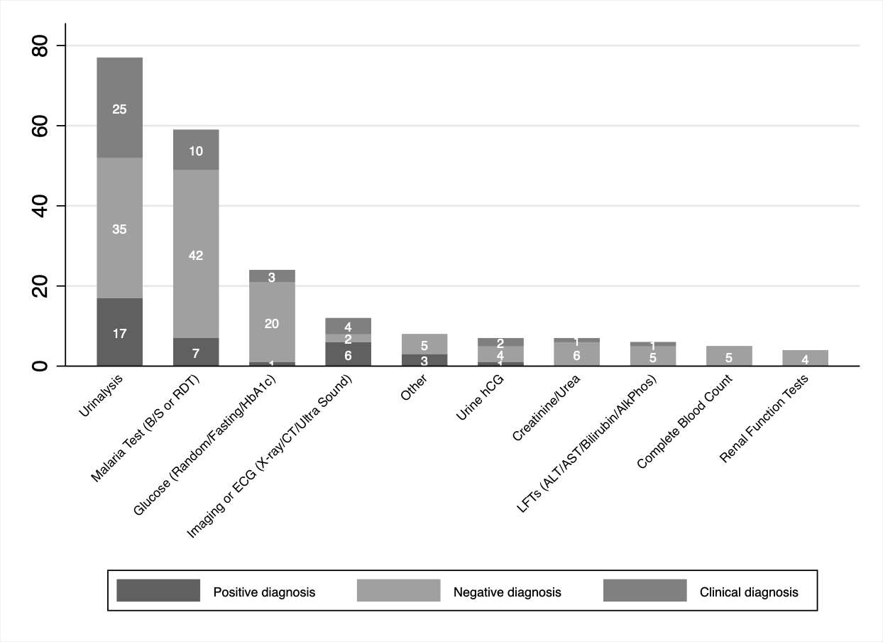
ALT=alanine transaminase, AST=aspartate transferase, B/S=blood smear, CT=computed tomography scan, ECG=echo cardiogram, hCG=human chorionic gonadotropin, LFT=liver function test, RDT=rapid diagnostic test

