Supplementary material

Manuscript title:   
The Efficacy of Psychological Interventions for Child and Adolescent PTSD:   
A Network Meta-Analysis

Thole H. Hoppen*1, Ph.D., Lena Wessarges1, B.Sc., Marvin Jehn1, M.Sc., Julian Mutz2, Ph.D., Ahlke Kip1, Ph.D., Pascal Schlechter, Ph.D. 1, Richard Meiser-Stedman3, Ph.D., & Nexhmedin Morina1, Ph.D.

1Institute of Psychology, University of Münster, Münster, Germany

2Social, Genetic and Developmental Psychiatry Centre, Institute of Psychiatry, Psychology & Neuroscience, King’s College London, London, United Kingdom

3Department of Clinical Psychology and Psychological Therapies, Norwich Medical School, University of East Anglia, Norwich, United Kingdom

Short Title: Efficacy of psychological interventions for pediatric PTSD

*Corresponding Author

Thole H. Hoppen, Ph.D.

Institute of Psychology

University of Münster

Fliednerstr. 21

48149 Münster

Germany

Tel: +492518339415

Fax: +492518331331

e-Mail: [thoppen@uni-muenster.de](mailto:thoppen@uni-muenster.de)

Hyperlinked Contents

**Appendix A:** **Search string used for systematic literature search**

**Appendix B: References of screened reviews as part of the systematic literature search**

**Appendix C: Quality criteria for risk of bias assessment**

**Appendix D: Quality coding of included trials**

**Appendix E: Categorization of interventions and control conditions**

**Appendix F: Trial characteristics of included trials**

**Appendix G: References of studies included in the present network meta-analysis**

**Appendix H: Trial and sample characteristics across comparison dyads**

**Appendix I: Short-term efficacy: Forest plot compared to passive control conditions**

**Appendix J: Short-term efficacy: Forest plot compared to active control conditions**

**Appendix K: Short-term efficacy: Net splitting results**

**Appendix L: Short-term efficacy: Net heat plot**

**Appendix M: Short-term efficacy: Funnel plot**

**Appendix N: Short-term efficacy: Outlier-adjusted results**

**Appendix O: Mid-term efficacy: Forest plot compared to passive control conditions**

**Appendix P: Mid-term efficacy: Forest plot compared to active control conditions**

**Appendix Q: Mid-term efficacy: Funnel plot**

**Appendix R: Mid-term efficacy: Net splitting results**

**Appendix S: Mid-term efficacy: Net heat plot** **before (top) and after (bottom) exclusion of MDTs**

**Appendix T: Mid-term efficacy: MDTs excluded due to detected inconsistency**

**Appendix U: Long-term efficacy: Forest plot compared to passive control conditions**

**Appendix V: Long-term efficacy: Forest plot compared to active control conditions**

**Appendix W: Long-term efficacy: Net splitting results**

**Appendix X: Long-term efficacy: Net heat plot**

**Appendix Y: Long-term efficacy: Funnel plot**

**Appendix A:** **Search string used for systematic literature search**

|  |  |
| --- | --- |
| Databases | Search Terms |
| MEDLINE and PsycINFO | ( TI ( ptsd OR ptss OR post-traumatic stress OR posttraumatic stress OR post-traumatic syndrome OR posttraumatic syndrome) OR AB ( ptsd OR ptss OR post-traumatic stress OR posttraumatic stress OR post-traumatic syndrome OR posttraumatic syndrome ) OR SU ( ptsd OR ptss OR post-traumatic stress OR posttraumatic stress OR post-traumatic syndrome OR posttraumatic syndrome ) ) AND ( TI ( treatment* OR intervention* OR therap* OR psychotherap* OR exposure OR counse*ing OR trial* ) OR AB ( treatment* OR intervention* OR therap* OR psychotherap* OR exposure OR counse*ing OR trial* ) OR SU ( treatment* OR intervention* OR therap* OR psychotherap* OR exposure OR counse*ing OR trial* ) ) |
| PTSDpubs | (ptsd OR ptss OR post-traumatic stress OR posttraumatic stress OR post-traumatic syndrome OR posttraumatic syndrome) AND (treatment* OR intervention* OR therap* OR psychotherap* OR exposure OR counse*ing OR trial*) |
| Web of Science | ALL=( ptsd OR ptss OR post-traumatic stress OR posttraumatic stress OR post-traumatic syndrome OR posttraumatic syndrome ) AND ALL=( treatment* OR intervention* OR therap* OR psychotherap* OR exposure OR counse*ing OR trial* ) |
| Note that the search string contains both APA thesaurus and MeSH search terms. | |

**Appendix B: References of screened reviews as part of the systematic literature search**

1. Alozkan‐Sever C, Uppendahl JR, Cuijpers P, et al. Research Review: Psychological and psychosocial interventions for children and adolescents with depression, anxiety, and post‐traumatic stress disorder in low‐and middle‐income countries–a systematic review and meta‐analysis. *J Child Psychol Psychiatry*. 2023;64(12):1776-1788. doi:10.1111/jcpp.13891.
2. Alzaghoul AF, McKinlay AR, Archer M. Post-traumatic stress disorder interventions for children and adolescents affected by war in low-and middle-income countries in the Middle East: systematic review. *BJPsych Open*. 2022;8(5):1-16. doi:10.1192/bjo.2022.552.
3. Annous N, Al-Hroub A, El Zein F. A systematic review of empirical evidence on art therapy with traumatized refugee children and youth. *Front Psychol*. 2022;13(5). doi:10.3389/fpsyg.2022.811515.
4. Badesha K, Wilde S, Dawson DL. Mental health mobile app use to manage psychological difficulties: An umbrella review. *Ment Health Rev (Brighton)*. 2022;27(3):241-280. doi:10.1108/MHRJ-02-2021-0014.
5. Baetz CL, Branson CE, Weinberger E, et al. The effectiveness of PTSD treatment for adolescents in the juvenile justice system: A systematic review. *Psychol Trauma*. 2022;14(4):642-652. doi:10.1037/tra0001073.
6. Bandelow B, Allgulander C, Baldwin DS, et al. World Federation of Societies of Biological Psychiatry (WFSBP) guidelines for treatment of anxiety, obsessive-compulsive and posttraumatic stress disorders–Version 3. Part I: Anxiety disorders. *World J Biol Psychiatry*. 2023;24(2):79-117. doi:10.1080/15622975.2022.2086295.
7. Braito I, Rudd T, Buyuktaskin D, Ahmed M, Glancy C, Mulligan A. Review: systematic review of effectiveness of art psychotherapy in children with mental health disorders. *Ir J Med Sci*. 2022;191(3):1369-1383. doi:10.1007/s11845-021-02688-y.
8. Byrne G. A systematic review of treatment interventions for individuals with intellectual disability and trauma symptoms: A review of the recent literature. *Trauma Violence Abuse*. 2022;23(2):541-554. doi:10.1177/1524838020960219.
9. Cantor AG, Nelson HD, Pappas M, et al. Telehealth for Women’s Preventive Services for Reproductive Health and Intimate Partner Violence: a Comparative Effectiveness Review. *J Gen Intern Med*. 2023;38(7):1735-1743. doi:10.1007/s11606-023-08033-6.
10. Caro P, Turner W, Caldwell DM, Macdonald G. Comparative effectiveness of psychological interventions for treating the psychological consequences of sexual abuse in children and adolescents: a network meta‐analysis. *Cochrane Database Syst Rev*. 2023;6:CD013361.
11. Capaldi JM, Shabanian J, Finster LB, et al. Post-traumatic stress symptoms, post-traumatic stress disorder, and post-traumatic growth among cancer survivors: a systematic scoping review of interventions. *Health Psychol Rev*. 2023:1-34. doi:10.1080/17437199.2022.2162947.
12. Cowling MM, Anderson JR. The effectiveness of therapeutic interventions on psychological distress in refugee children: A systematic review. *J Clin Psychol*. 2023;79(8):1857-1874. doi:10.1002/jclp.23479.
13. Davis RS, Meiser-Stedman R, Afzal N, et al. Systematic Review and Meta-analysis: Group-based interventions for treating posttraumatic stress symptoms in children and adolescents. *J Am Acad Child Adolesc Psychiatry*. 2023;62(11):1217-1232. doi:10.1016/j.jaac.2023.02.013.
14. de Haan A, Meiser-Stedman R, Landolt MA, et al. Efficacy and moderators of efficacy of cognitive behavioural therapies with a trauma focus in children and adolescents: an individual participant data meta-analysis of randomised trials. *Lancet Child Adolesc Health*. 2023;8(1):28-39.
15. Diano F, Sica LS, Ponticorvo M. A systematic review of mobile apps as an adjunct to psychological interventions for emotion dysregulation. *Int J Environ Res Public Health*. 2023;20(2). doi:10.3390/ijerph20021431.
16. English A, McKibben E, Sivaramakrishnan D, Hart N, Richards J, Kelly P. A Rapid Review Exploring the Role of Yoga in Healing Psychological Trauma. *Int J Environ Res Public Health*. 2022;19(23). doi:10.3390/ijerph192316180.
17. Genç E. The effectiveness of trauma treatment approaches in refugee children and adolescents: A systematic review. *Child Youth Serv Rev*. 2022;141.
18. Grainger L, Thompson Z, Morina N, Hoppen T, Meiser‐Stedman R. Associations between therapist factors and treatment efficacy in randomized controlled trials of trauma‐focused cognitive behavioral therapy for children and youth: A systematic review and meta‐analysis. *J Trauma Stress*. 2022;35(5):1405-1419.
19. Grande AJ, Hoffmann MS, Evans-Lacko S, et al. Efficacy of school-based interventions for mental health problems in children and adolescents in low and middle-income countries: A systematic review and meta-analysis. *Front Psychiatry*. 2023;13. doi:10.3389/fpsyt.2022.1012257.
20. Hermosilla S, Forthal S, Sadowska K, Magill EB, Watson P, Pike KM. We need to build the evidence: A systematic review of psychological first aid on mental health and well‐being. *J Trauma Stress*. 2023;36(1):5-16. doi:10.1002/jts.22888.
21. Hertenstein E, Trinca E, Wunderlin M, et al. Cognitive behavioral therapy for insomnia in patients with mental disorders and comorbid insomnia: A systematic review and meta-analysis. *Sleep Med Rev*. 2022;62.
22. Heywood SE, Connaughton J, Kinsella R, Black S, Bicchi N, Setchell J. Physical therapy and mental health: a scoping review. *Phys Ther*. 2022;102(11).
23. Hoogsteder LM, Thije L ten, Schippers EE, Stams GJJ. A meta-analysis of the effectiveness of EMDR and TF-CBT in reducing trauma symptoms and externalizing behavior problems in adolescents. *Int J Offender Ther Comp Criminol*. 2022;66(6-7):735-757.
24. Hoppen TH, Meiser-Stedman R, Jensen TK, Birkeland MS, Morina N. Efficacy of psychological interventions for post-traumatic stress disorder in children and adolescents exposed to single versus multiple traumas: meta-analysis of randomised controlled trials. *Br J Psychiatry*. 2023;222(5):196-203.
25. Huang T, Li H, Tan S, et al. The efficacy and acceptability of exposure therapy for the treatment of post-traumatic stress disorder in children and adolescents: a systematic review and meta-analysis. *BMC Psychiatry*. 2022;22(1):1-12.
26. Hudays A, Gallagher R, Hazazi A, Arishi A, Bahari G. Eye Movement Desensitization and Reprocessing versus Cognitive Behavior Therapy for Treating Post-Traumatic Stress Disorder: A Systematic Review and Meta-Analysis. *Int J Environ Res Public Health*. 2022;19(24).
27. Hutchinson R, King N, Majumder P. How effective is group intervention in the treatment for unaccompanied and accompanied refugee minors with mental health difficulties: A systematic review. *Int J Soc Psychiatry*. 2022;68(3):484-499.
28. Kalisch LA, Lawrence KA, Baud J, Spencer-Smith M, Ure A. Therapeutic supports for neurodiverse children who have experienced interpersonal trauma: A scoping review. *Rev J Autism Dev Disord*. 2023:1-23. doi:10.1007/s40489-023-00363-9.
29. Kip A, Iseke LN, Papola D, Gastaldon C, Barbui C, Morina N. Efficacy of psychological interventions for PTSD in distinct populations-An evidence map of meta-analyses using the umbrella review methodology. *Clin Psychol Rev*. 2022;100.
30. Kularatna S, Hettiarachchi R, Senanayake S, Murphy C, Donovan C, March S. Cost-effectiveness analysis of paediatric mental health interventions: a systematic review of model-based economic evaluations. *BMC Health Serv Res*. 2022;22(1):1-17.
31. Le Roux IH, Cobham VE. Psychological Interventions for Children Experiencing PTSD After Exposure to a Natural Disaster: A Scoping Review. *Clin Child Fam Psychol Rev*. 2022;(25):249-282. doi:10.1007/s10567-021-00373-1.
32. Lee J, Dhauna J, Silvers JA, Houston MH, Barnert ES. Therapeutic dance for the healing of sexual trauma: A systematic review. *Trauma Violence Abuse*. 2023;24(4):2143-2164.
33. Lobanov-Rostovsky S, Kiss L. The mental health and well-being of internally displaced female Yazidis in the Kurdistan Region of Iraq: a realist review of psychosocial interventions and the impact of COVID-19. *GLOB MENT HEALTH*. 2022;9:1-13.
34. Lotzin A, Franc de Pommereau A, Laskowsky I. Promoting recovery from disasters, pandemics, and trauma: a systematic review of brief psychological interventions to reduce distress in adults, children, and adolescents. *Int J Environ Res Public Health*. 2023;20(7). doi:10.3390/ijerph20075339.
35. Macgowan MJ, Naseh M, Rafieifar M. Eye Movement Desensitization and Reprocessing to Reduce Post-Traumatic Stress Disorder and Related Symptoms among Forcibly Displaced People: A Systematic Review and Meta-Analysis. *Res Soc Work Pract*. 2022;32(8):863-877.
36. Mavranezouli I, Megnin‐Viggars O, Daly C, et al. Research Review: Psychological and psychosocial treatments for children and young people with post‐traumatic stress disorder: a network meta‐analysis. *J Child Psychol Psychiatry*. 2020;61(1):18-29.
37. Mazzeo G, Bendixen R. Community-Based Interventions for Childhood Trauma: A Scoping Review. *OTJR*. 2023;43(1):14-23. doi:10.1177/15394492221091718.
38. Mendlowicz MV, Gekker M, Xavier Gomes de Araújo, Alexandre, et al. The top-100 cited articles on post-traumatic stress disorder: a historical bibliometric analysis. *Psychol Health Med*. 2022:1-20.
39. Mitchell S, Mitchell R, Shannon C, Dorahy M, Hanna D. Effects of baseline psychological symptom severity on dropout from trauma-focused cognitive behavior therapy for posttraumatic stress disorder: A meta-analysis. *Traumatology*. 2023;29(2):112-124.
40. Morison L, Simonds L, Stewart S-JF. Effectiveness of creative arts-based interventions for treating children and adolescents exposed to traumatic events: A systematic review of the quantitative evidence and meta-analysis. *Arts Health*. 2022;14(3):237-262.
41. Oystrick V, Coholic D, Schinke R. A Scoping Review of Mindfulness-Based and Arts-Based Parenting Interventions for Adolescent Mothers. *Child Adolesc Social Work J*. 2023:1-23. doi:10.1007/s10560-023-00923-2.
42. Ozamiz-Etxebarria N, Legorburu Fernandez I, Idoiaga-Mondragon N, Olaya B, Cornelius-White JHD, Santabárbara J. Post-Traumatic Stress in Children and Adolescents during the COVID-19 Pandemic: A Meta-Analysis and Intervention Approaches to Ensure Mental Health and Well-Being. *Sustainability*. 2023;15(6). doi:10.3390/su15065272.
43. Paggiaro AO, Paggiaro PBS, Fernandes RAQ, Freitas NO, Carvalho VF, Gemperli R. Posttraumatic stress disorder in burn patient: a systematic review. *J Plast Reconstr Aesthet Surg*. 2022;75(5):1586-1595.
44. Peters W, Rice S, Alvarez‐Jimenez M, et al. Relative efficacy of psychological interventions following interpersonal trauma on anxiety, depression, substance use, and PTSD symptoms in young people: A meta‐analysis. *Early Interv Psychiatry*. 2022;16(11):1175-1184.
45. Ramírez-Guarín V, Codina N, Pestana JV. A systematic review of psychosocial interventions for child soldiers: types, length and main findings. *J Soc Work Pract*. 2023;37(1):79-95. doi:10.1080/02650533.2022.2031934.
46. Roche L, McLay L, Sigafoos J, Whitcombe‐Dobbs S. A review of behavioral treatments for sleep disturbances in civilians who have experienced trauma. *Behav Interv*. 2022;37(3):835-863.
47. Rossouw J, Sharp T, Halligan S, Seedat S. Psychotherapeutic interventions for childhood posttraumatic stress disorder: an update. *Curr Opin Psychiatry*. 2022;35(6):417-424.
48. Samarah EMS. Narrative exposure therapy to address PTSD symptomology with refugee and migrant children and youth: A review. *Traumatology*:in print.
49. Semmlinger V, Ehring T. Predicting and preventing dropout in research, assessment and treatment with refugees. *Clin Psychol Psychother*. 2022;29(3):767-782.
50. Soltan F, Cristofalo D, Marshall D, et al. Community‐based interventions for improving mental health in refugee children and adolescents in high‐income countries. *Cochrane Database Syst Rev*. 2022;(5):CD013657.
51. Somers K, Spruit A, Stams GJ, Vandevelde S, Lindauer R, Assink M. Identifying effective moderators of cognitive behavioural trauma treatment with caregiver involvement for youth with PTSD: A meta-analysis. *Eur Child Adolesc Psychiatry*:in print.
52. Stewart TM, Fry D, Wilson J, et al. Adolescent Mental Health Priorities During the Covid-19 Pandemic. *Sch Ment Health*. 2023;15(1):247-259.
53. Sunderland N, Stevens F, Knudsen K, Cooper R, Wobcke M. Trauma aware and anti-oppressive arts-health and community arts practice: Guiding principles for facilitating healing, health and wellbeing. *Trauma Violence Abuse*. 2023;24(4):2429-2447.
54. Szota K, Schulte KL, Christiansen H. Interventions involving caregivers for children and adolescents following traumatic events: A systematic review and meta-analysis. *Clin Child Fam Psychol Rev*. 2023;26(1):17-32. doi:10.1007/s10567-022-00415-2.
55. Thielemann JF, Kasparik B, König J, Unterhitzenberger J, Rosner R. A systematic review and meta-analysis of trauma-focused cognitive behavioral therapy for children and adolescents. *Child Abuse Negl*. 2022;134:105899. doi:10.1016/j.chiabu.2022.105899.
56. Thomas FC, Puente‐Duran S, Mutschler C, Monson CM. Trauma‐focused cognitive behavioral therapy for children and youth in low and middle‐income countries: A systematic review. *Child Adolesc Ment Health*. 2022;27(2):146-160.
57. Trubey R, Evans R, McDonald S, et al. Effectiveness of Mental Health and Wellbeing Interventions for Children and Young People in Foster, Kinship, and Residential Care: Systematic Review and Meta-Analysis. *Trauma Violence Abuse*:in print.
58. van der Hoeven ML, Assink M, Stams G-JJM, Daams JG, Lindauer RJL, Hein IM. Victims of child abuse dropping out of trauma-focused treatment: a meta-analysis of risk factors. *J Child Adolesc Trauma*. 2023;16(2):269-283.
59. Venturo-Conerly KE, Eisenman D, Wasil AR, Singla DR, Weisz JR. Meta-analysis: the effectiveness of youth psychotherapy interventions in low-and middle-income countries. *J Am Acad Child Adolesc Psychiatry*. 2023;62(8):859-873.
60. Vieira S, Liang X, Guiomar R, Mechelli A. Can we predict who will benefit from cognitive-behavioural therapy? A systematic review and meta-analysis of machine learning studies. *Clin Psychol Rev*. 2022;97:102193.
61. Villarreal-Zegarra D, Alarcon-Ruiz CA, Melendez-Torres GJ, et al. Development of a framework for the implementation of synchronous digital mental health: realist synthesis of systematic reviews. *JMIR Ment Health*. 2022;9(3):e34760.
62. Wamser‐Nanney R, Walker HE. Attrition from pediatric trauma‐focused cognitive behavioral therapy: A meta‐analysis. *J Trauma Stress*. 2023;36(1):17-30. doi:10.1002/jts.22890.
63. Wang W, Chen K, Zhang H. Effectiveness of Trauma-Focused Cognitive Behavioral Therapy Among Maltreated Children: A Meta-Analysis. *Res Soc Work Pract*. 2023;33(8):913-928. doi:10.1177/104973152211472.
64. Wichmann MLY, Pawils S, Richters J, Metzner F. School-based interventions for child and adolescent victims of interpersonal violence. *Trauma Violence Abuse*. 2023;24(3).
65. Willmot RA, Sharp RA, Kassim AA, Parkinson JA. A scoping review of community-based mental health intervention for children and adolescents in South Asia. *Glob Ment Health*. 2023;10(1):e1. doi:10.1017/gmh.2022.49.
66. Xian-Yu C-Y, Deng N-J, Zhang J, et al. Cognitive behavioral therapy for children and adolescents with post-traumatic stress disorder: meta-analysis. *J Affect Disord*. 2022;308:502-511.
67. Xie S, Cheng Q, Tan S, et al. The efficacy and acceptability of group trauma-focused cognitive behavior therapy for the treatment of post-traumatic stress disorder in children and adolescents: A systematic review and meta-analysis. *General Hospital Psychiatry*. 2024;86:127-134.
68. Xiang Y, Cipriani A, Teng T, et al. Comparative efficacy and acceptability of psychotherapies for post-traumatic stress disorder in children and adolescents: a systematic review and network meta-analysis. *BMJ Ment Health*. 2021;24(4):153-160.
69. Xiong T, Milios A, McGrath PJ, Kaltenbach E. The influence of social support on posttraumatic stress symptoms among children and adolescents: a scoping review and meta-analysis. *Eur J Psychotraumatol*. 2022;13(1):2011601.
70. Yohannan J, Carlson JS, Volker MA. Cognitive behavioral treatments for children and adolescents exposed to traumatic events: A meta‐analysis examining variables moderating treatment outcomes. *J Trauma Stress*. 2022;35(2):706-717.
71. Yosep, I., Mardhiyah, A., Ramdhanie, G. G., Sari, C. W. M., Hendrawati, H., & Hikmat, R. Cognitive Behavior Therapy by Nurses in Reducing Symptoms of Post-Traumatic Stress Disorder on Children as Victims of Violence: A Scoping Review. *Healthcare*. 2023;11(3):e407. https://www.mdpi.com/2227-9032/11/3/407. Published January 31, 2023.
72. Young G. Psychotherapeutic change mechanisms and causal psychotherapy: Applications to child abuse and trauma. *J Child Adolesc Trauma*. 2022;15(3):911-923.
73. Zadeh R, Jogia J. The Use of Art Therapy in Alleviating Mental Health Symptoms in Refugees: A Literature Review. *Int J Ment Health Promot*. 2023;25(3):309-326. doi:10.32604/ijmhp.2023.022491.
74. Zisopoulou T, Varvogli L. Stress Management Methods in Children and Adolescents: Past, Present, and Future. *Horm Res Paediatr*. 2023;96(1):97-107.

**Appendix C: Quality criteria for risk of bias assessment**

Quality criteria based on Cuijpers et al. (2010), sum score ranges from 0 to 8, high-quality trials fulfilled at least six of these eight criteria.

|  |  |
| --- | --- |
| 1. All participants met diagnostic criteria for PTSD at baseline as assessed via a diagnostic interview based on any iteration of the DSM or ICD | 1. Positive   0. Negative / insufficient information |
| 1. Use of treatment manual   *(i.e., published, or specifically designed for the study;* ***all*** *psychological interventions of the RCT/included in the analyses were manual-based*  *→ insufficient: manual mentioned but without a reference/specification)* | 1. Positive   0. Negative / insufficient information |
| 1. Therapists were trained in applying the manual   *(i.e., specifically for the study or general training for respective manual)* | 1. Positive   0. Negative / insufficient information |
| 1. Treatment integrity was checked formally   *(i.e., by regular supervision and/or recordings and/or systematic screenings of protocol adherence with a standardized instrument)* | 1. Positive   0. Negative / insufficient information |
| 1. Data analyzed with intent-to-treat analysis   *(i.e., all persons who were randomized to the conditions initially were included in analyses; insufficient: if authors stated that both ITT and completer analyses were performed but only reported on completer results)* | 1. Positive   0. Negative / insufficient information |
| 1. Study had an adequate level of statistical power to find effects and included *N* ≥ 50 participants in the comparison groups (i.e., *n1+n2*)   *(note: may differ across assessment timepoints due to attrition in completer analyses)* | 1. Positive   0. Negative / insufficient information |
| 1. Randomization by independent (3rd) party   *(e.g., independent person or computerized with valid randomization technique)* | 1. Positive   0. Negative / insufficient information |
| 1. Blind assessors for outcomes   *(i.e., PTSD outcomes were assessed either in a diagnostic interviewer with blinded assessors or via a self-report measure; negative score: non-blinded interviewers)* | 1. Positive   0. Negative / insufficient information |

**Appendix D: Quality coding of included trials**

|  |  |  |  |  |  |  |  |  |  |
| --- | --- | --- | --- | --- | --- | --- | --- | --- | --- |
|  | Q1 | Q2 | Q3 | Q4 | Q5 | Q6 | Q7 | Q8 | Quality sum score  (possible range = 0-8) |
| Reference | 100% PTSD rate at baseline | manual-based treatment | therapists trained to apply manual | formal integrity check | usable intent-to-treat (ITT) data reported | *N* > 50, high power to detect effects | independent randomization | blinded outcome assessments |
| Ahmad et al. (2007) | 1 | 1 | 0 | 0 | 1 | 0 | 0 | 1 | 4 |
| **Ahmadi et al. (2022) Post** | **0** | **1** | **1** | **1** | **0** | **1** | **1** | **1** | **6** |
| Ahmadi et al. (2022) FU 1 | 0 | 1 | 1 | 1 | 0 | 0 | 1 | 1 | 5 |
| Ahrens & Rexford (2002) | 0 | 1 | 1 | 0 | 0 | 0 | 0 | 1 | 3 |
| Al-Hadethe et al. (2015) | 0 | 0 | 0 | 0 | 0 | 0 | 1 | 1 | 2 |
| Auslander et al. (2017) | 0 | 1 | 1 | 1 | 0 | 0 | 1 | 1 | 5 |
| **Auslander et al. (2020)** | **0** | **1** | **1** | **1** | **1** | **1** | **1** | **0** | **6** |
| **Banoglu & Korkmazlar (2021)** | **1** | **1** | **1** | **1** | **0** | **1** | **0** | **1** | **6** |
| **Barron et al. (2016)** | **0** | **1** | **1** | **1** | **1** | **1** | **1** | **1** | **7** |
| Barron et al. (2021) | 0 | 1 | 1 | 1 | 1 | 0 | 0 | 1 | 5 |
| **Bidstrup et al. (2021)** | **0** | **1** | **1** | **1** | **1** | **0** | **1** | **1** | **6** |
| **Carrion et al. (2013)** | **0** | **1** | **1** | **1** | **1** | **1** | **1** | **1** | **7** |
| **Catani et al. (2009)** | **0** | **1** | **1** | **1** | **1** | **0** | **1** | **1** | **6** |
| Celano et al. (1996) | 0 | 1 | 1 | 1 | 0 | 0 | 0 | 1 | 4 |
| Chemtob et al. (2002) | 1 | 1 | 1 | 1 | 0 | 0 | 0 | 1 | 5 |
| Chen et al. (2014) | 0 | 1 | 0 | 0 | 0 | 0 | 0 | 1 | 2 |
| Cohen et al. (2004) | 0 | 1 | 1 | 1 | 0 | 1 | 0 | 1 | 5 |
| **Cohen et al. (2005)** | **0** | **1** | **0** | **1** | **1** | **1** | **1** | **1** | **6** |
| **Cohen et al. (2011)** | **0** | **1** | **1** | **1** | **1** | **1** | **1** | **1** | **7** |
| Danielson et al. (2012) | 0 | 0 | 1 | 1 | 1 | 0 | 1 | 1 | 5 |
| Dawson et al. (2018) | 0 | 0 | 1 | 0 | 1 | 1 | 1 | 1 | 5 |
| **de Roos et al. (2011)** | **0** | **1** | **1** | **1** | **1** | **0** | **1** | **1** | **6** |
| **de Roos et al. (2017)** | **0** | **1** | **1** | **1** | **1** | **1** | **1** | **1** | **7** |
| Deblinger et al. (1996) | 0 | 1 | 1 | 1 | 0 | 0 | 0 | 0 | 3 |
| **Diehle et al. (2015)** | **0** | **1** | **1** | **1** | **1** | **0** | **1** | **1** | **6** |
| **Dorsey et al. (2020) Kenya urban** | **0** | **1** | **1** | **1** | **1** | **1** | **1** | **1** | **7** |
| **Dorsey et al. (2020) Kenya rural** | **0** | **1** | **1** | **1** | **1** | **1** | **1** | **1** | **7** |
| **Dorsey et al. (2020) Tanzania urban Post** | **0** | **1** | **1** | **1** | **1** | **1** | **1** | **1** | **7** |
| **Dorsey et al. (2020) Tanzania urban FU 2** | **0** | **1** | **1** | **1** | **1** | **0** | **1** | **1** | **6** |
| **Dorsey et al. (2020) Tanzania rural** | **0** | **1** | **1** | **1** | **1** | **0** | **1** | **1** | **6** |
| **El-Khani et al. (2021)** | **0** | **1** | **1** | **1** | **1** | **1** | **1** | **1** | **7** |
| **Ertl et al. (2011)** | **1** | **1** | **1** | **1** | **0** | **1** | **0** | **1** | **6** |
| Espil et al. (2022) | 0 | 0 | 1 | 1 | 0 | 0 | 0 | 0 | 2 |
| **Foa et al. (2013)** | **0** | **1** | **1** | **1** | **1** | **1** | **1** | **1** | **7** |
| **Ford et al. (2012)** | **0** | **1** | **1** | **1** | **1** | **1** | **1** | **0** | **6** |
| **Gilboa-Schechtman et al. (2010)** | **1** | **1** | **1** | **1** | **1** | **0** | **1** | **1** | **7** |
| **Goldbeck et al. (2016)** | **0** | **1** | **1** | **1** | **1** | **1** | **1** | **1** | **7** |
| **Gordon et al. (2008)** | **0** | **1** | **1** | **0** | **1** | **1** | **1** | **1** | **6** |
| **Hitchcock et al. (2021) study 2** | **1** | **1** | **1** | **1** | **1** | **0** | **1** | **1** | **7** |
| **Jensen et al. (2014)** | **0** | **1** | **1** | **1** | **1** | **1** | **1** | **1** | **7** |
| **Kameoka et al. (2020)** | **0** | **1** | **1** | **1** | **1** | **0** | **1** | **1** | **6** |
| **Kaminer et al. (2023)** | **0** | **1** | **1** | **1** | **1** | **1** | **1** | **1** | **7** |
| Kemp et al. (2010) | 0 | 1 | 1 | 1 | 0 | 0 | 0 | 0 | 3 |
| King et al. (2000) | 0 | 1 | 1 | 1 | 1 | 0 | 0 | 0 | 4 |
| **Langley et al. (2015)** | **0** | **1** | **1** | **1** | **0** | **1** | **1** | **1** | **6** |
| Lesmana et al. (2009) | 0 | 0 | 0 | 0 | 1 | 1 | 0 | 0 | 2 |
| **Li et al. (2023)** | **0** | **1** | **1** | **1** | **1** | **1** | **1** | **1** | **7** |
| **Li et al. (2024)** | **0** | **1** | **1** | **1** | **1** | **1** | **1** | **1** | **7** |
| McMullen et al. (2013) | 0 | 1 | 1 | 1 | 0 | 0 | 1 | 1 | 5 |
| **Meentken et al. (2020)** | **0** | **1** | **0** | **1** | **1** | **1** | **1** | **1** | **6** |
| Meiser-Stedman et al. (2017) | 1 | 1 | 1 | 1 | 0 | 0 | 0 | 1 | 5 |
| Molero et al. (2019) | 0 | 1 | 1 | 0 | 0 | 1 | 1 | 1 | 5 |
| **Murray et al. (2015)** | **0** | **1** | **1** | **1** | **1** | **1** | **1** | **1** | **7** |
| **O'Callaghan et al. (2013)** | **0** | **1** | **1** | **1** | **1** | **1** | **1** | **1** | **7** |
| **O'Callaghan et al. (2015)** | **0** | **1** | **1** | **1** | **1** | **1** | **1** | **1** | **7** |
| **Osorio et al. (2018)** | **0** | **1** | **1** | **1** | **1** | **0** | **1** | **1** | **6** |
| Peltonen et al. (2019) | 0 | 1 | 1 | 1 | 0 | 0 | 1 | 0 | 4 |
| Pityaratstian et al. (2015) | 1 | 1 | 1 | 0 | 0 | 0 | 0 | 1 | 4 |
| Roque-Lopez et al. (2021) | 0 | 1 | 1 | 0 | 0 | 0 | 1 | 0 | 3 |
| **Rosner et al. (2019)** | **1** | **1** | **1** | **1** | **1** | **1** | **1** | **1** | **8** |
| **Rossouw et al. (2020)** | **1** | **1** | **1** | **1** | **1** | **1** | **1** | **1** | **8** |
| Ruf et al. (2010) | 1 | 1 | 1 | 0 | 1 | 0 | 0 | 1 | 5 |
| Santiago et al. (2018) | 0 | 1 | 1 | 0 | 1 | 1 | 0 | 1 | 5 |
| **Schauer (2008)** | **1** | **1** | **1** | **1** | **1** | **0** | **1** | **1** | **7** |
| Scheeringa et al. (2011) | 0 | 1 | 0 | 1 | 0 | 0 | 1 | 0 | 3 |
| Schottelkorb et al. (2012) | 0 | 1 | 1 | 1 | 0 | 0 | 1 | 0 | 4 |
| Shechtman & Mor (2010) | 0 | 1 | 1 | 1 | 0 | 1 | 0 | 1 | 5 |
| **Shein-Szydlo et al. (2016)** | **1** | **1** | **1** | **1** | **0** | **1** | **1** | **1** | **7** |
| Sloan et al. (2011) | 1 | 1 | 1 | 1 | 0 | 0 | 0 | 1 | 5 |
| **Smith et al. (2007)** | **1** | **1** | **1** | **1** | **1** | **0** | **1** | **1** | **7** |
| **Stein et al. (2003)** | **0** | **1** | **1** | **1** | **0** | **1** | **1** | **1** | **6** |
| Trowell et al. (2002) | 0 | 1 | 1 | 1 | 0 | 1 | 0 | 0 | 4 |

**Bold** font indicates that the given trial was categorized as high-quality trial (i.e., fulfilling at least six of the eight quality criteria).

**Appendix E: Categorization of interventions and control conditions**

|  |  |  |
| --- | --- | --- |
| Overarching category | Families of psychological interventions (top) and control group categories (bottom) | Specific interventions/manuals for each family of interventions (top) and specific control conditions for control condition categories |
| Psychological interventions | Trauma-focused cognitive behavior therapy interventions (TF-CBTs) | Cognitive behavioral intervention for trauma in schools (CBITS), cognitive behavior therapy for trauma in street children (CBT-TSD), trauma-based cognitive therapy protocol for young children (CBT-3M), cognitive behavior writing therapy (CBWT), cognitive processing therapy (CPT), cognitive therapy for PTSD (CT-PTSD), developmentally-adapted cognitive processing therapy (D-CPT), narrative exposure therapy for children (KIDNET), modified written exposure therapy (m-WET), narrative exposure therapy (NET), exposure therapy, power up children's psychological immunity (PCPI), prolonged exposure (PE), prolonged exposure for adolescents (PE-A), recovering from abuse program (RAP), teaching recovery techniques (TRT), teaching recovery techniques (TRT+) manual adapted to disasters, teaching recovery techniques plus parenting (TRT+P), trauma-focused cognitive behavior therapy (TF-CBT), written exposure therapy (WET). |
| Eye movement desensitization and reprocessing (EMDR) | Various adapted manuals (e.g., EMDR, EMDR-group protocol for children or EMDR-Integrative group treatment protocol for ongoing traumatic stress) but all labelled EMDR. |
| Other trauma-focused interventions (o-TF interventions) | Psychodynamic psychotherapy (PDP), expressive supportive group intervention, spiritual hypnosis-assisted treatment. |
| Non-trauma-focused interventions (non-TF interventions) | Child-centered therapy, child-centered play therapy, non-directive supportive therapy, problem solving therapy, emotional freedom techniques (EFT),  family-oriented support (FAMOS), meditation. |
|  | Multi-disciplinary treatments (MDTs) | Bounce back, cue-centered therapy, risk reduction through family therapy (RRFT), trauma affect regulation: Guide for education and therapy (TARGET), eclectic psychosocial intervention, intensive multimodal group  program, mind body skills group. |
| Control conditions | Active control conditions | Care-as-usual (CAU), neutral writing, psychoeducation, supportive counselling, treatment-as-usual (TAU), usual care. |
|  | Passive control conditions | Waitlist control conditions (i.e., assessments only). |

**Appendix F: Trial characteristics of included trials**

|  |  |  |  |  |  |  |  |  |  |  |
| --- | --- | --- | --- | --- | --- | --- | --- | --- | --- | --- |
| **Publication,**  **Categorization of arms**  **(& number of sessions)** | **n** | **Intervention**  **(format of delivery, parent involvement)** | **Country of conduct** | **Age range (Mean)** | **% of total sample identifying as female** | **% of total sample fulfilling full PTSD diagnosis at baseline (measure)** | **Outcome measure (PTSD)** | **ITT data vs. completer data reported** | **Trauma type(s) experienced** | **Quality sum score (out of 8)** |
| Ahmad et al. (2007)  EMDR (8 sessions, 45 min.)  PCC/WL | 17  16 | EMDR  (individual) | Sweden | 6–16  (10.0) | 60.61 | 100 (DICA) | PTSS-C | ITT | Types varied between participants | 4 |
| Ahmadi et al. (2022) TF-CBT (5 sessions)  PCC/WL | 34  38 | m-WET  (group) | Afghanistan | 12-18  (16.05) | 100 | 100 (CRIES) | CRIES | Compl. | School terrorist attack | 6 |
| Ahrens & Rexford (2002)  TF-CBT (8 sessions, 60 min.)  PCC/WL | 19  19 | CPT  (individual) | USA | 15–18  (16.4) | 0 | 100 (PSS-SR) | PSS-SR | Compl. | Physical violence | 3 |
| Al-Hadethe et al. (2015)  TF-CBT  Other  PCC/WL | 19  20  20 | NET, EFT (individual in both conditions) | Iraq | 16-19 | 0 | 100 (SPTSS) | SPTSS | Compl. | War | 2 |
| Auslander et al. (2017)  TF-CBT (10 sessions, 90 min.)  ACC/TAU (n.r.) | 15  10 | CBITS  (group and individual mixed, parent involvement) | USA | 12-18  (14.7) | 100 | 67 (CPSS) | CPSS | Compl. | Types varied between participants | 5 |
| Auslander et al. (2020)  TF-CBT (14 sessions, 90 min)  ACC/UC (n.r.) | 115  108 | CBITS  (group and individual mixed, parent involvement) | USA | 12-19  (14.89) | 100 | 54 (CPSS) | CPSS | ITT | Types varied between participants | 6 |
| Banoglu & Korkmazlar (2021) EMDR (3-4 sessions, 90-120 min.)  PCC/WL | 42  19 | EMDR-GP/C  (group) | Turkey  (refugees) | 6-15 | 41 | 59.31  (CPTS-RI) | CPTS-RI | Compl. | War | 6 |
| Barron et al. (2016)  TF-CBT (5 sessions, 60 min.)  PCC/WL | 79  75 | TRT  (group) | Palestine | 11-18  (13.5) | 59.71 | n.r. | CRIES | ITT | War | 7 |
| Barron et al. (2021)  TF-CBT (5 sessions, 90 min.) PCC/WL | 14  16 | TRT  (group) | Brazil | 8-13  (10.1) | 46.67 | 96.67 (CRIES) | CRIES | ITT | Drug violence | 3 |
| Bidstrup et al. (2021)  Non-TF-PI (7 sessions, 60-90 min.)  ACC/UC (n.r., 60 min.) | 51  58 | FAMOS  (group and individual mixed, parent involvement) | Denmark | 2-5  (3.45) | 59 | 91.5  (PEDS) | PEDS | ITT | Cancer | 6 |
| Carrion et al. (2013)  MDT (15 sessions, 50 min.)  PCC/WL | 38  27 | Cue-centered treatment (individual, parent involvement) | USA | 8–17  (11.56) | 40.00 | n.r. | UCLA PTSD-RI | ITT | Physical violence | 7 |
| Catani et al. (2009)  TF-CBT (6 sessions, 60-90 min.)  Meditation (6 sessions, 60-90 min.) | 16  15 | KIDNET  (individual) | Sri Lanka | 8–14  (11.95) | 45.16 | 100 (UPID) | UPID | ITT | Types varied between participants | 6 |
| Celano et al. (1996)  TF-CBT (8 sessions, 60 min.)  ACC/TAU (8 sessions, 60 min.) | 15  17 | Recovering from abuse program  (individual, parent involvement) | USA | 8–13  (10.5) | 100 | n.r. | CITES-R | Compl. | Sexual assault | 4 |
| Chemtob et al. (2002)  EMDR (3 sessions, n.r.)  PCC/WL | 17  15 | EMDR  (individual) | USA | 6–12  (8.4) | 68.75 | 100 (CRI) | CRI | Compl. | Disaster | 5 |
| Chen et al. (2014)  TF-CBT (6 sessions, 60 min.)  ACC/Support  PCC/WL | 10  10  12 | TRT+  (group) | China | n.a.  (14.50) | 68.00 | 100 (CRIES) | CRIES | Compl. | Parental death and earthquake | 2 |
| Cohen et al. (2004)  TF-CBT (12 sessions, 45 min.)  Non-TF-PI (12 sessions, 45 min.) | 89  91 | TF-CBT,  child-centered  therapy (individual, parent involvement in  both conditions) | USA | 8–14  (10.7) | 78.82 | 89 (K-SADS) | K-SADS | Compl. | Sexual assault | 5 |
| Cohen, et al. (2005)  TF-CBT (12 sessions, 45 min.)  Non-TF-PI (12 sessions, 45 min.) | 41  41 | TF-CBT, non-directive supportive therapy  (individual, parent involvement in both conditions) | USA | 8–15  (11.4) | 68.29 | n.r. | TSCC | ITT | Sexual assault | 6 |
| Cohen et al. (2011)  TF-CBT (8 sessions, 45 min.)  Non-TF-PI (8 sessions, 45 min.) | 64  60 | TF-CBT,  child-centered  therapy (individual, parent involvement in both conditions) | USA | 7–14  (9.6) | 50.81 | n.r. | K-SADS | ITT | Types varied between participants | 7 |
| Danielson et al. (2012)  MDT (23 sessions, 60-90 min.)  ACC/TAU (13 sessions, n.r.) | 15  15 | RRFT  (individual, parent involvement) | USA | 13–17  (14.8) | 88.00 | n.r. | UPID | ITT | Sexual assault | 5 |
| Dawson et al. (2018)  TF-CBT (6 sessions, 60 min.)  Non-TF-PI (6 sessions, 60 min.) | 32  32 | TF-CBT, PST  (individual &  parent involvement  in both conditions) | Indonesia | 7-14  (10.7) | 48.44 | n.r. | UCLA PTSD-RI | ITT | War and tsunami | 5 |
| de Roos et al. (2011)  TF-CBT (4 sessions, 60 min.)  EMDR (4 sessions, 60 min.) | 26  26 | TF-CBT,  EMDR (individual, parent involvement in both conditions) | NL | 4–18  (10.1) | 44.23 | n.r. | UCLA PTSD-RI | ITT | Explosion | 6 |
| de Roos et al. (2017)  EMDR (6 sessions, 45 min.)  TF-CBT (6 sessions, 45 min.)  PCC/WL | 43  42  18 | EMDR,  CBWT  (individual) | NL | 8-18  (13.06) | 57.28 | 61.2 (CRTI) | CRTI | ITT | Types varied between participants | 7 |
| Deblinger et al. (1996)  TF-CBT-c (12 sessions, 45 min.)  TF-CBT-c&p (12 sessions 90 min.)  ACC/TAU (n.r.) | 24  22  22 | TF-CBT  (individual, child only vs. child & parent) | USA | 7–13  (9.8) | 83.00 | 71 (K-SADS) | K-SADS | Compl. | Sexual assault | 3 |
| Diehle et al. (2015)  TF-CBT (12 sessions, 60 min.)  EMDR (12 sessions, 60 min.) | 23  25 | TF-CBT,  EMDR  (individual, parent involvement in both conditions) | NL | 8–18  (12.9) | 62.50 | 50 (ADIS-P) | CAPS-CA | ITT | Types varied between participants | 6 |
| Dorsey et al. (2020)  TF-CBT (15 sessions, n.r.)  ACC/UC (n.r.) | 96  96 | TF-CBT  (individual and group mixed) | Kenya  /urban | 7-13  (10.7) | 50 | 100 (CPSS) | CPSS | ITT | Parental death and other types | 7 |
| Dorsey et al. (2020)  TF-CBT (15 sessions, n.r.)  ACC/UC (n.r.) | 64  64 | TF-CBT  (individual and group mixed) | Kenya  /rural | 7-13  (10.2) | 50 | 100 (CPSS) | CPSS | ITT | Parental death and other types | 7 |
| Dorsey et al. (2020)  TF-CBT (15 sessions, n.r.)  ACC/UC (n.r.) | 96 96 | TF-CBT  (individual and group mixed) | Tanzania /urban | 7-13 (10.9) | 50 | 100 (CPSS) | CPSS | ITT | Parental death and other types | 7 |
| Dorsey et al. (2020)  TF-CBT (15 sessions, n.r.)  ACC/UC (n.r.) | 64  64 | TF-CBT  (individual and group mixed) | Tanzania/  rural | 7-13  (10.5) | 50 | 100 (CPSS) | CPSS | ITT | Parental death and other types | 7 |
| El-Khani et al. (2021)  TF-CBT (7 sessions, 120 min.)  PCC/WL | 41  40 | TRT+P  (group, parent involvement) | Libanon (refugees) | 9-12 | 87.65 | 100 (CRIES) | CRIES | ITT | War | 7 |
| Ertl et al. (2011)  TF-CBT (8 sessions, 90-120 min.)  ACC/SC (8 sessions, 90-120 min.)  PCC/WL | 26  24  28 | KIDNET (individual) | Uganda | 12-25 (18.0) | 55.29 | 100 (CAPS-CA) | CAPS-CA | Compl. | War | 6 |
| Espil et al. (2022) TF-CBT (15-18 sessions, 50 min.)  MDT (15-18 sessions, 50 min.)  ACC/TAU (15-18 sessions, 50 min.) | 22  25  26 | TF-CBT, Cue-centered therapy  (individual) | USA | 7-17  (12.97) | 62.87 | 100 (UCLA PTSD-RI) | UCLA PTSD-RI | ITT | Types varied between participants | 2 |
| Foa et al. (2013)  TF-CBT (14 sessions, 60-90 min.)  ACC/SC (14 sessions, 60-90 min.) | 31  30 | PE  (individual) | USA | 13–18  (15.3) | 100 | 100 (CPSS-I) | CPSS-I | ITT | Sexual assault | 7 |
| Ford et al. (2012)  MDT (12 sessions, 50 min.)  ACC/TAU (12 sessions, 50 min.) | 33  26 | TARGET  (individual) | USA | 13–17  (14.7) | 100 | 63 (CAPS-CA) | CAPS-CA | ITT | Types varied between participants | 6 |
| Gilboa-Schechtman et al. (2010)  TF-CBT (12–15 sessions, 60-90 min.)  Other-TF-PI (15–18 sessions, 60-90 min.) | 19  19 | PE,  PDP  (individual) | Israel | 12–18  (14.1) | 63.16 | 100 (CPSS) | CPSS | ITT | Types varied between participants | 7 |
| Goldbeck et al. (2016)  TF-CBT (12 sessions, 90 min.)  PCC/WL | 76  83 | TF-CBT  (individual,  parent involvement) | Germany | 7-17  (13.03) | 71.70 | 75.5 (CAPS-CA) | CAPS-CA | ITT | Types varied between participants | 7 |
| Gordon et al. (2008)  MDT (12 sessions, 120 min.)  PCC/WL | 38  40 | Mind-body skills group  (group) | Kosovo | 14–18  (16.3) | 75.61 | 100 (HTQ) | HTQ | Compl. | War | 7 |
| Hitchcock et al. (2021)  TF-CBT (12 sessions, n.r.) ACC/TAU (n.r.) | 18  19 | CBT-3M  (individual, parent involvement) | UK | 3-8  (6.26) | 51.35 | 100 (DIPA, diagnosis PTSD-YC) | YCPC | ITT | Types varied between participants | 6 |
| Jensen et al. (2014)  TF-CBT (12-15 sessions, 45 min.)  ACC/TAU (n.r.) | 79  77 | TF-CBT  (individual, parent involvement) | Norway | 10–18  (15.1) | 79.49 | 66.7 (CAPS-CA) | CAPS-CA (post) CPSS (FUs) | ITT | Types varied between participants | 7 |
| Kameoka et al. (2020)  TF-CBT (12 sessions, 95 min.)  PCC/WL | 14  16 | TF-CBT  (individual, parent involvement) | Japan | 6-18  (13.9) | 73.3 | 100 (K-SADS) | K-SADS | ITT | Types varied between participants | 6 |
| Kaminer et al. (2023)  TF-CBT (8 sessions, 90 min.)  ACC/TAU (n.r., n.r.) | 37  38 | TF-CBT  (individual, parent involvement) | South Africa | 11-19 (14.92) | 72 | 81.3 (CPSS-5) | CPSS-5 | ITT | Types varied between participants | 7 |
| Kemp et al. (2010)  EMDR (4 sessions, 60 min.)  PCC/WL | 12  12 | EMDR  (individual) | Australia | 6–12  (8.9) | 44.44 | n.r. | CPTS-RI | Compl. | Motor vehicle accident | 3 |
| King et al. (2000)  TF-CBT-c (20 sessions, 50 min.)  TF-CBT-c&p (20 sessions, 50 min.)  PCC/WL | 12  12  12 | TF-CBT  (individual, child only, child & parent involvement) | Australia | 5–17  (11.5) | 69.44 | 69 (ADIS) | ADIS | ITT | Sexual assault | 4 |
| Langley et al. (2015)  MDT (10 group+2-3 individual sessions, 50-60 min. + 30-50 min.)  PCC/WL | 35  36 | Bounce Back  (individual  and group mixed,  parent involvement) | USA | 1st-5th  grade  (7.7) | 50.00 | n.r. | UPID | Compl. | Types varied between participants | 6 |
| Lesmana et al. (2009)  Other-TF-PI (1 session, 30 min.)  PCC/WL | 48  178 | SHAT  (group) | Indonesia | 6-12  (9.83) | 52.70 | 100 (n.r.) | Self-developed measure based on DSM-IV-TR criteria | ITT | Terrorist attack | 2 |
| Li et al. (2023)  TF-CBT (10 to 12 sessions, up to 50 min.)  ACC/TAU (36 sessions, 45 min.) | 118  116 | PCPI  (group and individual mixed) | China | 9-12  (10.41) | 41.45% | 82.91% (PCL-5) | UCLA PTSD-RI-5 | ITT | Types varied between participants | 7 |
| Li et al. (2024)  TF-CBT (10 sessions, up to 50 min.)  ACC/TAU (n.r., 45 min.) | 45  42 | PCPI  (group and individual mixed) | China | 9-12  (11.00) | 65.52% | 65.52% (PCL-5) | UCLA PTSD-RI-5 | ITT | Types varied between participants | 7 |
| McMullen et al. (2013)  TF-CBT (15 sessions, 45 min.)  PCC/WL | 24  24 | TF-CBT  (group and individual mixed) | DR Congo | 13–17  (15.8) | 0 | n.r. | UCLA PTSD-RI | Compl. | War | 5 |
| Meentken et al. (2020)  EMDR (3.5 sessions, 50 min.)  ACC/CAU (n.r.) | 37  37 | EMDR  (individual, parent involvement) | NL | 4-15  (9.6) | 33.78 | 100 (CAPS-CA) | CRTI | ITT | Types varied between participants | 6 |
| Meiser-Stedman et al. (2017)  TF-CBT (10 sessions, 90 min.)  PCC/WL | 14  15 | CT-PTSD  (individual) | UK | 8-17  (13.3) | 72.41 | 75.9 (CPTSDI) | CPTSDI | ITT | Types varied between participants | 5 |
| Molero et al. (2019)  EMDR (9 sessions, first session 95 min., subsequent sessions 50 min.)  PCC/WL | 30  33 | EMDR-IGTP-OTS  (group) | Spain | 13-17  (16.36) | 0 | n.r. | PCL-5 | Compl. | Types varied between participants | 5 |
| Murray et al. (2015)  TF-CBT (10-16 sessions, 60-90 min.)  ACC/TAU (n.r.) | 131  126 | TF-CBT (individual) | Zambia | 5-18  (13.6) | 50.97 | n.r. | UPID | ITT | Types varied between participants | 7 |
| O'Callaghan et al. (2013)  TF-CBT (15 sessions, 45 min.)  PCC/WL | 24  28 | TF-CBT  (group and individual mixed, parent involvement) | DR Congo | 12–17  (16.1) | 100 | 60 (UCLA  PTSD-RI) | UCLA PTSD-RI | ITT | War and sexual assault | 7 |
| O'Callaghan et al. (2015)  TF-CBT (9 sessions, 90 min)  MDT (9 sessions, 90 min.) | 26  24 | TF-CBT,  eclectic psychosocial intervention  (group, parent involvement in  both conditions) | DR Congo | 8–17  (14.8) | 42.00 | 92 (UCLA PTSD-RI) | UCLA PTSD-RI | ITT | War | 7 |
| Osorio et al. (2018)  EMDR (6 sessions, first session 100 min., subsequent sessions 50 min.)  PCC/WL | 11  12 | EMDR-IGTP-OTS  (group) | Mexiko | 13-21  (16.71) | 43.48 | n.r. | PCL-5 | ITT | Cancer | 6 |
| Peltonen & Kangaslampi (2019)  TF-CBT (7-10 sessions, 90 min.)  ACC/TAU (n.r., 45-90 min.) | 29  21 | NET (individual) | Finland | n.a.  (13.24) | 42.00 | n.r. | CRIES | ITT | Types varied between participants | 4 |
| Pityaratstian et al. (2015)  TF-CBT (3 sessions, 120 min.)  PCC/WL | 18  18 | TF-CBT  (group) | Thailand | 10-15  (12.3) | 72.22 | 100 (UCLA PTSD-RI) | UCLA PTSD-RI | ITT | Tsunami | 4 |
| Roque-Lopez et al. (2021)  MDT (seven days, 1-week intensive program)  ACC/TAU (seven days) | 19  17 | Intensive multimodal group  program  (group) | Colombia | 13-16  (14.05) | 100 | n.r. | SPRINT | Compl. | Types varied between participants | 3 |
| Rosner et al. (2019)  TF-CBT (30 sessions, 50 min.)  PCC/WL | 44  44 | D-CPT (individual) | Germany | 14-21  (18.1) | 85.23 | 100 (CAPS-CA) | CAPS-CA | ITT | Sexual assault and physical violence | 8 |
| Rossouw et al. (2020)  TF-CBT (7-14 sessions, 60 min.)  ACC/SC (7-14 sessions, 60 min.) | 31  32 | PE  (individual) | South Africa | 13–18  (15.35) | 87.30 | 100 (MINI-KID) | CPSS-I | ITT | Types varied between participants | 8 |
| Ruf et al. (2010)  TF-CBT (8 sessions, 90-120 min.)  PCC/WL | 13  13 | KIDNET  (individual) | Germany  (refugees) | 7–16  (11.5) | 46.15 | 100 (UPID) | UPID | ITT | War | 5 |
| Santiago et al. (2018)  MDT (10 group +2 individual sessions, 50-60 min + 30-50min.)  PCC/WL | 25  27 | Bounce Back (group and individual mixed, parent involvement) | USA | 1st-4th grade (7.76) | 36.54 | n.r. | UCLA PTSD-RI | ITT | Types varied between participants | 5 |
| Schauer (2008)  TF-CBT (6 sessions, 60-90 min.)  Non-TF-PI (6 sessions, 60-90 min.) | 25  22 | KIDNET,  Meditation  (individual) | Sri Lanka | 11-15  (13.1) | 61.70 | 100 (CAPS-CA) | CAPS-CA | ITT | War | 7 |
| Scheeringa et al. (2011)  TF-CBT (12 sessions, 45 min.)  PCC/WL | 20  11 | CBT (individual, parent involvement) | USA | 3–6  (5.3) | 33.80 | 72 (PAPA) | PAPA | Compl. | Types varied between participants | 3 |
| Schottelkorb et al. (2012)  TF-CBT (12-20 sessions, 90 min.)  Non-TF-PI (24 sessions, 30 min.) | 12  14 | TF-CBT,  CCPT  (individual,  parent involvement in both conditions) | USA  (refugees) | 6-13  (9.1) | 45.20 | 58 (UCLA) | UPID | Compl. | War | 5 |
| Shechtman & Mor (2010)  Other-TF-PI (10 sessions, n.r.)  PCC/WL | 84  52 | ESGI  (group) | Israel | 9-14 | 68.00 | n.r. | CPTS-RI | Compl. | War or parental death | 4 |
| Shein-Szydlo et al. (2016)  TF-CBT (12 sessions, 60 min.)  PCC/WL | 50  49 | CBT-TSC  (individual) | Mexico | 12-19  (14.9) | 63.64 | 100 (DISC) | CPSS | ITT | Types varied between participants | 7 |
| Sloan et al. (2011)  TF-CBT (3 sessions, 20 min.)  ACC/Neutral Writing (3 sessions, 20 min.) | 21  21 | Written Exposure Therapy (individual) | USA | n.r.  (18.90) | n.r. | 100 (PSS-I) | PSS-I | Compl. | Types varied between participants | 5 |
| Smith et al. (2007)  TF-CBT (10 sessions, n.r.)  PCC/WL | 12  12 | TF-CBT  (individual, parent involvement) | UK | 8–18  (13.8) | 39.47 | 100 (CAPS-CA) | CAPS-CA | ITT | Types varied between participants | 7 |
| Stein et al. (2003)  TF-CBT (10 sessions, 60 min.)  PCC/WL | 54  63 | TF-CBT  (group) | USA | 6th grade (11.0) | 56.35 | 100 (CPSS) | CPSS | Compl. | Types varied between participants | 6 |
| Trowell et al. (2002)  Other-TF-PI (30 sessions, 50 min.)  ACC/Psychoeducation (18 group sessions, n.r.) | 28  28 | PDP  (individual) | UK | 6–14  (10.0) | 100 | 73 (DSM-IV) | K-SADS | Compl. | Sexual assault | 4 |

*Note.* ADIS = Anxiety Disorders Interview Schedule; CAPS-CA = Clinician Administered PTSD Scale for Children and Adolescents; CAU = care-as-usual; CBT = cognitive behaviour therapy; CBT-TSC = CBT for trauma in street children; trauma-based cognitive therapy protocol for young children (CBT-3M); CCPT = Child Centered Play Therapy; CCT = Child Centered Therapy; CITES-R = Children's Impact of Traumatic Events Scales-Revised; Compl.= completer data; CPSS = Child PTSD Symptom Scale; CPSS-I = CPSS interview version; CPT = Cognitive Processing Therapy; CPTS-RI = Child Post-Traumatic Stress - Reaction Index; CPTSDI = Child PTSD Inventory; CRI = Child Reaction Index; CRIES = Children's Revised Impact of Event Scale; CRTI = Children’s Responses to Trauma Inventory; CT-PTSD = Cognitive Therapy for PTSD; D-CPT = Developmentally adapted Cognitive Processing Therapy; DICA = Diagnostic Interview for Children and Adolescents; DISC = Diagnostic Interview Schedule for Children; DR Kongo = Democratic Republic of Kongo; EMDR = Eye Movement Desensitization and Reprocessing; EMDR-GP/C = EMDR-group protocol for children; EMDR-IGTP-OTS = EMDR-Integrative Group Treatment Protocol for Ongoing Traumatic Stress; ESGI = Expressive supportive group intervention; FAMOS = Family-Oriented Support; FU = Follow-Up; HTQ = Harvard Trauma Questionnaire; ITT = intent-to-treat data; K-SADS = Schedule for Affective Disorders and Schizophrenia for School-Age Children; KIDNET = Narrative Exposure Therapy for Children; MDT = multi-disciplinary treatment; MINI-KID = Mini International Neuropsychiatric Interview for Children and Adolescents; n.a. = not applicable; NET = Narrative Exposure Therapy; NL = the Netherlands; Non-TF-PI = non-trauma-focused psychological intervention; n.r. = not reported; NST = Non-directive Supportive Therapy; Other-TF-PI = other trauma-focused psychological intervention; PAPA = The Preschool Age Psychiatric Assessment; PCPI = Power up Children's Psychological Immunity; PE = Prolonged Exposure; PEDS = Pediatric Emotional Distress Scale; PDP = Psychodynamic Psychotherapy; PSS-SR = PTSD Symptom Scale, PST = Problem Solving Therapy; Self-Report; PTSD = post-traumatic stress disorder; PTSS-C = Posttraumatic Stress Symptoms Scale for Children; RRFT = Risk Reduction through Family Therapy; SC = Supportive Counselling; SF-AT = Solution-Focused Art Therapy; SHAT = Spiritual-Hypnosis Assisted Treatment; TARGET = Trauma Affect Regulation: Guide for Education and Therapy; TAU = Treatment as Usual; TF-CBT = trauma-focused cognitive behaviour therapy; TF-CBT-c = trauma-focused cognitive behaviour therapy with child only; TF-CBT-c&p = trauma-focused cognitive behaviour therapy with child and parent; TRT = Teaching Recovery Techniques; TRT+ = Teaching Recovery Techniques adapted version (to vicitims of natural disasters); TRT+P = Teaching Recovery Techniques plus parenting; TSCC = Trauma Symptom Checklist for Children; UC = usual care; UCLA PTSD-RI = University of California–Los Angeles PTSD Reaction Index; UK = United Kingdom; UPID = The University of California at Los Angeles PTSD Index; USA = United States of America; WL = Waitlist control condition (i.e., assessment only).

**Appendix G: References of studies included in the present network meta-analysis**

1. Ahmad A, Larsson B, Sundelin Wahlsten V. EMDR treatment for children with PTSD: Results of a randomized controlled trial. *Nord J Psychiatry*. 2007;61(5):349-354.

2. Ahmadi SJ, Musavi Z, Samim N, Sadeqi M, Jobson L. Investigating the feasibility, acceptability and efficacy of using modified-written exposure therapy in the aftermath of a terrorist attack on symptoms of posttraumatic stress disorder among Afghan adolescent girls. *Front Psychiatry*. 2022;13:826633.

3. Ahrens J, Rexford L. Cognitive processing therapy for incarcerated adolescents with PTSD. *J Aggress Maltreat Trauma*. 2002;6(1):201-216.

4. Al-Hadethe A, Hunt N, Ghaffar A-Q, Thomas SA. Randomised controlled study comparing two psychological therapies for posttraumatic stress disorder (PTSD): Emotional Freedom Techniques (EFT) vs. Narrative Exposure Therapy (NET). *J Trauma Stress Disor Treat*. 2015;4(4).

5. Auslander W, Edmond T, Foster A, et al. Cognitive behavioral intervention for trauma in adolescent girls in child welfare: A randomized controlled trial. *Child Youth Serv Rev*. 2020;119.

6. Auslander W, McGinnis H, Tlapek S, et al. Adaptation and implementation of a trauma-focused cognitive behavioral intervention for girls in child welfare. *Am J Orthopsychiatry*. 2017;87(3):206-215.

7. Banoğlu K, Korkmazlar Ü. Efficacy of the eye movement desensitization and reprocessing group protocol with children in reducing posttraumatic stress disorder in refugee children. *Eur J Trauma Dissoc*. 2022;6(1):100241.

8. Barron I, Abdallah G, Heltne U. Randomized control trial of teaching recovery techniques in rural occupied Palestine: Effect on adolescent dissociation. *J Aggress Maltreat Trauma*. 2016;25(9):955-973.

9. Barron I, Freitas F, Bosch CA. Pilot randomized control trial: Efficacy of a group-based psychosocial program for youth with PTSD in the Brazilian favelas. *J Child Adolesc Trauma*. 2021;14(3):335-345.

10. Bidstrup PE, Salem H, Andersen EW, et al. Effects on Pediatric Cancer Survivors: The FAMily-Oriented Support (FAMOS) Randomized Controlled Trial. *J Pediatr Psychol*. 2023;48(1):29-38.

11. Carrion VG, Kletter H, Weems CF, Berry RR, Rettger JP. Cue‐centered treatment for youth exposed to interpersonal violence: A randomized controlled trial. *J Trauma Stress*. 2013;26(6):654-662.

12. Catani C, Kohiladevy M, Ruf M, Schauer E, Elbert T, Neuner F. Treating children traumatized by war and tsunami: A comparison between exposure therapy and meditation-relaxation in North-East Sri Lanka. *BMC Psychiatry*. 2009;9:1-11.

13. Celano M, Hazzard A, Webb C, McCall C. Treatment of traumagenic beliefs among sexually abused girls and their mothers: An evaluation study. *J Abnorm Child Psychol*. 1996;24(1):1-17.

14. Chemtob CM, Nakashima J, Carlson JG. Brief treatment for elementary school children with disaster-related posttraumatic stress disorder: A field study. *J Clin Psychol*. 2002;58(1):99-112.

15. Chen Y, Shen WW, Gao K, Lam CS, Chang WC, Deng H. Effectiveness RCT of a CBT intervention for Youths who lost parents in the Sichuan, China, earthquake. *Psychiatr Serv*. 2014;65(2):259-262.

16. Cohen JA, Mannarino AP, Iyengar S. Community treatment of posttraumatic stress disorder for children exposed to intimate partner violence: A randomized controlled trial. *Arch Pediatr Adolesc Med*. 2011;165(1):16-21.

17. Cohen JA, Mannarino AP, Knudsen K. Treating sexually abused children: 1 year follow-up of a randomized controlled trial. *Child Abuse Negl*. 2005;29(2):135-145.

18. Cohen JA, Deblinger E, Mannarino AP, Steer RA. A multisite, randomized controlled trial for children with sexual abuse–related PTSD symptoms. *J Am Acad Child Adolesc Psychiatry*. 2004;43(4):393-402.

19. Danielson CK, McCart MR, Walsh K, Arellano MA de, White D, Resnick HS. Reducing substance use risk and mental health problems among sexually assaulted adolescents: A pilot randomized controlled trial. *J Fam Psychol*. 2012;26(4):628-635.

20. Dawson K, Joscelyne A, Meijer C, Steel Z, Silove D, Bryant RA. A controlled trial of trauma-focused therapy versus problem-solving in Islamic children affected by civil conflict and disaster in Aceh, Indonesia. *Aust N Z J Psychiatry*. 2018;52(3):253-261.

21. de Roos C, Greenwald R, den Hollander-Gijsman M, Noorthoorn E, van Buuren S, Jongh A de. A randomised comparison of cognitive behavioural therapy (CBT) and eye movement desensitisation and reprocessing (EMDR) in disaster-exposed children. *Eur J Psychotraumatol*. 2011;2(1):5694.

22. de Roos C, van der Oord S, Zijlstra B, et al. Comparison of eye movement desensitization and reprocessing therapy, cognitive behavioral writing therapy, and wait‐list in pediatric posttraumatic stress disorder following single‐incident trauma: A multicenter randomized clinical trial. *J Child Psychol Psychiatry*. 2017;58(11):1219-1228.

23. Deblinger E, Lippmann J, Steer R. Sexually abused children suffering posttraumatic stress symptoms: Initial treatment outcome findings. *Child Maltreatment*. 1996;1(4):310-321.

24. Diehle J, Opmeer BC, Boer F, Mannarino AP, Lindauer RJL. Trauma-focused cognitive behavioral therapy or eye movement desensitization and reprocessing: What works in children with posttraumatic stress symptoms? A randomized controlled trial. *Eur Child Adolesc Psychiatry*. 2015;2(24):227-236.

25. Dorsey S, Lucid L, Martin P, et al. Effectiveness of task-shifted trauma-focused cognitive behavioral therapy for children who experienced parental death and posttraumatic stress in Kenya and Tanzania: A randomized clinical trial. *JAMA Psychiatry*. 2020;77(5):464-473.

26. El-Khani A, Cartwright K, Maalouf W, et al. Enhancing teaching recovery techniques (TRT) with parenting skills: RCT of TRT+ parenting with trauma-affected Syrian refugees in Lebanon utilising remote training with implications for insecure contexts and Covid-19. *Int J Environ Res Public Health*. 2021;18(16):8652.

27. Ertl V, Pfeiffer A, Schauer E, Elbert T, Neuner F. Community-implemented trauma therapy for former child soldiers in Northern Uganda: A randomized controlled trial. *JAMA*. 2011;306(5):503-512.

28. Espil FM, Balters S, Li R, et al. Cortical activation predicts posttraumatic improvement in youth treated with TF-CBT or CCT. *J Psychiatr Res*. 2022;156:25-35.

29. Foa EB, McLean CP, Capaldi S, Rosenfield D. Prolonged exposure vs supportive counseling for sexual abuse-related PTSD in adolescent girls: A randomized clinical trial. *JAMA*. 2013;310(24):2650-2657.

30. Ford JD, Steinberg KL, Hawke J, Levine J, Zhang W. Randomized trial comparison of emotion regulation and relational psychotherapies for PTSD with girls involved in delinquency. *J Clin Child Adolesc Psychol*. 2012;41(1):27-37.

31. Gilboa-Schechtman E, Foa EB, Shafran N, et al. Prolonged exposure versus dynamic therapy for adolescent PTSD: A pilot randomized controlled trial. *J Am Acad Child Adolesc Psychiatry*. 2010;49(10):1034-1042.

32. Goldbeck L, Muche R, Sachser C, Tutus D, Rosner R. Effectiveness of trauma-focused cognitive behavioral therapy for children and adolescents: A randomized controlled trial in eight German mental health clinics. *Psychother Psychosom*. 2016;85(3):159-170.

33. Gordon JS, Staples JK, Blyta A, Bytyqi M, Wilson AT. Treatment of posttraumatic stress disorder in postwar Kosovar adolescents using mind-body skills groups: A randomized controlled trial. *J Clin Psychiatry*. 2008;69(9):1469-1476.

34. Hitchcock C, Goodall B, Wright IM, et al. The early course and treatment of posttraumatic stress disorder in very young children: Diagnostic prevalence and predictors in hospital‐attending children and a randomized controlled proof‐of‐concept trial of trauma‐focused cognitive therapy, for 3‐to 8‐year‐olds. *J Child Psychol Psychiatry*. 2022;63(1):58-67.

35. Jensen TK, Holt T, Ormhaug SM, et al. A randomized effectiveness study comparing trauma-focused cognitive behavioral therapy with therapy as usual for youth. *J Clin Child Adolesc Psychol*. 2014;43(3):356-369.

36. Kameoka S, Tanaka E, Yamamoto S, et al. Effectiveness of trauma-focused cognitive behavioral therapy for Japanese children and adolescents in community settings: A multisite randomized controlled trial. *Eur J Psychotraumatol*. 2020;11(1):1767987.

37. Kaminer D, Simmons C, Seedat S, et al. Effectiveness of abbreviated trauma-focused cognitive behavioural therapy for South African adolescents: A randomized controlled trial. *Eur J Psychotraumatol*. 2023;14(1):2181602.

38. Kemp M, Drummond P, McDermott B. A wait-list controlled pilot study of eye movement desensitization and reprocessing (EMDR) for children with post-traumatic stress disorder (PTSD) symptoms from motor vehicle accidents. *Clin Child Psychol Psychiatry*. 2010;15(1):5-25.

39. King NJ, Tonge BJ, Mullen P, et al. Treating sexually abused children with posttraumatic stress symptoms: A randomized clinical trial. *J Am Acad Child Adolesc Psychiatry*. 2000;39(11):1347-1355.

40. Langley AK, Gonzalez A, Sugar CA, Solis D, Jaycox L. Bounce back: Effectiveness of an elementary school-based intervention for multicultural children exposed to traumatic events. *J Consult Clin Psychol*. 2015;83(5):853-865.

41. Lesmana CB, Suryani LK, Jensen GD, Tiliopoulos N. A spiritual-hypnosis assisted treatment of children with PTSD after the 2002 Bali terrorist attack. *Am J Clin Hypn*. 2009;52(1):23-34.

42. Li J, Li J, Yuan L, Zhou Y, Zhang W, Qu Z. The acceptability, feasibility, and preliminary effectiveness of group cognitive behavioral therapy for Chinese children with posttraumatic stress disorder: A pilot randomized controlled trial. *Psychol Trauma: Theory Res Pract Policy.* 2024;16(1):255-264.

43. Li J, Li J, Zhang W, Wang G, Qu Z. Effectiveness of a school-based, lay counselor-delivered cognitive behavioral therapy for Chinese children with posttraumatic stress symptoms: a randomized controlled trial. *Lancet Reg Health West Pac*. 2023;33:100699.

44. McMullen J, O’Callaghan P, Shannon C, Black A, Eakin J. Group trauma‐focused cognitive‐behavioural therapy with former child soldiers and other war‐affected boys in the DR Congo: A randomised controlled trial. *J Child Psychol Psychiatry*. 2013;54(11):1231-1241.

45. Meentken MG, van der Mheen M, van Beynum IM, et al. EMDR for children with medically related subthreshold PTSD: Short-term effects on PTSD, blood-injection-injury phobia, depression and sleep. *Eur J Psychotraumatol*. 2020;11(1):1705598.

46. Meiser‐Stedman R, Smith P, McKinnon A, et al. Cognitive therapy as an early treatment for post‐traumatic stress disorder in children and adolescents: A randomized controlled trial addressing preliminary efficacy and mechanisms of action. *J Child Psychol Psychiatry*. 2017;58(5):623-633.

47. Molero RJ, Jarero I, Givaudan M. Longitudinal multisite randomized controlled trial on the provision of the EMDR-IGTP-OTS to refugee minors in Valencia, Spain. *Am J Appl Psychol*. 2019;8(4):77-88.

48. Murray LK, Skavenski S, Kane JC, et al. Effectiveness of trauma-focused cognitive behavioral therapy among trauma-affected children in Lusaka, Zambia: A randomized clinical trial. *JAMA Pediatrics*. 2015;169(8):761-769.

49. O’Callaghan P, McMullen J, Shannon C, Rafferty H. Comparing a trauma focused and non trauma focused intervention with war affected Congolese youth: A preliminary randomised trial. *Intervention*. 2015;13(1):28-44.

50. O’Callaghan P, McMullen J, Shannon C, Rafferty H, Black A. A randomized controlled trial of trauma-focused cognitive behavioral therapy for sexually exploited, war-affected Congolese girls. *J Am Acad Child Adolesc Psychiatry*. 2013;52(4):359-369.

51. Osorio A, Pérez MC, Tirado SG, Jarero I, Givaudan M. Randomized controlled trial on the EMDR integrative group treatment protocol for ongoing traumatic stress with adolescents and young adults patients with cancer. *Am J Appl Psychol*. 2018;7(4):50-56.

52. Peltonen K, Kangaslampi S. Treating children and adolescents with multiple traumas: A randomized clinical trial of narrative exposure therapy. *Eur J Psychotraumatol*. 2019;10(1):1558708.

53. Pityaratstian N, Piyasil V, Ketumarn P, Sitdhiraksa N, Ularntinon S, Pariwatcharakul P. Randomized controlled trial of group cognitive behavioural therapy for post-traumatic stress disorder in children and adolescents exposed to tsunami in Thailand. *Behav Res Ther*. 2014;43(5):549-561.

54. Roque-Lopez S, Llanez-Anaya E, Álvarez-López MJ, et al. Mental health benefits of a 1-week intensive multimodal group program for adolescents with multiple adverse childhood experiences. *Child Abuse Negl*. 2021;122:105349.

55. Rosner R, Rimane E, Frick U, et al. Effect of developmentally adapted cognitive processing therapy for youth with symptoms of posttraumatic stress disorder after childhood sexual and physical abuse: A randomized clinical trial. *JAMA Psychiatry*. 2019;76(5):484-491.

56. Rossouw J, Yadin E, Alexander D, Seedat S. Long-term follow-up of a randomised controlled trial of prolonged exposure therapy and supportive counselling for post-traumatic stress disorder in adolescents: A task-shifted intervention. *Sch Psychol Q*. 2022;52(6):1022-1030.

57. Ruf M, Schauer M, Neuner F, Catani C, Schauer E, Elbert T. Narrative exposure therapy for 7‐to 16‐year‐olds: A randomized controlled trial with traumatized refugee children. *J Trauma Stress*. 2010;23(4):437-445.

58. Santiago CD, Raviv T, Ros AM, et al. Implementing the Bounce Back trauma intervention in urban elementary schools: A real-world replication trial. *Sch Psychol Q*. 2018;33(1):1-9.

59. Schauer E. *Trauma treatment for children in war: Build-up of an evidence-based large-scale mental health intervention in north-eastern Sri Lanka*. [Doctoral dissertation]; 2008.

60. Scheeringa MS, Weems CF, Cohen JA, Amaya‐Jackson L, Guthrie D. Trauma‐focused cognitive‐behavioral therapy for posttraumatic stress disorder in three‐through six year‐old children: A randomized clinical trial. *J Child Psychol Psychiatry*. 2011;52(8):853-860.

61. Schottelkorb AA, Doumas DM, Garcia R. Treatment for childhood refugee trauma: A randomized, controlled trial. *Int J Play Ther*. 2012;21(2):57-73.

62. Shechtman Z, Mor M. Groups for children and adolescents with trauma-related symptoms: Outcomes and processes. *Int J Group Psychother*. 2010;60(2):221-244.

63. Shein‐Szydlo J, Sukhodolsky DG, Kon DS, Tejeda MM, Ramirez E, Ruchkin V. A randomized controlled study of cognitive–behavioral therapy for posttraumatic stress in street children in Mexico City. *J Trauma Stress*. 2016;29(5):406-414.

64. Sloan DM, Marx BP, Greenberg EM. A test of written emotional disclosure as an intervention for posttraumatic stress disorder. *Behav Res Ther*. 2011;49(4):299-304.

65. Smith P, Yule W, Perrin S, Tranah T, Dalgleish TI, Clark DM. Cognitive-behavioral therapy for PTSD in children and adolescents: A preliminary randomized controlled trial. *J Am Acad Child Adolesc Psychiatry*. 2007;46(8):1051-1061.

66. Stein BD, Jaycox LH, Kataoka SH, et al. A mental health intervention for schoolchildren exposed to violence: A randomized controlled trial. *JAMA*. 2003;290(5):603-611.

67. Trowell J, Kolvin I, Weeramanthri T, et al. Psychotherapy for sexually abused girls: Psychopathological outcome findings and patterns of change. *Br J Psychiatry*. 2002;180(3):234-247.

**Appendix H: Trial and sample characteristics across comparison dyads**

|  |  |  |  |  |  |  |  |  |  |  |  |  |  |  |  |  |  |
| --- | --- | --- | --- | --- | --- | --- | --- | --- | --- | --- | --- | --- | --- | --- | --- | --- | --- |
|  | *Sample mean age* | | *% of participants identifying as female* | | *RCTs involving participants from high-income countries* | | *High-quality trialsa* | | *PTSD outcome assessment with interview-based measure* | | *Trials with individual delivery of interventionb* | | *Treatment length in minutesc* | | *Parent / caregiver involvement in treatment = yes* | | |
| *Comparison* | *mean* | *SD* | *mean* | *SD* | *k* | *% of trials* | *k* | *% of trials* | *k* | *% of trials* | *k* | *% of trials* | *mean* | *SD* | *k* | *% of trials* |
| TF-CBTs vs PCC | 13.61 | 3.05 | 56.92 | 30.05 | 10 | 50 | 11 | 55 | 10 | 50 | 12 | 60 | 732.37 | 442.05 | 5 | 25 |
| EMDR vs PCC | 12.24 | 3.70 | 45.08 | 22.37 | 5 | 71.43 | 3 | 42.86 | 3 | 42.86 | 4 | 57.14 | 349.25 | 85.54 | 0 | 0 |
| non-TF-PIs vs PCC | n.r. | n.r. | 0 | 0 | 0 | 0 | 0 | 0 | 0 | 0 | 1 | 100 | 300 | 0 | 0 | 0 |
| MDTs vs PCC | 10.83 | 4.07 | 50.54 | 17.66 | 3 | 75 | 3 | 75 | 3 | 75 | 1 | 25 | 867.50 | 385.26 | 3 | 75 |
| TF-CBTs vs ACC | 13.14 | 3.35 | 69.29 | 21.41 | 9 | 60 | 8 | 53.33 | 9 | 60 | 10 | 66.67 | 626.96 | 251.97 | 7 | 46.47 |
| EMDR vs ACC | 9.60 | 0 | 33.78 | 0 | 1 | 100 | 1 | 100 | 0 | 0 | 1 | 100 | 175 | 0 | 1 | 100 |
| non-TF-PIs vs ACC | 3.45 | 0 | 59 | 0 | 1 | 100 | 1 | 100 | 0 | 0 | 0 | 0 | 525 | 0 | 1 | 100 |
| MDTs vs ACC | 14.13 | 0.84 | 87.72 | 17.50 | 3 | 75 | 1 | 25 | 4 | 100 | 2 | 50 | 1050 | 595.30 | 2 | 50 |
| TF-CBTs vs MDTs | 13.89 | 1.29 | 52.44 | 14.76 | 1 | 50 | 1 | 50 | 2 | 100 | 0 | 0 | 817.50 | 10.61 | 2 | 100 |
| TF-CBTs vs non-TF-PIs | 11.33 | 1.69 | 51.29 | 22.39 | 5 | 55.56 | 5 | 55.56 | 6 | 66.67 | 9 | 100 | 605.83 | 376.31 | 5 | 55.56 |
| TF-CBTs vs EMDR | 12.02 | 1.66 | 54.67 | 9.41 | 3 | 100 | 3 | 100 | 2 | 66.67 | 3 | 100 | 410 | 268.89 | 2 | 66.67 |

*Note.* Abbreviations (alphabetical): ACC = active control conditions; EMDR = Eye Movement Desensitization and Reprocessing; MDTs = multidisciplinary treatments; n.r. = (mean age) not reported; TF-CBTs = Trauma-Focused Cognitive Behavior Therapies (i.e., any CBT-based intervention with a trauma focus); PCC = Passive Control Conditions; non-TF-PIs = non-trauma-focused psychological interventions.  
*a*Meeting at least six of eight trial quality criteria (see Appendices C and D above).  
*b*Treatment delivered individually and face-to-face.  
*c*Total treatment length in minutes ([mean] number of sessions multiplied by [mean] session length).

**Appendix I: Short-term efficacy: Forest plot compared to passive control conditions**

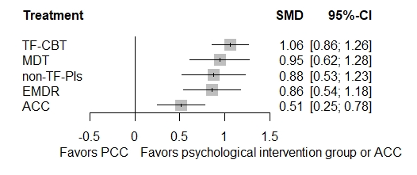

*Note*. ACC = active control conditions (e.g., = treatment-as-usual); MDT = multi-disciplinary treatments (e.g., intensive multimodal group program); non-TF-PIs = non-trauma-focused psychological interventions (e.g., non-directive supportive therapy); PCC = passive control conditions (e.g., = waitlist); TF-CBT = trauma-focused cognitive behaviour therapies (e.g., prolonged exposure).

**Appendix J: Short-term efficacy: Forest plot compared to active control conditions**

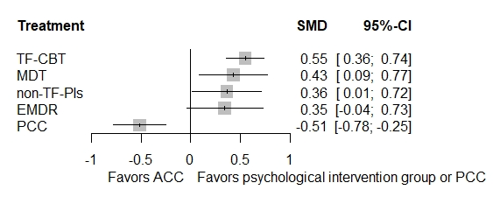

*Note*. ACC = active control conditions (e.g., = treatment-as-usual); MDT = multi-disciplinary treatments (e.g., intensive multimodal group program); non-TF-PIs = non-trauma-focused psychological interventions (e.g., non-directive supportive therapy); PCC = passive control conditions (e.g., = waitlist); TF-CBT = trauma-focused cognitive behaviour therapies (e.g., prolonged exposure).

**Appendix K: Short-term efficacy: Net splitting results**

|  |  |  |  |  |  |  |  |  |
| --- | --- | --- | --- | --- | --- | --- | --- | --- |
| comparison dyads | kes | prop | nma | direct effect | indirect effect | Difference in effects | z | p-value |
| ACC vs. EMDR | 0 | 0 | -0.3450 | n.a. | -0.3450 | n.a. | n.a. | n.a. |
| ACC vs. MDTs | 4 | 0.47 | -0.4314 | -0.3347 | -0.5174 | 0.1828 | 0.52 | 0.5999 |
| ACC vs. non-TF-PIs | 0 | 0 | -0.3643 | n.a. | -0.3643 | n.a. | n.a. | n.a. |
| ACC vs. PCC | 1 | 0.06 | 0.5147 | 0.1800 | 0.5343 | -0.3543 | -0.61 | 0.5438 |
| ACC vs. TF-CBTs | 21 | 0.92 | -0.5494 | -0.5427 | -0.6301 | 0.0874 | 0.24 | 0.8069 |
| EMDR vs. MDTs | 0 | 0 | -0.0863 | n.a. | -0.0863 | n.a. | n.a. | n.a. |
| EMDR vs. non-TF-PIs | 0 | 0 | -0.0193 | n.a. | -0.0193 | n.a. | n.a. | n.a. |
| EMDR vs. PCC | 7 | 0.74 | 0.8597 | 0.7776 | 1.0889 | -0.3113 | -0.84 | 0.4030 |
| EMDR vs. TF-CBTs | 3 | 0.44 | -0.2043 | 0.0556 | -0.4097 | 0.4653 | 1.33 | 0.1843 |
| MDTs vs. non-TF-PIs | 0 | 0 | 0.0671 | n.a. | 0.0671 | n.a. | n.a. | n.a. |
| MDTs vs. PCC | 4 | 0.55 | 0.9461 | 0.9329 | 0.9622 | -0.0293 | -0.09 | 0.9311 |
| MDTs vs. TF-CBTs | 2 | 0.22 | -0.1180 | 0.0949 | -0.1778 | 0.2727 | 0.67 | 0.5038 |
| non-TF-PIs vs. PCC | 1 | 0.13 | 0.8790 | 1.2999 | 0.8187 | 0.4812 | 0.88 | 0.3763 |
| non-TF-PIs vs. TF-CBTs | 9 | 0.97 | -0.1850 | -0.1808 | -0.3424 | 0.1616 | 0.17 | 0.8657 |
| TF-CBTs vs. PCC | 18 | 0.80 | 1.0640 | 1.0898 | 0.9581 | 0.1317 | 0.51 | 0.6097 |

*Note*. ACC = active control conditions (e.g., = treatment-as-usual); EMDR = Eye Movement Desensitization and Reprocessing; MDTs = multi-disciplinary treatments (e.g., intensive multimodal group program); non-TF-PIs = non-trauma-focused psychological interventions (e.g., non-directive supportive therapy); PCC = passive control conditions (e.g., = waitlist); TF-CBTs = trauma-focused cognitive behaviour therapies (e.g., prolonged exposure).

**Appendix L: Short-term efficacy: Net heat plot**

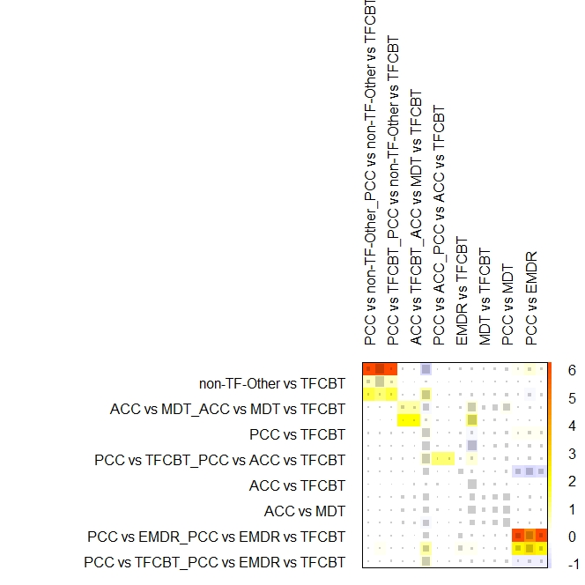

*Note*. ACC = active control conditions (e.g., = treatment-as-usual); MDT = multi-disciplinary treatments (e.g., intensive multimodal group program); non-TF-Other = non-trauma-focused psychological interventions (e.g., non-directive supportive therapy); PCC = passive control conditions (e.g., = waitlist); TF-CBT = trauma-focused cognitive behaviour therapies (e.g., prolonged exposure).

**Appendix M: Short-term efficacy: Funnel plot**

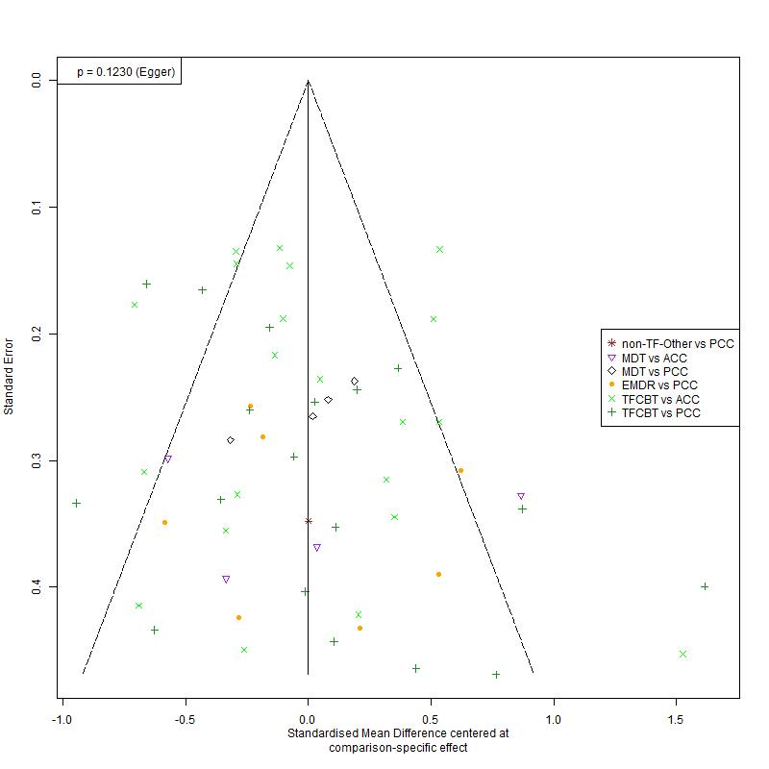

*Note*. ACC = active control conditions (e.g., = treatment-as-usual); MDT = multi-disciplinary treatments (e.g., intensive multimodal group program); non-TF-Other = non-trauma-focused psychological interventions (e.g., non-directive supportive therapy); PCC = passive control conditions (e.g., = waitlist); TF-CBT = trauma-focused cognitive behaviour therapies (e.g., prolonged exposure).

**Appendix N: Short-term efficacy: Outlier-adjusted results**

|  |  |  |  |  |  |  |  |  |  |
| --- | --- | --- | --- | --- | --- | --- | --- | --- | --- |
| *Reference group* | | | *Psych. interv.* |  | *kes (N)* | *SMD* | *95% CI* | *p* | *I2 (τ2)* |
|  |  | ***Main analysis (i.e., irrespective of trial quality and delivery format)*** | | | | | | |  |
| relative to PCC | | TF-CBTs# | |  | 17 (1,097) | **0.99** | **[0.80 – 1.19]** | **< .001** | 64.2  ***  (0.11) |
| EMDR | |  | 7 (297) | **0.84** | **[0.54 – 1.14]** | **< .001** |
| non-TF-PIs | |  | 1 (40) | **0.80** | **[0.47 – 1.13]** | **< .001** |
| MDTs | |  | 4 (270) | **0.93** | **[0.62 – 1.23]** | **< .001** |
|  | | ACC | |  | 1 (22) | **0.49** | **[0.25 – 0.74]** | **<.001** |
| relative to ACC | | TF-CBTs# | |  | 20 (2,018) | **0.50** | **[0.33 – 0.68]** | **< .001** |
| EMDR | |  | 0 (0) | 0.35 | [-0.01 – 0.70] | .059 |
| non-TF-PIs | |  | 0 (0) | 0.31 | [-0.01 – 0.64] | .061 |
| MDTs | |  | 4 (146) | **0.43** | **[0.12 – 0.75]** | **.008** |
| relative to EMDR | | TF-CBTs | |  | 3 (185) | 0.16 | [-0.16 – 0.48] | .334 |
| non-TF-PIs | |  | 0 (0) | -0.03 | [-0.45 – 0.39] | .877 |
| MDTs | |  | 0 (0) | 0.09 | [-0.33 – 0.51] | .673 |
| relative to  non-TF-PIs | | TF-CBTs | |  | 9 (631) | 0.19 | [-0.09 – 0.47] | .177 |
| MDTs | |  | 0 (0) | 0.12 | [-0.29 – 0.54] | .560 |
| relative to MDTs | | TF-CBTs | |  | 2 (72) | 0.07 | [-0.24 – 0.38] | .668 |

*Note*. ACC = active control conditions (e.g. = treatment-as-usual); EMDR = eye movement desensitization and reprocessing; kes = number of direct comparisons for the given comparison; MDTs = multidisciplinary treatments; N = total number of participants; non-TF-PIs = non-trauma-focused psychological interventions; PCC = passive control conditions (e.g. = waitlist); Psych. interv. = psychological interventions; SMD = standardized mean differences (i.e. = Hedges’ g); TF-CBTs = trauma-focused cognitive behaviour therapies. **Bold** font highlights statistical significance of findings. A positive (negative) SMD indicates superior (inferior) efficacy of the given psychological intervention relative to the given reference group.   
*** p < .001, ** p < .01, * p < .05, corresponding to the respective Q-statistic as a measure of heterogeneity in outcomes.

# 2 statistical outliers (i.e., McMullen et al., 2013 comparing TF-CBT to PCC & Barron et al., 2021 comparing TF-CBT to ACC) were excluded from this outlier-adjusted analyses.

**Appendix O: Mid-term efficacy: Forest plot compared to passive control conditions**

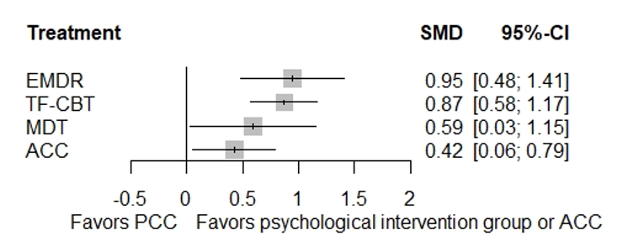

*Note*. ACC = active control conditions (e.g., = treatment-as-usual); EMDR = eye movement desensitization and reprocessing; MDT = multi-disciplinary treatments (e.g., intensive multimodal group program); PCC = passive control conditions (e.g., = waitlist); TF-CBT = trauma-focused cognitive behaviour therapies (e.g., prolonged exposure).

**Appendix P: Mid-term efficacy: Forest plot compared to active control conditions**

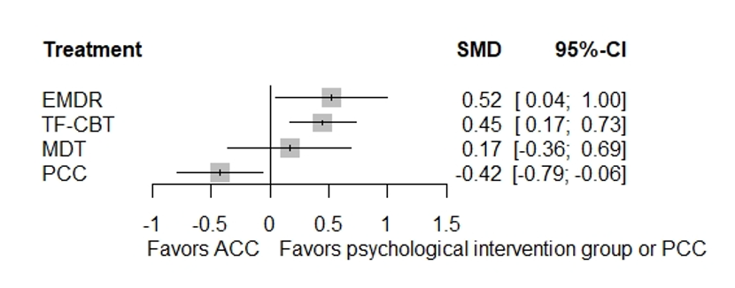

*Note*. ACC = active control conditions (e.g., = treatment-as-usual); EMDR = eye movement desensitization and reprocessing; MDT = multi-disciplinary treatments (e.g., intensive multimodal group program); PCC = passive control conditions (e.g., = waitlist); TF-CBT = trauma-focused cognitive behaviour therapies (e.g., prolonged exposure).

**Appendix Q: Mid-term efficacy: Funnel plot**

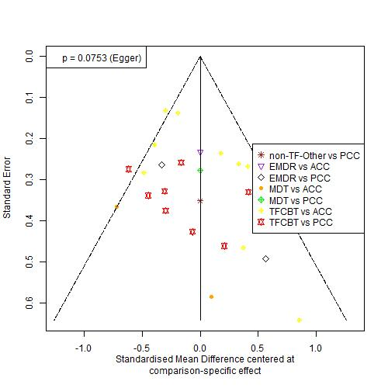

*Note*. ACC = active control conditions (e.g., = treatment-as-usual); EMDR = eye movement desensitization and reprocessing; MDT = multi-disciplinary treatments (e.g., intensive multimodal group program); PCC = passive control conditions (e.g., = waitlist); TF-CBT = trauma-focused cognitive behaviour therapies (e.g., prolonged exposure).

**Appendix R: Mid-term efficacy: Net splitting results**

|  |  |  |  |  |  |  |  |  |
| --- | --- | --- | --- | --- | --- | --- | --- | --- |
| comparison dyads | kes | prop | nma | direct effect | indirect effect | Difference in effects | z | p-value |
| ACC vs. EMDR | 1 | 0.30 | -0.5212 | 0.0386 | -0.7570 | 0.7956 | 1.49 | 0.1358 |
| **ACC vs. MDTs** | **3** | **0.66** | **-0.1664** | **-0.5535** | **0.5995** | **-1.1530** | **-2.03** | **0.0424** |
| ACC vs. PCC | 2 | 0.26 | 0.4240 | 0.2602 | 0.4827 | -0.2225 | -0.52 | 0.6016 |
| ACC vs. TF-CBTs | 9 | 0.85 | -0.4501 | -0.4241 | -0.5938 | 0.1697 | 0.42 | 0.6724 |
| EMDR vs. MDTs | 0 | n.a. | 0.3548 | n.a. | 0.3548 | n.a. | n.a. | n.a. |
| EMDR vs. PCC | 2 | 0.41 | 0.9451 | 1.1923 | 0.7746 | 0.4177 | 0.86 | 0.3883 |
| EMDR vs. TF-CBTs | 2 | 0.47 | 0.0711 | 0.1812 | -0.0270 | 0.2081 | 0.46 | 0.6458 |
| MDTs vs. PCC | 1 | 0.37 | 0.5903 | -0.0950 | 0.9884 | -1.0834 | -1.82 | 0.0682 |
| MDTs vs. TF-CBTs | 1 | 0.19 | -0.2837 | -0.3879 | -0.2600 | -0.1280 | -0.18 | 0.8584 |
| TF-CBTs vs. PCC | 9 | 0.80 | 0.8741 | 0.9187 | 0.6989 | 0.2198 | 0.58 | 0.5603 |

*Note*. ACC = active control conditions (e.g., = treatment-as-usual); EMDR = Eye Movement Desensitization and Reprocessing; MDTs = multi-disciplinary treatments (e.g., intensive multimodal group program); PCC = passive control conditions (e.g., = waitlist); TF-CBTs = trauma-focused cognitive behaviour therapies (e.g., prolonged exposure).

**Appendix S: Mid-term efficacy: Net heat plot before (top) and after (bottom) exclusion of MDTs**

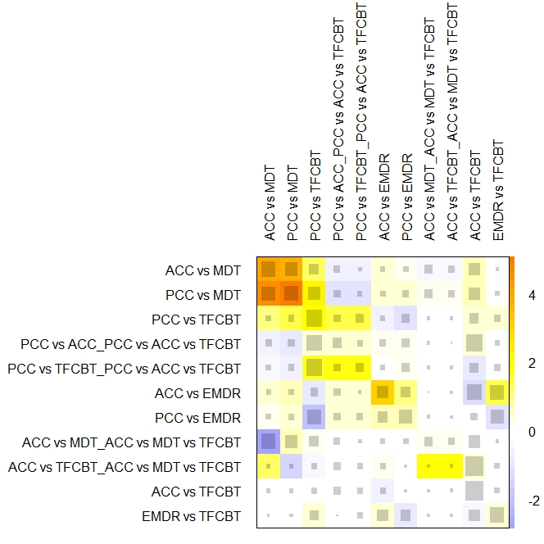

Note. ACC = active control conditions (e.g., = treatment-as-usual); EMDR = eye movement desensitization and reprocessing; MDT(s) = multi-disciplinary treatments (e.g., intensive multimodal group program); PCC = passive control conditions (e.g., = waitlist); TF-CBT = trauma-focused cognitive behaviour therapies (e.g., prolonged exposure).

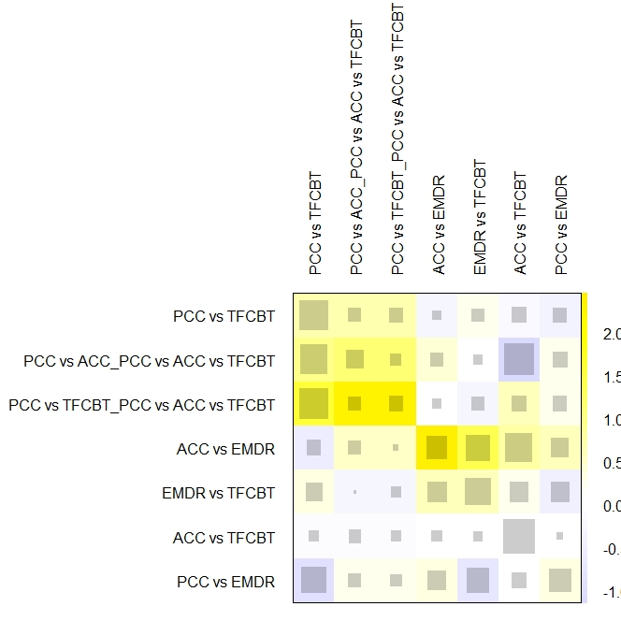

Note. ACC = active control conditions (e.g., = treatment-as-usual); EMDR = eye movement desensitization and reprocessing; MDT = multi-disciplinary treatments (e.g., intensive multimodal group program); PCC = passive control conditions (e.g., = waitlist); TF-CBT = trauma-focused cognitive behaviour therapies (e.g., prolonged exposure).

**Appendix T: Mid-term efficacy: MDTs excluded due to detected inconsistency**

|  |  |  |  |  |  |  |  |
| --- | --- | --- | --- | --- | --- | --- | --- |
| *Reference group Psych. interv.* | | | *kes (N)* | *SMD* | *95% CI* | *p* | *I2 (τ2)* |
|  | **FU1 (i.e., ≤ 5 months follow-up) *-* main analysis** | | | | | |  |
| relative to PCC | | TF-CBTs | 9 (389) | **0.94** | **[0.65 – 1.22]** | **< .001** | 62.9  ***  (0.11) |
| EMDR | 2 (86) | **0.99** | **[0.56 – 1.42]** | **< .001** |
|  | | ACC | 2 (74) | **0.54** | **[0.19 – 0.90]** | **.003** |
| relative to ACC | | TF-CBTs | 9 (813) | **0.39** | **[0.13 – 0.66]** | **.003** |
| EMDR | 1 (74) | **0.45** | **[0.01 – 0.89]** | **.046** |
| relative to EMDR | | TF-CBTs | 2 (125) | -0.05 | [-0.46 – 0.35] | .799 |

*Note*. ACC = active control conditions (e.g. = treatment-as-usual); EMDR = eye movement desensitization and reprocessing; kes = number of direct comparisons for the given comparison; MDTs = multidisciplinary treatments; N = total number of participants; PCC = passive control conditions (e.g. = waitlist); Psych. interv. = psychological interventions; SMD = standardized mean differences (i.e. = Hedges’ g); TF-CBTs = trauma-focused cognitive behaviour therapies.   
**Bold** font highlights statistical significance of findings. A positive (negative) SMD indicates superior (inferior) efficacy of the given psychological intervention relative to the given reference group.   
*** p < .001, ** p < .01, * p < .05, corresponding to the respective Q-statistic as a measure of heterogeneity in outcomes.

**Appendix U: Long-term efficacy: Forest plot compared to passive control conditions**

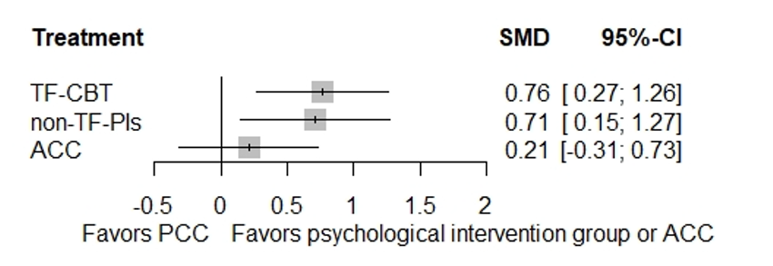

*Note*. ACC = active control conditions (e.g., = treatment-as-usual); non-TF-PIs = non-trauma-focused psychological interventions (e.g., non-directive supportive therapy); PCC = passive control conditions (e.g., = waitlist); TF-CBTs = trauma-focused cognitive behaviour therapies (e.g., prolonged exposure).

**Appendix V: Long-term efficacy: Forest plot compared to active control conditions**

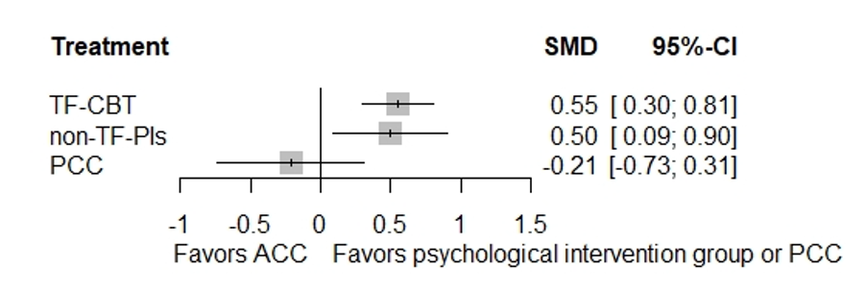

*Note*. ACC = active control conditions (e.g., = treatment-as-usual); non-TF-PIs = non-trauma-focused psychological interventions (e.g., non-directive supportive therapy); PCC = passive control conditions (e.g., = waitlist); TF-CBTs = trauma-focused cognitive behaviour therapies (e.g., prolonged exposure).

**Appendix W: Long-term efficacy: Net splitting results**

|  |  |  |  |  |  |  |  |  |
| --- | --- | --- | --- | --- | --- | --- | --- | --- |
| comparison dyads | kes | prop | nma | direct effect | indirect effect | Difference in effects | z | p-value |
| ACC vs. non-TF-PIs | 1 | 0.20 | -0.4982 | -0.8293 | -0.4140 | -0.4153 | -0.81 | 0.4203 |
| ACC vs. PCC | 1 | 0.37 | 0.2107 | 0.0354 | 0.3147 | -0.2793 | -0.50 | 0.6137 |
| ACC vs. TF-CBTs | 9 | 0.92 | -0.5539 | -0.5091 | -1.0608 | 0.5516 | 1.16 | 0.2451 |
| non-TF-PIs vs. PCC | 1 | 0.36 | 0.7089 | 1.2387 | 0.4162 | 0.8225 | 1.37 | 0.1706 |
| non-TF-PIs vs. TF-CBTs | 5 | 0.84 | -0.0557 | -0.1320 | 0.3404 | -0.4723 | -0.98 | 0.3287 |
| TF-CBTs vs. PCC | 3 | 0.83 | 0.7646 | 0.6403 | 1.3929 | -0.7526 | -1.11 | 0.2649 |

*Note*. ACC = active control conditions (e.g., = treatment-as-usual); non-TF-PIs = non-trauma-focused psychological interventions (e.g., non-directive supportive therapy); PCC = passive control conditions (e.g., = waitlist); TF-CBTs = trauma-focused cognitive behaviour therapies (e.g., prolonged exposure).

**Appendix X: Long-term efficacy: Net heat plot**

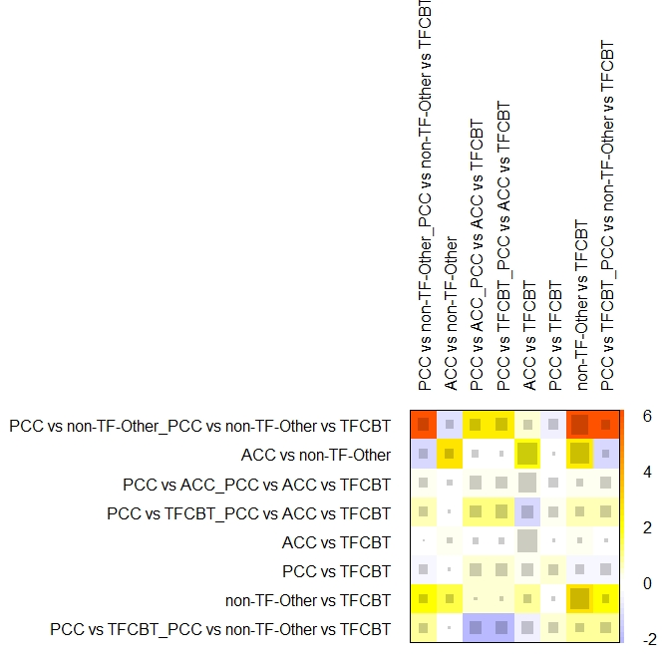

*Note*. ACC = active control conditions (e.g., = treatment-as-usual); non-TF-Other = non-trauma-focused psychological interventions (e.g., non-directive supportive therapy); PCC = passive control conditions (e.g., = waitlist); TF-CBTs = trauma-focused cognitive behaviour therapies (e.g., prolonged exposure).

**Appendix Y: Long-term efficacy: Funnel plot**

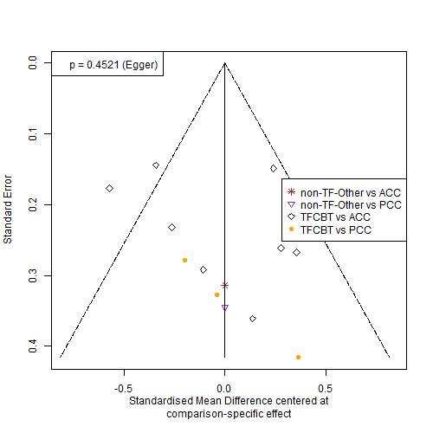

*Note*. ACC = active control conditions (e.g., = treatment-as-usual); non-TF-Other = non-trauma-focused psychological interventions (e.g., non-directive supportive therapy); PCC = passive control conditions (e.g., = waitlist); TF-CBTs = trauma-focused cognitive behaviour therapies (e.g., prolonged exposure).