Prevalence and determinants of scabies: a global systematic review and meta-analysis
Supplementary Information
List of Materials
Table S1: Search strategy
Table S2: Quality of studies
Table S3: Summary of studies used to estimate the global prevalence of scabies.
Table S4: Study characteristics
Figure S5: Leave-one out forest plot
Figure S6: Influence Analysis
Figure S7: Baujat Plot showing the outlier studies according to heterogeneity.
Table S8: Meta-regression of scabies prevalence and socioeconomic factors
Table S9: Risk of publication bias.

Table S1: Search strategy
PubMed Search: 29/07/2024
Search | Query | Results
PubMed
#1 | scabies | 1880
#2 | (skin diseases) OR (skin defect) OR (skin examination) | 751,810
#3 | (controlled study) OR (cross-sectional study) OR (major clinical study) OR (comparative study) | 1,834,170
#4 | (prevalence) OR (risk factor) OR (incidence) OR (disease association) | 4,062,922
#5 | #1 AND #2 | 1,706
#6 | #5 AND #3 | 201
#5 | #6 AND #4 | 138
Limit to “Human”, year 2000 to 2024, English

Scopus
#1 | scabies | 3,671
#2 | (skin diseases) OR (skin defect) OR (skin examination) | 398,090
#3 | (controlled study) OR (cross-sectional study) OR (major clinical study) OR (comparative study) | 6,589,027
#4 | (prevalence) OR (risk factor) OR (incidence) OR (disease association) | 3,584,954
#5 | #1 AND #2 | 2,045
#6 | #5 AND #3 | 697
#5 | #6 AND #4 | 397
Limit to “Human”, year 2000 to 2024, English

Cochrane Search
#1 | scabies | 325
#2 | (skin diseases) OR (skin defect) OR (skin examination) | 33,357
#3 | (controlled study) OR (cross-sectional study) OR (major clinical study) OR (comparative study) | 6,589,027
#4 | (prevalence) OR (risk factor) OR (incidence) OR (disease association) | 1,338,480
#5 | #1 AND #2 | 99
#6 | #5 AND #3 | 78
#5 | #6 AND #4 | 33
Limit to “Human”, year 2000 to 2024, English

(((Scabies) AND ((skin diseases) OR (skin defect) OR (skin examination))) AND ((controlled study) OR (cross-sectional study) OR (major clinical study) OR (comparative study))) AND ((prevalence) OR (risk factor) OR (incidence) OR (disease association)))

Table S2: Quality of studies
- Analytical Cross-sectional studies
Author | Were the criteria for inclusion in the sample clearly defined? | Were the study subjects and the setting described in detail? | Was the exposure measured in a valid and reliable way? | Were objective, standard criteria used for measurement of the condition? | Were confounding factors identified? | Were strategies to deal with confounding factors stated? | Were the outcomes measured in a valid and reliable way? | Was appropriate statistical analysis used? | Score percentage
(GMB) Armitage et al | ☑ | ☑ | ☑ | ☑ | ☑ | ☑ | ☑ | ☑ | 100
(CMR) Kouotou et al | ☑ | ☑ | ☑ | ☑ | ⮽ | ☑ | ☑ | ☑ | 88
(EGY) Hegab et al | ⮽ | ☑ | ☑ | ☑ | ☑ | ☑ | ☑ | ☑ | 88
(ETH) Ararsa et al | ☑ | ☑ | ☑ | ☑ | ⮽ | ☑ | ☑ | ☑ | 88
(ETH) Haile et al | ☑ | ☑ | ☑ | ☑ | ⮽ | ☑ | ☑ | ☑ | 88
(GHA) Birjandi et al | ☑ | ☑ | ☑ | ☑ | ⮽ | ☑ | ☑ | ☑ | 88
(LBR) Collinson et al | ☑ | ☑ | ☑ | ☑ | ⮽ | ☑ | ☑ | ☑ | 88
(VUT) Callum et al | ☑ | ☑ | ☑ | ☑ | ⮽ | ☑ | ☑ | ☑ | 88
(ETH) Dagne et al | ⮽ | ☑ | ☑ | ☑ | ⮽ | ☑ | ☑ | ☑ | 75
(ETH) Enbiale et al | ☑ | ☑ | ☑ | ☑ | ⮽ | ⮽ | ☑ | ☑ | 75
(ETH) Melese et al | ⮽ | ☑ | ☑ | ☑ | ⮽ | ☑ | ☑ | ☑ | 75
(ETH) Walker et al | ☑ | ☑ | ☑ | ☑ | ⮽ | ⮽ | ☑ | ☑ | 75
(FJI) Romani et al | ⮽ | ☑ | ☑ | ☑ | ⮽ | ☑ | ☑ | ☑ | 75
(IND) Satyamanasa et al | ☑ | ☑ | ☑ | ☑ | ⮽ | ⮽ | ☑ | ☑ | 75
(WSM) Taiaroa et al | ☑ | ☑ | ⮽ | ☑ | ⮽ | ☑ | ☑ | ☑ | 75
(SLB) Lake et al | ☑ | ☑ | ⮽ | ☑ | ⮽ | ☑ | ☑ | ☑ | 75
(SLB) Mason et al | ☑ | ☑ | ⮽ | ☑ | ⮽ | ☑ | ☑ | ☑ | 75
(SLB) Osti et al | ☑ | ☑ | ☑ | ☑ | ⮽ | ⮽ | ☑ | ☑ | 75
(TLS) Korte et al | ⮽ | ☑ | ☑ | ☑ | ⮽ | ☑ | ☑ | ☑ | 75
(TLS) Matthews et al | ☑ | ☑ | ⮽ | ☑ | ⮽ | ☑ | ☑ | ☑ | 75
(GBR) Hewitt et al | ☑ | ☑ | ☑ | ☑ | ⮽ | ⮽ | ☑ | ☑ | 75
(ETH) Enbiale et al | ☑ | ☑ | ⮽ | ☑ | ⮽ | ⮽ | ☑ | ☑ | 63
(ETH) Misganaw et al | ☑ | ☑ | ☑ | ⮽ | ⮽ | ☑ | ⮽ | ☑ | 63
(FJI) Romani et al | ⮽ | ☑ | ⮽ | ☑ | ⮽ | ☑ | ☑ | ☑ | 63
(FJI) Steer et al | ☑ | ☑ | ⮽ | ☑ | ⮽ | ⮽ | ☑ | ☑ | 63
(GHA) Amoako et al | ⮽ | ☑ | ☑ | ☑ | ⮽ | ⮽ | ☑ | ☑ | 63
(IRN) Dehkordi et al | ⮽ | ☑ | ☑ | ☑ | ⮽ | ⮽ | ☑ | ☑ | 63
(MWI) Casas et al | ☑ | ☑ | ⮽ | ☑ | ⮽ | ⮽ | ☑ | ☑ | 63
(NGA) Kalu et al | ☑ | ☑ | ⮽ | ☑ | ⮽ | ⮽ | ☑ | ☑ | 63
(LKA) Gunathilaka et al | ⮽ | ☑ | ☑ | ☑ | ⮽ | ⮽ | ☑ | ☑ | 63
(TUR) Ural et al | ⮽ | ☑ | ☑ | ☑ | ⮽ | ⮽ | ☑ | ☑ | 63
(FJI) Steer et al | ⮽ | ☑ | ⮽ | ☑ | ⮽ | ⮽ | ☑ | ☑ | 50
(FJI) Tsoi et al | ⮽ | ☑ | ⮽ | ☑ | ⮽ | ⮽ | ☑ | ☑ | 50
(GHA) Kaburi et al | ⮽ | ☑ | ⮽ | ☑ | ⮽ | ⮽ | ☑ | ☑ | 50
(IND) Devidas et al | ☑ | ☑ | ⮽ | ⮽ | ⮽ | ⮽ | ☑ | ☑ | 50
(LAO) Wootton et al | ⮽ | ☑ | ⮽ | ☑ | ⮽ | ⮽ | ☑ | ☑ | 50
(MYS) Zayyid et al | ⮽ | ☑ | ⮽ | ☑ | ⮽ | ⮽ | ☑ | ☑ | 50
(NZL) Thornley et al | ⮽ | ☑ | ⮽ | ☑ | ⮽ | ⮽ | ☑ | ☑ | 50
(TLS) Santos et al | ⮽ | ☑ | ⮽ | ☑ | ⮽ | ⮽ | ☑ | ☑ | 50
(TLS) Tsoi et al | ⮽ | ☑ | ⮽ | ☑ | ⮽ | ⮽ | ☑ | ☑ | 50
(IND) Burman et al | ☑ | ☑ | ⮽ | ⮽ | ⮽ | ⮽ | ☑ | ☑ | 50
(MYS) Yap et al | ⮽ | ☑ | ⮽ | ⮽ | ⮽ | ⮽ | ☑ | ☑ | 38
(NGA) Ogunbiyi et al | ⮽ | ☑ | ⮽ | ☑ | ⮽ | ⮽ | ☑ | ☑ | 50
(AUS) Kearns et al | ☑ | ☑ | ☑ | ☑ | ⮽ | ⮽ | ☑ | ☑ | 75
(AUS) Tasani et al | ☑ | ☑ | ☑ | ☑ | ⮽ | ⮽ | ☑ | ☑ | 75
(FJI) Haar et al | ☑ | ☑ | ☑ | ☑ | ☑ | ⮽ | ☑ | ☑ | 88
(FJI) Hardy et al | ☑ | ☑ | ☑ | ☑ | ⮽ | ☑ | ☑ | ☑ | 88
(IND) Behera et al | ☑ | ☑ | ☑ | ☑ | ⮽ | ☑ | ☑ | ☑ | 88
(SLB) Coscione et al | ☑ | ☑ | ☑ | ☑ | ☑ | ☑ | ☑ | ☑ | 100
(SLB) Marks et al | ☑ | ☑ | ☑ | ☑ | ⮽ | ⮽ | ☑ | ☑ | 75
(SLB) Marks et al | ☑ | ☑ | ☑ | ☑ | ⮽ | ☑ | ☑ | ☑ | 88
(TZA) Martin et al | ⮽ | ☑ | ⮽ | ☑ | ⮽ | ⮽ | ☑ | ☑ | 50

- Case-Control Study
Study | Were the groups comparable other than the presence of disease in cases or the absence of disease in controls? | Were cases and controls matched appropriately? | Were the same criteria used for identification of cases and controls? | Was exposure measured in a standard, valid and reliable way? | Was exposure measured in the same way for cases and controls? | Were confounding factors identified? | Were strategies to deal with confounding factors stated? | Were outcomes assessed in a standard, valid and reliable way for cases and controls? | Was the exposure period of interest long enough to be meaningful? | Was appropriate statistical analysis used? | Score Percentage
(ETH) Sara et al | ☑ | ⮽ | ☑ | ☑ | ☑ | ☑ | ☑ | ☑ | ⮽ | ☑ | 80

- Cohort Study
Studies | Were the two groups similar and recruited from the same population? | Were the exposures measured similarly to assign people to both exposed and unexposed groups? | Was the exposure measured in a valid and reliable way? | Were confounding factors identified? | Were strategies to deal with confounding factors stated? | Were the groups/participants free of the outcome at the start of the study (or at the moment of exposure)? | Were the outcomes measured in a valid and reliable way? | Was the follow up time reported and sufficient to be long enough for outcomes to occur? | Was follow up complete, and if not, were the reasons to loss to follow up described and explored? | Were strategies to address incomplete follow up utilized? | Was appropriate statistical analysis used? | Score percentage
(FJI) Steer et al | ☑ | ☑ | ⮽ | ⮽ | ⮽ | ⮽ | ☑ | ☑ | ☑ | ⮽ | ☑ | 55

Table S3: Summary of studies used to estimate the global prevalence of scabies
Study Characteristics | Number or Percentage | 95% C.I. Lower | 95% C.I. Upper
Number of studies | 70
Number of subjects | 10,324,381
Number of scabies cases | 1,275,191
Prevalence of scabies | 11.9% | 9.60% | 14.7%
Tau-squared (τ²) | 1.04 | 0.74 | 1.52
I² | 100%
H-statistic | 82.4
C. I., confidence interval.

Table S4: Study characteristics
Sl No | Author | Year of Publication | Country | Prevalence (in %) | Prevalence (absolute number) | Sample (n) | Study Period | Diagnosis | GINI | HDI | WHO | UNSD | Area | Population | GDP (per capita USD) | Income | Age Group
1 | (TUR) Ciftci et al | 2006 | Turkey | 0.4 | 5 | 1134 | 2004-2005 | Traditional (Burrows, Pruritus) | 43.5 | 0.696 | European Region | Asia | Urban | School | 6031.8 | Upper Middle Income | 4-6 years
2 | (MAR) Laraqui et al | 2018 | Morocco | 1 | 11 | 1102 | 2017 | Traditional (Burrows, Pruritus) | 39.5 | 0.671 | Eastern Mediterranean Region | Africa | Urban and Rural | Community | 3288.5 | Lower Middle Income | All ages
3 | (LKA) Gunathilaka et al | 2019 | Sri Lanka | 1.5 | 3 | 205 | 2016-2017 | Traditional (Burrows, Pruritus) | 39.3 | 0.771 | South-East Asian Region | Asia | Urban and Rural | School | 4401 | Lower Middle Income | 5-16 years
4 | (TUR) Inanir et al | 2002 | Turkey | 2.2 | 17 | 785 |  | Traditional (Burrows, Pruritus) | 43.5 | 0.685 | European Region | Asia | Rural | School | 3640.8 | Upper Middle Income | 6-14 years
5 | (FRA) Philippe et al | 2005 | France | 2.9 | 27 | 930 | 2000-2003 | Traditional (Burrows, Pruritus) | 32.6 | 0.844 | European Region | Europe | Urban | Other (Childcare centre, Welfare Home, Clinic/Hospital) | 22416 | High Income | All ages
6 | (IRN) Dehkordi et al | 2021 | Iran | 3.1 | 15 | 480 | 2018 | Traditional (Burrows, Pruritus) | 42 | 0.787 | Eastern Mediterranean Region | Asia | Urban and Rural | School | 3874 | Lower Middle Income | 6-13 years
7 | (AUS) Kearns et al | 2015 | Australia | 4.2 | 42 | 1002 | 2010-2011 | Traditional (Burrows, Pruritus) | 34.7 | 0.923 | Western Pacific Region | Oceania | Rural | Community | 52133 | High Income | All ages
8 | (IND) Satyamanasa et al | 2021 | India | 4.3 | 43 | 1000 | 2021 | Traditional (Burrows, Pruritus) | 34.2 | 0.633 | South-East Asian Region | Asia | Urban | School | 2238 | Lower Middle Income | 5-15 years
9 | (EGY) Hegab et al | 2015 | Egypt | 4.4 | 92 | 2104 | 2014 | Traditional (Burrows, Pruritus) | 31.8 | 0.699 | Eastern Mediterranean Region | Africa | Urban and Rural | School | 3197 | Lower Middle Income | 6-12 years
10 | (TZA) Martin et al | 2018 | Tanzania | 4.4 | 101 | 2269 | 2012 | Traditional (Burrows, Pruritus) | 37.8 | 0.504 | African Region | Africa | Rural | Community | 856 | Low Income | All ages
11 | (IND) Grills et al | 2012 | India | 4.6 | 54 | 1172 | 2010 | Traditional (Burrows, Pruritus) | 35.4 | 0.572 | South-East Asian Region | Asia | Rural | Community | 1350.6 | Lower Middle Income | All ages
12 | (LAO) Wootton et al | 2018 | Lao | 4.7 | 16 | 340 | 2017 | Traditional (Burrows, Pruritus) | 38.8 | 0.607 | South-East Asian Region | Asia | Rural | Community | 2440 | Lower Middle Income | All ages
13 | (NGA) Ogunbiyi et al | 2005 | Nigeria | 4.7 | 50 | 1066 | 2005 | Traditional (Burrows, Pruritus) | 40.1 | 0.469 | African Region | Africa | Urban | School | 1250 | Low Income | 4-15 years
14 | (ETH) Amare & Lindtjorn | 2021 | Ethiopia | 5.3 | 46 | 861 | 2017 | Traditional (Burrows, Pruritus) | 35 | 0.472 | African Region | Africa | Rural | School | 755.8 | Low Income | 7-14 years
15 | (GNB) Marks et al | 2019 | Guinea-Bissau | 5.3 | 56 | 1062 | 2018 | Traditional (Burrows, Pruritus) | 34.8 | 0.48 | African Region | Africa | Rural | Community | 807.361 | Low Income | 1-9 years
16 | (ETH) Walker et al | 2017 | Ethiopia | 5.5 | 19 | 343 | 2016 | Traditional (Burrows, Pruritus) | 35 | 0.47 | African Region | Africa | Rural | School | 706 | Low Income | <17 years
17 | (TGO) Saka et al | 2022 | Togo | 6.1 | 86 | 1401 | 2021 | Traditional (Burrows, Pruritus) | 37.9 | 0.539 | African Region | Africa | Rural | Community | 965 | Low Income | All ages
18 | (FRA) Rigal et al | 2016 | France | 7 | 10 | 142 | 2009-2011 | Traditional (Burrows, Pruritus) | 32.7 | 0.875 | European Region | Europe | Urban | Other (Childcare centre, Welfare Home, Clinic/Hospital) | 41737 | High Income | 0-11 years
19 | (IND) Devidas et al | 2021 | India | 7.61 | 16 | 210 | 2015 | Traditional (Burrows, Pruritus) | 35.7 | 0.629 | South-East Asian Region | Asia | Rural | Community | 1590 | Lower Middle Income | <5 years
20 | (MYS) Yap et al | 2010 | Malaysia | 8.1 | 76 | 944 | 2009 | Traditional (Burrows, Pruritus) | 45.5 | 0.762 | Western Pacific Region | Asia | Urban | School | 7167 | Upper Middle Income | 13-17 years
21 | (IND) Behera et al | 2021 | India | 8.40 | 92 | 1094 | 2017-2018 | Intergrated Management of Childhood Illeness (IMCI) | 35.7 | 0.645 | South-East Asian Region | Asia | Rural | Community | 1974 | Lower Middle Income | All ages
22 | (ETH) Bogino et al | 2023 | Ethiopia | 8.9 | 37 | 418 | 2020 | IACS | 35 | 0.489 | African Region | Africa | Urban | Other (Childcare centre, Welfare Home, Clinic/Hospital) | 918.7 | Low Income | 17-60 years
23 | (ETH) Dagne et al | 2019 | Ethiopia | 9.3 | 46 | 494 | 2018 | Traditional (Burrows, Pruritus) | 35 | 0.489 | African Region | Africa | Urban and Rural | School | 758 | Low Income | 5-19 years
24 | (LBR) Collinson et al | 2020 | Liberia | 9.3 | 123 | 1318 | 2020 | IACS | 35.3 | 0.48 | African Region | Africa | Urban | Community | 598 | Low Income | All ages
25 | (ETH) Enbiale et al | 2020 | Ethiopia | 9.7 | 875890 | 9057427 | 2018 | Traditional (Burrows, Pruritus) | 35 | 0.489 | African Region | Africa | Urban and Rural | Community | 758 | Low Income | All ages
26 | (POL) Bartosik et al | 2023 | Poland | 9.9 | 32 | 322 | 2014 | Traditional (Burrows, Pruritus) | 32.8 | 0.867 | European Region | Europe | Urban | Other (Childcare centre, Welfare Home, Clinic/Hospital) | 14182 | High Income | All ages
27 | (SLB) Coscione et al | 2018 | Solomon Islands | 10.2 | 12 | 118 | 2018 | Intergrated Management of Childhood Illeness (IMCI) | 37.1 | 0.566 | Western Pacific Region | Oceania | Rural | Community | 2450 | Lower Middle Income | All ages
28 | (GHA) Birjandi et al | 2019 | Ghana | 10.3 | 286 | 2766 | 2018 | Traditional (Burrows, Pruritus) | 43.5 | 0.62 | African Region | Africa | Urban | School | 2180 | Lower Middle Income | 11-18 years
29 | (NGA) Kalu et al | 2015 | Nigeria | 10.5 | 42 | 400 | 2012-13 | Traditional (Burrows, Pruritus) | 35.5 | 0.506 | African Region | Africa | Rural | School | 2976.8 | Lower Middle Income | 6-12 years
30 | (GBR) Hewitt et al | 2014 | United Kingdom | 10.70 | 39 | 363 | 2012-2013 | Traditional (Burrows, Pruritus) | 32.7 | 0.922 | European Region | Europe | Urban | Other (Childcare centre, Welfare Home, Clinic/Hospital) | 47447 | High Income | >75
31 | (ETH) Misganaw et al | 2022 | Ethiopia | 10.82 | 92 | 850 | 2020 | Traditional (Burrows, Pruritus) | 35 | 0.498 | African Region | Africa | Urban | Community | 918 | Low Income | 5-14 years
32 | (TUR) Ural et al | 2022 | Turkey | 10.90 | 41 | 376 | 2021 | IACS | 41.9 | 0.838 | European Region | Asia | Urban and Rural | Other (Childcare centre, Welfare Home, Clinic/Hospital) | 9661.2 | Upper Middle Income | All ages
33 | (ETH) Sara et al | 2018 | Ethiopia | 11 | 4532 | 41278 | 2016 | Traditional (Burrows, Pruritus) | 35 | 0.47 | African Region | Africa | Urban and Rural | Community | 705 | Low Income | All ages
34 | (IND) Burman et al | 2020 | India | 11.00 | 44 | 400 | 2018-2019 | Traditional (Burrows, Pruritus) | 35 | 0.645 | South-East Asian Region | Asia | Urban and Rural | School | 1974 | Lower Middle Income | 13-15 years
35 | (NZL) Thornley et al | 2023 | New Zealand | 11 | 16 | 145 | 2021-2022 | IACS | 32.5 | 0.937 | Western Pacific Region | Oceania | Urban | Other (Childcare centre, Welfare Home, Clinic/Hospital) | 48,781 | High Income | <14 years
36 | (GHA) Kaburi et al | 2019 | Ghana | 11.20 | 92 | 823 | 2017 | Traditional (Burrows, Pruritus) | 43.5 | 0.616 | African Region | Africa | Urban | School | 1999 | Lower Middle Income | 2-7 years
37 | (SLB) Marks et al | 2019 | Solomon Islands | 11.8 | 75 | 638 | 2016-2017 | Traditional (Burrows, Pruritus) | 37.1 | 0.564 | Western Pacific Region | Oceania | Rural | Community | 2283 | Lower Middle Income | All ages
38 | (ETH) Yirgu et al | 2023 | Ethiopia | 13.4 | 192 | 1437 | 2018 | Traditional (Burrows, Pruritus) | 35 | 0.479 | African Region | Africa | Rural | Community | 758.3 | Low Income | All ages
39 | (FIJ) Hardy et al | 2021 | Fiji | 13.5 | 513 | 3812 | 2017 | Traditional (Burrows, Pruritus) | 30.7 | 0.728 | Western Pacific Region | Oceania | Rural | Community | 5825 | Upper Middle Income | All ages
40 | (FJI) Hardy et al | 2020 | Fiji | 13.5 | 513 | 3812 | 2019 | Traditional (Burrows, Pruritus) | 30.7 | 0.746 | Western Pacific Region | Oceania | Rural | Community | 5968 | Upper Middle Income | All ages
41 | (FJI) Steer et al | 2009 | Fiji | 14 | 63 | 451 | 2006-07 | Traditional (Burrows, Pruritus) | 40.4 | 0.706 | Western Pacific Region | Oceania | Urban and Rural | Other (Childcare centre, Welfare Home, Clinic/Hospital) | 5825 | Upper Middle Income | Infants
42 | (FJI) Tsoi et al | 2021 | Fiji | 14.00 | 470 | 3351 | 2019 | IACS | 30.7 | 0.746 | Western Pacific Region | Oceania | Urban and Rural | Community | 5968.3 | Upper Middle Income | All ages
43 | (WSM) Taiaroa et al | 2020 | Samoa | 14.4 | 120 | 833 | 2018 | Intergrated Management of Childhood Illeness (IMCI) | 38.7 | 0.716 | Western Pacific Region | Oceania | Rural | School | 4189 | Upper Middle Income | 4-15 years
44 | (SLB) Lake et al | 2021 | Solomon Islands | 15 | 787 | 5239 | 2019 | IACS | 37.1 | 0.567 | Western Pacific Region | Oceania | Rural | Community | 2398.8 | Lower Middle Income | All ages
45 | (MWI) Casas et al | 2021 | Malawi | 15.40 | 2392 | 15487 | 2018 | Traditional (Burrows, Pruritus) | 44.7 | 0.51 | African Region | Africa | Rural | Community | 537.9 | Low Income | All ages
46 | (GMB) Armitage et al | 2019 | Gambia | 15.9 | 229 | 1441 | 2018 | Intergrated Management of Childhood Illeness (IMCI) | 35.9 | 0.495 | African Region | Africa | Urban | Community | 758 | Low Income | <5 years
47 | (AUS) Tasani et al | 2016 | Australia | 16.5 | 84 | 508 | 2016 | Traditional (Burrows, Pruritus) | 33.7 | 0.935 | Western Pacific Region | Oceania | Rural | Community | 49875 | High Income | <13 years
48 | (TLS) Santos et al | 2010 | Timor-Leste | 17.3 | 266 | 1535 | 2007 | Traditional (Burrows, Pruritus) | 27.8 | 0.585 | South-East Asian Region | Asia | Urban and Rural | Community | 533 | Lower Middle Income | 4 months-97 years
49 | (CMR) Kouotou et al | 2016 | Cameroon | 17.80 | 338 | 1902 | 2015 | Traditional (Burrows, Pruritus) | 46.6 | 0.56 | African Region | Africa | Urban | School | 1399.7 | Lower Middle Income | 9-22 years
50 | (BWA) Rainer et al | 2024 | Botswana | 18.2 | 78 | 429 | 2022 | IACS | 53.3 | 0.708 | African Region | Africa | Rural | Community | 7726 | Upper Middle Income | All ages
51 | (FJI) Steer et al | 2009 | Fiji | 18.5 | 640 | 3462 | 2006-07 | Traditional (Burrows, Pruritus) | 40.4 | 0.706 | Western Pacific Region | Oceania | Urban and Rural | School | 5825 | Upper Middle Income | 5-15 years
52 | (SLB) Marks et al | 2020 | Solomon Islands | 18.7 | 261 | 1399 | 2015 | Intergrated Management of Childhood Illeness (IMCI) | 37.1 | 0.559 | Western Pacific Region | Oceania | Rural | Community | 2134 | Lower Middle Income | All ages
53 | (SLB) Mason et al | 2016 | Solomon Islands | 19.2 | 366 | 1908 | 2014 | Traditional (Burrows, Pruritus) | 37.1 | 0.558 | Western Pacific Region | Oceania | Rural | Community | 2235 | Lower Middle Income | All ages
54 | (ETH) Ararsa et al | 2023 | Ethiopia | 19.26 | 88 | 457 | 2021 | IACS | 35 | 0.498 | African Region | Africa | Urban | Community | 925 | Low Income | 5-14 years
55 | (ETH) Melese et al | 2023 | Ethiopia | 21.5 | 203 | 942 | 2021 | Traditional (Burrows, Pruritus) | 35 | 0.498 | African Region | Africa | Rural | Community | 925 | Low Income | All ages
56 | (TLS) Korte et al | 2018 | Timor-Leste | 22.4 | 312 | 1396 | 2016 | Traditional (Burrows, Pruritus) | 28.7 | 0.604 | South-East Asian Region | Asia | Urban and Rural | School | 1348 | Lower Middle Income | 5-24 years
57 | (FJI) Steer et al | 2009 | Fiji | 23 | 105 | 457 | 2006-07 | Traditional (Burrows, Pruritus) | 40.4 | 0.706 | Western Pacific Region | Oceania | Urban and Rural | School | 5825 | Upper Middle Income | 5-15 years
58 | (FJI) Romani et al | 2015 | Fiji | 23.6 | 2564 | 10887 | 2007 | Traditional (Burrows, Pruritus) | 40.4 | 0.706 | Western Pacific Region | Oceania | Urban and Rural | Community | 3793 | Upper Middle Income | All ages
59 | (ETH) Haile et al | 2020 | Ethiopia | 23.8 | 139 | 583 | 2019 | Traditional (Burrows, Pruritus) | 35 | 0.498 | African Region | Africa | Urban and Rural | Community | 840 | Low Income | <15 years
60 | (VUT) Callum et al | 2019 | Vanuatu | 30 | 563 | 1879 | 2019 | Traditional (Burrows, Pruritus) | 32.3 | 0.611 | Western Pacific Region | Oceania | Rural | Community | 3077 | Lower Middle Income | All ages
61 | (MYS) Zayyid et al | 2010 | Malaysia | 31 | 37 | 120 | Not Reported | Traditional (Burrows, Pruritus) | 45.5 | 0.762 | Western Pacific Region | Asia | Urban | Other (Childcare centre, Welfare Home, Clinic/Hospital) | 7167 | Upper Middle Income | 4-18 years
62 | (FJI) Haar et al | 2014 | Fiji | 31.80 | 242 | 760 | 2004 | Traditional (Burrows, Pruritus) | 38.1 | 0.704 | Western Pacific Region | Oceania | Rural | Community | 3124 | Lower Middle Income | All ages
63 | (CMR) Kouotou et al | 2017 | Cameroon | 32.1 | 242 | 755 | 2014 | Traditional (Burrows, Pruritus) | 46.6 | 0.553 | African Region | Africa | Urban | Other (Childcare centre, Welfare Home, Clinic/Hospital) | 1632 | Lower Middle Income | All ages
64 | (TLS) Matthews et al | 2021 | Timor-Leste | 33.4 | 348 | 1043 | 2019 | IACS | 28.7 | 0.614 | South-East Asian Region | Asia | Urban and Rural | School | 1584 | Lower Middle Income | <19 years
65 | (ETH) Enbiale et al | 2018 | Ethiopia | 33.5 | 379000 | 1125770 | 2015 | Traditional (Burrows, Pruritus) | 35 | 0.46 | African Region | Africa | Urban and Rural | Community | 630 | Low Income | All ages
66 | (TLS) Tsoi et al | 2021 | Timor-Leste | 33.80 | 321 | 951 | 2019 | IACS | 28.7 | 0.614 | South-East Asian Region | Asia | Urban and Rural | School | 1584 | Lower Middle Income | <19 years
67 | (BAN) Hasan et al | 2024 | Bangladesh | 33.9 | 317 | 935 | 2023 | IACS | 33.4 | 0.67 | South-East Asian Region | Asia | Rural | Other (Childcare centre, Welfare Home, Clinic/Hospital) | 2529 | Lower Middle Income | 3-18 years
68 | (FJI) Romani et al | 2017 | Fiji | 36.4 | 746 | 2051 | 2012-2013 | Intergrated Management of Childhood Illeness (IMCI) | 36.7 | 0.726 | Western Pacific Region | Oceania | Rural | Community | 4586 | Upper Middle Income | All ages
69 | (SLB) Osti et al | 2019 | Solomon Islands | 54.3 | 176 | 324 | 2018 | IACS | 37.1 | 0.566 | Western Pacific Region | Oceania | Urban and Rural | School | 2451 | Lower Middle Income | 4-15 years
70 | (GHA) Amoako et al | 2020 | Ghana | 71 | 200 | 283 | 2019 | IACS | 43.5 | 0.631 | African Region | Africa | Urban and Rural | Community | 2167 | Lower Middle Income | All ages

Figure S5: Leave-one out forest plot
(a) Studies sorted by proportion | (b) Studies sorted by heterogeneity
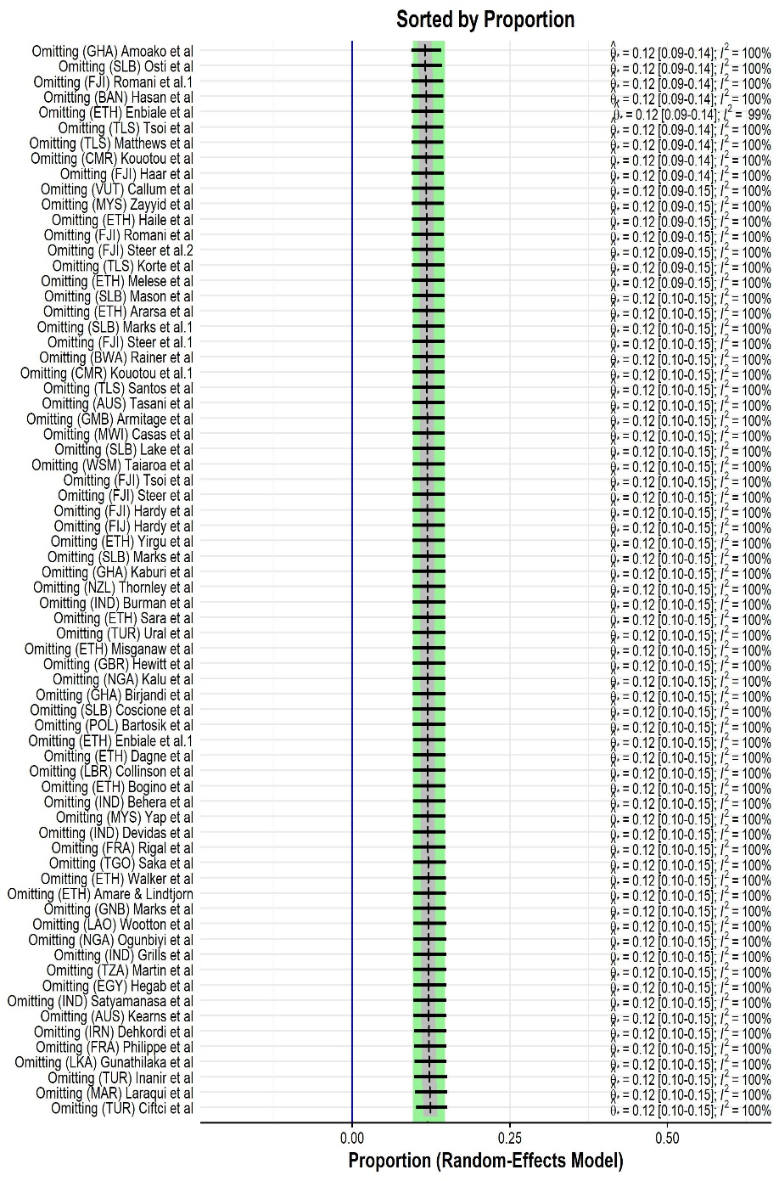 | 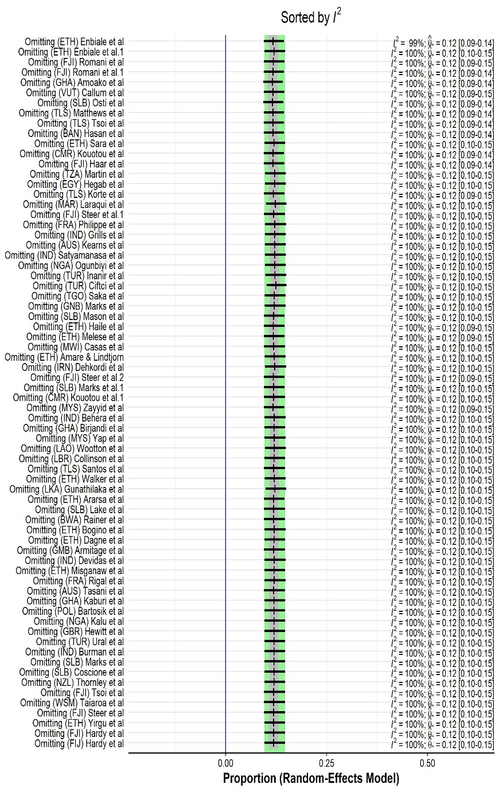

Figure S6: Influence Analysis
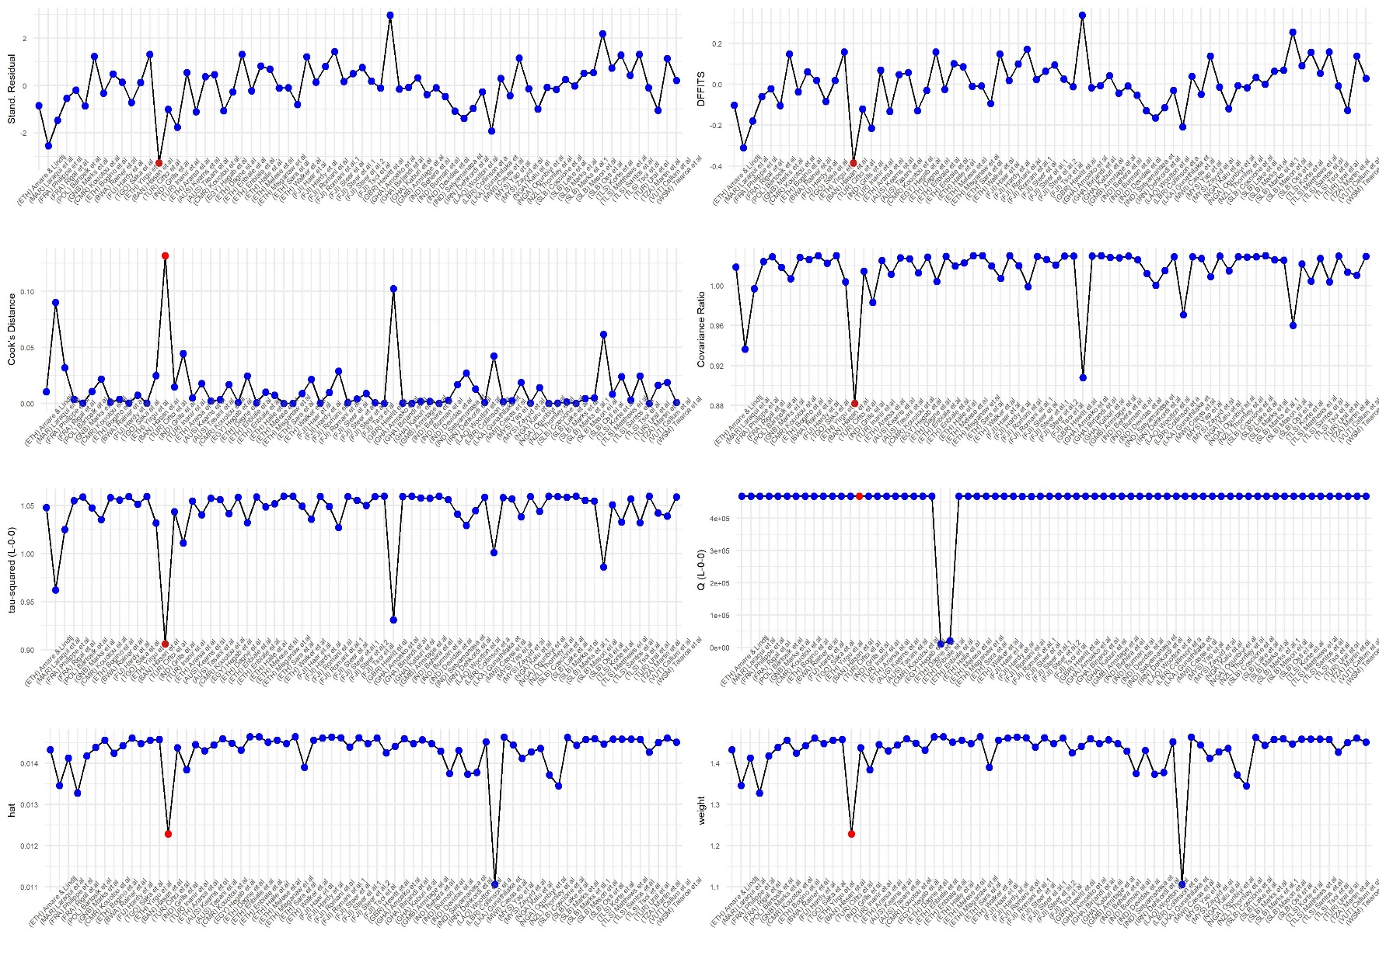

Figure S7: Baujat Plot showing the outlier studies according to heterogeneity.
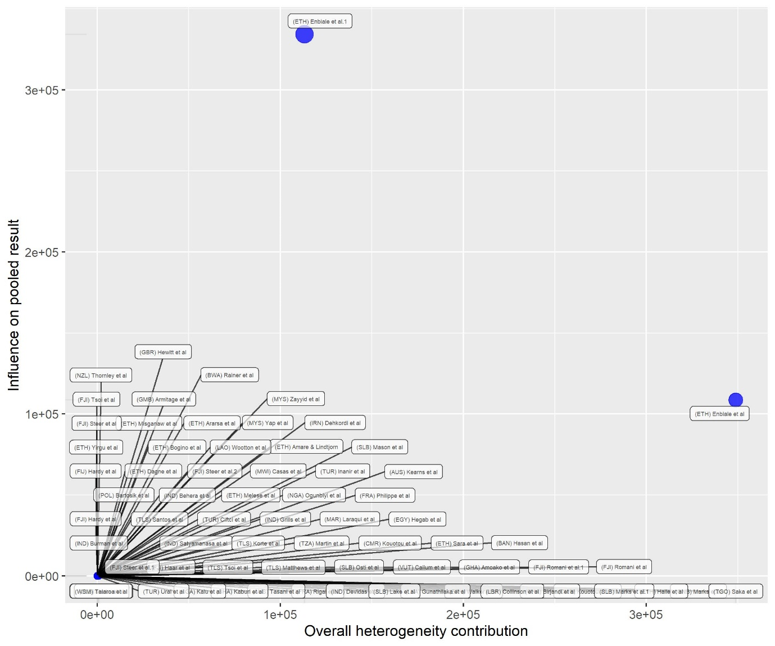

Table S8: Meta-regression of scabies prevalence and socioeconomic factors
 | β coefficient | standard error | p-value | Lower 95% CI | Upper 95% CI
Model 1 | -0.17 | 0.49 | 0.72 | -1.14 | 0.79
Model 2 | -0.04 | 0.08 | 0.67 | -0.19 | 0.12
Model 3 | -0.10 | 0.15 | 0.50 | -0.40 | 0.19
Model 1: logit GINI vs logit prevalence; Model 2: log GDP vs log prevalence; Model 3 logit HDI vs logit prevalence

Table S9: Risk of publication bias.
 | Harbord Test |  |  | Peters Test
 | Bias | t | p-value | Bias | t | p-value
Family size | 0.48 | 0.24 | 0.82 | 80.31 | 0.63 | 0.56
Share clothes | 4.95 | 2.67 | 0.05 | 465.7 | 1.33 | 0.24
Bed sharing | -2.22 | -0.77 | 0.48 | 22.12 | 0.22 | 0.84
Gender | 0.91 | 0.97 | 0.34 | 63.29 | 0.68 | 0.50
Location | -0.65 | -0.12 | 0.91 | 169.74 | 0.19 | 0.86
Frequency of bathing | 5.18 | 1.67 | 0.17 | 84.58 | 0.20 | 0.85
Source of water | 5.53 | 0.72 | 0.54 | 378.08 | 1.62 | 0.24
Contact with itchy person | 5.61 | 1.02 | 0.36 | 92.45 | 0.15 | 0.88
Presence of pets | -0.92 | -0.15 | 0.89 | 268.4 | 0.42 | 0.71
Soap use | 1.55 | 0.90 | 0.41 | 1.55 | 0.90 | 0.41

