**Supplemental Material**

Use of undetectable viral load to improve population-based survey estimates of known HIV-positive status and antiretroviral treatment coverage in Kenya

Peter W. Young, Emily Zielinski-Gutierrez, Joyce Wamicwe, Irene Mukui, Andrea A. Kim, Anthony Waruru, Clement Zeh, Mirjam E. Kretzschmar, Kevin M. De Cock

**Table S1.** Comparison of antiretroviral (ARV) detection and undetectable viral load (UVL) by self-reported HIV status, KAIS 2012

|  |  |  |  |  |  |
| --- | --- | --- | --- | --- | --- |
|  |  | **UVL biomarker** | | | |
| Status | **ARV biomarker** | Present | Absent | Missing | Total |
| **Unaware of HIV-positive status** | present | 40 | 15 | 0 | 55 |
| absent | 14 | 209 | 10 | 233 |
| missing | 11 | 29 | 15 | 55 |
| total | 65 | 253 | 25 | 343 |
| **Aware of HIV-positive status, not on ART** | present | 8 | 3 | 1 | 12 |
| absent | 12 | 61 | 0 | 73 |
| missing | 5 | 10 | 0 | 15 |
| total | 25 | 74 | 1 | 100 |
| **Aware of HIV-positive status, on ART** | present | 132 | 35 | 1 | 168 |
| absent | 3 | 15 | 0 | 18 |
| missing | 10 | 5 | 4 | 19 |
| total | 145 | 55 | 5 | 205 |
| Self-reported adherent last 30 days | present | 116 | 3 | 9 | 128 |
| absent | 27 | 11 | 4 | 42 |
| missing | 1 | 0 | 14 | 15 |
| total | 144 | 14 | 27 | 185 |
| Self-reported non-adherent last 30 days | present | 16 | 0 | 1 | 17 |
| absent | 8 | 3 | 1 | 12 |
| missing | 0 | 0 | 5 | 5 |
| total | 24 | 3 | 7 | 34 |
|  | N | 235 | 382 | 31 | 648 |

Note: ARV biomarker is present if ARVs detected in blood, UVL biomarker present if viral load undetectable (<550 copies/mL). Self-reported adherence is based on response to question among those who self-reported aware of HIV-positive status and on ART: ‘In the last 30 days, have you missed taking any of your ARV pills?’ One respondent who reported ‘don’t know’ to this question was excluded from the self-reported adherence analysis.

**Figure S1. Absolute and relative changes in ART coverage and HIV cascade indicators due to adjustment, by covariates, KAIS 2012**

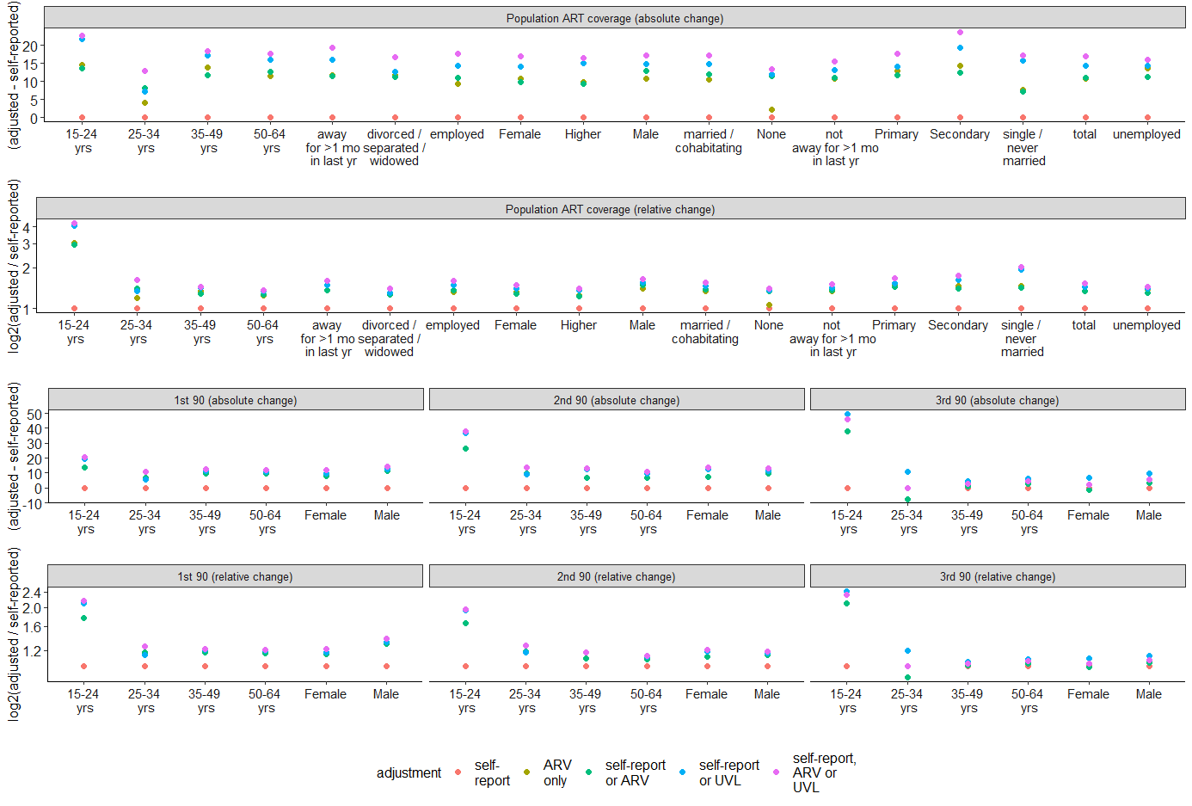

Note: relative differences are shown on log (2) scale, All differences are shown versus self-report. self-report: self-report only, self-report or ARV: either self-reported known-positive/on ART or ARVs detected, self-report or UVL: either self-reported known-positive/on ART or viral load was undetectable.

**Table S2.** Sensitivity analysis of self-reported and adjusted estimates of HIV care cascade restricted to participants with ARV and UVL biomarkers present, KAIS 2012

|  |  |  |  |  |  |  |  |  |  |  |  |  |  |
| --- | --- | --- | --- | --- | --- | --- | --- | --- | --- | --- | --- | --- | --- |
| Characteristic | | Self-report | | | Self-report or ARV | | | Self-report or UVL | | | Self-report, ARV or UVL | | |
| Variable | level | n | % | se | n | % | se | n | % | se | n | % | se |
| **Awareness of HIV infection (1st 90)** | | | | | | | | | | |  |  |  |
| Gender | Male | 62 | 37.1 | 4.5 | 81 | 50.0 | 5.3 | 82 | 50.3 | 5.3 | 86 | 52.4 | 5.4 |
| Female | 207 | 55.8 | 3.0 | 243 | 65.5 | 2.7 | 241 | 64.9 | 2.7 | 252 | 67.9 | 2.7 |
| Age group | 15–24 yrs | 15 | 21.7 | 6.0 | 23 | 39.2 | 7.9 | 25 | 44.8 | 8.4 | 26 | 46.2 | 8.3 |
| 25–34 yrs | 76 | 42.0 | 4.6 | 90 | 50.3 | 4.7 | 86 | 46.9 | 4.7 | 95 | 53.0 | 4.7 |
| 35–49 yrs | 126 | 56.5 | 4.0 | 149 | 67.7 | 3.6 | 148 | 67.5 | 3.6 | 152 | 68.5 | 3.6 |
| 50–64 yrs | 52 | 58.5 | 5.8 | 62 | 69.4 | 5.5 | 64 | 71.2 | 5.3 | 65 | 72.0 | 5.3 |
| Total |  | 269 | 48.5 | 3.0 | 324 | 59.4 | 3.0 | 323 | 59.2 | 3.1 | 338 | 61.8 | 3.1 |
| **ART coverage among previously-diagnosed (2nd 90)** | | | | | | | | | | |  |  |  |
| Gender | Male | 44 | 71.8 | 6.4 | 66 | 81.8 | 5.0 | 68 | 82.9 | 4.6 | 73 | 84.3 | 4.4 |
| Female | 141 | 68.0 | 3.4 | 185 | 76.0 | 3.0 | 191 | 79.3 | 2.9 | 204 | 80.8 | 2.8 |
| Age group | 15–24 yrs | 6 | 41.8 | 10.8 | 14 | 67.8 | 10.0 | 18 | 77.5 | 7.4 | 19 | 78.2 | 7.2 |
| 25–34 yrs | 42 | 51.8 | 6.4 | 58 | 61.8 | 5.7 | 55 | 60.5 | 5.9 | 65 | 65.5 | 5.6 |
| 35–49 yrs | 94 | 75.4 | 4.5 | 123 | 82.8 | 3.7 | 127 | 86.1 | 3.0 | 132 | 86.9 | 2.9 |
| 50–64 yrs | 43 | 84.9 | 5.4 | 56 | 92.4 | 3.7 | 59 | 93.6 | 2.9 | 61 | 95.0 | 2.6 |
| Total |  | 185 | 69.2 | 3.5 | 251 | 77.9 | 3.0 | 259 | 80.5 | 2.7 | 277 | 81.9 | 2.6 |
| **Viral suppression among those on ART (3rd 90)** | | | | | | | | | | |  |  |  |
| Gender | Male | 32 | 75.5 | 6.4 | 49 | 78.0 | 5.1 | 56 | 84.3 | 4.4 | 56 | 79.6 | 4.8 |
| Female | 108 | 76.5 | 4.0 | 139 | 75.3 | 3.6 | 158 | 82.7 | 3.0 | 158 | 77.6 | 3.3 |
| Age group | 15–24 yrs | 2 | 34.6 | 19.8 | 9 | 72.4 | 11.3 | 14 | 82.9 | 7.8 | 14 | 79.7 | 8.4 |
| 25–34 yrs | 27 | 58.4 | 8.6 | 33 | 50.3 | 7.5 | 40 | 68.1 | 7.2 | 40 | 55.5 | 7.0 |
| 35–49 yrs | 77 | 83.3 | 4.2 | 101 | 84.8 | 3.6 | 110 | 87.8 | 3.1 | 110 | 85.7 | 3.3 |
| 50–64 yrs | 34 | 80.6 | 6.4 | 45 | 82.2 | 5.4 | 50 | 85.6 | 5.0 | 50 | 83.3 | 5.1 |
| Total |  | 140 | 76.2 | 3.4 | 188 | 76.2 | 3.0 | 214 | 83.2 | 2.5 | 214 | 78.2 | 2.7 |

Note: self-reported: self-report only, self-report or ARV: either self-reported known-positive/on ART or ARVs detected, self-report or UVL: either self-reported known-positive/on ART or viral load was undetectable, se: standard error, viral suppression defined as <1000 copies/mL. Percentages and standard errors are weighted and adjusted to account for the survey design.