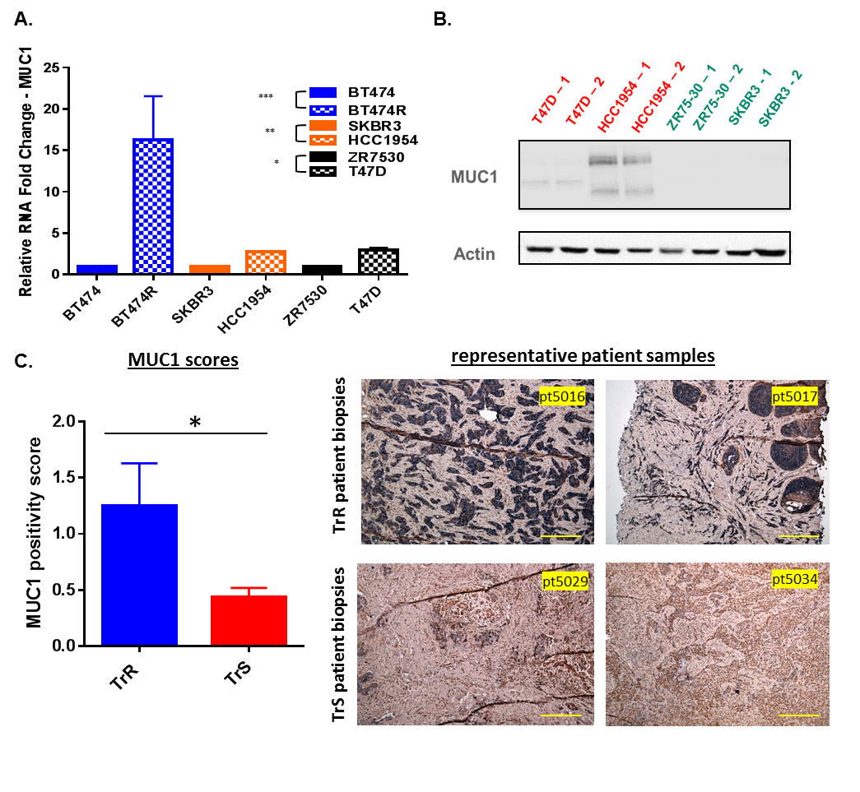

**Fig. S1. MUC1 is significantly upregulated in TrR cell lines and patient tumors.** (A) mRNA levels and (B) protein levels were significantly upregulated in TrR cell lines. (C) Immunohistochemistry of MUC1 stain on FFPE patient core biopsies (*P<0.05) and the representative pictures of stain are shown (scale bar: 100µm). Positivity score was calculated by the product of stain intensity and percentage of positive cells. Student’s t-test was performed for statistical significance.

Table S1. Pre-designed primers information and sequence of primers for genes in TrR signature