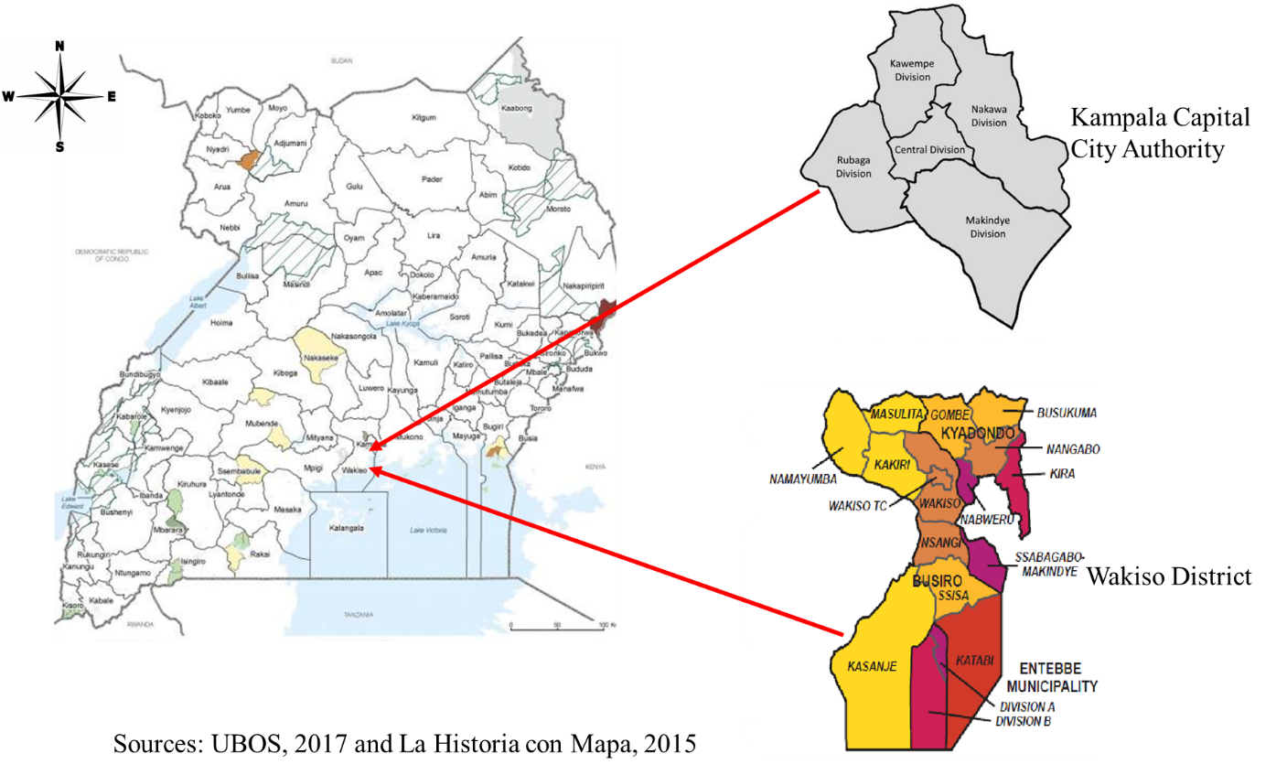

**S1 Figure: Map showing the location and geographical details of the two districts from which the study participants were got.**

Kampala Capital City Authority serves as the capital city of Uganda. It is divided into five administrative units called “divisions” and has an estimated human population of 1.5 million. Approximately 8% of households in Kampala own dogs. The average number of dogs owned per household is 1.7. Wakiso district is divided into 18 administrative units called sub-counties with a population of approximately 2 million people. Approximately 14% of households in Wakiso own dogs. The ownership stands at 1.9 dogs per household. However, the population of stray and free-roaming dogs in both districts is not known. Much as Mulago and Entebbe Hospitals are located in Kampala and Wakiso respectively, dog bite patients from either district can report to any of the healthcare facilities to receive PET.