**Supplemental Appendix**

**Severe Acute Respiratory Syndrome Coronavirus 2 (SARS-CoV-2) Infection During Pregnancy In China: A Retrospective Cohort Study**

Ming-Zhu Yin1,2,7,9*, Li-juan Zhang3,8*, Guang-Tong Deng2,7*, Chao-Fei Han4,8*, Min-Xue Shen2,7*, Hong-Yin Sun2,7, Fu-Rong Zeng2,7, Wei Zhang3,7, Lan Chen5,8, Qing-Qing Luo5,8, Du-Juan Yao5,8, Min Wu5,8, Shi-Huan Yu3,8*, Hui Chen4,8*, Xiang Chen2,7*, David Baud5,9*

**Supplemental Appendix list**

Table S1-2

Figure S1

**Table S1. Age and history of disease of pregnant vs. nonpregnant women of childbearing age infected with COVID-19.**

|  |  |  |  |  |
| --- | --- | --- | --- | --- |
| Characteristics | Total  (N=66) | Pregnant  (n=31) | Nonpregnant  (n=35) | *P* |
| Age (year), mean±SD | 32.0±4.7 | 31.0±4.3 | 32.9±4.8 | 0.108 |
| Aged 20-34, n (%) | 52 (78.8) | 25 (80.6) | 20 (57.1) | 0.041 |
| Aged 35-40, n (%) | 14 (21.2) | 6 (19.4) | 15 (42.9) |  |
| History of disease, n (%) |  |  |  |  |
| COPD | 0 (0.0) | 0 (0.0) | 0 (0.0) | ... |
| Hypertension | 1 (1.5) | 1 (3.2) | 0 (0.0) | 0.284* |
| Diabetes | 1 (1.5) | 1 (3.2) | 0 (0.0) | 0.284* |
| Cardiovascular disease | 1 (1.5) | 1 (3.2) | 0 (0.0) | 0.284* |
| Cerebrovascular disease | 0 (0.0) | 0 (0.0) | 0 (0.0) | ... |
| Chronic kidney disease | 0 (0.0) | 0 (0.0) | 0 (0.0) | ... |
| Cancer | 0 (0.0) | 0 (0.0) | 0 (0.0) | ... |
| HBV infection | 5 (7.6) | 0 (0.0) | 5 (14.3) | 0.029 |
| HIV infection | 0 (0.0) | 0 (0.0) | 0 (0.0) | ... |
| TB infection | 0 (0.0) | 0 (0.0) | 0 (0.0) | ... |

SD: standard deviation; COPD: chronic obstructive pulmonary disease; HBV: hepatitis B virus; HIV: human immunodeficiency virus. TB: tuberculosis.

* Fisher’s exact probability.

**Table S2. Characteristics of non-pregnant women of childbearing age infected with COVID-19 in Wuhan vs. its neighboring Hunan province.**

|  |  |  |
| --- | --- | --- |
| Characteristics | Wuhan  (n=31) | Hunan  (n=159) |
| Age (year), mean±SD | 33.1±5.0 | 32.9±4.8 |
| Aged 20-34, n (%) | 17 (53.3) | 90 (56.6) |
| Aged 35-40, n (%) | 14 (46.7) | 69 (43.4) |
| Travel history in Hubei in 14 days prior to onset, n (%) | 31 (100.0) | 81 (50.9) |
| Severity, n (%) |  |  |
| Mild / moderate | 28 (90.3) | 155 (96.5) |
| Severe / critical | 3 (9.7) | 4 (2.5) |
| Interval from onset to hospitalization (days) , mean±SD | 13.4±8.4 | 3.5±6.2 |
| Discharged patients, n (%) | 27 (90.0) | 159 (100.0) |
| Length of stay (day), mean±SD | 18.0±5.7 | 12.2±5.9 |

SD: standard deviation.

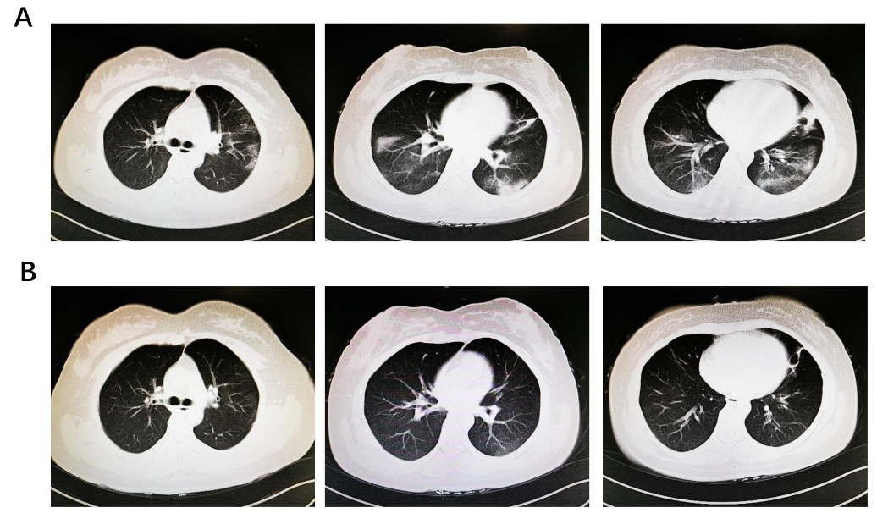

**Figure S1. Chest Computed Tomographic Images of a 38-Year-Old Pregnant Women (Gestational age: 28 weeks) Infected With 2019 Novel Coronavirus（2019-nCoV.）**(**A**) Computed tomography images on day 12 after symptom onset. (**B**) Computed tomography images on day 24 after symptom onset.