Supplementary Information
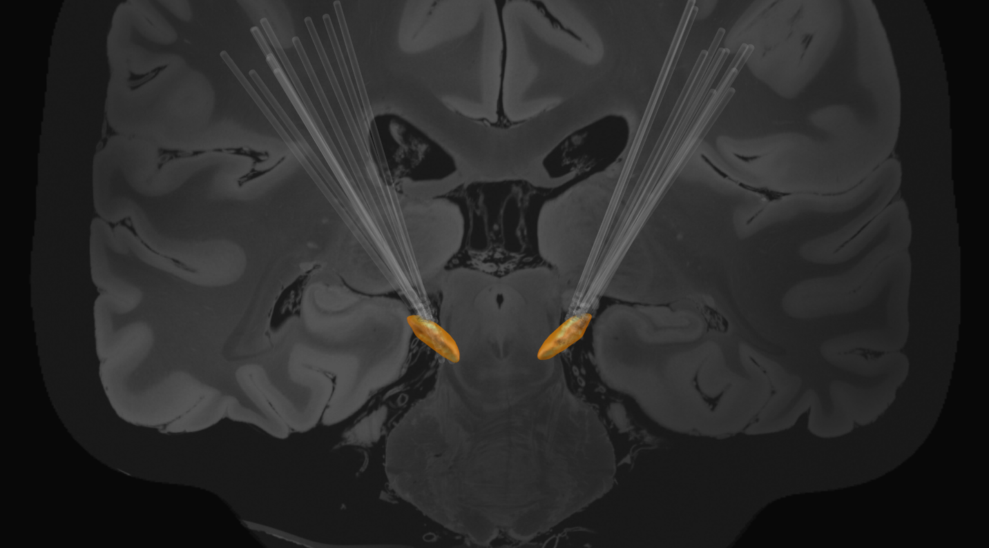
Figure S1. Reconstructed STN DBS lead locations for twenty-four STNs

Localization of DBS Leads
Location of DBS leads was determined by the Lead-DBS toolbox (Horn et al., 2019) based on preoperative T1 and T2 MRIs and postoperative CT scans. Postoperative CT scans and preoperative T2 scans were co-registered to preoperative T1 scans, which were then normalized into MNI space using SPM12 (Statistical Parametric Mapping 12; Wellcome Trust Centre for Neuroimaging, UCL, London, UK) and Advanced Normalization Tools (Avants et al., 2011). DBS electrode localizations were then corrected for brain-shift in the postoperative CT scan (Horn and Kühn, 2015). Finally, DBS electrodes were localized in template space using the PaCER algorithm (Husch et al., 2018) and projected onto the DISTAL Atlas to visualize overlap with the STN (Ewert et al., 2018).

Participant | LSTN | RSTN
1 | 0-2 | 8-10
2 | 0-2 | 8-10
3 | 0-2 | 8-10
4 | 1-3 | 9-11
5 | 0-2 | 9-11
6 | 0-2 | 9-11
7 | 0-2 | 9-11
8 | 1-3 | 9-11
9 | 0-2 | 8-10
10 | 0-2 | 8-10
11 | 0-2 | 8-10
12 | 0-2 | 8-10
Table S1. Recording contacts for each STN for all participants

Task | Band | Duration  (ms) | Peak Power  (V²) | Average Power  (V²)
RAFT | Elevated Band | 690±600 | 11.70±14.73 | 2.41±2.25
 | Non-elevated Band | 200±140 | 1.31±0.67 | 0.54±0.21
rWFE | Elevated Band | 560±350 | 10.24±9.35 | 2.24±1.82
 | Non-elevated Band | 200±160 | 1.28±0.76 | 0.53±0.24
SIP | Elevated Band | 730±950 | 11.87±11.46 | 2.62±1.99
 | Non-elevated Band | 180±130 | 1.43±0.95 | 0.61±0.41
FW | Elevated Band | 1080±1240 | 16.78±16.79 | 3.35±2.71
 | Non-elevated Band | 180±130 | 1.50±1.01 | 0.63±0.43
Table S2. Burst metrics for all movement tasks (mean±SD) for both the elevated and non-elevated band

References
Avants BB, Tustison NJ, Song G, Cook PA, Klein A, Gee JC. A Reproducible Evaluation of ANTs Similarity Metric Performance in Brain Image Registration. Neuroimage 2011; 54: 2033–2044. https://doi.org/10.1016/j.neuroimage.2010.09.025
Ewert S, Plettig P, Li N, Chakravarty MM, Collins DL, Herrington TM, et al. Toward defining deep brain stimulation targets in MNI space: A subcortical atlas based on multimodal MRI, histology and structural connectivity. NeuroImage 2018; 170: 271–282. https://doi.org/10.1016/j.neuroimage.2017.05.015
Horn A, Kühn AA. Lead-DBS: a toolbox for deep brain stimulation electrode localizations and visualizations. Neuroimage 2015; 107: 127–135. https://doi.org/10.1016/j.neuroimage.2014.12.002
Horn A, Li N, Dembek TA, Kappel A, Boulay C, Ewert S, et al. Lead-DBS v2: Towards a comprehensive pipeline for deep brain stimulation imaging. NeuroImage 2019; 184: 293–316. https://doi.org/10.1016/j.neuroimage.2018.08.068
Husch A, V. Petersen M, Gemmar P, Goncalves J, Hertel F. PaCER - A fully automated method for electrode trajectory and contact reconstruction in deep brain stimulation. NeuroImage: Clinical 2018; 17: 80–89. https://doi.org/10.1016/j.nicl.2017.10.004

