Assessing COVID-19 Risk, Vulnerability and Infection Prevalence in Communities
Amin Kiaghadi¹, Hanadi S. Rifai^{2*}, and Winston Liaw³

¹ Civil and Environmental Engineering, University of Houston; Aerospace Engineering, University of Texas, Austin
² Civil and Environmental Engineering, University of Houston
³ Health Systems and Population Health Sciences, College of Medicine, University of Houston

* Corresponding author
Email: rifai@uh.edu

Tables:

S1 Table. Rotated component matrix from the Principal Component Analysis. Varimax with Kaiser Normalization was chosen as the rotation method. Highlighted values indicated values greater than 0.5 or the maximum among the components
Variable | Component
 | 1 | 2 | 3 | 4 | 5
Access to HBP medications | -0.16 | -0.91 | 0.03 | 0.15 | 0.16
Age above 50 | -0.22 | 0.87 | 0.01 | -0.11 | 0.00
Age above 60 | -0.22 | 0.88 | -0.03 | -0.01 | -0.01
Age above 70 | -0.17 | 0.88 | -0.08 | 0.05 | 0.02
Age above 80 | -0.16 | 0.75 | -0.09 | 0.16 | 0.07
Arthritis | 0.53 | 0.80 | 0.00 | -0.13 | -0.08
Asthma | 0.90 | -0.02 | 0.07 | -0.06 | -0.33
At least one disability | 0.46 | 0.55 | 0.18 | -0.02 | -0.20
Below the poverty line | 0.81 | -0.16 | 0.07 | 0.24 | 0.04
Binge drinking | -0.81 | -0.44 | 0.11 | 0.05 | 0.04
Cancer | -0.30 | 0.89 | -0.11 | -0.09 | -0.03
Cholesterol | 0.61 | 0.66 | -0.03 | -0.11 | 0.31
Cholesterol screening | 0.66 | -0.65 | 0.05 | 0.16 | 0.25
Chronic heart disease | 0.73 | 0.63 | 0.09 | -0.02 | 0.11
Chronic kidney disease | 0.85 | 0.48 | 0.13 | 0.03 | -0.02
COPD | 0.90 | 0.34 | 0.03 | -0.02 | 0.03
Current smoker | 0.94 | -0.27 | 0.04 | 0.02 | 0.02
Diabetes | 0.91 | 0.35 | 0.13 | -0.05 | -0.01
Distance to a hazardous site | 0.03 | -0.12 | 0.28 | 0.01 | 0.06
Drive time to a medical facility | -0.10 | -0.08 | -0.12 | -0.60 | -0.14
Education beyond high school diploma | 0.76 | -0.24 | 0.08 | 0.00 | 0.48
Fecal Occult blood test, Sigmoidoscopy, or Colonoscopy | 0.82 | -0.40 | 0.04 | 0.08 | 0.35
FEMA Harvey claims ratio | -0.30 | 0.24 | 0.01 | -0.60 | -0.02
Harvey inundation ratio | -0.06 | 0.01 | -0.03 | -0.50 | 0.06
HBP | 0.75 | 0.60 | 0.06 | -0.11 | -0.23
Household density | -0.12 | -0.26 | -0.16 | 0.70 | -0.10
Insurance coverage | 0.73 | -0.37 | -0.13 | 0.14 | 0.36
Living alone | -0.21 | 0.05 | 0.26 | 0.61 | -0.38
Low sleep quality | 0.90 | -0.24 | 0.06 | -0.03 | -0.25
Mammography | 0.74 | -0.26 | -0.04 | 0.13 | 0.56
Median age (year ) | -0.38 | 0.76 | 0.03 | -0.06 | -0.02
No physical activity | 0.96 | -0.12 | 0.05 | 0.02 | 0.22
NO₂ concentration | -0.02 | 0.14 | 0.85 | 0.31 | -0.01
Number of dry cleaners, petroleum storage tanks, and IHWCA¹ sites | 0.07 | -0.11 | 0.36 | -0.28 | 0.21
Number of hazardous releases | 0.05 | 0.03 | 0.01 | -0.16 | 0.42
Obesity | 0.96 | -0.08 | 0.15 | -0.04 | -0.05
Older men up to date on core clinical preventive services | 0.86 | -0.27 | 0.15 | -0.02 | -0.01
Older women up to date on core clinical preventive services | 0.92 | -0.24 | 0.15 | 0.08 | 0.14
Ozone concentration | -0.13 | 0.02 | -0.88 | 0.01 | 0.06
Pap Smear | 0.87 | -0.23 | -0.03 | 0.14 | 0.30
PM_{2.5} concentration | 0.19 | 0.05 | 0.80 | -0.01 | -0.12
Poor Mental condition | 0.92 | -0.30 | 0.05 | 0.03 | 0.16
Poor Physical condition | 0.96 | 0.04 | 0.08 | 0.02 | 0.22
Stroke | 0.84 | 0.46 | 0.13 | -0.01 | -0.20
Visit doctor for routine checkup | 0.06 | -0.76 | 0.03 | 0.20 | 0.58
Visit dentist or dental clinic | 0.94 | -0.27 | 0.08 | 0.06 | 0.14
¹ IHWCA: Industrial and Hazardous Waste Corrective Action

S2 Table. Descriptive summary statistics for all 46 variables. Median and median absolute deviation are reported instead of mean and standard deviation because none of the datasets were normally distributed
Variable | N | Minimum | Maximum | Median | Median Absolute Deviation
Household density (number of houses per 1,000 sq. m) | 786 | 0.00 | 8.04 | 0.64 | 0.28
Drive time to a medical facility (minutes) | 786 | 0.00 | 25.23 | 4.74 | 1.57
Access to HBP medications (%) | 584 | 25.90 | 85.10 | 72.50 | 6.10
Cholesterol screening (%) | 584 | 39.10 | 88.80 | 67.80 | 8.90
Insurance coverage (%) | 786 | 42.00 | 100.00 | 80.00 | 9.00
Visit doctor for routine checkup (%) | 584 | 54.80 | 80.40 | 67.30 | 4.25
Visit dentist or dental clinic (%) | 584 | 25.20 | 82.50 | 51.85 | 15.95
Mammography (%) | 584 | 61.70 | 81.20 | 74.00 | 5.00
Pap Smear (%) | 584 | 56.20 | 86.40 | 75.60 | 7.20
Fecal Occult blood test, Sigmoidoscopy, or Colonoscopy (%) | 584 | 28.70 | 74.20 | 54.05 | 11.55
Older men up to date on core clinical preventive services (%) | 584 | 0.00 | 39.90 | 25.70 | 6.10
Older women up to date on core clinical preventive services (%) | 584 | 0.00 | 45.40 | 28.05 | 7.65
Arthritis (%) | 584 | 4.00 | 30.90 | 18.55 | 4.30
Asthma (%) | 584 | 6.30 | 14.60 | 8.70 | 1.30
HBP (%) | 584 | 9.80 | 52.00 | 29.50 | 5.80
Cancer (%) | 584 | 0.80 | 10.80 | 4.60 | 1.40
Cholesterol (%) | 584 | 13.20 | 48.50 | 38.05 | 4.65
Chronic kidney disease (%) | 584 | 0.80 | 6.00 | 2.70 | 0.70
COPD (%) | 584 | 1.70 | 14.80 | 5.70 | 2.00
Chronic heart disease (%) | 584 | 0.80 | 11.40 | 5.60 | 1.90
Diabetes (%) | 584 | 2.10 | 25.50 | 11.90 | 4.40
Poor Mental condition (%) | 584 | 6.10 | 21.80 | 12.60 | 3.60
Poor Physical condition (%) | 584 | 4.70 | 26.40 | 13.20 | 5.00
Stroke (%) | 584 | 0.50 | 10.00 | 2.80 | 1.10
At least one disability (%) | 786 | 1.00 | 100.00 | 9.00 | 2.00
Median age (year ) | 786 | 0.00 | 60.40 | 33.55 | 3.35
Age above 50 (%) | 786 | 0.00 | 66.00 | 27.00 | 6.00
Age above 60 (%) | 786 | 0.00 | 51.00 | 15.00 | 4.00
Age above 70 (%) | 786 | 0.00 | 29.00 | 6.00 | 2.00
Age above 80 (%) | 786 | 0.00 | 14.00 | 2.00 | 1.00
Distance to a hazardous site (m) | 786 | 79.3 | 9386.8 | 2105.4 | 858.5
Number of hazardous releases (unitless) | 786 | 1 | 1469 | 12 | 6
Number of dry cleaners, petroleum storage tanks, and IHWCA¹ sites | 786 | 0 | 60 | 4 | 2
Ozone concentration (ppb) | 786 | 17.57 | 26.57 | 21.24 | 1.35
NO₂ concentration (ppm) | 786 | 4.62 | 16.20 | 8.32 | 1.41
PM_{2.5} concentration (µg/m³) | 786 | 8.24 | 11.70 | 9.98 | 0.37
FEMA Harvey claims ratio (%) | 786 | 0.00 | 0.37 | 0.04 | 0.02
Harvey inundation ratio (%) | 786 | 0.00 | 0.99 | 0.12 | 0.12
Binge drinking (%) | 584 | 8.10 | 27.80 | 15.70 | 2.60
Current smoker (%) | 584 | 7.00 | 34.40 | 18.10 | 5.65
No physical activity (%) | 584 | 15.40 | 51.40 | 33.20 | 9.60
Obesity (%) | 584 | 18.30 | 51.50 | 34.60 | 7.80
Low sleep quality (%) | 584 | 24.10 | 49.00 | 37.00 | 5.50
Education beyond high school diploma (%) | 786 | 30.77 | 100.00 | 83.02 | 12.00
Below the poverty line (%) | 786 | 0.00 | 100.00 | 14.00 | 8.00
Living alone (%) | 786 | 0.00 | 100.00 | 24.00 | 8.00
¹ IHWCA: Industrial and Hazardous Waste Corrective Action

S3 Table: Results of the K-Means analysis: final cluster centers for different variables at each category
Category | Variable | Cluster
 |  | 1 | 2 | 3
Category 1 | Household density (number of houses per 1,000 sq. m) | 0.89 | 0.75 | 0.98
 | Drive time to a medical facility (minutes) | 4.31 | 4.85 | 5.07
 | Access to HBP medicine (%) | 29.46 | 26.91 | 26.68
 | Cholesterol screening (%) | 40.06 | 30.87 | 21.66
 | Insurance coverage (%) | 66.99 | 78.02 | 91.23
 | Visit doctor for routine checkup (%) | 34.92 | 31.03 | 30.62
 | Visit dentist or dental clinic (%) | 61.18 | 46.81 | 27.76
 | Mammography (%) | 31.13 | 25.49 | 21.71
 | Pap Smear (%) | 31.38 | 23.68 | 17.39
 | Fecal Occult blood test, Sigmoidoscopy, or Colonoscopy (%) | 56.65 | 44.54 | 33.32
 | Older men up to date on core clinical preventive services (%) | 78.60 | 73.81 | 65.73
 | Older women up to date on core clinical preventive services (%) | 78.00 | 71.07 | 61.53
Category 2 | Arthritis (%) | 26.48 | 19.24 | 14.97
 | Asthma (%) | 10.9 | 8.91 | 7.85
 | HBP (%) | 44.68 | 31 | 24.14
 | Cancer (%) | 5.58 | 4.7 | 4.67
 | Cholesterol (%) | 42.76 | 39.01 | 32.16
 | Chronic kidney disease (%) | 4.18 | 2.94 | 2.06
 | COPD (%) | 9.02 | 6.32 | 3.77
 | Chronic heart disease (%) | 8.82 | 6.11 | 3.78
 | Diabetes (%) | 20.68 | 13.5 | 7.97
 | Mental condition not good (%) | 14.96 | 13.69 | 9.69
 | Physical condition not good (%) | 18.46 | 14.99 | 8.72
 | Stroke (%) | 6.23 | 3.25 | 1.89
 | At least one disability (%) | 16.99 | 9.5 | 7.48
 | Median age (year ) | 35.94 | 32.93 | 34.82
 | Age above 50 (%) | 32.39 | 26.44 | 26.65
 | Age above 60 (%) | 19.88 | 14.86 | 15.25
 | Age above 70 (%) | 9.67 | 6.51 | 6.43
 | Age above 80 (%) | 3.46 | 2.36 | 2.29
Category 3 | Distance to a hazardous site (m) | 1571 | 1451 | 1409
 | Number of hazardous events (unitless) | 1455.91 | 542.81 | 18.8
 | Number of dry cleaners, petroleum storage tanks, and IHWCA¹ sites | 10.55 | 7.67 | 4.55
 | Ozone concentration (ppb) | 23.18 | 21.67 | 21.29
 | NO₂ concentration (ppm) | 7.52 | 8.95 | 8.82
 | PM_{2.5} concentration (µg/m³) | 8.71 | 10.22 | 10.13
Category 4 | FEMA Harvey claims ratio (%) | 11.00 | 5.00 | 3.00
 | Harvey inundation ratio (%) | 75.00 | 36.00 | 6.00
Category 5 | Binge drinking (%) | 18.22 | 16.10 | 13.47
 | Current smoker (%) | 17.02 | 22.63 | 11.10
 | No physical activity (%) | 11.52 | 17.60 | 23.19
 | Obesity (%) | 25.70 | 34.08 | 41.35
 | Low sleep quality (%) | 30.37 | 36.90 | 41.07
 | Education beyond high school diploma (%) | 94.61 | 76.97 | 62.45
 | Below the poverty line (%) | 7.92 | 16.07 | 28.75
 | Living alone (%) | 32.94 | 26.95 | 26.75
¹ IHWCA: Industrial and Hazardous Waste Corrective Action

Figures:

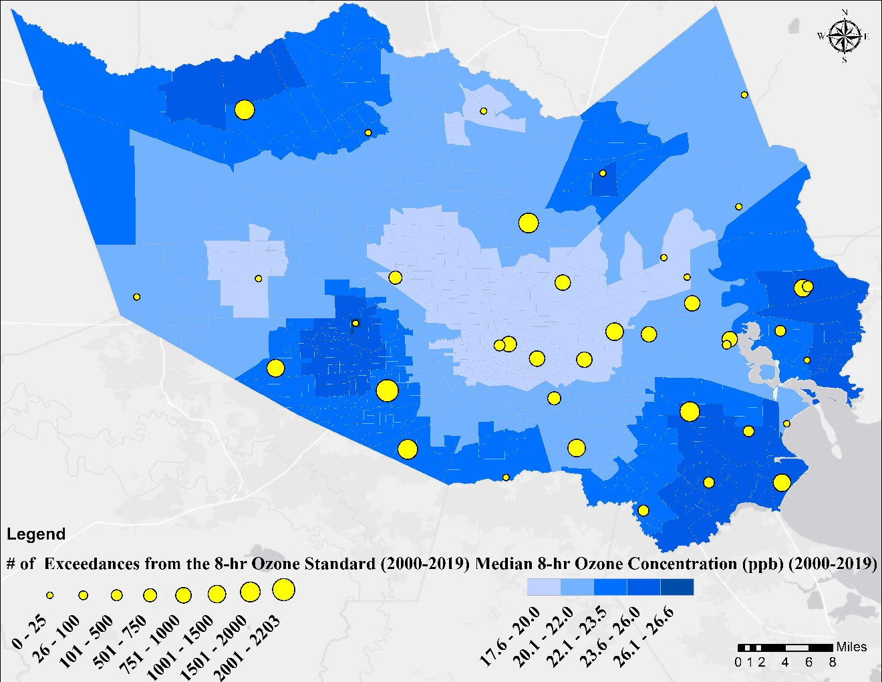
S1 Fig. Map showing the median of averaged 8-hr concentration of Ozone (ppb) in Harris County. The yellow dots show the location of air quality monitoring stations maintained by the TCEQ. The magnitude of the dots shows how many times the averaged 8-hr ozone concentration in a specific station exceeded the 70 ppb standard established by EPA from 2000-2019
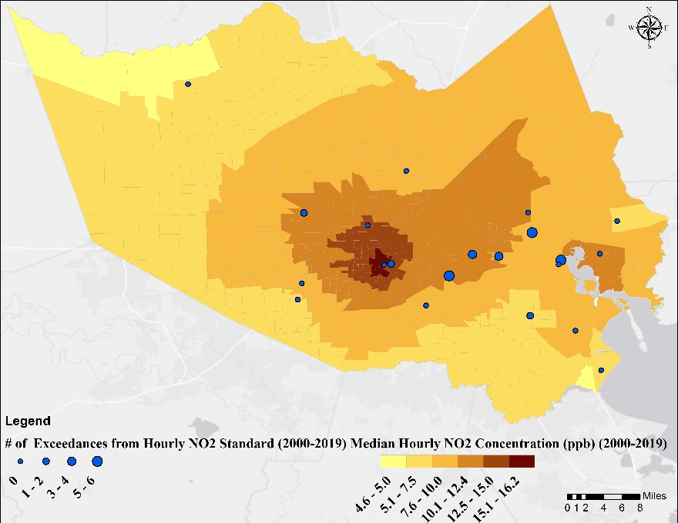
S2 Fig. Map showing the median of hourly concentration of NO₂ in Harris County. The yellow dots show the location of air quality monitoring stations maintained by TCEQ. The magnitude of the dots shows how many times the hourly NO₂ concentration in a specific station exceeded the 100 ppb standard established by EPA from 2000-2019

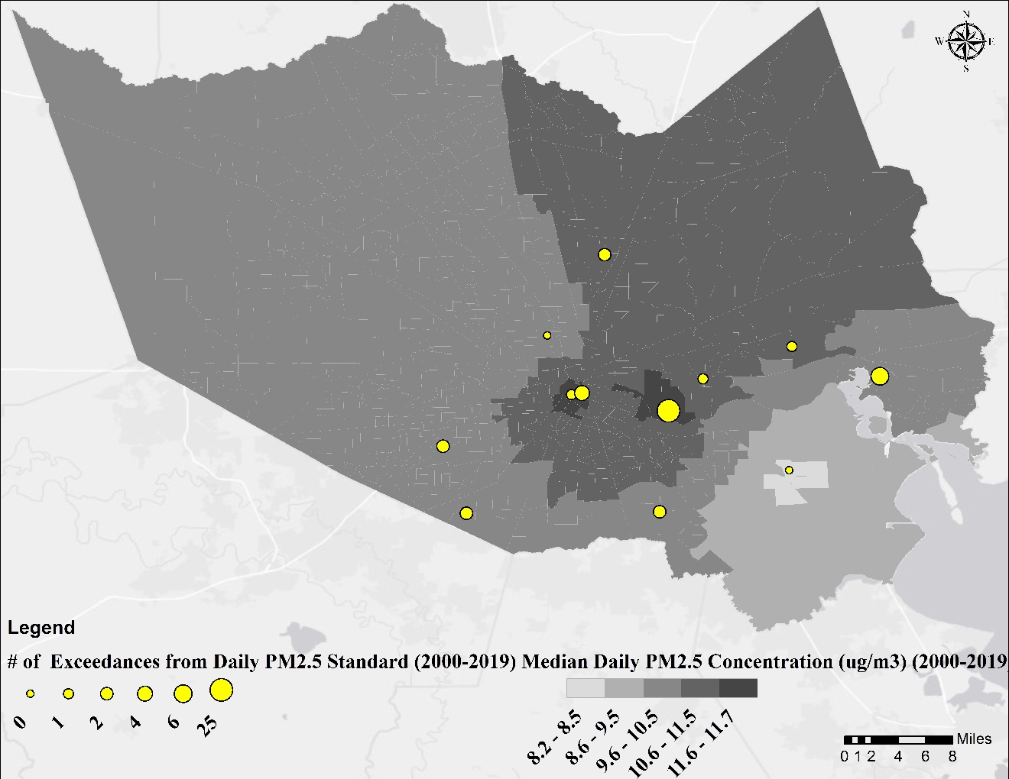
S3 Fig. Map showing the median of averaged daily concentration of PM_{2.5} in Harris County. The yellow dots show the location of air quality monitoring stations maintained by TCEQ. The magnitude of the dots shows how many times the averaged daily PM_{2.5} concentration in a specific station exceeded the 35 µg/m³ standard established by EPA from 2000-2019

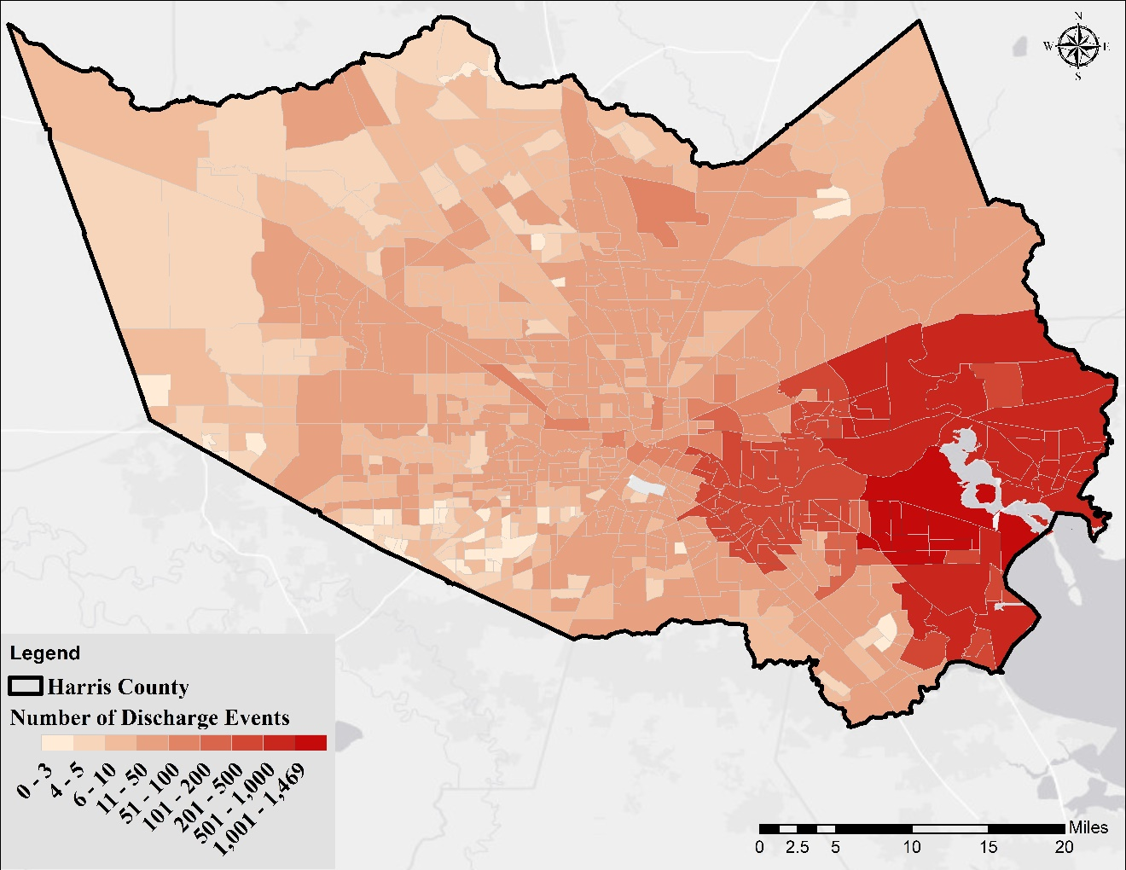
S4 Fig. Map showing the sum of reported environmental release events from 2000-2020 and leaking petroleum tanks within each census tract

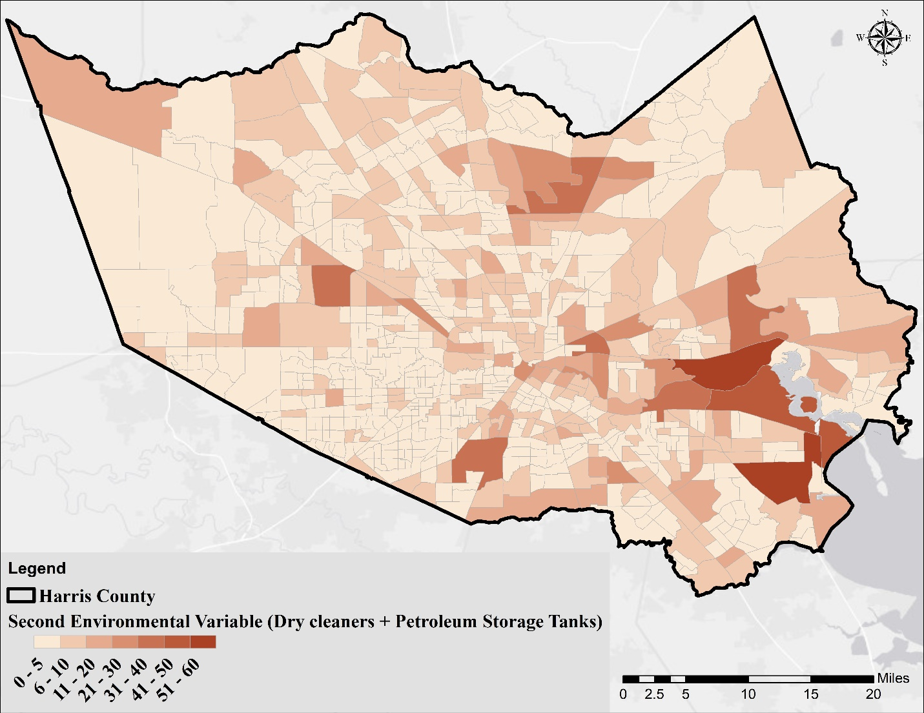
S5 Fig. Map showing the second environmental variable, which is the sum of the number of dry cleaners, petroleum tanks, and sites that are part of an Industrial and Hazardous Waste Corrective Action (IHWCA) program defined by the TCEQ within each census tract

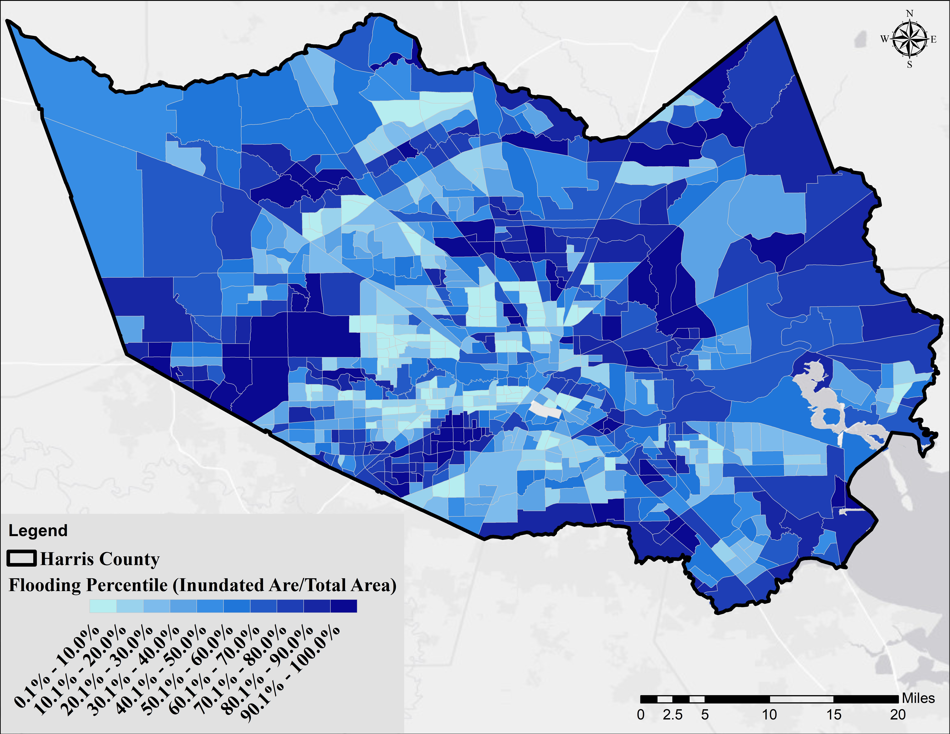
S6 Fig. Map showing flood vulnerability based on the inundation method

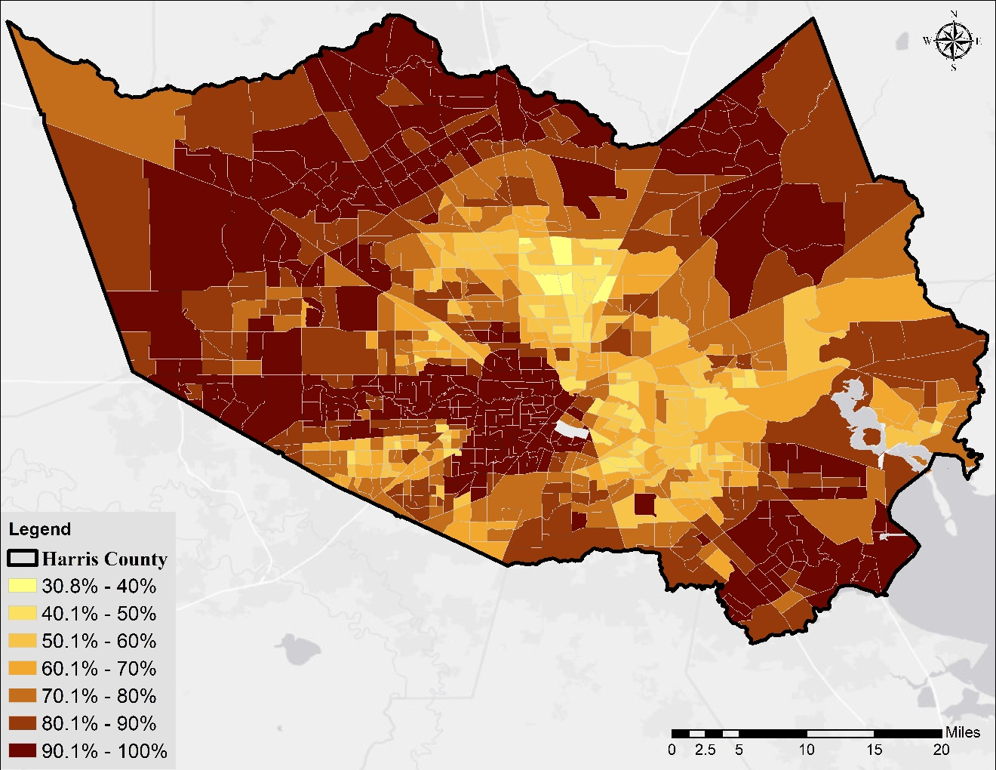
S7 Fig. Map showing the percentage of age 25 years and over to the total population in each census tract with a high school diploma or higher degree

S8 Fig. The averaged exceedance in the 5 categories for the tracts with the highest and lowest overall vulnerability (highest averaged exceedance in 5 categories) within Harris County

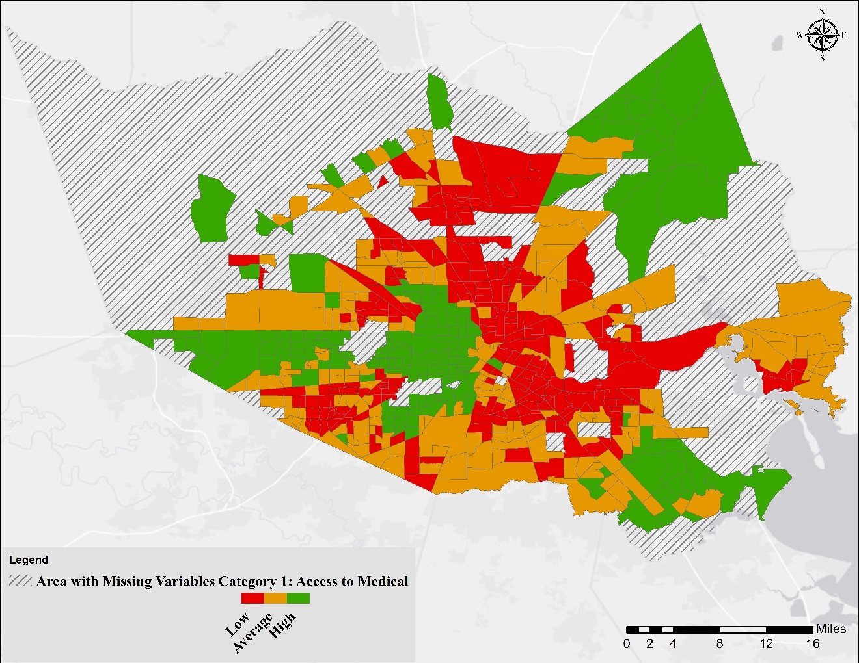
S9 Fig. Results of the K-means cluster analysis. Different colors reflect the belongingness of tracts to the three classes defined in the method for Category 1: Access to Medical (see Table 1 for more details). Areas with hatched lines represent census tracts with missing data on chronic disease risk factors, health outcomes, and clinical preventive service form [1]

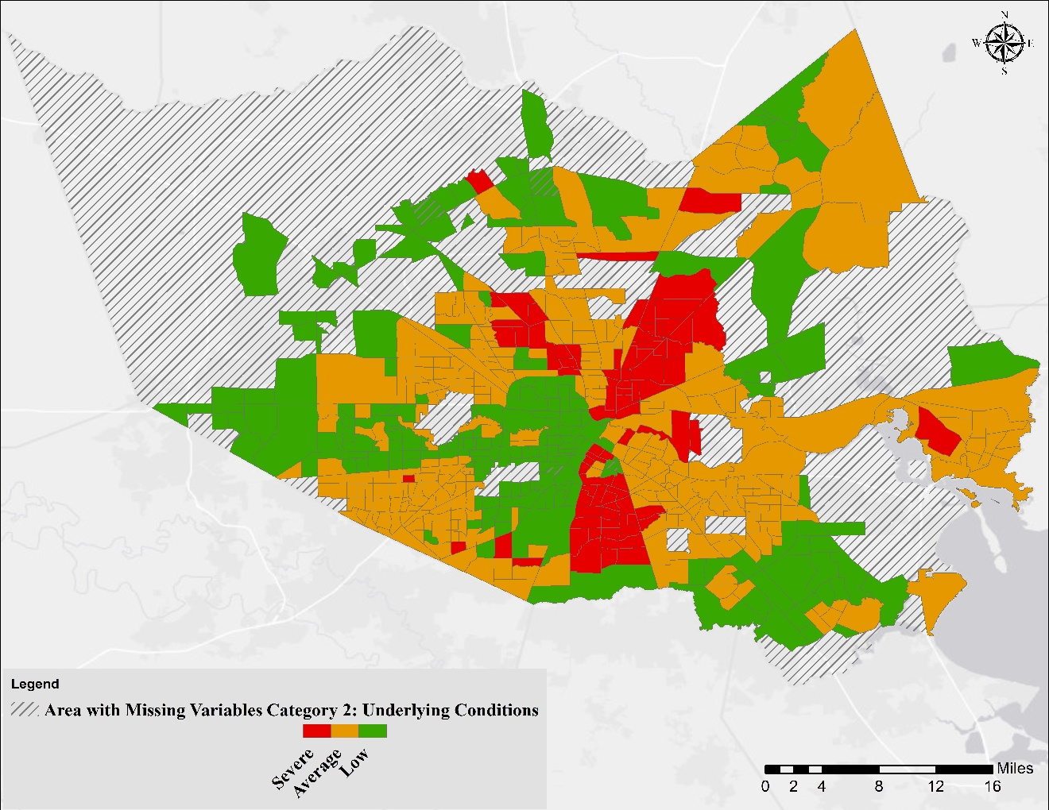
S10 Fig. Results of the K-means cluster analysis. Different colors reflect the belongingness of tracts to the three classes defined in the method for Category 2: Underlying Conditions (see Table 1 for more details). Areas with hatched lines represent census tracts with missing data on chronic disease risk factors, health outcomes, and clinical preventive service form [1]

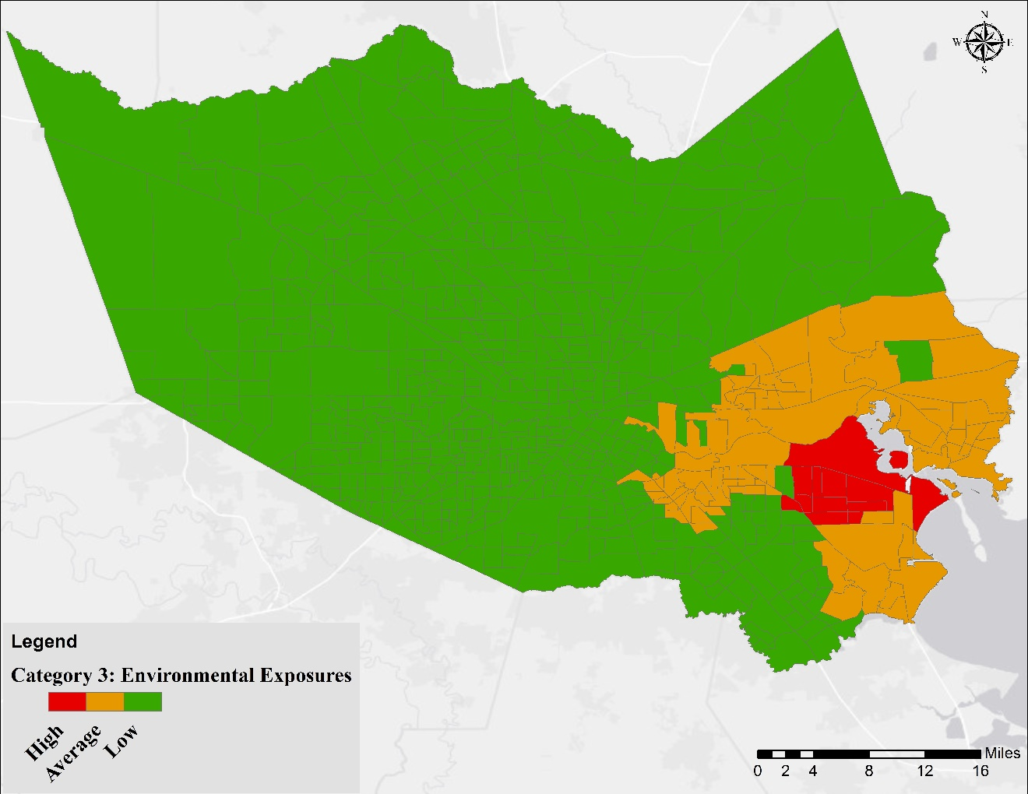
S11 Fig. Results of the K-means cluster analysis. Different colors reflect the belongingness of tracts to the three classes defined in the method for Category 3: Environmental Exposures (see Table 1 for more details)

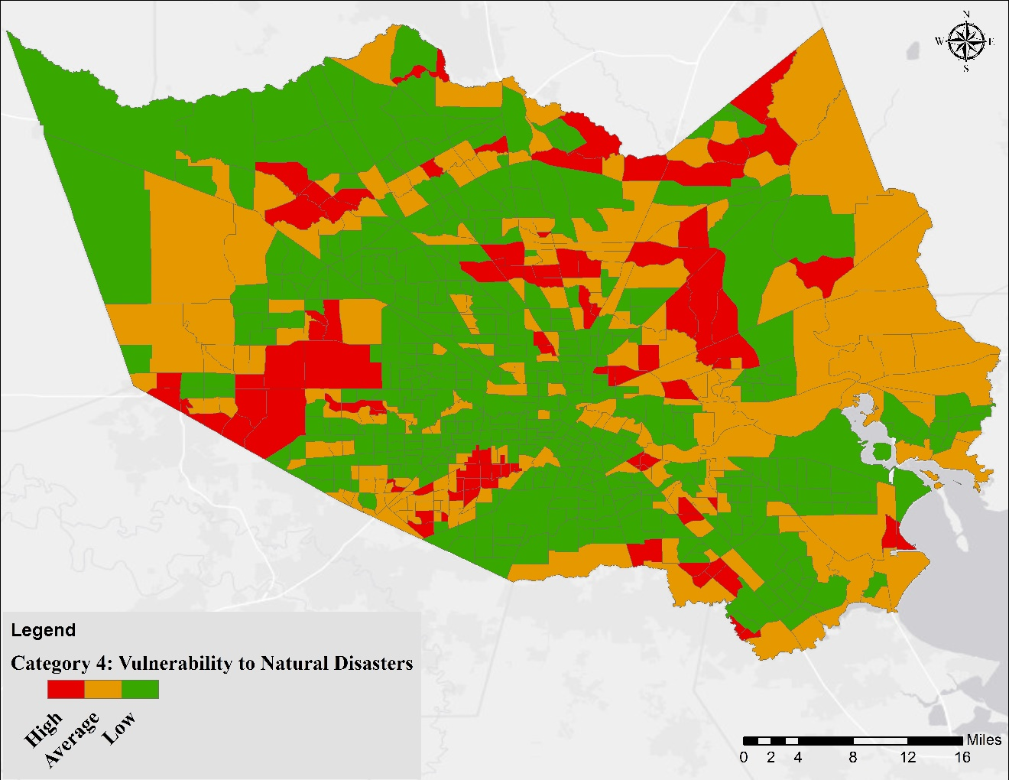
S12 Fig. Results of the K-means cluster analysis. Different colors reflect the belongingness of tracts to the three classes defined in the method for Category 4: Vulnerability to Natural Disasters (see Table 1 for more details)

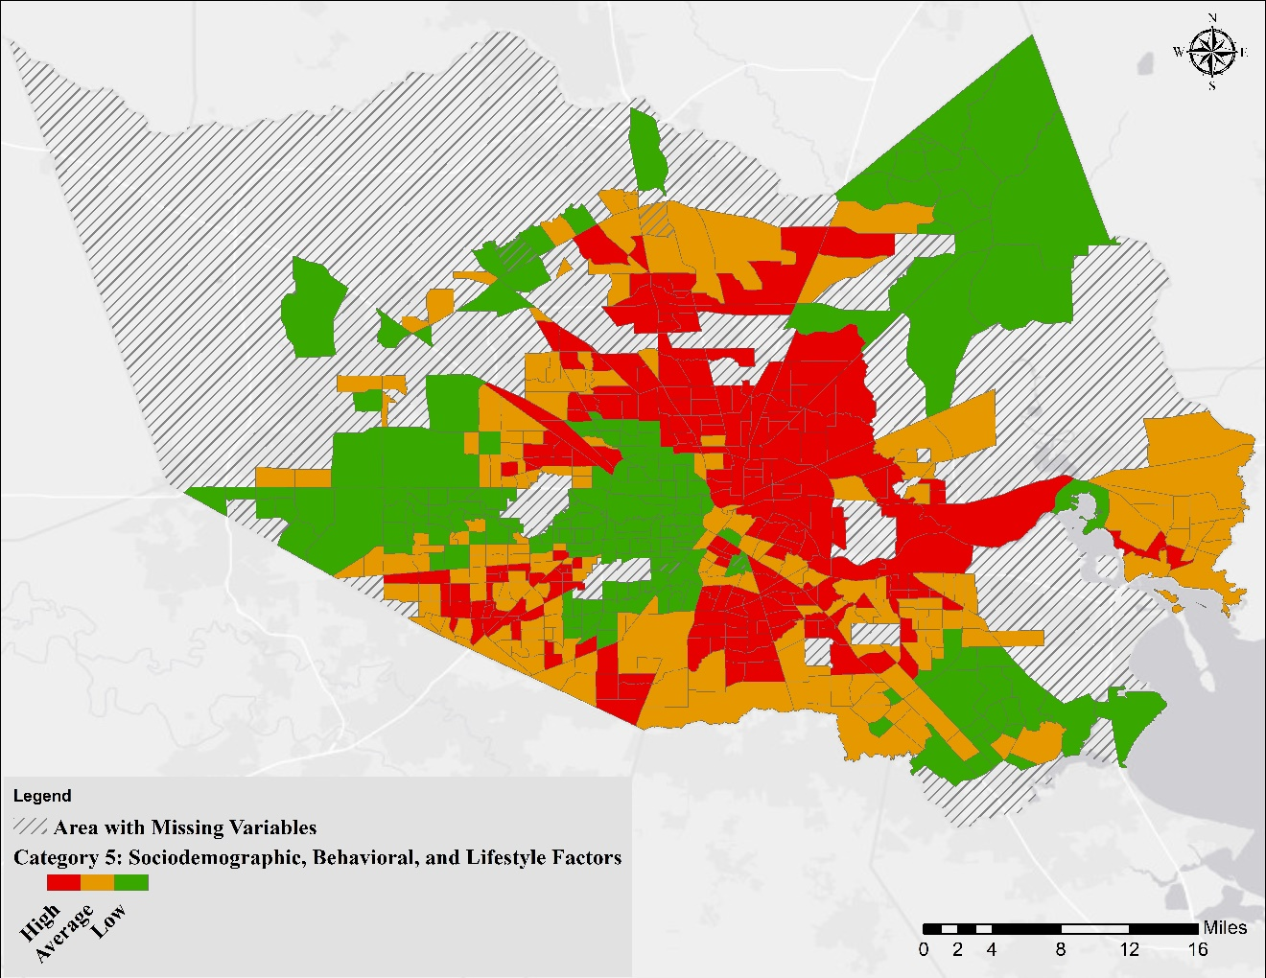
S13 Fig. Results of the K-means cluster analysis. Different colors reflect the belongingness of tracts to the three classes defined in the method for Category 5: Sociodemographic, Behavioral, and Lifestyle Factors (see Table 1 for more details). Areas with hatched lines represent census tracts with missing data on chronic disease risk factors, health outcomes, and clinical preventive service form [1]

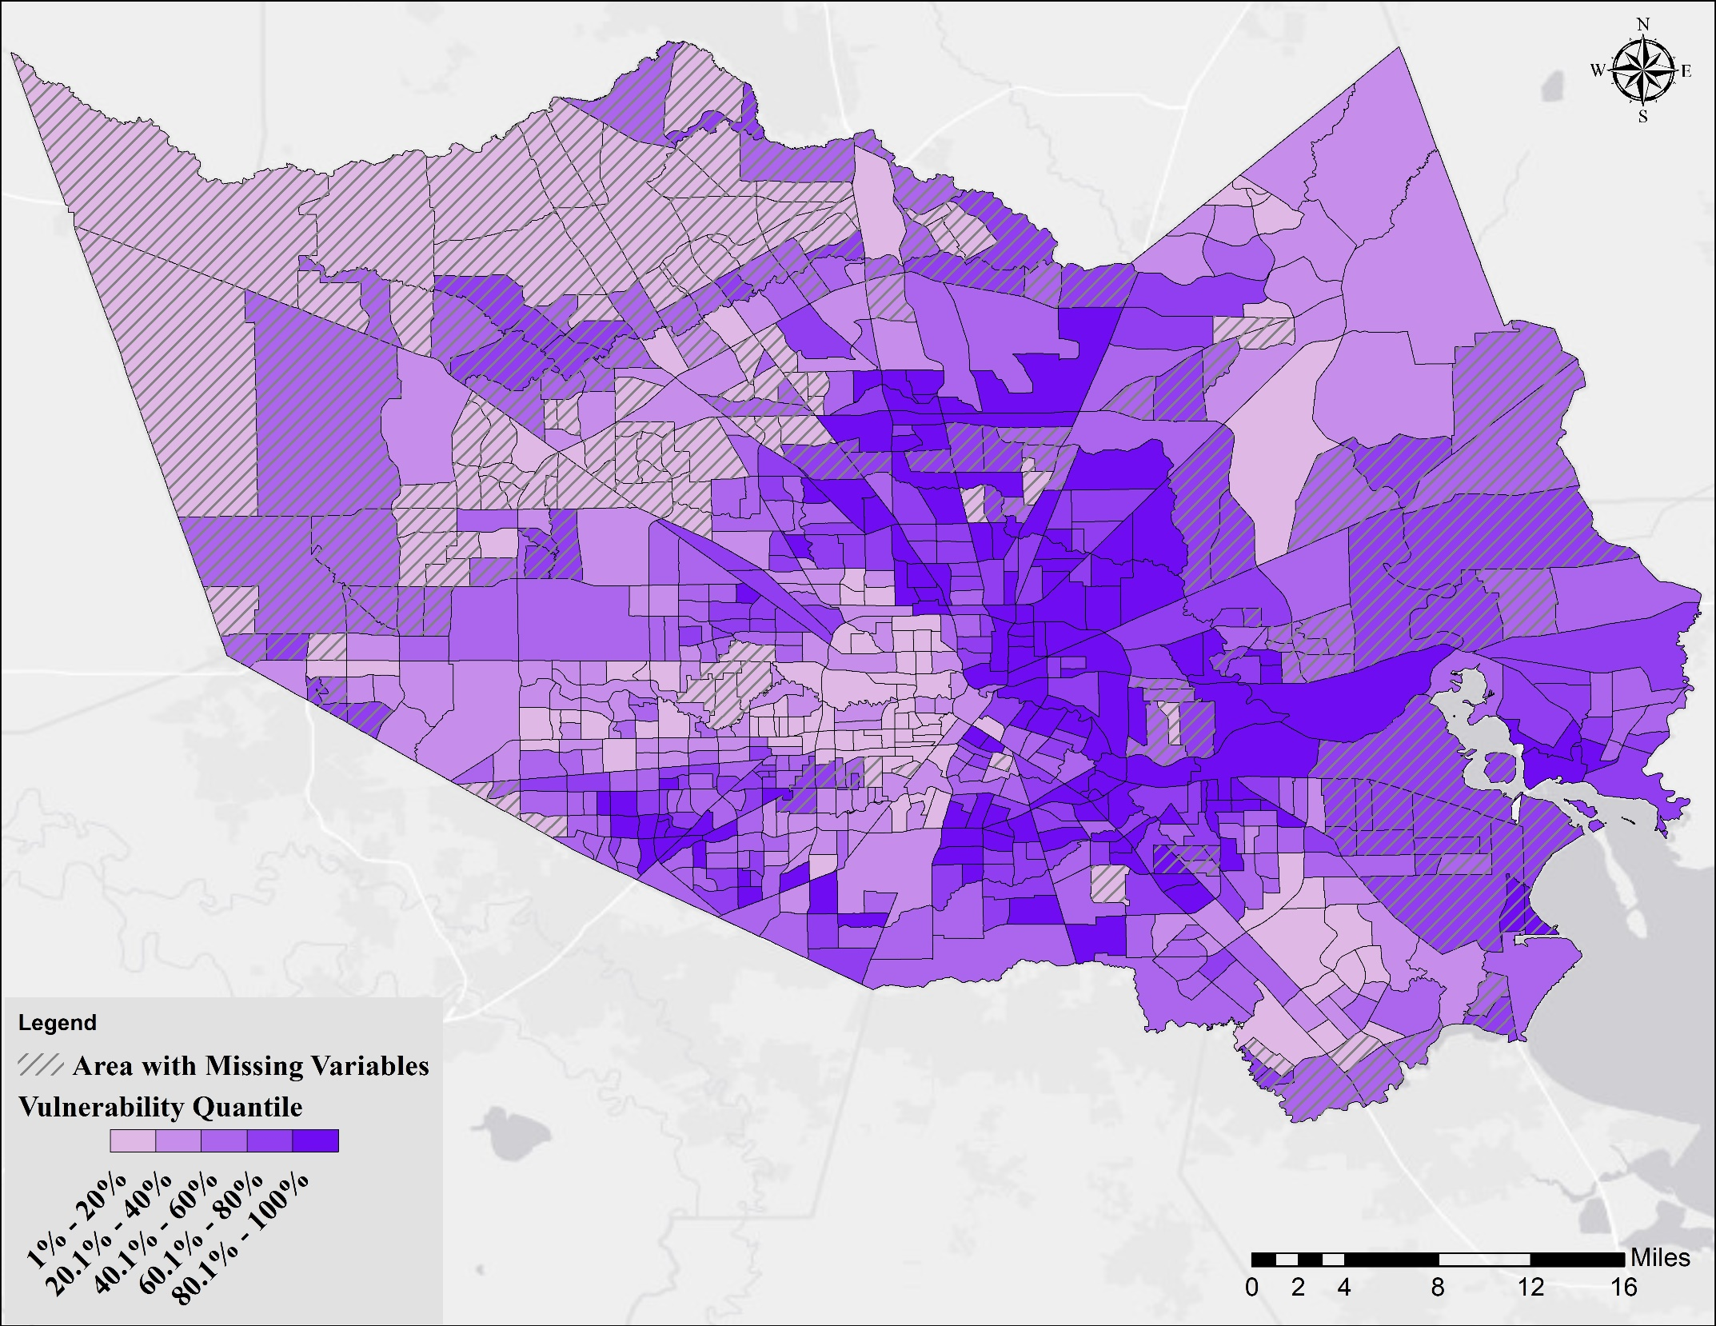
S14 Fig. Results of the K-means analysis method. The graduated colors reflect the percentile of the overall vulnerability. Areas with hatched lines represent census tracts with missing data on chronic disease risk factors, health outcomes, and clinical preventive service form [1]

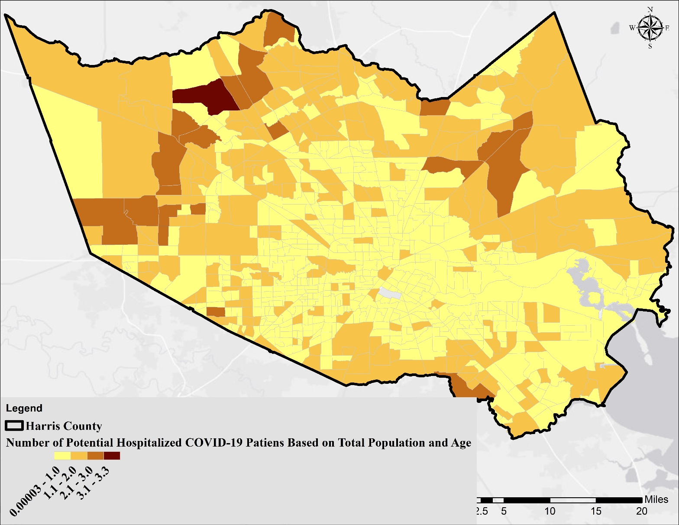
S15 Fig. Number of potential hospitalized COVID-19 patients based on age distribution and rates reported by the CDC [2].

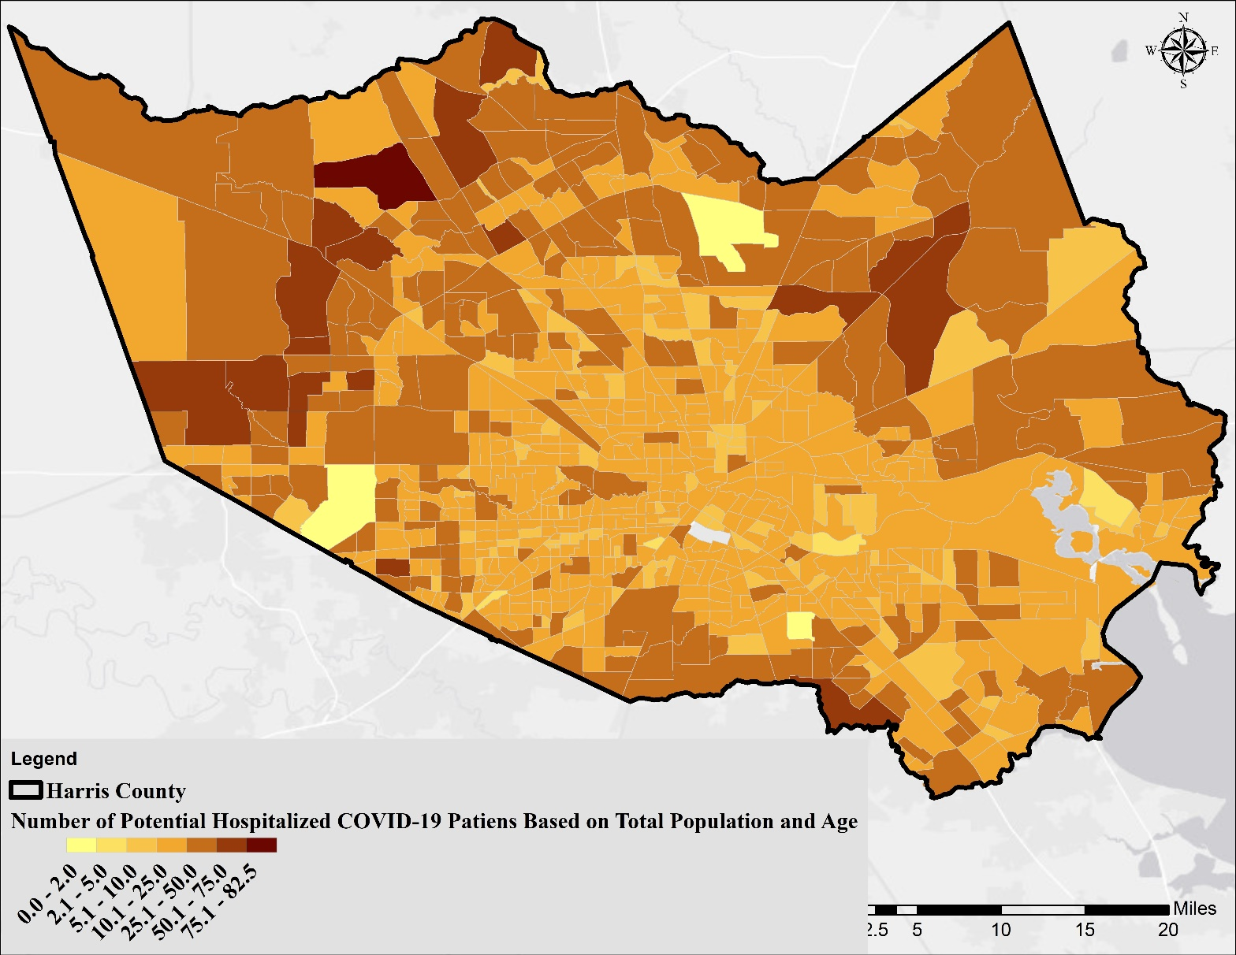
S16 Fig. Number of potential hospitalized COVID-19 patients based on age distribution and rates reported by the New York Department of Health and Mental Hygiene [3]

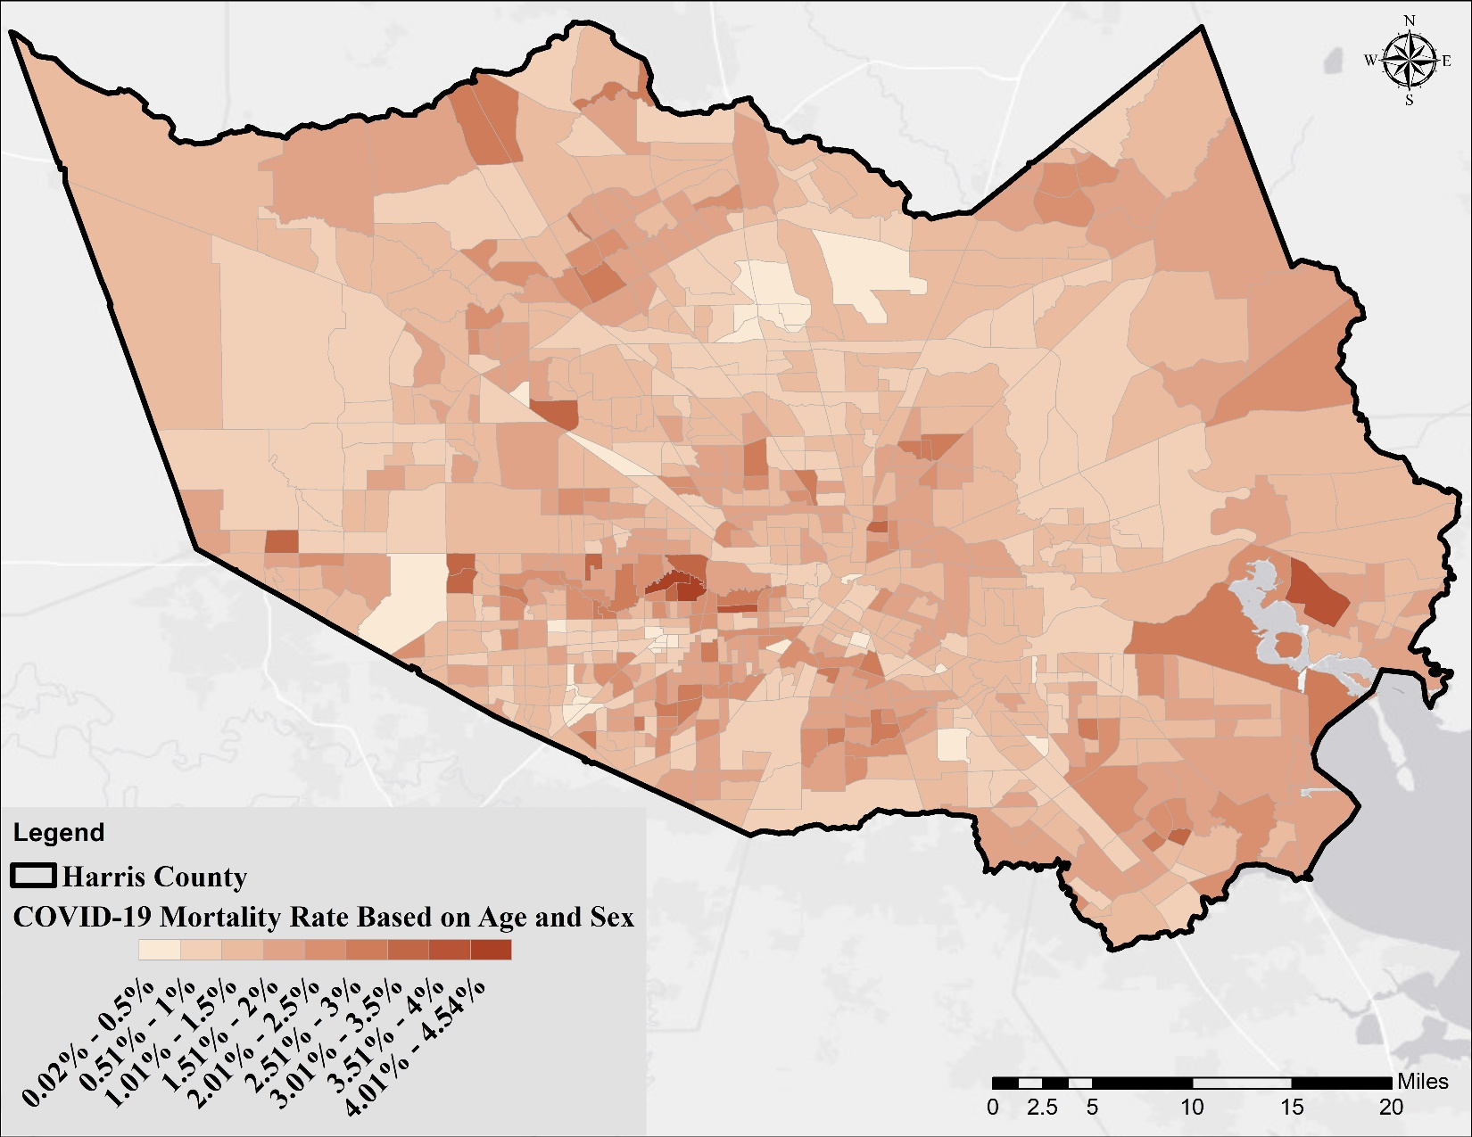
S17 Fig.The mortality rate for each census tract based on age and sex distribution. Rates associated with each age interval were extracted from [4]

References
1. HealthLanscape. The 500 Cities Mapper. 2020. Available: https://www.healthlandscape.org/500Cities/
2. CDC COVID-19 Response Team. Laboratory-Confirmed COVID-19-Associated Hospitalizations. In: Centers for Disease Control and Prevention [Internet]. 2020 [cited 22 Apr 2020]. Available: https://gis.cdc.gov/grasp/COVIDNet/COVID19_3.html
3. New York City Department of Health and Mental Hygiene. COVID-19: Data. 2020 [cited 23 Apr 2020]. Available: https://www1.nyc.gov/site/doh/covid/covid-19-data.page
4. Flavia Riccardo, Xanthi Andrianou, Antonino Bella, Martina Del Manso AMU, Massimo Fabiani, Stefania Bellino, Stefano Boros, Fortunato (Paolo) D’Ancona MCR, Antonietta Filia, Ornella Punzo, Andrea Siddu, Corrado Di Benedetto, Marco Tallon AC, Maria Rita Castrucci, Patrizio Pezzotti, Paola Stefanelli GR. COVID-19 outbreak, National update: March 23, 2020 (in Italian). Rome, Italy; 2020. Available: https://www.epicentro.iss.it/coronavirus/bollettino/Bollettino-sorveglianza-integrata-COVID-19_26-marzo 2020.pdf

