**Supplementary Figure 1.** Structures of nsp2 and nsp3 near mutation sites in SARS-CoV-2. (A) No clash between nsp2 GLY212 and nsp2 ASN183 in Wuhan-Hu-1 based on I‐Tasser model. (B) There was a clash between ASP212 and ASN183 after mutation G212D. (C) No clash between nsp3 ALA58 and nsp3 ILE62 in Wuhan-Hu-1 based on I-Tasser model. (D) A clash was formed between nsp3 THR58 and nsp3 ILE62 after mutation A58T.

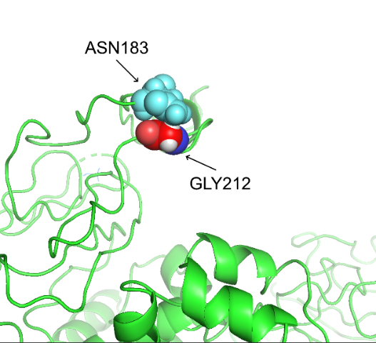 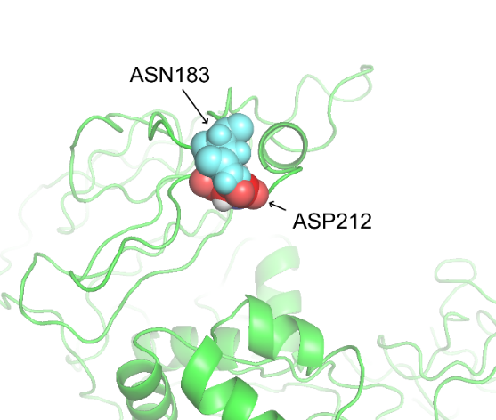

D

C

B

A

