**Supplemental material**

**Initial risk assessment**

Patients meeting the definition of a suspected case were called by a medical student (under supervision) to complete a risk assessment. All patients were asked a set of standardized questions:

- Do you feel short of breath?

- Are you breathing quickly or finding it difficult to breath?

- If yes, can you count your respiratory rate over one minute? (respiratory rate >20 breaths/minute was considered tachypnoea)

- Has your fever worsened over the last 3 days or have you had a new fever after 2 days being fever-free?

- Have you felt confused or lethargic?

If the patient answered “yes” to any of these questions they were advised to attend a specialist health service. Among the 132 patients that were triaged to hospital, 76 (58% of 132) had shortness of breath, 76 (58% of 132) reported rapid breathing, 33 (25% of 132) persistent fever and 22 (17% of 132) altered mental status.

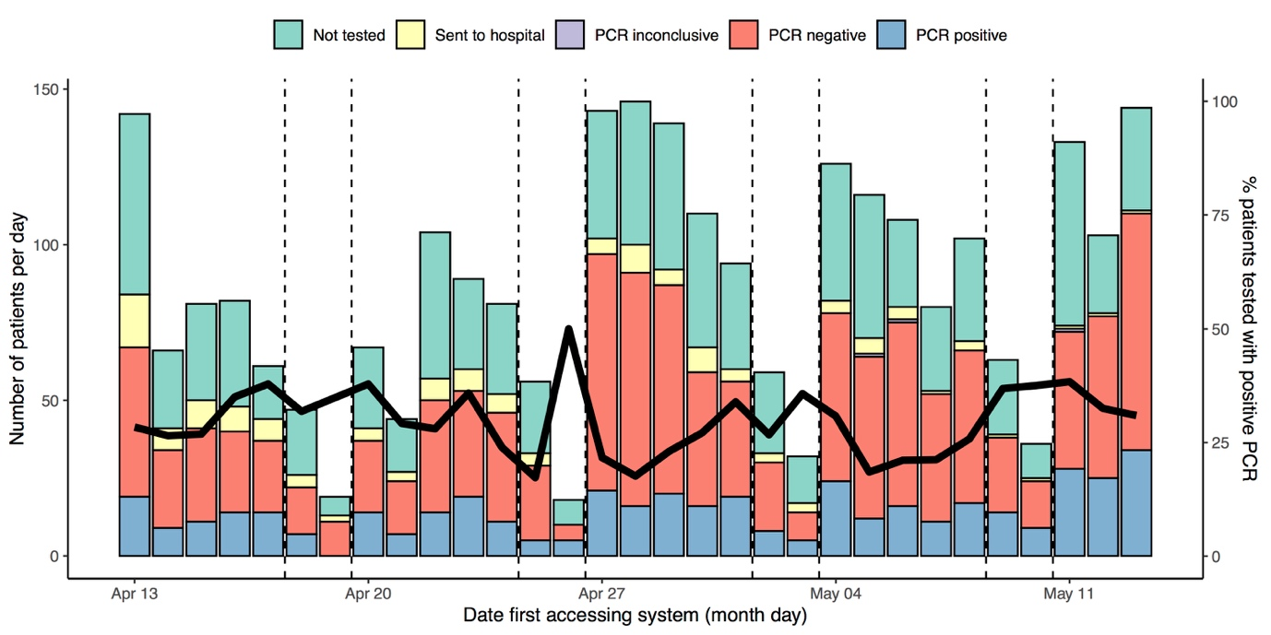

**Figure S1** Time series of presentations to the Corona São Caetano platform. Dashed vertical lines denote the weekends with a reduced number of presentations. Thick black line corresponds to the right-hand y-axis: proportion of RT-PCRs performed with positive result.

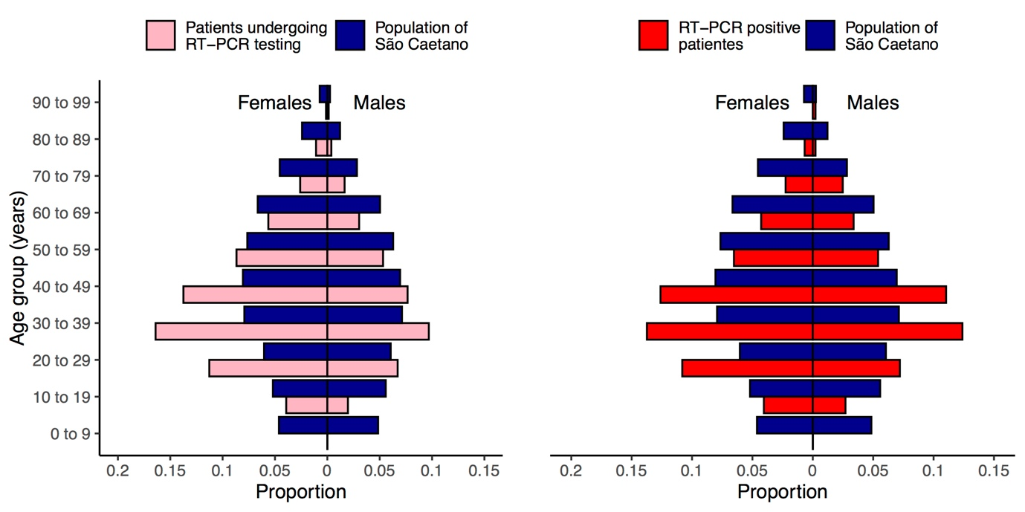

**Figure S2** Age-sex distribution the city of São Caetano do Sul compared with that of patients accessing the Corona São Caetano system and being tested with RT-PCR (left-hand panel) and those testing positive for SARS-CoV-2 (right-hand panel).



**Figure S3**  Distribution of delay between symptom onset and swab collection among 444 RT-PCR-positive patients and 52 RT-PCR-negative patients that subsequently tested seropositive (left-hand panel). Histogram of delay between symptom onset and swab collection among patients with COVID-19 (right-hand panel).

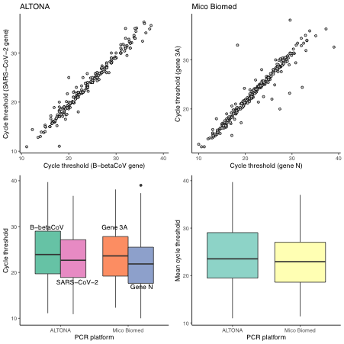

**Figure S4** Comparison of cycle thresholds across PCR platforms and genes amplified. Upper two panels show the concordance between cycle thresholds for the two separate genes amplified by the ALTONA (left) and Mico Biomed (right) kits. Lower left panel – distribution of cycle thresholds by gene amplified and RT-PCR platform used. Lower right-hand panel – distribution of the mean cycle threshold (mean of cycle thresholds for separate genes) between different RT-PCR platforms.

**Table S1 Univariate and adjusted associations between RT-PCR cycle thresholds and patient characteristics**

|  |  |  |  |  |
| --- | --- | --- | --- | --- |
|  | **Unadjusted analysis** | | **Adjusted analysis \*** | |
| **Beta** (difference in means) | **95% Confidence interval** | **Beta**  (difference in means) | **95% Confidence interval** |
| **Age** (years) | **-0.05** | **-0.09 to -0.01** | **-0.06** | **-0.09 to -0.03** |
| **Male sex** | **-1.36** | **-2.49 to -0.23** | -1.05 | -2.09 to <0.001 |
| **Days from symptom onset to swab collection** (days, log2) | **3.28** | **2.33 to 4.03** | **3.27** | **0.42 to 7.70** |
| **PCR platform** (ALTONA as reference) | **-1.19** | **-2.37 to -0.02** | **-1.53** | **-2.6 to -0.45** |
| **Symptoms at presentation**  Fever  Myalgia  Arthralgia  Anosmia  Agusia  Diarrhea  Nausea  Vomiting  Anorexia  Headache  Fatigue  Coryza  Blocked nose  Cough  Sore throat | **-1.78**  -1.31  **-1.64**  **3.15**  **2.99**  **2.19**  **1.50**  **2.99**  0.56  -0.58  0.84  -0.78  -0.36  -1.33  -0.49 | **-2.96 to -0.59**  -2.75 to 0.12  **-2.77 to -0.52**  **2.04 to 4.25**  **1.89 to 4.09**  **0.84 to 3.53**  **0.28 to 2.72**  **0.52 to 5.46**  -0.57 to 1.70  -2.12 to 0.97  -0.50 to 2.18  -1.92 to 0.34  -1.53 to 0.81  -2.70 to 0.03  -1.62 to 0.64 | **-1.11**  -0.78  **-1.24**  **2.21**  **1.96**  **1.36**  1.09  2.02  0.47  -0.81  0.34  -0.68  **-1.48**  **-1.60**  -0.45 | **-2.11 to -0.001**  -2.11 to 0.53  **-2.18 to -0.10**  **1.0 to 3.29**  **0.88 to 3.0**  **0.12 to 2.61**  -0.04 to 2.24  -0.28 to 4.33  -0.58 to 1.51  -2.25 to 0.63  -0.91 to 1.59  -1.72 to 0.34  **-2.59 to -0.37**  **-2.86 to -0.33**  -1.52 to 0.61 |

* All variables adjusted for age (continuous in years), sex (female as reference group), PCR platform (ALTONA platform as the reference group) and time between symptom onset and swab collection (log base 2). Analysis was performed within a linear regression framework. Positive beta coefficients indicate higher cycle thresholds (lower viral load) associated with that variable, whereas negative beta coefficients indicate lower cycle thresholds when the variable is present. Results in bold reached statistical significance.