Figure S1. The α diversities of the vaginal microbiome during pregnancy were significantly lower than those of postpartum. Differences in the α diversities of the vaginal microbiome between pregnancy and postpartum according to the observed species, PD whole tree (Faith’s Phylogenetic Diversity, which adds up all the branch lengths of the phylogenetic tree as a measure of diversity), Shannon and Simpson index. Each box plot represents the median, interquartile range, minimum, and maximum values.

Figure S2. The vaginal microbiome of pregnant women was more similar to each other during pregnancy. Weighted and unweighted PCoA (A-B) and ANOSIM (C-D) based on the distance matrix of UniFrac dissimilarity of the vaginal microbial communities in pregnancy and postpartum. Respective ANOSIM R values show the community variation between the compared groups, and significant P values are indicated. The axes represent the two dimensions explaining the greatest proportion of variance in the communities. Each dot represents a sample.

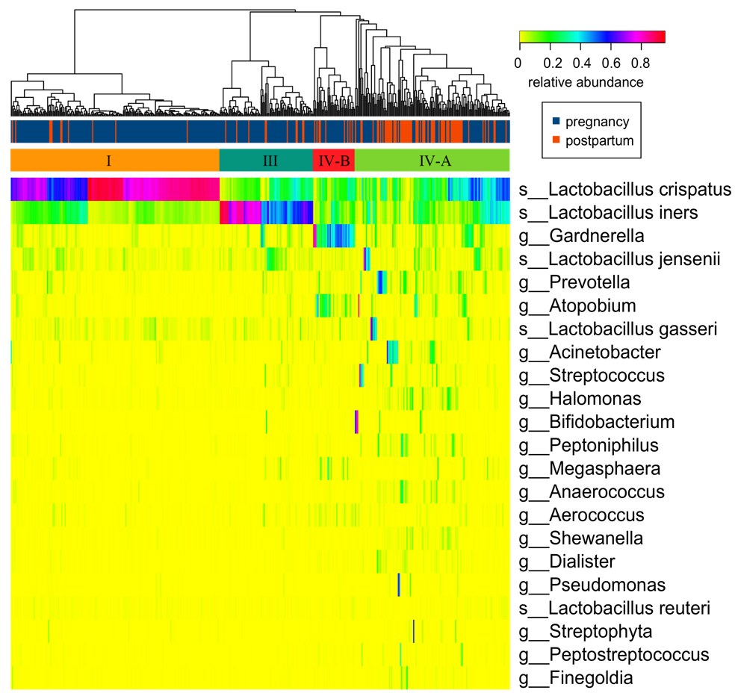
Figure S3. The vaginal microbiome of most women after delivery was classified as CST IV-A. Color bar from yellow to red shows the relative abundance of each microbial taxon. The prefixes g_, s_ represent genus, and species respectively.

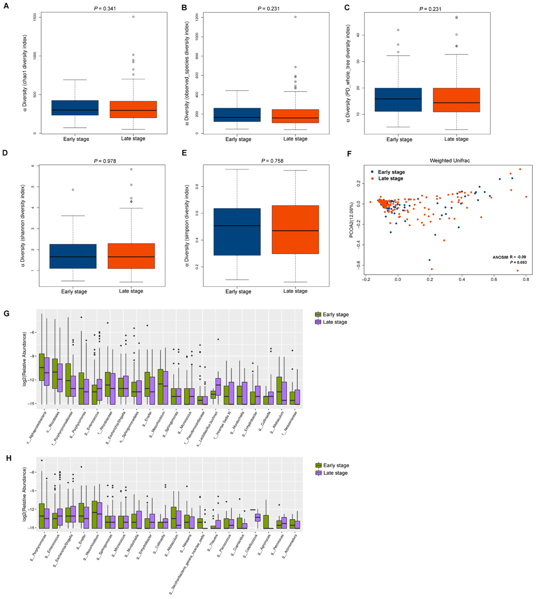
Figure S4. Little difference was shown between early and late stages of pregnancy in microbial diversity, community structure and composition of the vaginal microbiome. (A-E) Differences in the microbial diversities of the vaginal microbiome between early and late stages according to the Chao 1, observed species, PD whole tree, Shannon and Simpson index. (F) Weighted ANOSIMs and PCoA based on the distance matrix of UniFrac dissimilarity of the vaginal microbiome of early and late pregnant stages. (G) Relative abundance of the discriminating taxa in the vaginal microbiome between early and late pregnant stages at all levels. (H) Relative abundance of the discriminating taxa in the vaginal microbiome of early and late pregnant stages at the genus level. The discriminating taxa were identified based on LEfSe analysis with a threshold of LDA scores (log10) > 2 and P < 0.05. The prefixes p_, c_, o_, f_, g_, s_ represent phylum, class, order, family, genus, and species respectively.

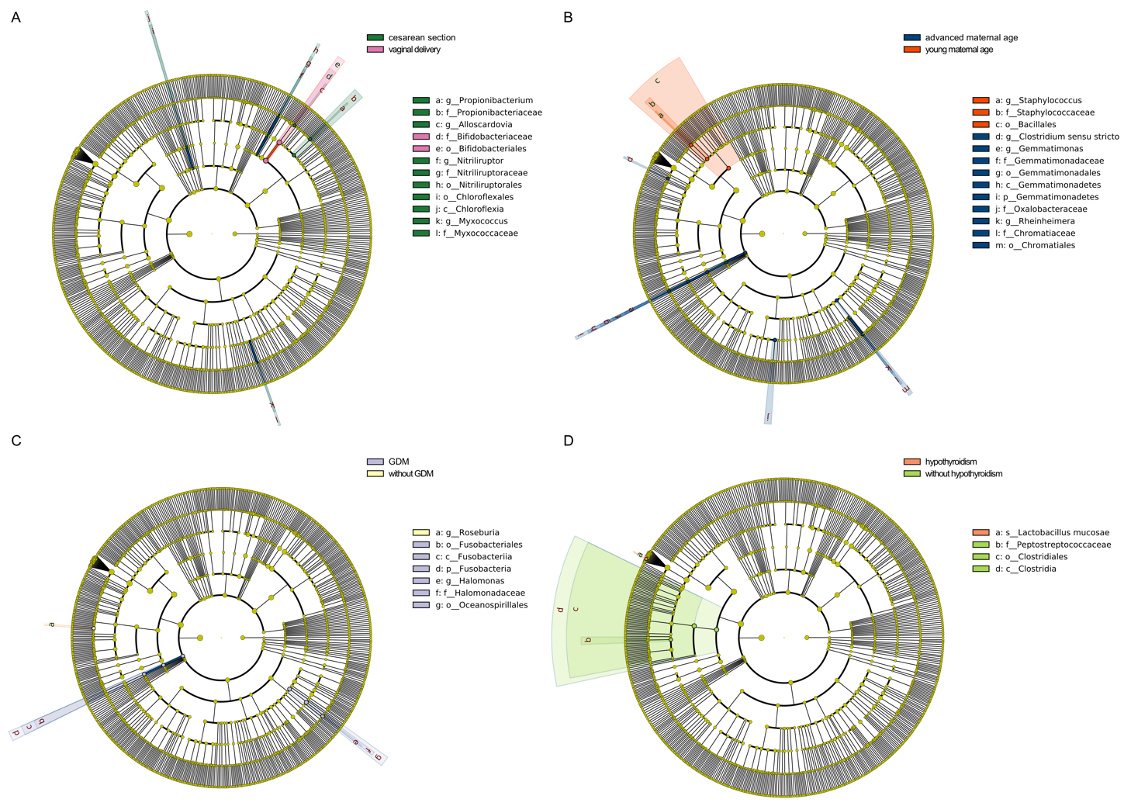
Figure S5. LEfSe analysis showed the discriminant bacteria of vaginal microbiome during pregnancy corresponding to multiple complex factors. (A) Different delivery mode. (B) Advanced maternal age vs. young maternal age. (C) With vs. without gestational diabetes mellitus. (D) With vs. without hypothyroidism. The LDA scores (log10) > 2 and P < 0.05 are listed. The prefixes p_, c_, o_, f_, g_, s_ represent phylum, class, order, family, genus, and species respectively.
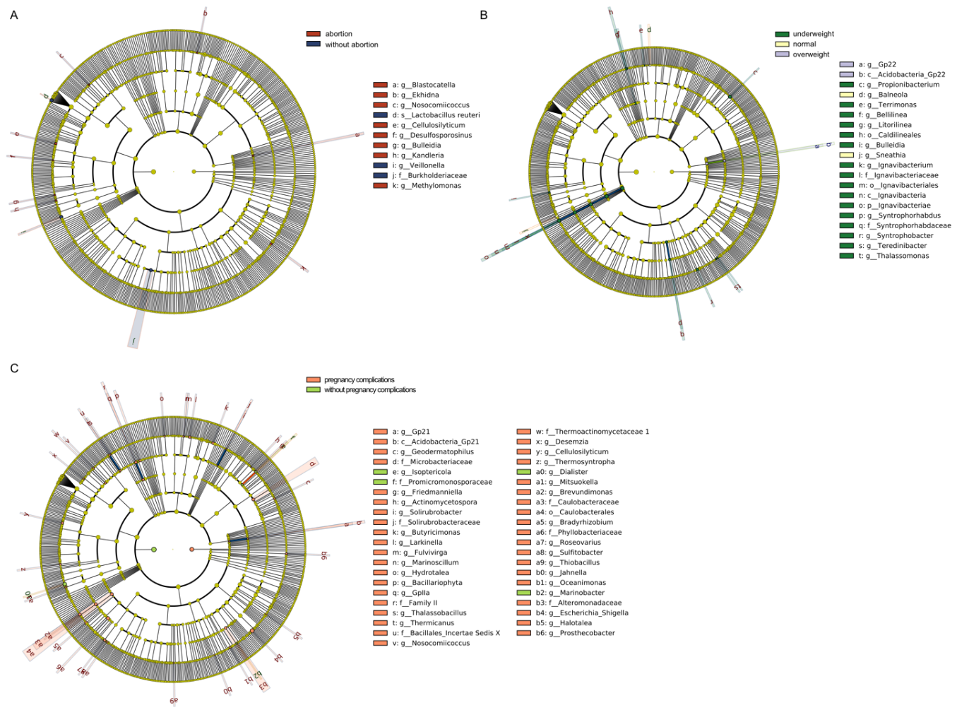
Figure S6. LEfSe analysis showed the discriminant bacteria of vaginal microbiome in postpartum corresponding to multiple complex factors. (A) Different body mass index before pregnancy. (B) With vs. without abortion history. (C) With vs. without pregnancy complications. The LDA scores (log10) > 2 and P < 0.05 are listed. The prefixes c_, o_, f_, g_, s_ represent class, order, family, genus, and species respectively.
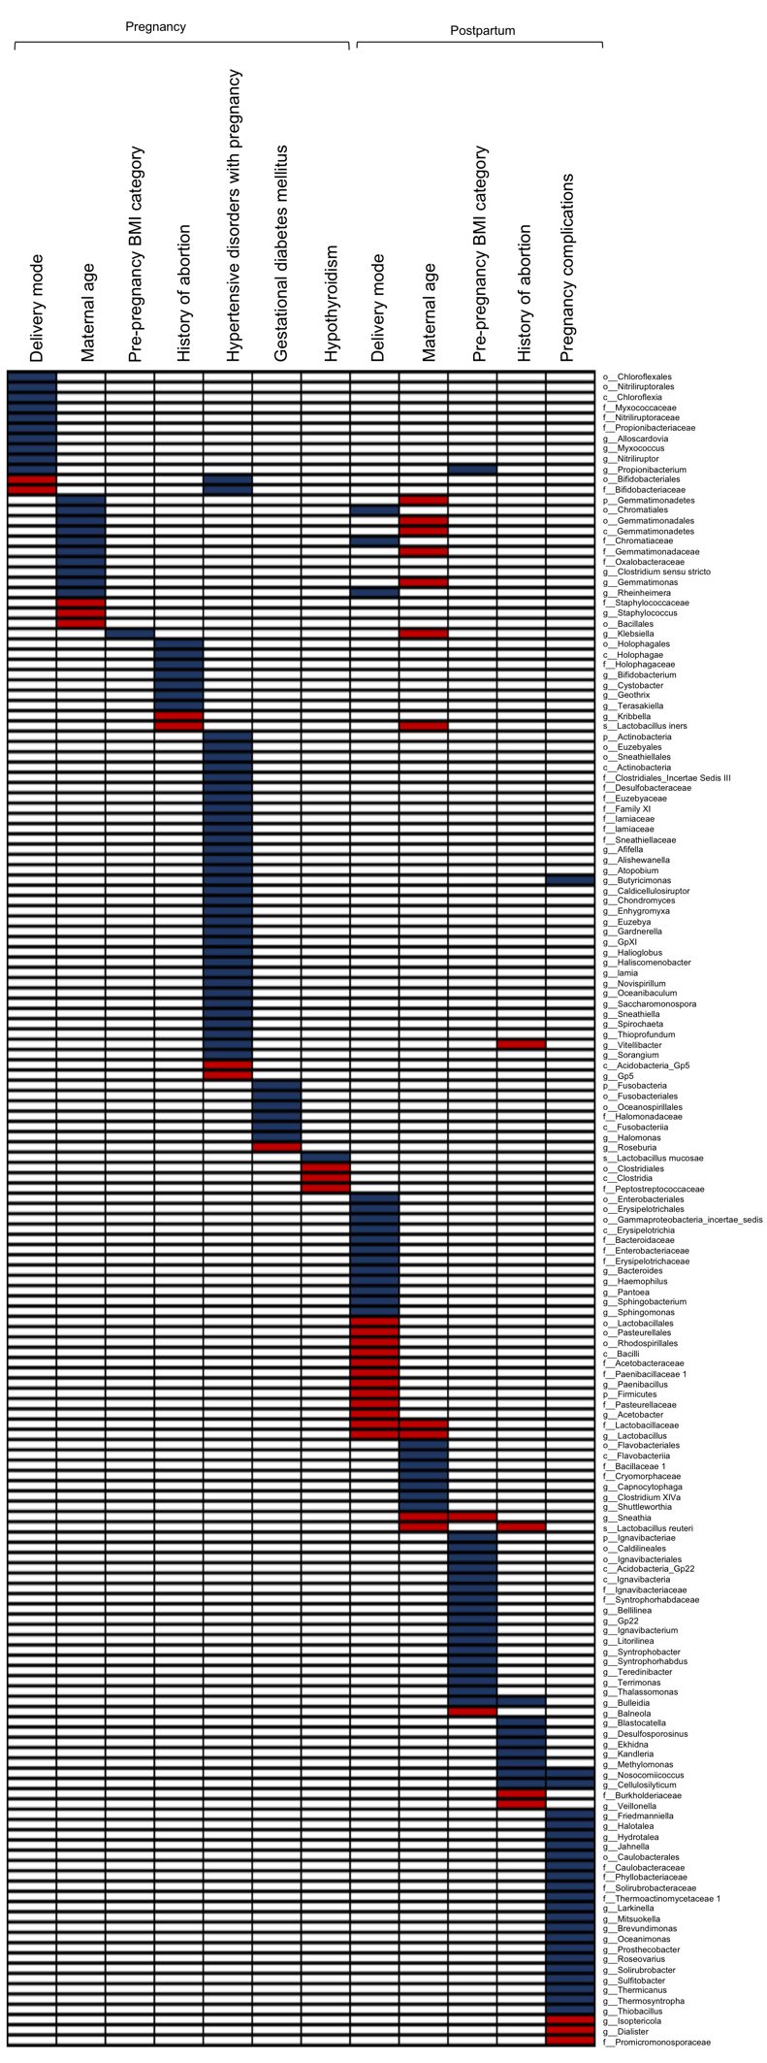
Figure S7. Most discriminant bacteria of the vaginal microbiome were different under complex factors during pregnancy and postpartum. The relative abundance of 163 bacterial taxa, including 5 phyla, 12 classes, 22 orders, 35 families, 86 genera, and 3 species, varied significantly between groups during pregnancy and postpartum based on LEfSe analysis. The LDA scores (log10) > 2 and P < 0.05 are listed. The boxes filled in blue and red color represent the discriminating taxa enriched and depleted in the vaginal microbiome of women who delivered cesarean, with advanced maternal age, overweight, HBP, hypothyroidism or other pregnancy complications, and without abortion history or gestational diabetes mellitus during pregnancy and postpartum, respectively. The prefixes p_, c_, o_, f_, g_, s_ represent phylum, class, order, family, genus, and species respectively.
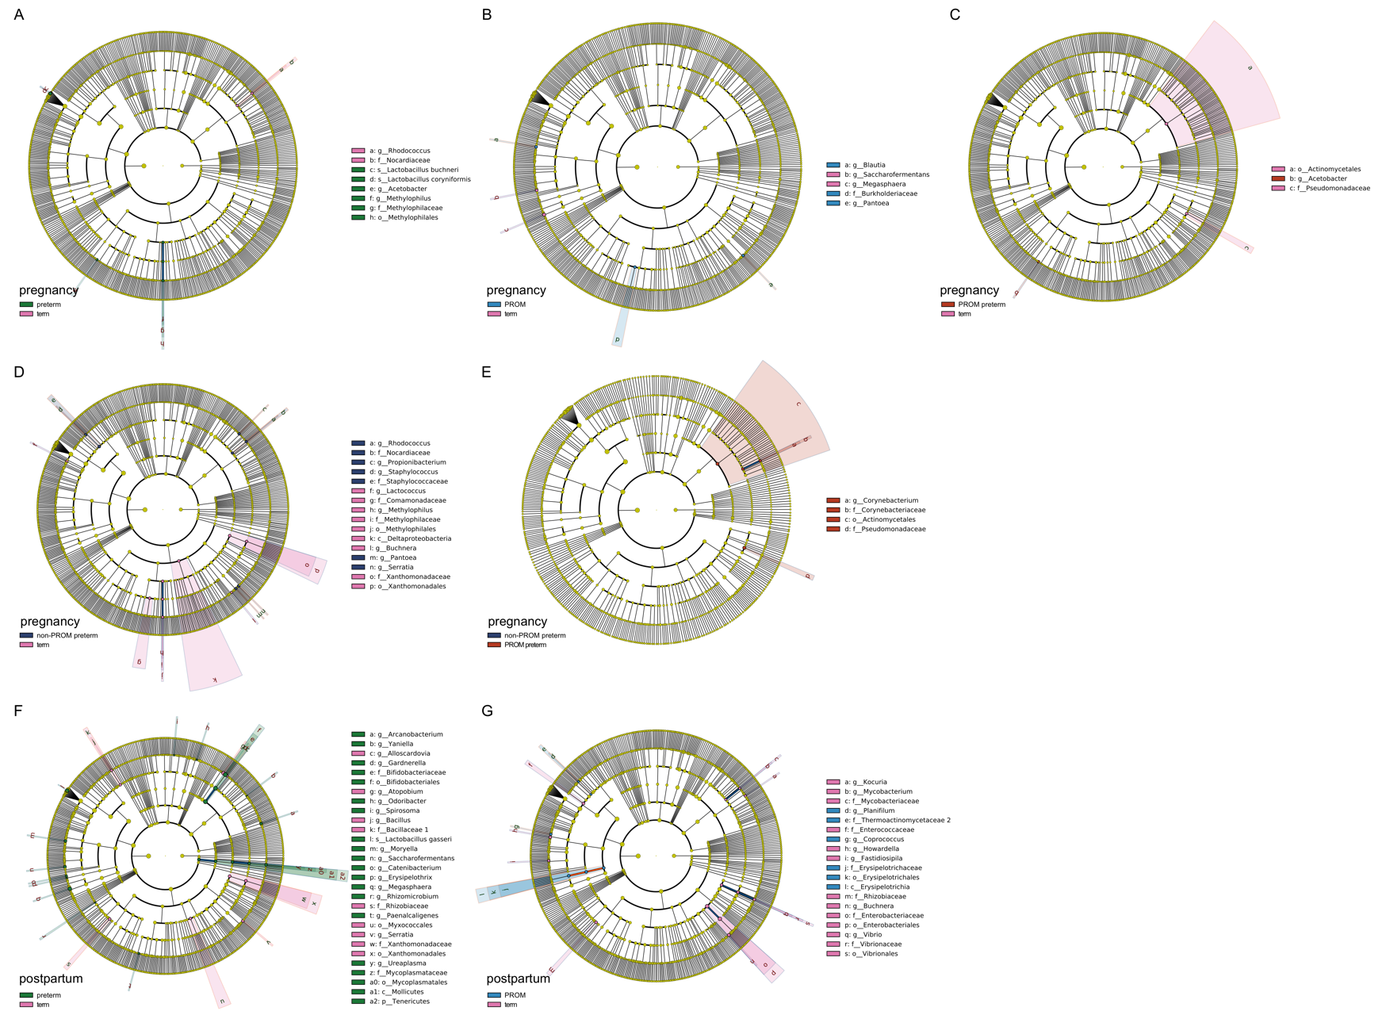
Figure S8. PTB and PROM were accompanied by some bacteria enrichment in the vaginal microbiome. Based on LEfSe analysis, the relative abundances of 68 bacterial taxa varied significantly between groups. The LDA scores (log10) > 2 and P < 0.05 are listed. (A) Preterm vs. term group during pregnancy. (B) PROM vs. term group during pregnancy. (C) PROM related preterm vs. term group during pregnancy. (D) Non-PROM related preterm vs. term group during pregnancy. (E) PROM related preterm vs. non-PROM related preterm during pregnancy. (F) Preterm vs. term group in postpartum. (G) PROM vs. term group in postpartum. The prefixes p_, c_, o_, f_, g_, s_ represent phylum, class, order, family, genus, and species respectively.

