Supplementary Materials for

*Declining SARS-CoV-2 PCR sensitivity with time* and dependence on clinical features: consequences for control

Authors: B.J.M. Bergmans1, C.B.E.M. Reusken2, A.J.G. van Oudheusden1, G.J. Godeke2, A. A. Bonačić Marinović2, E. de Vries1,3, Y.C.M. Kluiters-de Hingh1, R. Vingerhoets1, M.A.H. Berrevoets1, J.J. Verweij1, A.E. Nieman1, J. Reimerink2, J.L. Murk1, A.N. Swart2*

Affiliations:

1 Laboratory of Medical Microbiology and Immunology, Elisabeth-TweeSteden Hospital, Tilburg, The Netherlands.

2 Centre for Infectious Disease Control, National Institute for Public Health and the Environment (RIVM), Bilthoven, The Netherlands

3 Tranzo, Tilburg School of Social and Behavioral Sciences, Tilburg University, Tilburg, The Netherlands.

Correspondence to: [arno.swart@rivm.nl](mailto:arno.swart@rivm.nl)

**This file includes:**

Materials and Methods

Supplementary Text

Figs. S1 to S5

Tables S1 to S9

Materials and Methods

Patient cohort, setting and data collection

The study was performed in the Elisabeth-TweeSteden Hospital, Tilburg, The Netherlands, a 996-bed Dutch teaching hospital and tertiary referral center located in the central part of the Noord-Brabant province. Adults tested for SARS-CoV-2 real-time reverse transcriptase polymerase chain reaction (RT-PCR) on at least one combined naso- and oropharyngeal upper respiratory tract swab (URT-swab) between March 15th - April 15th 2020, were eligible for enrolment. These weeks signified the peak of the coronavirus epidemic in the Noord-Brabant province. Inclusion criteria were a minimum age of 18 years and either respiratory tract or gastrointestinal symptoms compatible with COVID-19 (coughing, sneezing, dyspnea, rhinitis, fever or diarrhea) at time of URT-swab collection. Some patients had one or multiple follow-up RT-PCR on different clinical samples (either repeated URT-swab, sputum, broncho-alveolar lavage fluid (BALF) or feces) if the first URT-swab was negative and clinical suspicion remained.

Participants were assigned a trial number and all data and laboratory results were encoded and processed according to this number. Sampling dates, PCR results and Ct-values of the first URT-swab and of other samples were obtained from the Laboratory Information System. After inclusion, data on sex, age, day of symptom onset, duration of hospital stay, mortality, immunosuppression and disease severity were collected from the electronic health records. Disease severity was graded as follows: 1 for outpatients; 2 for patients admitted to a regular hospital ward; 3 for patients admitted to the Intensive Care Unit (ICU). After inclusion, serum samples were collected.

A patient was considered immunocompromised if, at time of the URT-swab collection, at least one of the following criteria was met: solid malignancy with active chemotherapy (not including hormone-based therapy); hematologic malignancy irrespective of chemotherapy status; auto-immune disease treated systemically with immunosuppressants; HIV-infection with high viral load and CD4 below 450 cells/µL; transplant recipient using systemic immunosuppressants; primary immunodeficiency.

Sample collection

URT-swabs were collected in accordance with standardized guidelines. The same swab was first placed in the back of the throat and swirled around, after which it was placed deep into the nose and swirled around. Samples arrived in the laboratory within 30 minutes after collection. URT-swabs, sputum, BALF and feces were stored at 4 °C upon arrival at the laboratory; nucleic acid extraction and viral PCRs were performed within 24 hours. Serum samples were collected at least 12 days after onset of symptoms. When already available at our laboratory, left-over sera (taken for other purposes) were used. In all other cases, except when they had died or been transferred to another hospital, participants were asked to donate a blood sample for this study. Blood samples were drawn in our hospital and transported to our laboratory within one hour at ambient temperature. Upon arrival, blood samples were centrifuged and sera were stored at -20 °C until testing.

Molecular diagnostics

Total nucleic acids (NA) were extracted, using the QIAsymphony DSP virus/pathogen midi kit and pathogen complex 400 protocol of the QIAsymphony Sample Processing (SP) system (Qiagen, Hilden, Germany). Respiratory and fecal samples were tested with SARS-CoV-2 RT-PCR. A duplex PCR for Sars-Cov-2 E-gen/PDV(20, 30) was performed for all samples with optimized primer and probe concentrations in a volume of 25 µL with TaqMan® Fast Virus 1-Step Master Mix (Thermofisher) and 10 µL NA sample.

Amplification, detection, and analysis were performed with the Rotor-gene real-time detection system (QIAgen). Negative and positive control samples were included in each amplification run. RT-PCR results were considered positive if the cycle threshold (Ct-) value was 50.

Serology

SARS-CoV-2 antibodies (Beijing Wantai Biological Pharmacy Enterprise, Beijing, China; Cat # WS1096) were detected according to the instructions of the manufacturer. The presence of SARS-CoV-2 antibodies is expressed as a sample/cut-off ratio.

The manufacturers of the Wantai assay recommend index values of 1.1 and higher as evidence for the presence of specific antibodies. However, we observed that at this cut-off value, several RT-PCR confirmed patients scored negative. Based on this observation, and corroborated by visual inspection of the distribution of index-values, a cut-off of 0.25 was found to be more appropriate (see Supplementary text). The assay clearly separated COVID-19 RT-PCR negative and positive patients, as all negative patients had index values < 0.25 (Fig. 2a), except for two immunocompromised patients (clinical characteristics can be found in Table S5). Notably, three of five patients whose index values were between 0.25 and 1.1 were RT-PCR confirmed COVID-19 patients (Fig. 2b) of which two were also immunocompromised. Characteristics of these five patients can be found in Table S6.

Additionally, an in-house protein microarray was performed for the detection of antibody responses to SARS-CoV-2-S1 and SARS-CoV-2-N antigens. Sera were tested for the presence of IgG antibodies reactive with coronaviruses SARS-CoV-2 S1 subunit and nucleocapside antigens in a protein microarray as described before (6,7). Transiently expressed by transfection in mammalian HEK293 cells of spike S1 protein of SARS-CoV-2 was kindly provided by the faculty of veterinary medicine at Utrecht University and nucleocapsid N protein (40588-V08B) was obtained from Sino Biological. These antigens were spotted in duplicates in three drops of 333 pL on 24-pads nitrocellulose-coated slides (ONCYTE AVID, GraceBio Labs) using a non-contact Marathon Arrayjet micro-array spotter (Roslin, UK). Slides were pre-treated with Blotto blocking buffer to avoid non-specific binding (ThermoFisher Scientific Inc, Rockford, MA, USA). Sera were tested in four 4-fold dilutions starting at 1:10, diluted in Blotto containing 0.1% Surfact-Amps20 (Pierce). Subsequently, slides were incubated with goat anti-human IgG, F(ab’)2 fragment specific, Alexa Fluor 647-conjugated (Jackson ImmunoResearch), diluted 1:1000 in Blotto buffer with 0.1% Surfact-Amps20. Incubation steps were followed by a washing step with 1× Phosphate Buffered Saline with Tween® (PBST). After the last wash, slides were washed with sterile water and dried. Slides were scanned with the Tecan Powerscanner using the 635 nm red laser. ScanArray Express software version 4.0.0.0004 (PerkinElmer) was used to quantify fluorescent signals and titers were calculated by using R studio version 4.0.0 as previously described (*16*, *17*). Titers were defined as the interpolated serum concentration that provokes a response half way on a concentration-response curve between the minimum and maximum signal.

In the microarray, the threshold value for the detection of specific antibodies against N or S1 has been set at a titer of >1:20.

Statistical analysis

Towards the goal of determining sensitivity of the test assays used, we set up a Bayesian statistical framework which allowed us to estimate sensitivities of each test without resorting to a ‘gold standard’. We assumed perfect specificity for both PCR (see (20–23), describing high analytical sensitivity for PCR) and serology (see (31)). This is further justified by noting that all individuals enrolled in the cohort were clinically diagnosed for COVID-19 by observing typical symptoms. It is feasible to determine sensitivities without a perfect benchmark to compare with, which can be understood by realizing that each individual with both positive and negative outcomes gives evidence against the sensitivity of the negative tests, since an individual must be positive when at least one test scores positive (assuming the 100% specificity as outlined above). For the PCR test, we observed a striking increase of Ct-value as the time since onset of symptoms increased. This motivated us to also include this duration as a covariate in the analysis.

Test coverage visualization

We may visualize the test results in the cohort using an 'upset' plot (32, 33), encoding positive individuals with a solid circle, and negative or missing individuals with a grey circle. Figure S4 shows the diverse patterns of positive and negative-or-missing individuals that occur, highlighting that sensitivity is not perfect. Note that the largest set is the set of all negative-or-missing test results.

In the following, we will assume

* each test has perfect specificity, i.e. Sp=1 (see (*31*) for the Wantai test)
* given the disease status of the patient, test outcomes are independent
* the sensitivity of each test is a quantity which may possibly vary over strata of the population

We denote the number of tests by $m$, and index them by $j$. The tests are applied to $n$ individuals indexed by $i$. All individuals were suspected of infection with COVID-19, by diagnosis based on clinical presentation. We assume the specificity of each test to be perfect. The test result $t_{ij}$ is either positive (1), negative (0), or missing (an arbitrary dummy value). Let the variable $t_{ij}^{}$ denote missingness, encoded by a zero if the test result is missing, and a one otherwise.

We can write for the events $T^{+}$ and $T^{−}$, denoting positive or negative test results, and the events $X^{+}$ and $X^{−}$ denoting true infection status, the following

In the last line, we introduced the true, unknown, prevalence $p≡P$. We collect test results $t_{ij}$ in a matrix $T∈R^{n×m}$, and write $T_{i}$ for the $i$-th row of $T$. The missingness matrix $T^{}$ is constructed likewise using the $t_{ij}^{}$. Also introduce $s_{j}$ for the unknown senitivity of test $j$, and $s$ as the column vector $\left(s_{1},…,s_{m}\right)$. Then we can calculate the likelihood of the combined results $T$ as

$P\left(s,p∨T,T^{}\right)=\prod_{\left(i,j\right):t_{ij}^{}=1}{}$ (1)

It is apparent from this expression that $p$ and $s$ are not identifiable, and we will need to find an expression for $p$ dependent on the test data and $s$. The log-likelihood (1) can be expressed by introducing the elementwise multiplication operator $∘$, and $x∨$ as the sum of the elements of vector $x$,

$\begin{matrix}L\left(s∨p,T,T^{}\right) & \sum_{i,j}{t_{i,j}^{}}\left[\left(1−t_{i,j}\right)log\left(1−s_{j}p\right)+t_{i,j}log\left(s_{j}p\right)\right] \\ & \end{matrix}$ (2)

We are left with finding an expression for the prevalence. It can be approximated by calculating the average probability of positivity over each person given the test results.

$\overset{}{p}=\frac{1}{n}\sum_{i=1}^{n}{P}$ (3)

The probability of a positive person given his test results is one when at least one test is positive, since we assume the specificity is perfect. In other cases, we need to find the probability of a positive individual, given all tests are negative.

$P$ (4)

The probability that all tests are negative for a positive individual is the probability of all tests being false-negative. We can then proceed as follows

(5)

Define,

$$q_{i}≡\prod_{j}{\left(1−t_{ij}^{}s_{j}\right)}$$

and set $k$ to be the number of not-all-negative-or-missing tests. We can estimate the probabilities of all-negative and not-all-negative tests in equation (5) from the data (i.e. $P\left(T_{i}≠0\right)=k/n$ and $P\left(T_{i}=0\right)={\left(n−k\right)}/n$), insert the definition of $q_{i}$, and we obtain

(6)

To check our calculation, we observe that when all sensitivities are one the first line above equals zero (in the second line we divide by zero but in the limit we approach zero); also when all sensitivities are zero the above gives no information on $P$, which is as expected since a sensitivity of zero is equivalent to not performing the test.

Introduce the set of all-negative-or-missing tests $N=\{i∨\sum_{j}{t_{ij}^{}}t_{ij}=0\}$, then we can write the prevalence (3), using equations (4) and (5) as

$$\overset{}{p}=\frac{k}{n}\left[1+\frac{1}{n−k}\sum_{i∈N}{\frac{q_{i}}{1−q_{i}}}\right]$$

Note that $q_{i}$ is function of the sensitivities, and therefore equally the estimated prevalence depends on the sensitivities to be estimated. Hence, in the likelihood (2) the conditionality on $p$ vanishes, allowing to estimate the sensitivities from the data $T$ and $T^{}$.

Dealing with missingness

We need to consider the study design, where not all tests were performed on all patients. The missingness of the data is not at random, whenever an earlier test was negative a later test has a higher tendency of being performed. There is however a pragmatic way of dealing with this issue: testing for correlations between the outcome of a test and the missingness of another test, using a Fisher correlation test. If no correlation is present, we can safely include the test in our analysis. From Table S7 it is evident that the repeated URT PCR, PCR on the feces, and PCR on other materials have strong correlation with the initial URT PCR test. Hence, from this point onward, we delete those tests from our analysis.

Bayesian inference of the parameters

We put a standard Jeffrey's prior on the sensitivities,

$$s_{j}∼Beta\left({1/{2,1}}/2\right)$$

except for the Wantai test ($j=2$), for which we have prior knowledge that 28 of 30 tests were correcty identified as positive in a previous study (3),

$$s_{2}∼Beta\left(1/2+{28,1}/2+2\right).$$

The model is fit using stan (4), and all data is processed and visualized in R version 3.6.0 (34). Convergence was checked by observing stabilization of four chains, run for 4000 iterations.

Figure 3 and Fig. S1 show the results of the analysis. We display ‘posterior distributions’, which represent uncertainty estimates produced by the Bayesian inference. Clearly, the serological Wantai test and the N-protein microarray test perform best, followed by the URT PCR and microarray S1-protein test. The prevalence is very precisely estimated at 58%. Negative predictive values are similarly performant as the sensitivities. Table S1 gives the result in tabular form.

Time dependence of PCR results

The Ct-values increase linearly with days since symptoms $d_{i}$. Assuming a normal distribution for the Ct-values, we model the Ct value as follows

$Ct∼N\left(α_{0}+αd_{i},σ_{ct}\right)$

We also included censoring at the limit of detection (taken to be 50), and inflation to allow for negative individuals to be present at Ct-values over 50, yielding in this case a contribution to the log-likelihood of

$$\sum_{i}{p}+\left(1−p\right)\left(1−Φ\left(ct_{i};α_{0}+αd_{i},σ_{ct}\right)\right)$$

where $Φ$ is the cumulative distribution function of the normal distribution. Note that via this likelihood contribution, the prevalence is also influenced. We obtain Fig. 4 and S2.

The estimates for the parameters (Table S2) clearly show that there is a trend, although individual variation is considerable.

Individual level sensitivities

In order to accommodate sensitivities that are dependent on an individual’s personal days-since-onset-of-symptoms, we need to write the equations dependent on $i$. In particular, we need $s_{ij}$ for the sensitivity of test $j$ on individual $i$. We proceed as follows

$$\begin{matrix}L\left(s∨p,T,T^{}\right) & \sum_{i,j}{t_{i,j}^{}}\left[\left(1−t_{i,j}\right)log\left(1−s_{i,j}p\right)+t_{i,j}log\left(s_{i,j}p\right)\right] \\ & \end{matrix}$$

where the matrix $S$ contains elements $s_{ij}$. The expression for the prevalence is unmodified, but the definition for $q_{i}$ becomes

$$q_{i}≡\prod_{j}{\left(1−t_{ij}^{}s_{ij}\right)}$$

A model for PCR sensitivity and days-since-onset-of-symptoms

We observe in Fig. S2 that Ct-values increase linearly with time, and are censored above a Ct-value of 50. Hence, when the tail of the normal distribution falls above this threshold, the virus is not detected even if it was present. This defines sensitivity, and it suggests a model where the sensitivity is proportional to one minus the cumulative density function of the Ct-value at day $d_{i}$. Since the Ct-value is proportional to the days-since-onset-of-symptoms, it makes sense to model the sensitivity as a function of days-since-onset-of-symptoms also as a sigmoid curve. We pose the model

$$s\left(d_{i}\right)=s_{PCR}\frac{1}{1+βexp\left(d_{i}−β0\right)}$$

The factor $s_{PCR}$ is a baseline sensitivity, $β$ is the location of the inflexion point, and $β_{0}$ the location of the inflexion point. The variable $d_{i}$ denotes the days since onset of symptoms for individual $i$. We place vague priors on the unknown parameters and fit the model as described earlier. The estimated parameters are summarized in Fig. 5, Fig. S3 and Table S8.

The addition of the individual level of days-since-onset-of-symptoms did not change the results for the sensitivities and prevalence much compared to Table S2, as shown in Table S9.

|  |  |  |
| --- | --- | --- |
| **Severity** | **Test** | **Sensitivity** |
| ICU | PCR | 0.95 (0.84, 1.00) |
| ICU | serum_our | 0.94 (0.86, 0.99) |
| ICU | EC50_CoV_S1 | 0.94 (0.77, 1.00) |
| ICU | EC50_CoV_N | 0.95 (0.80, 1.00) |
| OUTP | PCR | 0.79 (0.57, 0.99) |
| OUTP | serum_our | 0.95 (0.87, 0.99) |
| OUTP | EC50_CoV_S1 | 0.95 (0.79, 1.00) |
| OUTP | EC50_CoV_N | 0.97 (0.86, 1.00) |
| WARD | PCR | 0.86 (0.77, 0.95) |
| WARD | serum_our | 0.96 (0.90, 0.99) |
| WARD | EC50_CoV_S1 | 0.97 (0.88, 1.00) |
| WARD | EC50_CoV_N | 0.97 (0.88, 1.00) |
| **Deceased** | **Test** | **Sensitivity** |
| No | PCR | 0.83 (0.75, 0.92) |
| No | serum_our | 0.97 (0.93, 0.99) |
| No | EC50_CoV_S1 | 0.98 (0.91, 1.00) |
| No | EC50_CoV_N | 0.98 (0.93, 1.00) |
| Yes | PCR | 0.95 (0.84, 1.00) |
| Yes | serum_our | 0.93 (0.84, 0.99) |
| Yes | EC50_CoV_S1 | 0.92 (0.67, 1.00) |
| Yes | EC50_CoV_N | 0.95 (0.78, 1.00) |
| **Immunosuppressed** | **Test** | **Sensitivity** |
| No | PCR | 0.85 (0.78, 0.93) |
| No | serum_our | 0.97 (0.93, 0.99) |
| No | EC50_CoV_S1 | 0.98 (0.92, 1.00) |
| No | EC50_CoV_N | 0.99 (0.94, 1.00) |
| Yes | PCR | 0.93 (0.76, 1.00) |
| Yes | serum_our | 0.92 (0.82, 0.99) |
| Yes | EC50_CoV_S1 | 0.82 (0.54, 1.00) |
| Yes | EC50_CoV_N | 0.85 (0.58, 1.00) |
| **Sex** | **Test** | **Sensitivity** |
| F | PCR | 0.80 (0.67, 0.95) |
| F | serum_our | 0.96 (0.89, 0.99) |
| F | EC50_CoV_S1 | 0.97 (0.85, 1.00) |
| F | EC50_CoV_N | 0.97 (0.87, 1.00) |
| M | PCR | 0.91 (0.82, 0.99) |
| M | serum_our | 0.96 (0.90, 0.99) |
| M | EC50_CoV_S1 | 0.97 (0.86, 1.00) |
| M | EC50_CoV_N | 0.98 (0.91, 1.00) |

**Table S1.** Mean and 95% Bayesian credible interval for the sensitivities, prevalence and negative predictive values for the model including days since onset of symptoms. *ICU, Intensive Care Unit; OUTP, outpatients; WARD, non-ICU hospitalized patients; EC50_CoV-N, SARS-CoV-2 N protein microarray; EC50_CoV-S1, SARS-CoV-2 S1 protein microarray; serum_our, Wantai serology using cut-off value of 0.25; PCR, polymerase-chain reaction.*

|  |  |  |  |
| --- | --- | --- | --- |
|  | **Slope** | **Intercept** | **Variation** |
| **Severity** | **alpha** | **alpha0** | **sigma_ct** |
| ICU | 0.31 (0.03, 0.67) | 26.09 (22.71, 29.06) | 6.38 (5.36, 7.66) |
| OUTP | 1.33 (0.41, 2.39) | 38.43 (26.73, 50.30) | 23.36 (17.00, 31.85) |
| WARD | 0.19 (0.06, 0.33) | 27.25 (25.85, 28.57) | 5.79 (5.26, 6.42) |
| **Immunosuppressed** | **alpha** | **alpha0** | **sigma_ct** |
| No | 0.24 (0.11, 0.38) | 26.81 (25.49, 28.11) | 6.03 (5.53, 6.58) |
| Yes | 0.19 (0.01, 0.45) | 25.98 (23.39, 28.29) | 5.25 (4.18, 6.67) |
| **Deceased** | **alpha** | **alpha0** | **sigma_ct** |
| No | 0.17 (0.03, 0.32) | 27.50 (26.02, 28.88) | 5.99 (5.46, 6.61) |
| Yes | 0.34 (0.13, 0.56) | 25.22 (23.18, 27.23) | 5.72 (4.91, 6.73) |
| **Sex** | **alpha** | **alpha0** | **sigma_ct** |
| Female | 0.31 (0.10, 0.54) | 27.28 (25.21, 29.29) | 6.11 (5.28, 7.12) |
| Male | 0.20 (0.05, 0.35) | 26.44 (25.00, 27.84) | 5.82 (5.29, 6.43) |

**Table S2.** Slope, intercept and variation of Ct-values across different patient characteristics. *ICU, Intensive Care Unit; OUTP, outpatients; WARD, non-ICU hospitalized patients*

|  |  |  |  |  |  |  |  |  |  |  |  |
| --- | --- | --- | --- | --- | --- | --- | --- | --- | --- | --- | --- |
| Patient | Immuno-  suppression | Age (range) | Sex | Interval symptom onset and PCR collection (days) | Interval symptom onset and serum collection (days) | Severity category | PCR | Ct-value | Wantai index value | Microarray SARS-CoV-2-S1 titre | Microarray SARS-CoV-2 N titre |
| 1 | Yes | 80-90 | Male | 14 | 22 | WARD | positive | 26.46 | 0.037 | 10 | 1280 |
| 2 | Yes | 60-70 | Male | 10 | 25 | WARD | positive | 24.37 | 0.711 | 261 | 1280 |
| 3 | No | 50-60 | Male | 3 | 21 | OUTP | positive | 17.8 | 2.279 | 10 | 10 |
| 4 | Yes | 50-60 | Female | 3 | 12 | WARD | positive | 39.38 | 5.884 | 10 | 10 |

Table S3.

Patient characteristics of Wantai-microarray discrepant individuals. *ICU, Intensive Care Unit; OUTP, outpatients; WARD, non-ICU hospitalized patients; PCR, polymerase-chain reaction.*

|  |  |  |
| --- | --- | --- |
| Diagnosis | n | % |
|  | 73 | 100 |
| Chronic lymphocytic leukemia | 6 | 8.2% |
| Psoriasis | 6 | 8.2% |
| Rheumatoid arthritis | 5 | 6.8% |
| Multiple myeloma | 5 | 6.8% |
| Colon carcinoma | 5 | 6.8% |
| Pulmonary carcinoma | 4 | 5.5% |
| Prostate cancer, metastasized | 4 | 5.5% |
| Breast cancer | 4 | 5.5% |
| Acute myeloid leukemia | 3 | 4.1% |
| Systemic lupus erythematosus | 3 | 4.1% |
| B-cell lymphoma | 3 | 4.1% |
| Follicular lymphoma | 3 | 4.1% |
| Kidney transplant recipient | 2 | 2.7% |
| Sarcoidosis | 2 | 2.7% |
| Crohn's disease | 2 | 2.7% |
| Polymyalgia rheumatica | 2 | 2.7% |
| Myasthenia gravis | 2 | 2.7% |
| Cholangiocarcinoma | 1 | 1.4% |
| HIV, newly-detected | 1 | 1.4% |
| Myelodysplastic syndrome | 1 | 1.4% |
| Monoclonal gammopathy of undetermined significance, progressive | 1 | 1.4% |
| Myelofibrosis | 1 | 1.4% |
| Auto-immune hepatitis | 1 | 1.4% |
| Bladder cancer | 1 | 1.4% |
| Renal cell carcinoma | 1 | 1.4% |
| Multiple sclerosis | 1 | 1.4% |
| Oral cancer | 1 | 1.4% |
| Ependymoma | 1 | 1.4% |
| Common variable immunodeficiency disorder (CVID) | 1 | 1.4% |

Table S4.

Diagnoses among immunocompromised patients in our cohort.

|  |  |  |  |  |  |  |  |  |  |  |  |  |
| --- | --- | --- | --- | --- | --- | --- | --- | --- | --- | --- | --- | --- |
| Patient | Sex | Age (range) | Immunosuppression | Disease severity | Interval symptom onset and PCR collection (days) | Interval symptom onset and serum collection (PCR) | RT-PCR | Ct-value | Wantai index value | Microarray N | Microarray S1 | Discrepant serology |
| 1 | Male | 80-90 | Yes | WARD | 22 | 22 | positive | 26.46 | 0.03684 | 10 | 1280 | Yes (patient 1, Table S3) |
| 2 | Female | 40-50 | Yes | WARD | 27 | 30 | positive | 34.90 | 0.04211 | 10 | 10 | No |

**Table S5.**

Characteristics of patients who tested positive in RT-PCR and negative in both Wantai and microarray. *ICU, Intensive Care Unit; OUTP, outpatients; WARD, non-ICU hospitalized patients; PCR, polymerase-chain reaction.*

|  |  |  |  |  |  |  |  |  |  |  |
| --- | --- | --- | --- | --- | --- | --- | --- | --- | --- | --- |
| Patient | Sex | Age (range) | Immunosuppression | Disease severity category |  | Interval symptom onset and PCR collection (days) | Interval symptom onset and serum collection (days) | RT-PCR result | Ct-value | Wantai index value |
| 1 | Female | 80-90 | No | WARD |  | 7 | 14 | positive | 16.64 | 0.28947 |
| 2 | Male | 60-70 | Yes | ICU |  | 17 | 30 | positive | 22.81 | 0.47368 |
| 3 | Female | 60-70 | No | OUTP |  | 21 | 49 | negative | NA | 0.66842 |
| 4 | Male | 60-70 | Yes | WARD |  | 10 | 25 | positive | 24.37 | 0.71053 |
| 5 | Female | 80-90 | No | WARD |  | 0 | 13 | negative | NA | 0.87895 |

Table S6.

Patient characteristics of five patients with Wantai values between the newly established cut-off value of 0.25 and manufacturer’s cut-off value of 1.1. *ICU, Intensive Care Unit; OUTP, outpatients; WARD, non-ICU hospitalized patients; PCR, polymerase-chain reaction*

|  |  |  |  |  |  |  |  |
| --- | --- | --- | --- | --- | --- | --- | --- |
| **rownames** | **serum_our** | **PCR** | **PCR_repeat** | **PCR_feces** | **PCR_other** | **EC50_CoV_S1** | **EC50_CoV_N** |
| serum_our | - | - | 0.305 | 0.582 | 0.747 | - | - |
| PCR | 0.224 | - | 5.51e-14 | 5.76e-07 | 1.73e-08 | 0.224 | 0.224 |
| PCR_repeat | 0.0956 | - | - | 0.0275 | 0.102 | 0.0956 | 0.0956 |
| PCR_feces | 0.479 | - | 0.477 | - | 0.472 | 0.479 | 0.479 |
| PCR_other | 1 | - | 0.453 | 0.339 | - | 1 | 1 |
| EC50_CoV_S1 | - | - | 0.505 | 0.15 | 0.431 | - | - |
| EC50_CoV_N | - | - | 0.502 | 0.276 | 0.431 | - | - |

**Table S7.** Correlation between non-missing test outcomes (rows) and corresponding missingness of other tests (columns), assessed by Fisher's test. The numbers are the p-values of the correlation. The missingness of a test at positions corresponding to non-missing values of another test could take only one single value. In this case correlation is not defined, cannot be computed, and is indicated as '-’.

*EC50_CoV-N, SARS-CoV-2 N protein microarray; EC50_CoV-S1, SARS-CoV-2 S1 protein microarray; serum_our, Wantai serology using cut-off value of 0.25; PCR, polymerase-chain reaction; PCR_repeat, PCR on repeated URT-swab; PCR_feces, PCR on feces; PCR_other, PCR on other clinical samples.*

|  |  |  |  |
| --- | --- | --- | --- |
|  | **Baseline Se** | **Inflexion point** | **Slope** |
| **Severity** | **s** | **beta_0** | **beta** |
| All | 0.877 | 34.92 (27.11, 54.47) | 0.84 (0.13, 2.25) |
| ICU | 0.962 | 25.88 (17.19, 53.03) | 1.01 (0.18, 2.37) |
| OUTP | 0.861 | 24.59 (14.50, 49.25) | 0.71 (0.08, 2.11) |
| WARD | 0.861 | 41.09 (29.54, 65.71) | 0.91 (0.13, 2.28) |
| **Deceased** | **s** | **beta_0** | **beta** |
| All | 0.878 | 34.80 (27.25, 54.50) | 0.86 (0.13, 2.27) |
| No | 0.846 | 33.73 (25.58, 53.75) | 0.83 (0.13, 2.24) |
| Yes | 0.955 | 41.83 (27.75, 68.96) | 0.85 (0.11, 2.29) |
| **Immunesuppressed** | **s** | **beta_0** | **beta** |
| All | 0.877 | 34.52 (27.16, 52.48) | 0.85 (0.13, 2.23) |
| No | 0.867 | 34.38 (26.82, 52.72) | 0.84 (0.13, 2.26) |
| Yes | 0.93 | 40.18 (22.79, 67.15) | 0.79 (0.09, 2.23) |
| **Sex** | **s** | **beta_0** | **beta** |
| All | 0.878 | 34.64 (27.32, 53.68) | 0.85 (0.12, 2.27) |
| Female | 0.827 | 36.69 (24.20, 59.75) | 0.75 (0.06, 2.25) |
| Male | 0.915 | 36.97 (26.97, 60.97) | 0.84 (0.12, 2.26) |

**Table S8.** Mean and 95% Bayesian credible interval for the baseline(s), inflexion point (ct_0) and slope (beta) of the model for Ct-value dependent sensitivity.

|  |  |  |
| --- | --- | --- |
| **Severity** | **Test** | **Sensitivity** |
| All | PCR | 0.87 (0.79, 0.94) |
| All | serum_our | 0.97 (0.93, 0.99) |
| All | EC50_CoV_S1 | 0.98 (0.90, 1.00) |
| All | EC50_CoV_N | 0.98 (0.93, 1.00) |
| ICU | PCR | 0.93 (0.83, 0.99) |
| ICU | serum_our | 0.94 (0.86, 0.99) |
| ICU | EC50_CoV_S1 | 0.94 (0.77, 1.00) |
| ICU | EC50_CoV_N | 0.95 (0.81, 1.00) |
| OUTP | PCR | 0.77 (0.57, 0.95) |
| OUTP | serum_our | 0.95 (0.88, 0.99) |
| OUTP | EC50_CoV_S1 | 0.95 (0.79, 1.00) |
| OUTP | EC50_CoV_N | 0.97 (0.87, 1.00) |
| WARD | PCR | 0.86 (0.77, 0.95) |
| WARD | serum_our | 0.96 (0.90, 0.99) |
| WARD | EC50_CoV_S1 | 0.97 (0.87, 1.00) |
| WARD | EC50_CoV_N | 0.97 (0.88, 1.00) |
| **Immunesuppression** | **Test** | **Sensitivity** |
| All | PCR | 0.87 (0.79, 0.94) |
| All | serum_our | 0.97 (0.93, 0.99) |
| All | EC50_CoV_S1 | 0.98 (0.90, 1.00) |
| All | EC50_CoV_N | 0.98 (0.93, 1.00) |
| No | PCR | 0.85 (0.78, 0.93) |
| No | serum_our | 0.97 (0.93, 0.99) |
| No | EC50_CoV_S1 | 0.98 (0.92, 1.00) |
| No | EC50_CoV_N | 0.99 (0.93, 1.00) |
| Yes | PCR | 0.92 (0.74, 1.00) |
| Yes | serum_our | 0.92 (0.82, 0.99) |
| Yes | EC50_CoV_S1 | 0.82 (0.54, 1.00) |
| Yes | EC50_CoV_N | 0.85 (0.58, 1.00) |
| **Deceased** | **Test** | **Sensitivity** |
| All | PCR | 0.87 (0.79, 0.94) |
| All | serum_our | 0.97 (0.93, 0.99) |
| All | EC50_CoV_S1 | 0.98 (0.90, 1.00) |
| All | EC50_CoV_N | 0.98 (0.93, 1.00) |
| No | PCR | 0.83 (0.75, 0.92) |
| No | serum_our | 0.97 (0.93, 0.99) |
| No | EC50_CoV_S1 | 0.98 (0.91, 1.00) |
| No | EC50_CoV_N | 0.98 (0.93, 1.00) |
| Yes | PCR | 0.95 (0.84, 1.00) |
| Yes | serum_our | 0.93 (0.84, 0.99) |
| Yes | EC50_CoV_S1 | 0.92 (0.68, 1.00) |
| Yes | EC50_CoV_N | 0.95 (0.78, 1.00) |
| **Sex** | **Test** | **Sensitivity** |
| All | PCR | 0.87 (0.80, 0.94) |
| All | serum_our | 0.97 (0.93, 0.99) |
| All | EC50_CoV_S1 | 0.98 (0.90, 1.00) |
| All | EC50_CoV_N | 0.98 (0.93, 1.00) |
| Female | PCR | 0.80 (0.68, 0.95) |
| Female | serum_our | 0.96 (0.89, 0.99) |
| Female | EC50_CoV_S1 | 0.97 (0.86, 1.00) |
| Female | EC50_CoV_N | 0.97 (0.87, 1.00) |
| Male | PCR | 0.91 (0.82, 0.99) |
| Male | serum_our | 0.96 (0.90, 0.99) |
| Male | EC50_CoV_S1 | 0.97 (0.87, 1.00) |
| Male | EC50_CoV_N | 0.98 (0.91, 1.00) |

**Table S9**. Mean and 95% Bayesian credible interval for the sensitivities and prevalence for the model including days-since-onset-of-symptoms. Finally, we present the estimated sensitivity of the PCR test as a function of the number of days-since-onset-of-symptoms in Fig. S5. For at least 40 days, sensitivity remains stable. After this period, the mean (best estimate) starts to decline, which is however highly uncertain. This is not unexpected given the very low number of patients recorded after 40 days since onset of symptoms.

*All, all patients; ICU, Intensive Care Unit; OUTP, outpatients; WARD, non-ICU hospitalized patients; EC50_CoV-N, SARS-CoV-2 N protein microarray; EC50_CoV-S1, SARS-CoV-2 S1 protein microarray; serum_our, Wantai serology using cut-off value of 0.25; PCR, polymerase-chain reaction.*

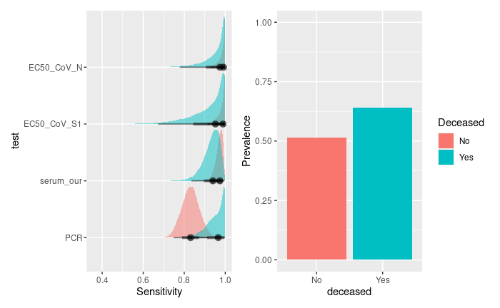

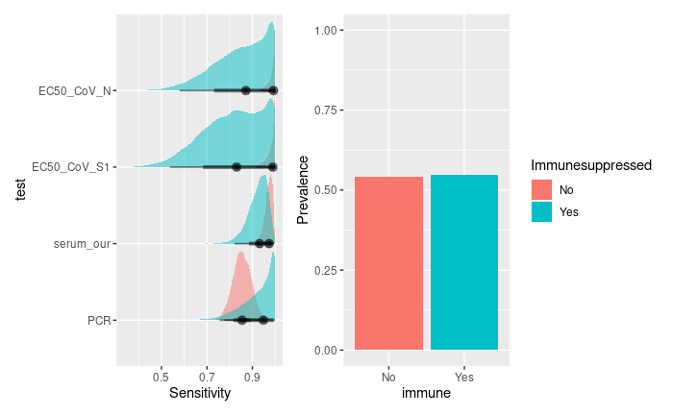

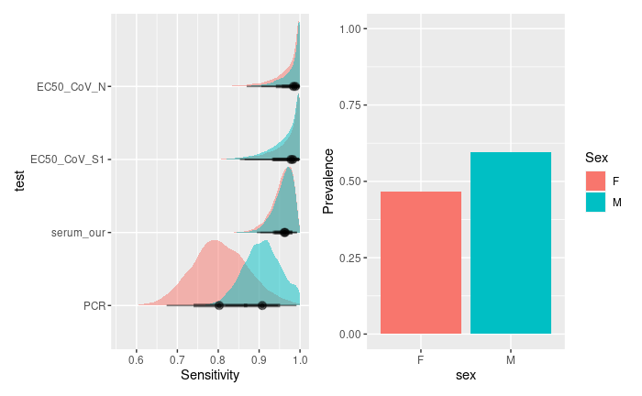

**Fig. S1.** Posterior densities of the sensitivities (left panel), prevalence (right panel)

*ICU, Intensive Care Unit; OUTP, outpatients; WARD, non-ICU hospitalized patients; EC50_CoV-N, SARS-CoV-2 N protein microarray; EC50_CoV-S1, SARS-CoV-2 S1 protein microarray; serum_our, Wantai serology using cut-off value of 0.25; PCR, polymerase-chain reaction; F, female; M, male*

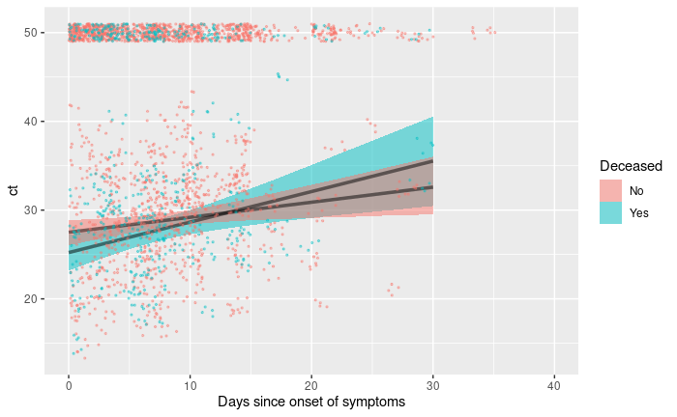

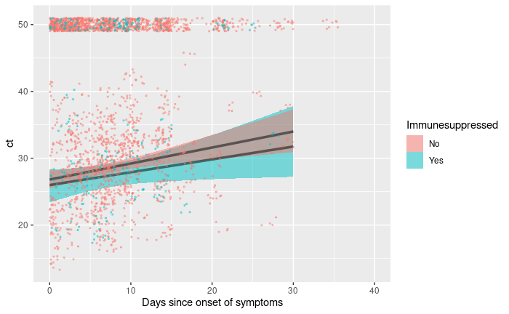

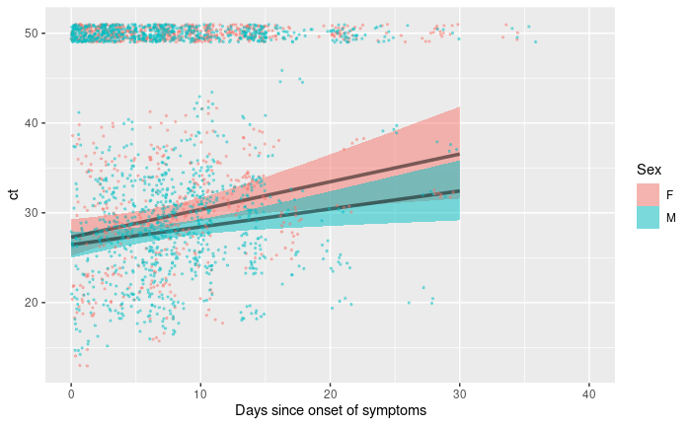

**Fig. S2.** Linear increase of Ct-value related to days-since-onset-of-symptoms. The shaded band indicates 95% credible interval. The dots are the original data. Dots positioned at a Ct of 50 were right-censored in the zero-inflated model (i.e. count as either above 50 or a negative individual).

*ICU, Intensive Care Unit; OUTP, outpatients; WARD, non-ICU hospitalized patients; EC50_CoV-N, SARS-CoV-2 N protein microarray; EC50_CoV-S1, SARS-CoV-2 S1 protein microarray; serum_our, Wantai serology using cut-off value of 0.25; PCR, polymerase-chain reaction; F, female; M, male*

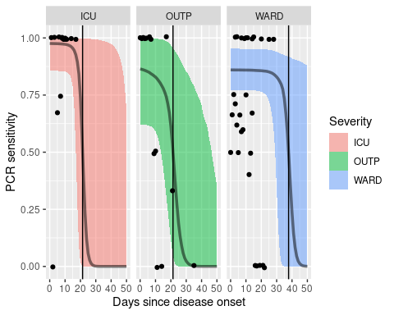

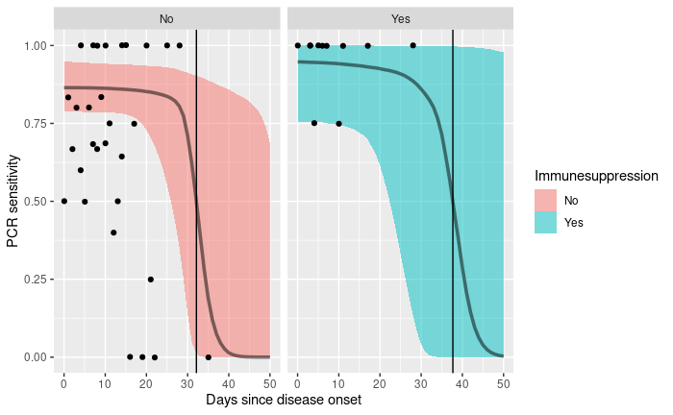

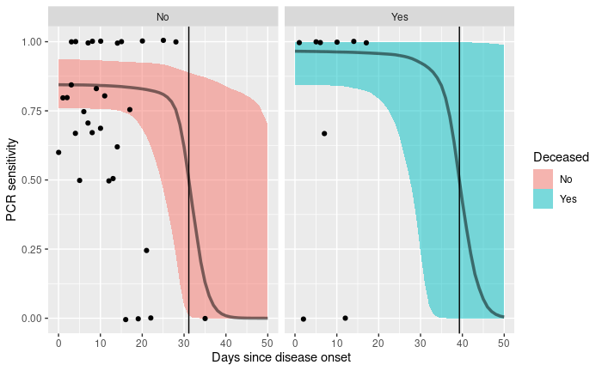

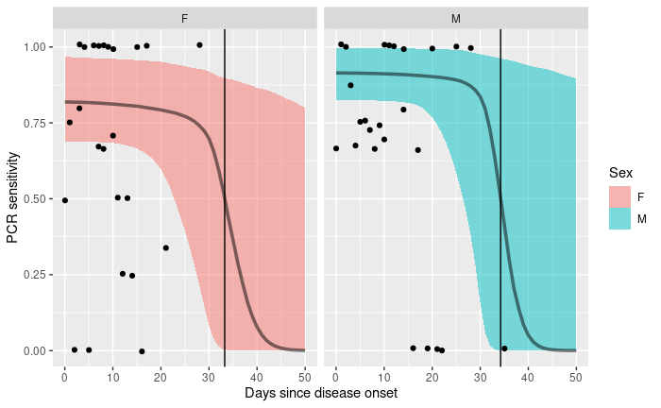

**Fig. S3.** The estimated sensitivities of the PCR test, as a function of the days since onset of symptoms.

*ICU, Intensive Care Unit; OUTP, outpatients; WARD, non-ICU hospitalized patients; EC50_CoV-N, SARS-CoV-2 N protein microarray; EC50_CoV-S1, SARS-CoV-2 S1 protein microarray; serum_our, Wantai serology using cut-off value of 0.25; PCR, polymerase-chain reaction; F, female; M, male*

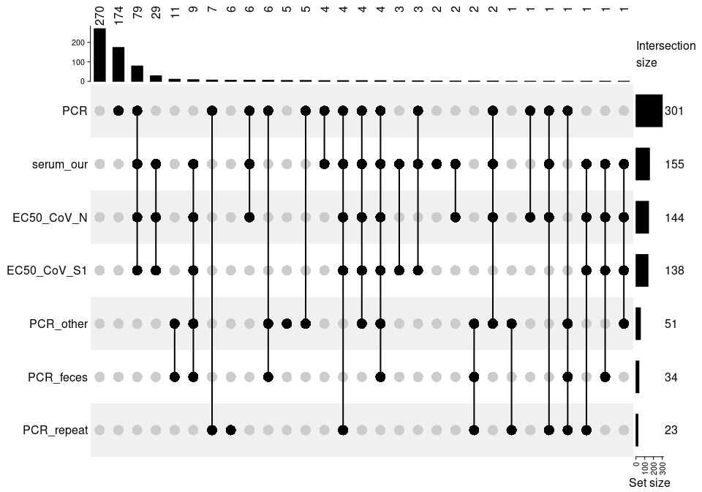

**Fig. S4**. Positivity of test, along with number of occurrences of each set (top) and tests (right).

*EC50_CoV-N, SARS-CoV-2 N protein microarray; EC50_CoV-S1, SARS-CoV-2 S1 protein microarray; serum_our, Wantai serology using cut-off value of 0.25; PCR, polymerase-chain reaction; PCR_repeat, PCR on repeated URT-swab; PCR_feces, PCR on feces; PCR_other, PCR on other clinical samples.*

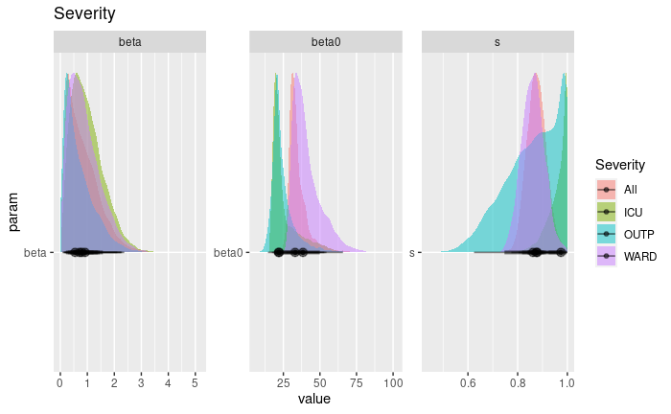

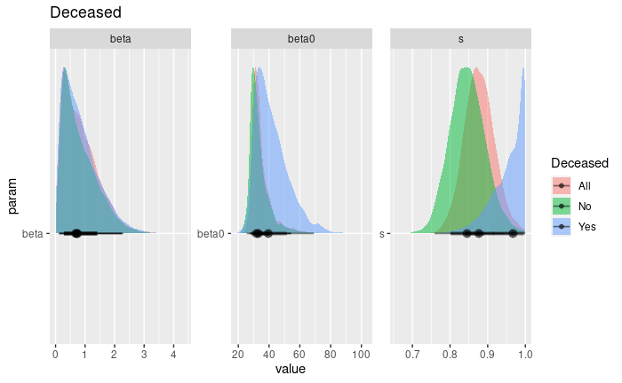

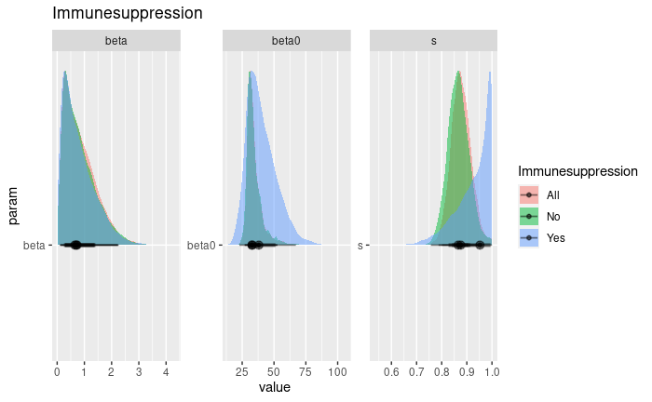

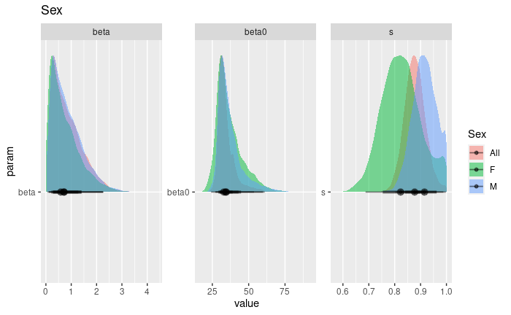

**Fig. S5.:** Posterior densities of the parameters ‘beta' (slope at inflexion point), 'beta0' (inflexion point) and 's' (baseline sensitivity).

*All, all patients; ICU, Intensive Care Unit; OUTP, outpatients; WARD, non-ICU hospitalized patients; F, female; M, male*