Supplementary Figures

Supplementary Figure S1. Power (α=0.05) to detect the rs16969968×AOS interaction effect, given the main effect estimates previously reported or estimated in the current study using the entire sample (left) or only EUR-ancestry individuals (right).
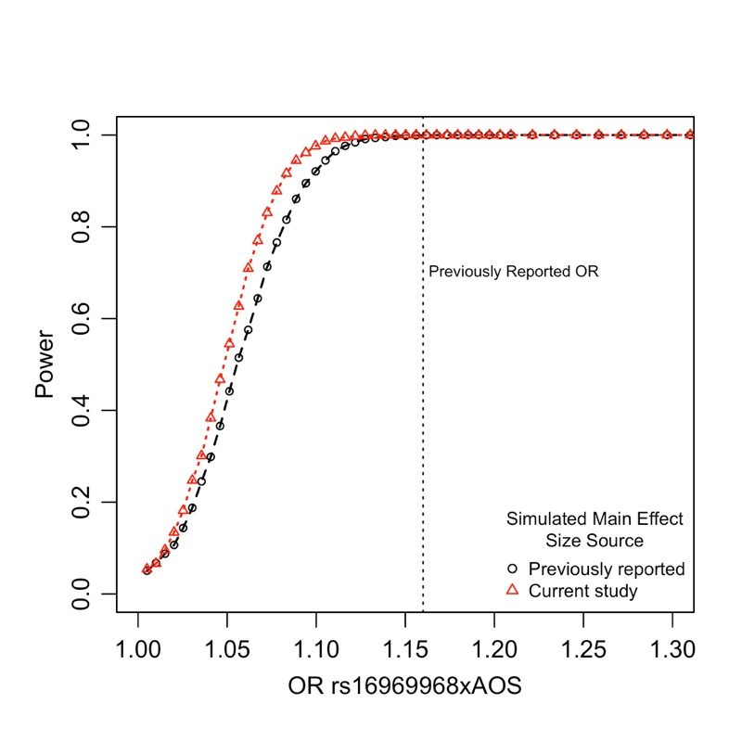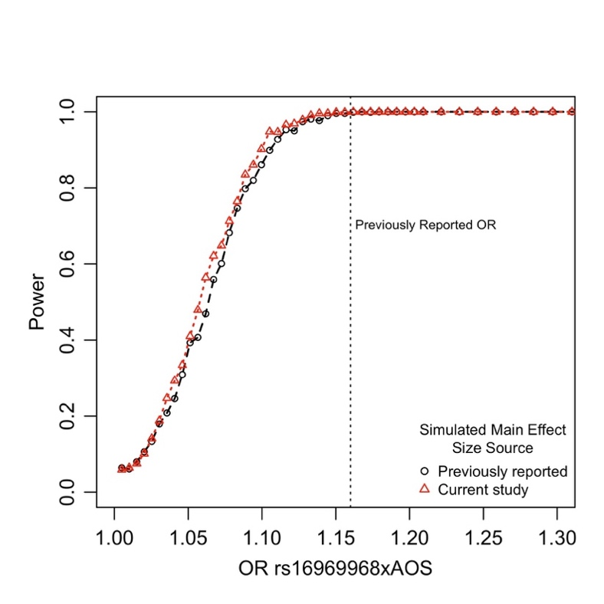

Supplementary Figure S2. Clustering of non-EUR-ancestry individuals within the UK Biobank. A. Percent variance explained (PVE) as a function of the number of clusters, K, in non-European-ancestry individuals within the UK Biobank. B. Clusters k=1-10 coded by color and symbol on the first 8 PC axes. C. PCs 1-6 coded by self-reported ethnicity within the UK Biobank (data field 21000).

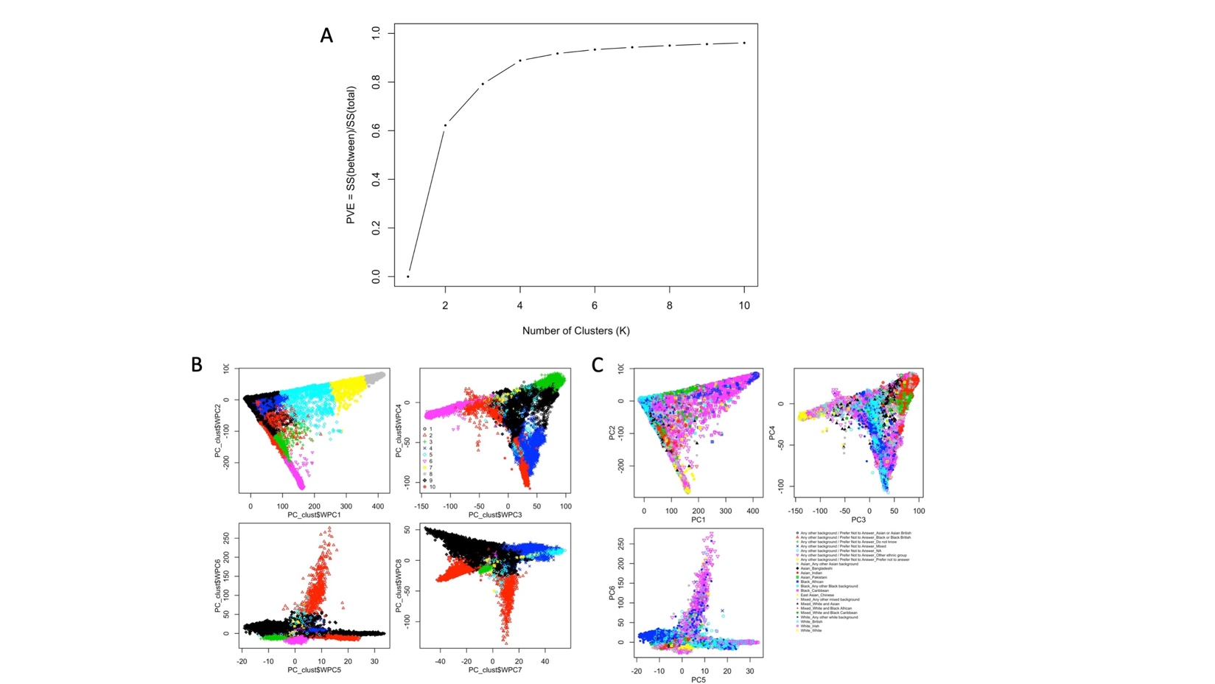

Figure S3. Distributions of A) CPD, B) log₁₀(CPD) outcomes, and C) the age of onset of regular smoking (AOS). The median AOS is indicated by the red line (at 16 years of age). D) Across the entire sample, using either logistic or linear regression and the same variables as Hartz et al., rs16969968 is not associated with AOS, matching GSCAN findings (Liu et al. 2018 Nat. Gen.).

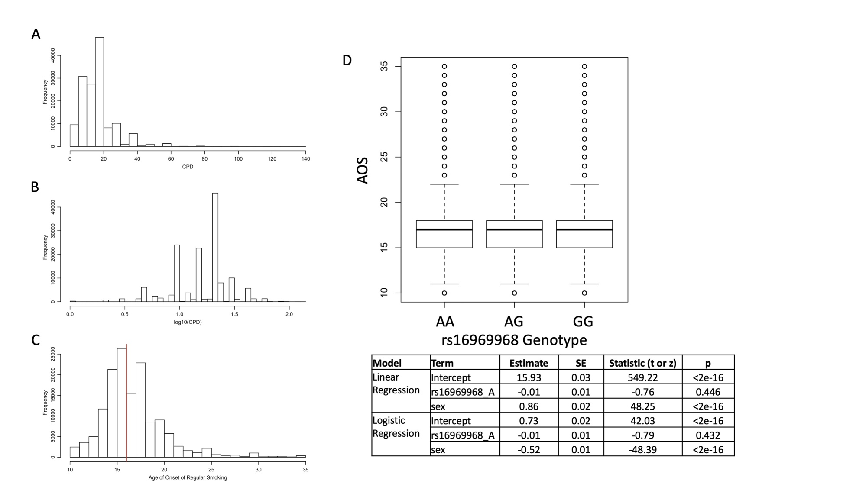
Figure S4. Main effects of rs16969968 genotype (A) and AOS (B) on cigarettes per day (CPD or log₁₀(CPD)), and rs16969968 effect on CPD and log₁₀(CPD) as a function of early or late age of initiation (C) within the EUR-ancestry group of individuals only.
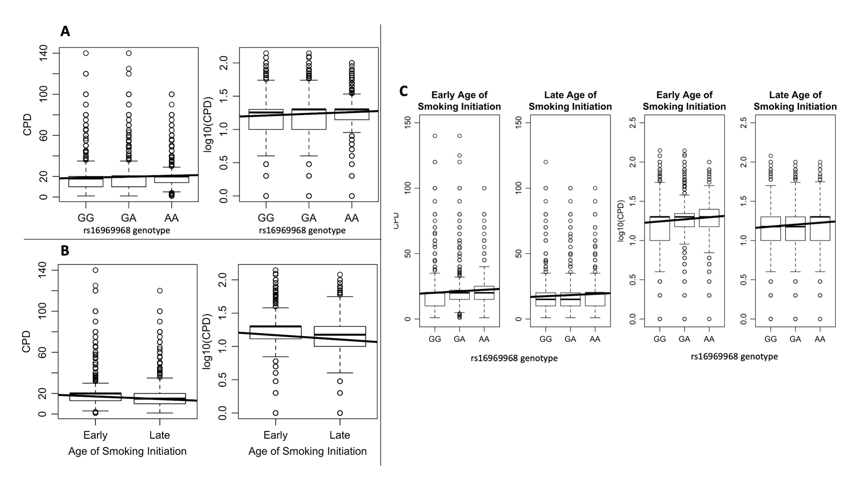

Figure S5. EUR Allelic effect size estimates, β, of the rs16969968 risk allele, A, estimated in stratified association analyses by early and late age of initiation within the EUR-ancestry set of individuals, with CIs indicated using either α=0.05 (solid line) or genome-wide Bonferroni-corrected α=5e-8 (dashed line). For the heavy vs. light smoker phenotype, allelic effects (β) were transformed to OR using the BOLT-LMM³²-suggested transformation, of e^{β / (u(1-u))}, where u=0.42 is the proportion of cases. Effect size difference Z-test p-values are shown for each comparison. See Table S1 for estimates and statistics.

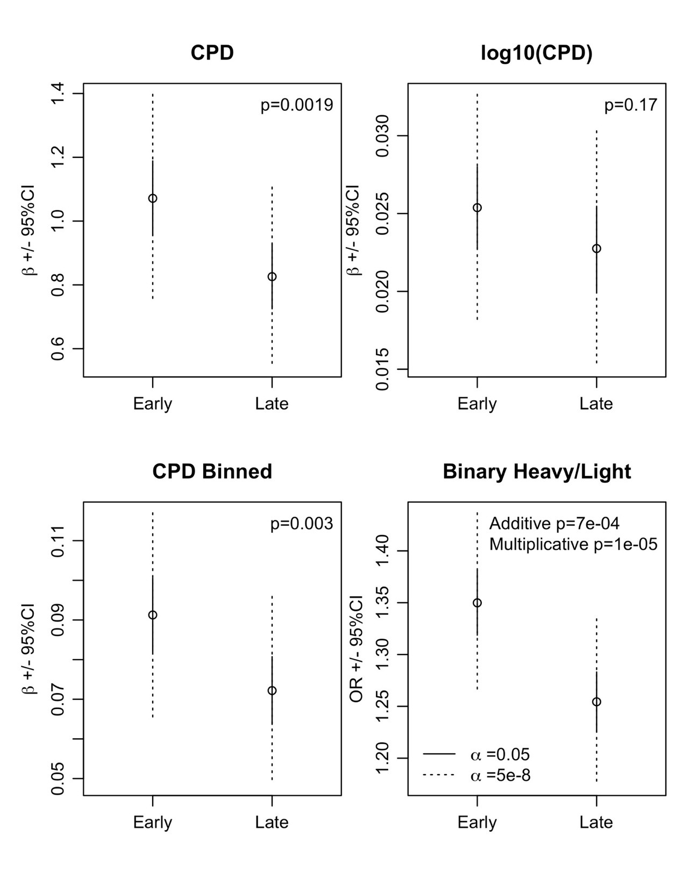

Figure S6. Power to detect the statistical interaction effect across a range of sample sizes for the interaction effect size estimated previously (OR=1.16) and from the current study within EUR-ancestry individuals (OR=1.03), applying either a nominal α=0.05 or genome-wide Bonferroni-corrected α=5e-8.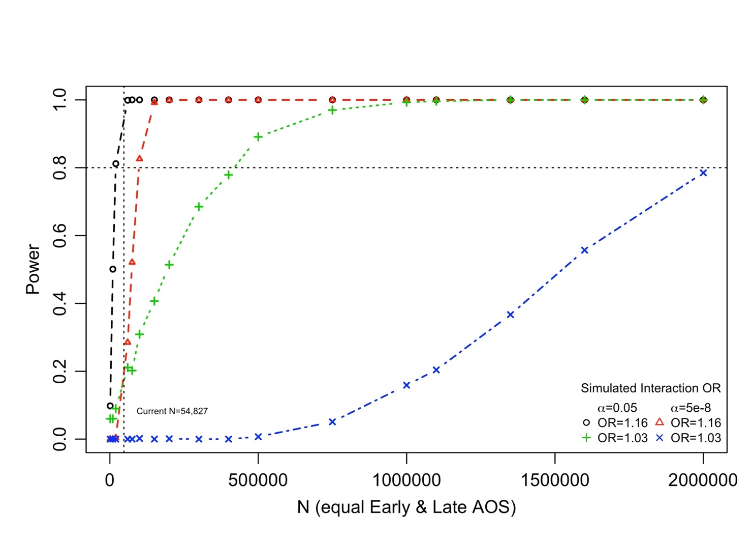

Figure S7. Power to detect the statistical interaction effect across a range of sample sizes for the interaction effect size estimated previously (OR=1.16) and the upper 95% CI OR estimate from the current study (OR=1.035), applying either a nominal α=0.05 or genome-wide Bonferroni-corrected α=5e-8. 