**SUPPLEMENTAL MATERIAL**

**The role of NIH funding in vaccine readiness; foundational research and NIH funding underlying candidate SARS-CoV-2 vaccines**

Anthony E. Kiszewskia, Ekaterina Galkina Cleary,b,c Matthew J. Jackson,a,b Fred D. Ledleya,b,d,1

a Department of Natural & Applied Sciences, Bentley University, Waltham, MA 02452; b Center for Integration of Science and Industry, Bentley University, Waltham MA 02452; c Department of Mathematical Sciences, Bentley University, Waltham, MA 02452; and d Department of Management, Bentley University, Waltham, MA 02452.

To whom correspondence should be addressed: fledley@bentley.edu

**CONTENTS**

**Supplemental Table 1.** PubMed search terms and results for vaccine technologies and diseases.

**Supplemental Table 2.** Program years and Costs by Activity Code Category for vaccine technologies and published research on Coronavirus vaccines.

**Supplemental Figure 1 A-G.** Annual publications for seven vaccine technologies used in candidate COVID-19 vaccines exhibiting logistic or exponential advance fit to the TIME model.

**Supplemental Figure 2 A-G.** Cumulative publications for seven vaccine technologies used in candidate COVID-19 vaccines exhibiting logistic or exponential advance fit to the TIME model.

**Supplemental Figure 3 A-G.** Cumulative publications for seven vaccine technologies used in candidate COVID-19 vaccines exhibiting logistic or exponential advance fit to the TIME model.

|  |  |  |  |  |  |
| --- | --- | --- | --- | --- | --- |
| **Supplemental Table 1. PubMed search terms and results for vaccine technologies and diseases.** | | | | | |
|  | |  | |  | |
| **Target/Technology** | **Search Term/PubMed Translation** | | **PMID** | |
| *Viral Technologies* | | |  | |
| Synthetic vaccines | ("Vaccines, Synthetic/administration and dosage"[Mesh] OR "Vaccines, Synthetic/adverse effects"[Mesh] OR "Vaccines, Synthetic/biosynthesis"[Mesh] OR "Vaccines, Synthetic/chemical synthesis"[Mesh] OR "Vaccines, Synthetic/immunology"[Mesh] OR "Vaccines, Synthetic/isolation and purification"[Mesh] OR "Vaccines, Synthetic/therapeutic use"[Mesh] OR "Vaccines, Synthetic/virology"[Mesh]) | | 21722 | |
| DNA (nucleic acid) vaccines | ("Vaccines, DNA/administration and dosage"[Mesh] OR "Vaccines, DNA/biosynthesis"[Mesh] OR "Vaccines, DNA/immunology"[Mesh] OR "Vaccines, DNA/isolation and purification"[Mesh] OR "Vaccines, DNA/virology"[Mesh]) | | 7618 | |
| Adjuvants, general | "Adjuvants, Immunologic"[Mesh] AND ("vaccine"[All Fields] OR "vaccines"[All Fields] OR "vaccines"[MeSH Terms]) | | 14334 | |
| Live, Attenuated virus | ("Vaccines, Attenuated/administration and dosage"[Mesh] OR "Vaccines, Attenuated/adverse effects"[Mesh] OR "Vaccines, Attenuated/immunology"[Mesh] OR "Vaccines, Attenuated/isolation and purification"[Mesh] OR "Vaccines, Attenuated/therapeutic use"[Mesh] OR "Vaccines, Attenuated/virology"[Mesh]) | | 8144 | |
| Inactivated virus | ("Vaccines, Inactivated/administration and dosage"[Mesh] OR "Vaccines, Inactivated/immunology"[Mesh] OR "Vaccines, Inactivated/isolation and purification"[Mesh] OR "Vaccines, Inactivated/therapeutic use"[Mesh] OR "Vaccines, Inactivated/virology"[Mesh]) | | 5925 | |
| Viral vector-based | ("Genetic Vectors/administration and dosage"[Mesh] OR "Genetic Vectors/immunology"[Mesh] OR "Genetic Vectors/therapeutic use"[Mesh] OR "Genetic Vectors/virology"[Mesh] ) AND ("vaccine"[All Fields] OR "vaccines"[All Fields] OR "vaccines"[MeSH Terms]) | | 1191 | |

**Supplemental Table 1 (*continued)***

|  |  |  |
| --- | --- | --- |
| **Target/Technology** | **Search Term/PubMed Translation** | **PMID** |
| TLR9 receptor agonists (adjuvant) | ("Toll-Like Receptor 9/agonists"[Mesh] OR "Toll-Like Receptor 9/immunology"[Mesh] OR "Toll-Like Receptor 9/therapeutic use"[Mesh]) | 1226 |
| mRNA vaccines | RNA AND (modified OR self-amplifying) AND ("vaccine"[All Fields] OR "vaccines"[All Fields] OR "vaccines"[MeSH Terms]) | 864 |
| Virus-like particles | (virus-like particle) OR VLP AND ("vaccine"[All Fields] OR "vaccines"[All Fields] OR "vaccines"[MeSH Terms]) | 3473 |
| Nanoparticle-based | ("Nanoparticles/administration and dosage"[Mesh] OR "Nanoparticles/biosynthesis"[Mesh] OR "Nanoparticles/chemical synthesis"[Mesh] OR "Nanoparticles/immunology"[Mesh] OR "Nanoparticles/isolation and purification"[Mesh] OR "Nanoparticles/therapeutic use"[Mesh] OR "Nanoparticles/virology"[Mesh]) AND ("vaccine"[All Fields] OR "vaccines"[All Fields] OR "vaccines"[MeSH Terms]) | 759 |

**Supplemental Table 1 *(continued)***

|  |  |  |
| --- | --- | --- |
| **Target/Technology** | **Search Term/PubMed Translation** | **PMID** |
| Vaccines against selected epidemic threats | |  |
| HIV | ("AIDS Vaccines/administration and dosage"[Mesh] OR "AIDS Vaccines/adverse effects"[Mesh] OR "AIDS Vaccines/agonists"[Mesh] OR "AIDS Vaccines/biosynthesis"[Mesh] OR "AIDS Vaccines/genetics"[Mesh] OR "AIDS Vaccines/immunology"[Mesh] OR "AIDS Vaccines/pharmacology"[Mesh] OR "AIDS Vaccines/therapeutic use"[Mesh]) | 5803 |
| Ebola | ("Ebola Vaccines/administration and dosage"[Mesh] OR "Ebola Vaccines/adverse effects"[Mesh] OR "Ebola Vaccines/biosynthesis"[Mesh] OR "Ebola Vaccines/genetics"[Mesh] OR "Ebola Vaccines/immunology"[Mesh] OR "Ebola Vaccines/isolation and purification"[Mesh] OR "Ebola Vaccines/pharmacology"[Mesh] OR "Ebola Vaccines/therapeutic use"[Mesh]) | 449 |
| Zika | ("Zika Virus/genetics"[Mesh] OR "Zika Virus/immunology"[Mesh] OR "Zika Virus/isolation and purification"[Mesh] OR "Zika Virus/ultrastructure"[Mesh]) AND ("vaccine"[All Fields] OR "vaccines"[All Fields] OR "vaccines"[MeSH Terms]) | 374 |
| Dengue | ("Dengue Vaccines/administration and dosage"[Mesh] OR "Dengue Vaccines/adverse effects"[Mesh] OR "Dengue Vaccines/biosynthesis"[Mesh] OR "Dengue Vaccines/genetics"[Mesh] OR "Dengue Vaccines/immunology"[Mesh] OR "Dengue Vaccines/pharmacology"[Mesh] OR "Dengue Vaccines/therapeutic use"[Mesh]) | 721 |
| Coronavirus1 |  |  |
|  | "Coronavirus/immunology"[Mesh] AND ("vaccine"[All Fields] OR "vaccines"[All Fields] OR "vaccines"[MeSH Terms]) | 1197 |
|  | "Spike Glycoprotein, Coronavirus"[Mesh] | 1372 |
|  | "nucleocapsid protein, Coronavirus" [Supplementary Concept] | 255 |

1 – The coronavirus search included all unique PMID identified in the three searches shown.

|  |  |  |  |  |
| --- | --- | --- | --- | --- |
| **Supplemental Table 2. Program years and Costs by Activity Code Category for vaccine technologies and published research on Coronavirus vaccines.** | | | | |
|  |  |  |  |  |
| **Activity Code Category** | **Viral technologies** | | **Coronavirus** | |
| **Project Years** | **Project Costs** | **Project Years** | **Project Costs** |
| **(#, since 2000)** | **($, millions)** | **(#, since 2000)** | **($, millions)** |
| Research Projects | 6569 | $2,294.4 | 284 | $110.2 |
| Cooperative Agreements | 1405 | $5,582.2 | 61 | $261.3 |
| Research Program Projects and Centers | 1675 | $5,167.4 | 65 | $170.8 |
| Training Programs | 605 | $262.7 | 36 | $12.8 |
| Research Career Programs | 370 | $77.6 | 10 | $1.1 |
| General Clinical Research Centers Program | 85 | $294.9 | na | na |
| Fellowship Programs | 137 | $4.0 | 12 | $0.4 |
| Institutional Training and Director Program Projects | 64 | $54.2 | na | na |
| Research-Related Programs | 58 | $39.3 | 8 | $2.7 |
| Research Construction Programs | 31 | $9.3 | na | na |
| Non-HHS Federal Awards | 21 | na | na | na |
| Resource Programs | 30 | $67.9 | na | na |
| Community Services Program | 2 | $14.0 | na | na |
|  |  |  |  |  |
| Intramural Programs | 1413 | $1,461.2 | 59 | $195.6 |
|  |  |  |  |  |
| Not Categorized | 906 | $1,841.5 | 23 | $11.9 |

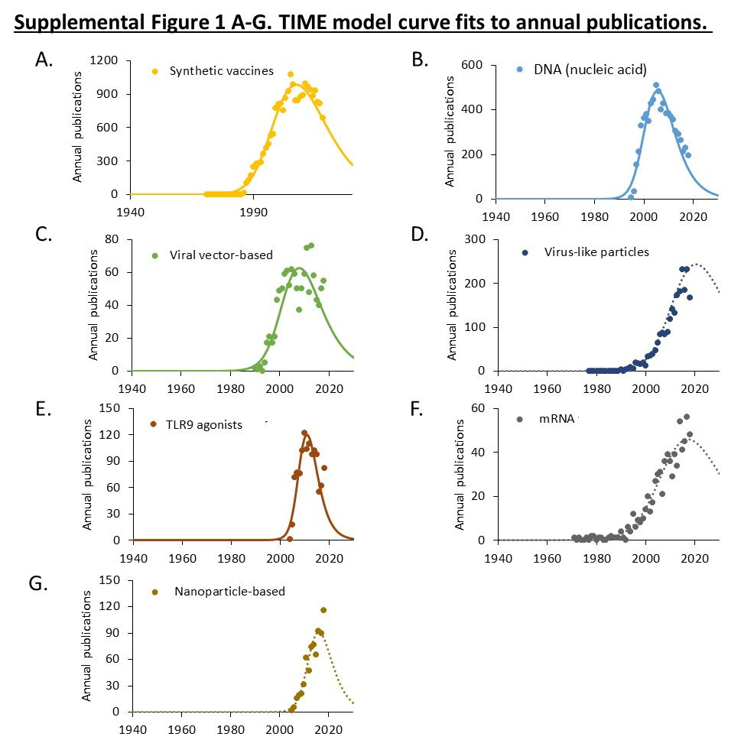

**Supplemental Figure 1 A-G. Annual publications for seven vaccine technologies used in candidate COVID-19 vaccines exhibiting logistic or exponential advance fit to the TIME MODEL**. The curve shown represents the first derivative of the exponentiated logistic function. The *established* point represents the point of maximum deceleration of publication activity.

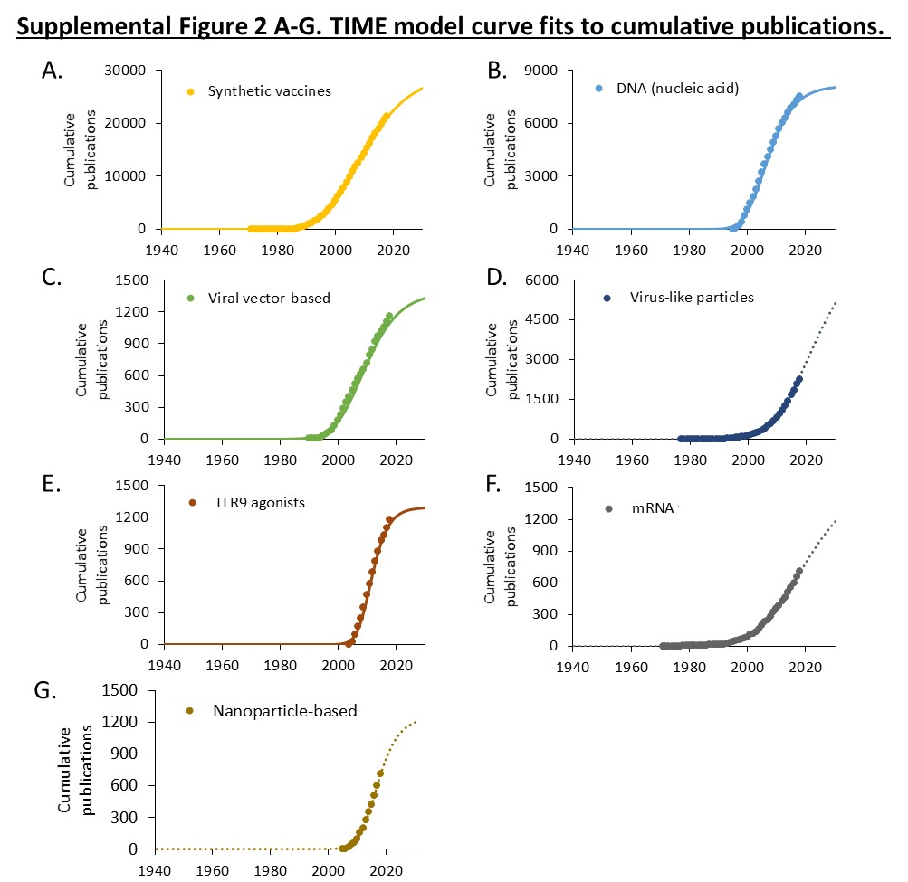

**Supplemental Figure 2 A-G. Cumulative publications for seven vaccine technologies used in candidate COVID-19 vaccines exhibiting logistic or exponential advance fit to the TIME MODEL.** The curve shown represents exponentiated logistic function. Data is shown on a linear scale.

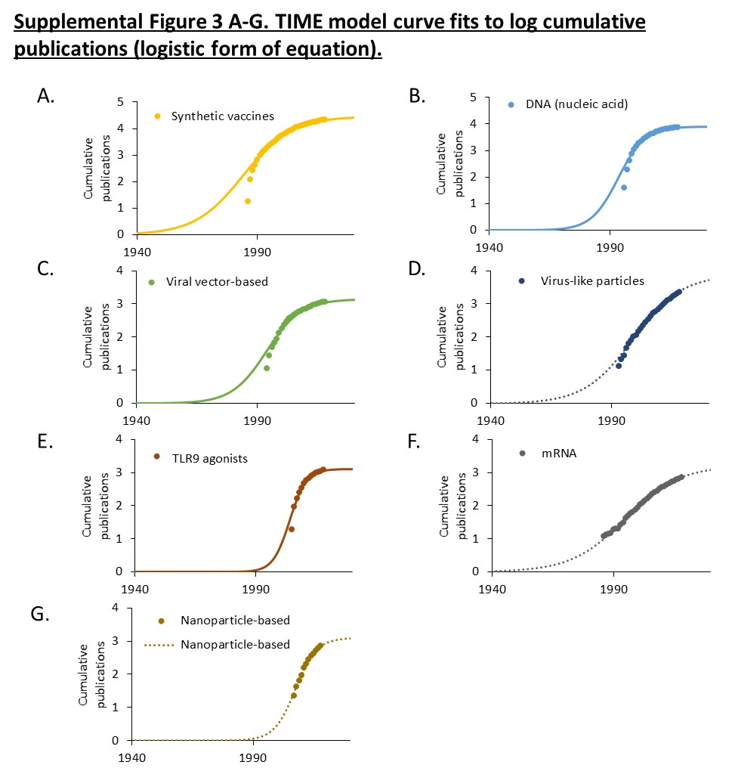

**Supplemental Figure 3 A-G. Cumulative publications for seven vaccine technologies used in candidate COVID-19 vaccines exhibiting logistic or exponential advance fit to the TIME MODEL.** The curve shown represents exponentiated logistic function. Data is shown on a log scale, which illustrates the classic “S-curve” pattern of technological advance seen in other fields of technology.