**Supplementary File 8**: Cross-Ancestry analysis related to UKB vs. AFR comparison. Blue=query variants; Orange= functional non-coding variants; Red=functional coding variants; 1-7=RegulomeDB score.

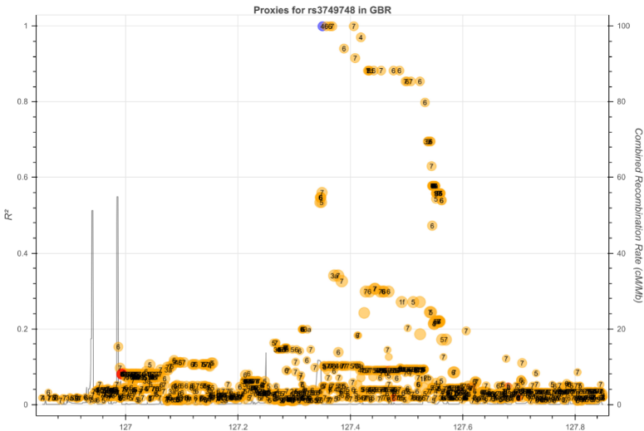

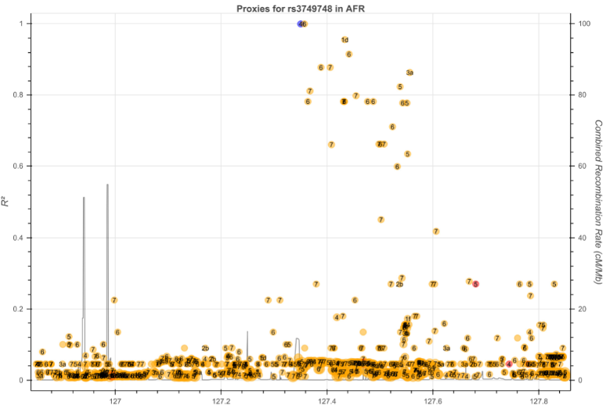

**Figure S8.1**

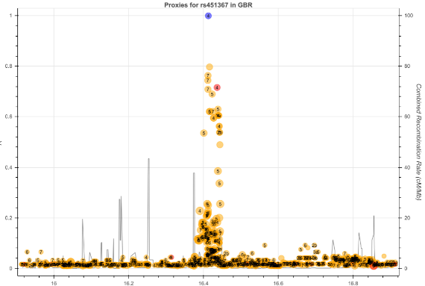

**Figure S8.2**

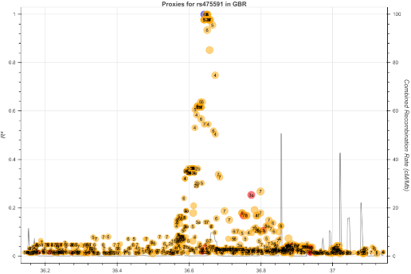

**Figure S8.3**

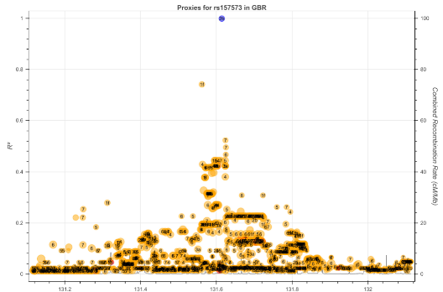

**Figure S8.4**

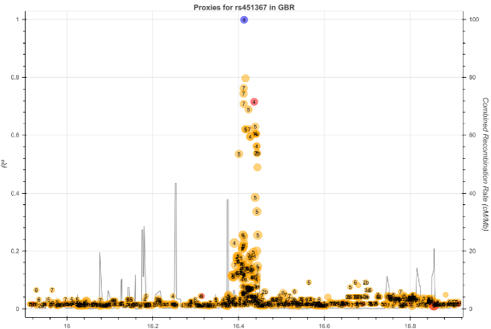

**Figure S8.5**